A-level Economics

Bridging Course - Week 3

St Mary’s Catholic School
A-level Economics Bridging Course

Entry Requirements for Studying A-level Economics?
- Students are expected to achieve at least a grade 6 in GCSE Maths and English Language.
- Students must have an interest in the news and current affairs
- Students should have an interest in debates and discussion in lessons, and be willing, and able, to share their ideas.
What to expect from A-level Economics
There aren’t many A- level subjects as dynamic as Economics. The news is full of examples of Economics in action. Within the course we study human behaviour, how markets work and how they fail and seek to understand the dynamics of change at a micro level (e.g. within an industry) and at a macro level (e.g. within and between countries).
Whilst studying this course students will develop their analytic and evaluative skills. These will be tested through short explanation questions but a large amount of the course (1/3 of your overall mark) will involve writing longer essay style questions. The course will also use economic models and diagrams to analyse real life events.
It doesn’t matter if you haven’t studied Economics before. You might have an interest in Economics and want to know more about the impact economics has on the world around you. You might want to investigate some of the stories you hear in the news – Why do some economies grow and others don’t? Will the Eurozone survive? Why didn’t economists predict the Global Financial Crisis? This course will help you to understand all this and more.

This bridging course will provide you with a mixture of information about A-level Economics, and what to expect from the course, as well as key work to complete. Students who are expecting to study Economics at A-level, and are likely to meet the entry requirements, must complete the bridging course fully and thoroughly, to the best of their ability.

You should complete all work on paper and keep it in a file, in an ordered way. You will submit it to your teacher in September. All of the work will be reviewed and selected work will be assessed, and you will be given feedback on it. This work will be signalled to you. If you do not have access to the internet, please contact the school and appropriate resources will be sent to you.

If you are thinking about studying Economies at A-level you should attempt this work to see whether or not you think studying a subject like this is right for you. If you later decide to study Economics, you must ensure you complete this work in full. This work should be completed after you have read and completed the Study Skills work that all of Year 12 should complete.

Review of Week 2 Bridging Course

Last week you researched the 2008 Financial Crisis. To check your understanding complete the questions below:

- What is a housing bubble?
- Summarise the cause or the 2008 Financial crisis.

Answers are on the last page of this document

The following work requires a lot of reading, and some of the ideas might be challenging to understand on first reading. Remember to take regular breaks, go back to any of the tasks after some time away, and try your best. Your Economics teacher will go over the following with you in lessons, early in Year 12.

This third week of tasks will focus on Globalisation. This work will be reviewed on return to school.

How global are you? Can you name all the global brands? Answers or on the final page.

Task one

The linked video introduces the concept of globalisation. Watch the video and answer the questions below:

https://youtu.be/QlPuvHwpZ7A

- What is globalisation?
- How can we measure globalisation?
- Give examples of how firms have become global brands.

Task two

Make a list of the causes of globalisation. The video below will help.

https://youtu.be/LYpgCDXmAEE

Task three

Using the image below, make a list of possible disadvantages of globalisation.

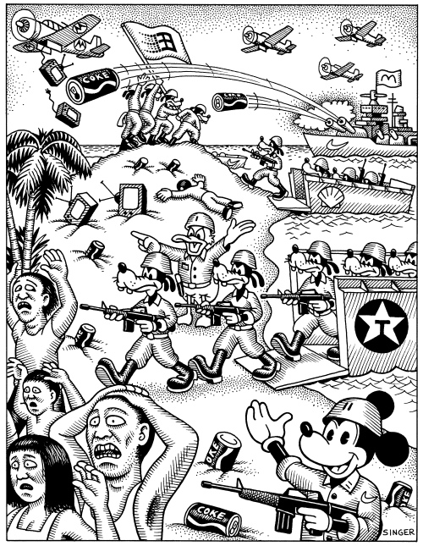

Now use the link below to check and improve your answers.

https://youtu.be/p78r-e0MClw

Task four

Using your own knowledge and the knowledge gained from the above tasks, answer the questions below. These will be assessed, and feedback given.

1.What words do you associate with globalisation?

2.Explain what globalisation is. Consider world trade, investment flows, migration.

3.Explain each of these factors that have led to multinational corporations driving globalisation.

- Improvements in transport and communications
- Lack of regulation (health and safety and environmental)
- Differences in labour costs and tax systems

- What other factors have caused globalisation?

- Explain the main arguments for and against globalisation.

Further reading

https://www.tutor2u.net/economics/reference/transnational-businesses-and-globalisation

https://www.tutor2u.net/economics/collections/topic-revision-globalisation

https://www.wired.co.uk/article/china-coronavirus-trump-geopolitics

https://www.theguardian.com/commentisfree/2020/mar/08/the-coronavirus-outbreak-shows-us-that-no-one-can-take-on-this-enemy-alone

https://youtu.be/VtkPYz9Lm10

Answers to review questions

- A housing bubble is a run-up in housing prices fuelled by demand, speculation, and exuberant spending to the point of collapse.
- The primary cause of the great recession was the credit crunch (2007-08) where the global banking system became short of funds, leading to a decline in confidence and decline in bank lending.

Answers to brand questions

