A-level Economics

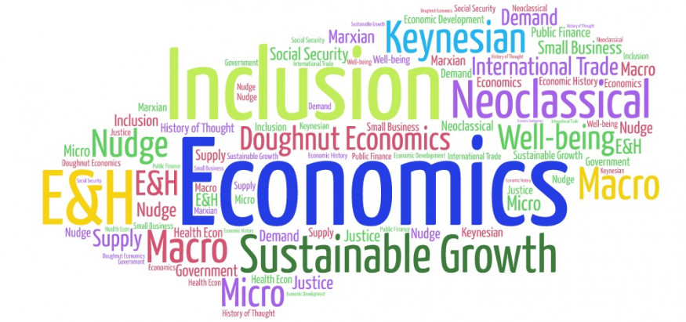

Bridging Course - Week 1

St Mary’s Catholic School
A-level Economics Bridging Course

Entry Requirements for Studying A-level Economics?
- Students are expected to achieve at least a grade 6 in GCSE Maths and English Language.
- Students must have an interest in the news and current affairs
- Students should have an interest in debates and discussion in lessons, and be willing, and able, to share their ideas.
What to expect from A-level Economics
There aren’t many A- level subjects as dynamic as Economics. The news is full of examples of Economics in action. Within the course we study human behaviour, how markets work and how they fail and seek to understand the dynamics of change at a micro level (e.g. within an industry) and at a macro level (e.g. within and between countries).
Whilst studying this course students will develop their analytic and evaluative skills. These will be tested through short explanation questions but a large amount of the course (1/3 of your overall mark) will involve writing longer essay style questions. The course will also use economic models and diagrams to analyse real life events.
It doesn’t matter if you haven’t studied Economics before. You might have an interest in Economics and want to know more about the impact economics has on the world around you. You might want to investigate some of the stories you hear in the news – Why do some economies grow and others don’t? Will the Eurozone survive? Why didn’t economists predict the Global Financial Crisis? This course will help you to understand all this and more.

This bridging course will provide you with a mixture of information about A-level Economics, and what to expect from the course, as well as key work to complete. Students who are expecting to study Economics at A-level, and are likely to meet the entry requirements, must complete the bridging course fully and thoroughly, to the best of their ability.

You should complete all work on paper and keep it in a file, in an ordered way. You will submit it to your teacher in September. All of the work will be reviewed and selected work will be assessed, and you will be given feedback on it. This work will be signalled to you. If you do not have access to the internet, please contact the school and appropriate resources will be sent to you.

If you are thinking about studying Economies at A-level you should attempt this work to see whether or not you think studying a subject like this is right for you. If you later decide to study Economics, you must ensure you complete this work in full. This work should be completed after you have read and completed the Study Skills work that all of Year 12 should complete.

Course outline

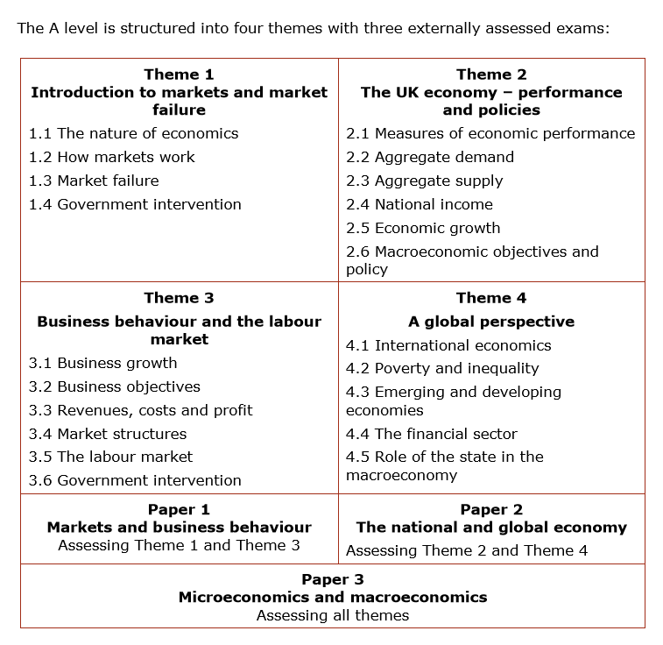

The following work requires a lot of reading, and some of the ideas might be challenging to understand on first reading. Remember to take regular breaks, go back to any of the tasks after some time away, and try your best. Your Economics teacher will go over the following with you in lessons, early in Year 12.

This first week of tasks will focus on what Economics is and how it links to everyday life.

Task one

In order to begin to understand what Economics is use the link below to make notes on the difference between Micro and Macroeconomics.

https://www.tutor2u.net/economics/reference/head-start-economics-introduction-to-macroeconomics

Task two

Making decisions is vital in Economics. Use the link below to complete the activity of ‘Prime Minister for the day’

https://www.tutor2u.net/economics/reference/introduction-to-macroeconomics-prime-minister-for-the-day-activity

Task three

‘What is Economics really about’ - Complete the next activity on paper. You need to decide who should get the treatment and why. This will be discussed when the course commences.

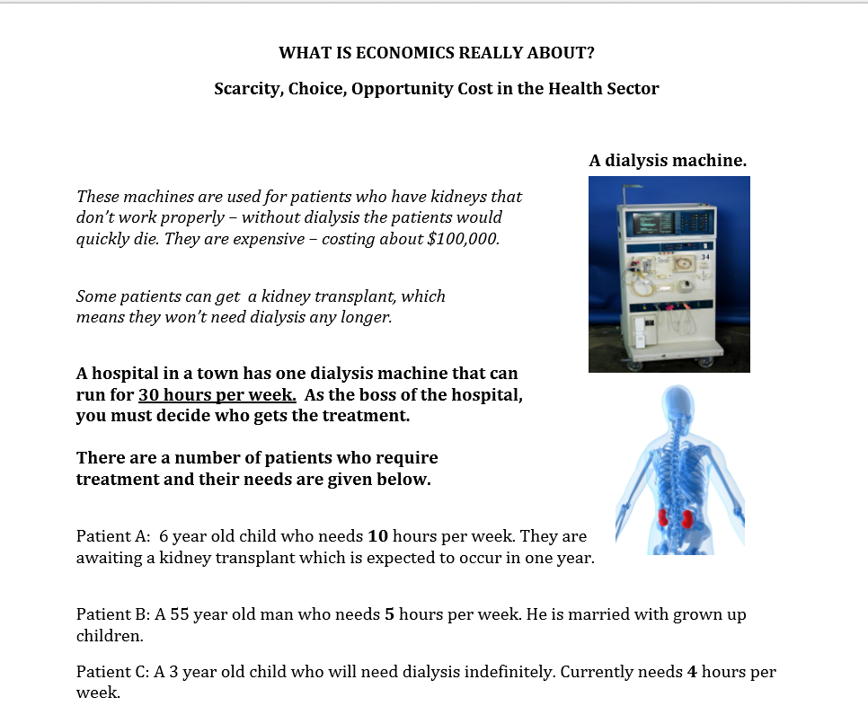
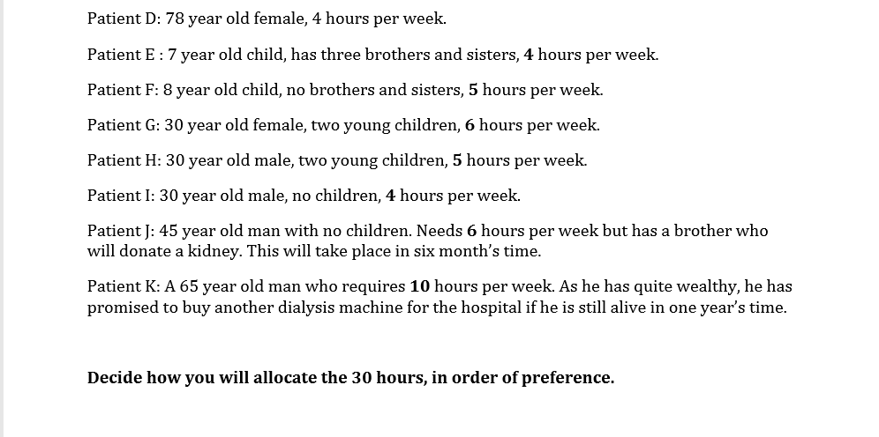

Task four

Economics is evident in everyday life. This task will allow you to think about some of the big issues that face countries.

For each issue on the slides that follow, point your smartphone on the QR code to access recommended background reading. You will also be able to find relevant videos on YouTube and BBC news. Each slide contains a question. Using the resources and your own knowledge answers the questions on paper and keeps these with your notes.

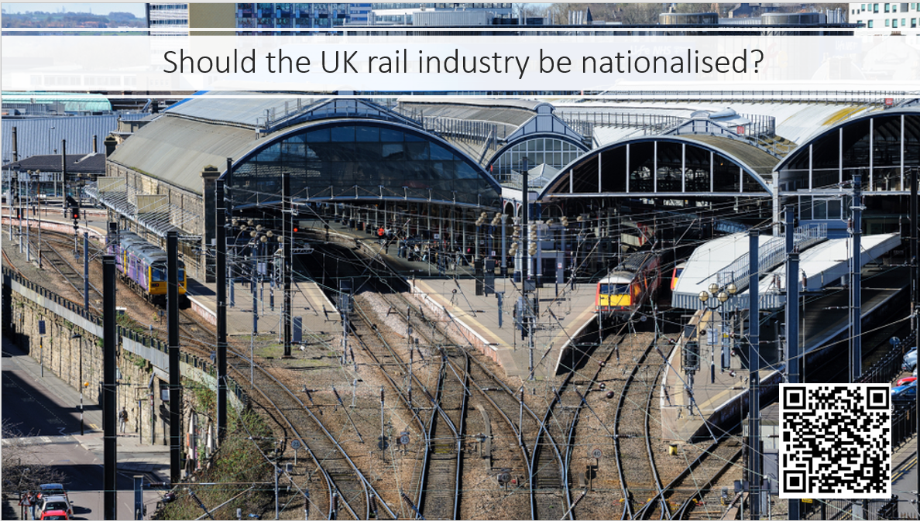

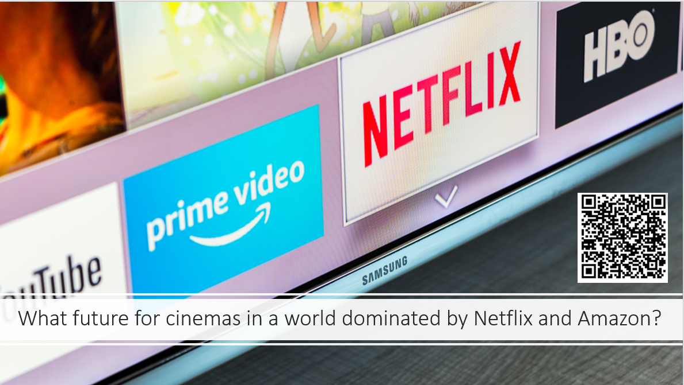

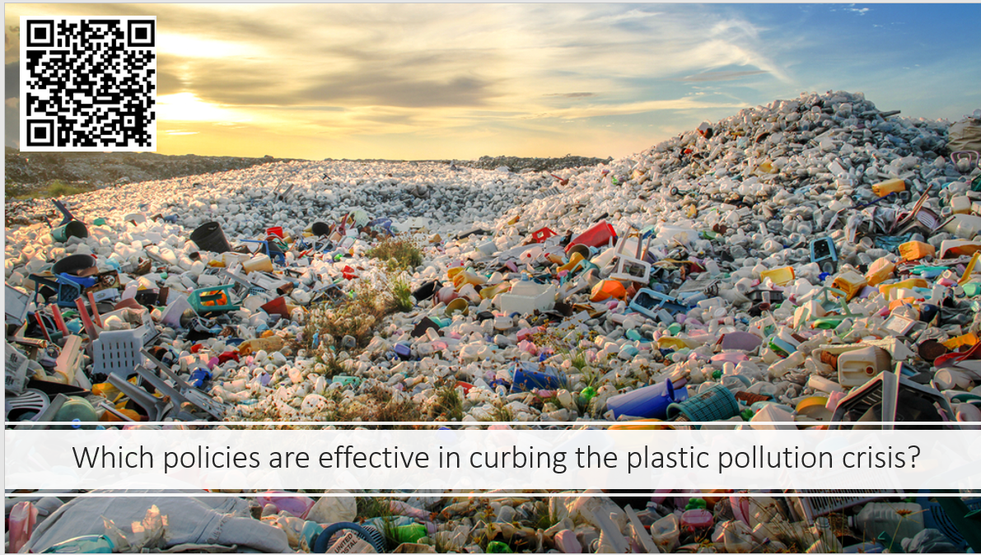

Task five- increasing your knowledge about economic events.

Below I have copied an extract from a specialist Economics website. Use the resources they have suggested to ensure that you have a good understanding of what Economics is and how it links to the world around us.

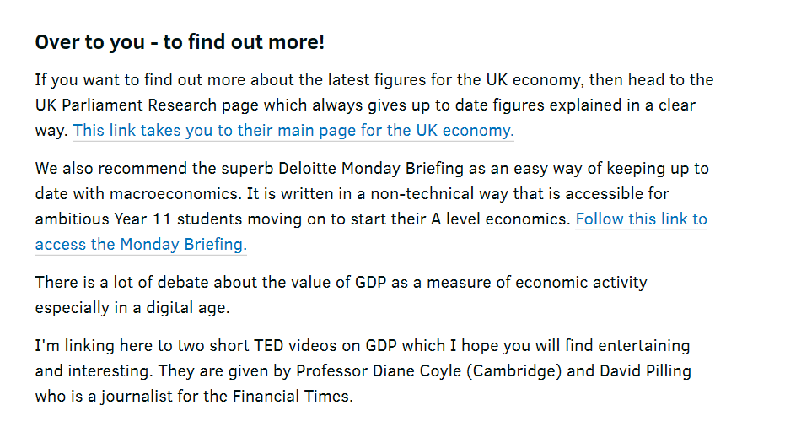

UK Parliament link

https://commonslibrary.parliament.uk/category/economy-business/economy-economy/

Deloitte link

https://blogs.deloitte.co.uk/mondaybriefing/

TED links
https://youtu.be/1n9tWZEj3Bs

https://youtu.be/RmgQtAudP-k

