Review Activity
Nutrition

- List 2 macronutrients.

- List 2 micronutrients.

- List one effect of a lack of vitamin D in the diet.

- List one effect of a lack of iron in the diet.

- List one effect of a lack of protein in the diet.

- Can you recall as much information as possible and add information to the Eat Well Plate
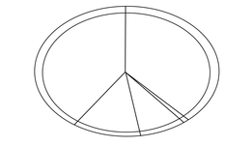

- Suggest 3 healthy food swaps you would recommend to an individual who eats lost of sugary snacks.

- In the box list the impact of a balanced vs. unbalanced diet.
Balanced | Unbalanced.

- Label the body image with words associated with the impact of obesity.



