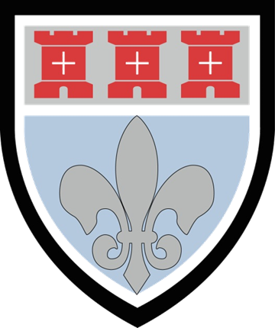
Y9

Y9
Health and Social Care
Extra Support
Resource Booklet
Autumn Term

SRU 2019
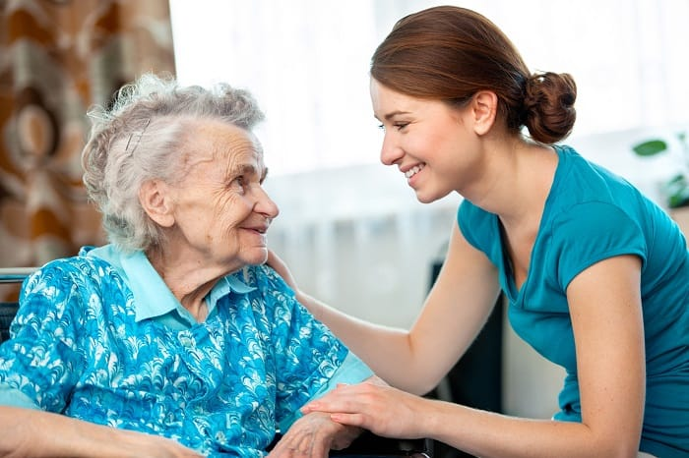
Communication in Health and Social Care

Effective communication is vital to working in health and social care. An important part of communication is the giving and receiving of information. This term you will develop knowledge and skills which underpin effective communication. You will also gain an understanding that these skills need to be adapted to different circumstances, e.g. a nurse trying to take blood from a patient who has a fear of needles needs to use their voice and body language to reassure the patient and control the situation.

Additionally, people who access services do so because they have needs and these have to be expressed by the individual and understood by the practitioner; communication facilitates this. It is not always easy to communicate effectively and factors that inhibit and support communication will also be covered during this term. You will investigate a range of these factors, for example language, environmental conditions, positioning and body language. You will develop an understanding that many of these factors can have a negative impact on communication and that these barriers will need to be overcome in order to communicate effectively.



Verbal communication

Verbal communication occurs when one person speaks and another person listens. Care workers need a range of verbal communication skills to: respond to questions, find out about an individual’s problems or needs, contribute to team meetings, break bad news, provide support to others and deal with problems and complaints.

Activity:
Complete the missing words.
A person’s choice of words, as well as the way they speak, influences the effectiveness of their communication. The pace, ________, pitch and volume of the speaker’s voice are important. For example, it is never a good idea to _________, or to talk so loudly that the listener believes you are shouting. This kind of behaviour is likely to draw attention away from the verbal ‘message’ or content of what is being said. ____________, speaking too quickly, failing to complete sentences and using a hostile or _____________ tone will also impair the effectiveness of communication.
It is important to speak __________ and at a pace the other person can follow. Effective communicators also avoid using slang, jargon and acronyms, to prevent misunderstandings developing. Speaking in a measured, clear and reasonably paced manner will help listeners to hear and _____________ what is being said. A relaxed, encouraging and __________ tone of voice also helps the speaker to convey ___________, sincerity and appropriate respect for the listener.

Shout Understand Aggressive Tone
Warmth Clearly Shouting Friendly

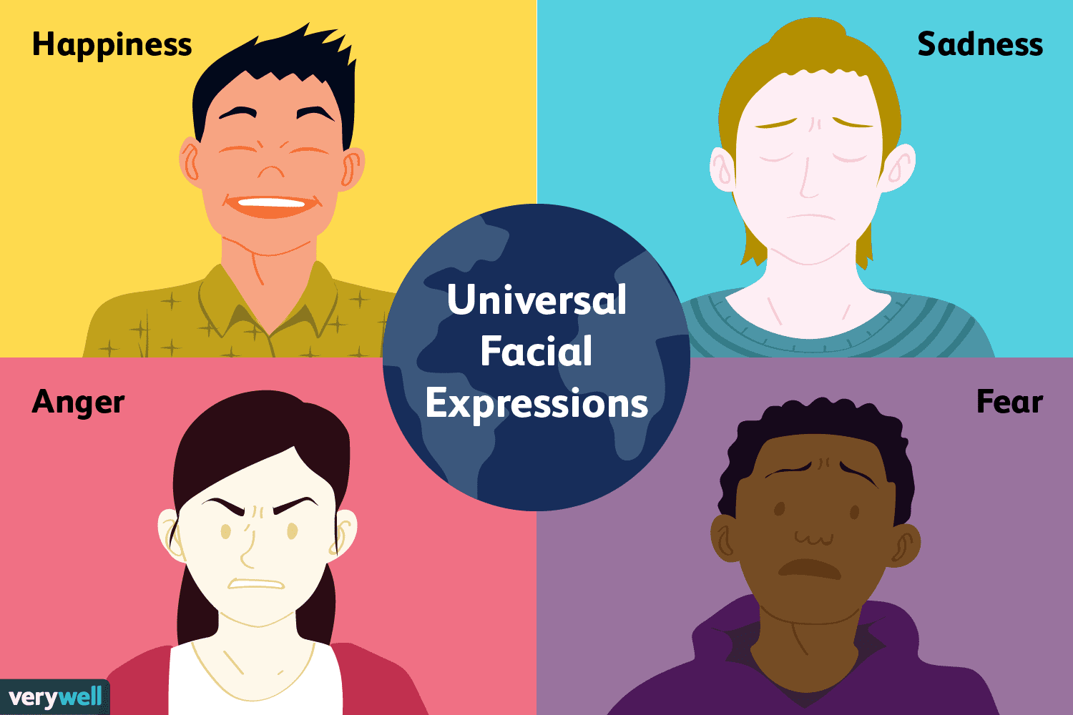

Non-verbal communication

As well as communicating through speech, people use a variety of forms of non-verbal communication. Some of these are referred to as body language. This is because they involve the individual using their body and appearance to communicate in some way. For example, a care worker’s behaviour, appearance and attitude send ‘messages’ to people who receive care (as well as to colleagues) about what they think and feel. Similarly, a person’s body language may tell a care worker that they are uncomfortable or experiencing pain even when they say, ‘I’m okay’. Non-verbal communication is a channel of communication that is ‘always on’.

Activity:
Complete the table below giving examples of non-verbal body language.

Non Verbal Communication | Examples
Facial Expression
Gestures
Proximity
Eye Contact

Label the picture with positive and negative examples of non-verbal communication

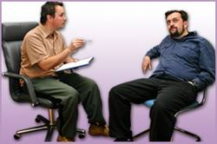

Consider the following case study and write your answer below:

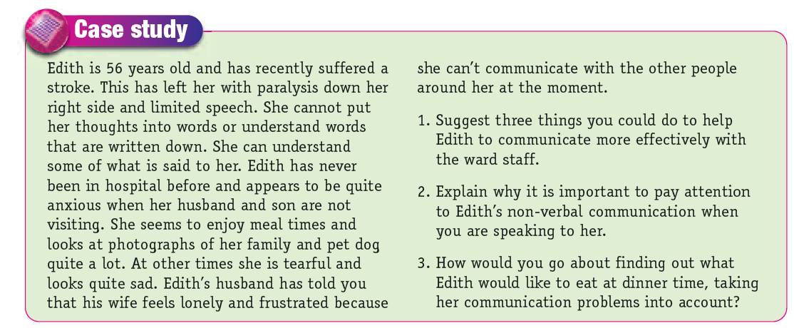

1.______________________________________________________________________________________________________________________________________________________________________________________________________________________________________________________________________________________________________________________________________________
2.______________________________________________________________________________________________________________________________________________________________________________________________________________________________________________________________________________________________________________________________________________
3.______________________________________________________________________________________________________________________________________________________________________________________________________________________________________________________________________________________________________________________________________________

Health Promotion
Health promotion is the provision of information and education both in individuals and to the nation. Health promotion enables people to take control over their health and wellbeing. It cannot be imposed or forced and it is done so that people have sufficient information to make up their own minds on what action to take.
Activity:
Do some research into the facts about skin cancer.
Research about the causes of skin cancer and produce a poster that can persuade people to use sunscreen and avoid sunbeds.

Vaccinations:
A vaccine is a substance that contains a weakened or synthetic form of the pathogen that causes a particular disease. The process of building up immunity by taking a vaccine is called immunisation.
Research Activity
Find out what vaccines are offered in the UK and the group of people who they are offered to.

Vaccine | Groups who would most benefit from the vaccine.
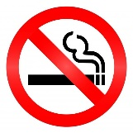
Stop Smoking Campaigns:

Complete the boxes below to include images and words to describe what the government has done to help raise awareness about the impact of smoking and to help people to stop.

Public Areas | Legislation
TV | Social Media
Selling of Tobacco | Products to stop smoking
.

