Please write clearly, in block capitals
Centre number Candidate number
Surname
Forenames(s)
Candidate’s signature

A-Level - Design & Technology (Product Design)
Date of Exam Time allowed: 2 hours 30 minutes
Materials
For this paper you must have:
- normal writing and drawing instruments
- a scientific calculator
- a protractor
Instructions
- Use black ink or black ball-point pen. Use pencil only for drawing.
- Fill in the information at the top of this page.
- Answer all questions.
- You must answer the questions in the spaces provided. Do not write on blank pages.
- Do all rough work in this paper. Cross through any work that you do not want to
be marked.
Information
- The marks for questions are shown in brackets.
- The maximum mark for this paper is 120.

Answer all questions.
1. The table below gives details of four specific papers and boards and a suitable application of use for each.
Specific paper or board | Suitable application of use
Bleed proof paper | Marker rendering of design ideas
Corrugated card | Retail packaging for a TV
Foil backed card | Drinks carton
Mount board | Model making
Describe the performance characteristics that make each paper or board
suitable for each identified application. [8 marks]
Bleed proof paper

Corrugated card

Foil backed card

Mount board

2. Explain the meaning of the term 'wastage' in relation to manufacturing. [2 marks]

3. Harnessing renewable energy in the UK is rapidly rising to meet demand. The bar chart below shows the change in renewable energy use in the UK in recent years.

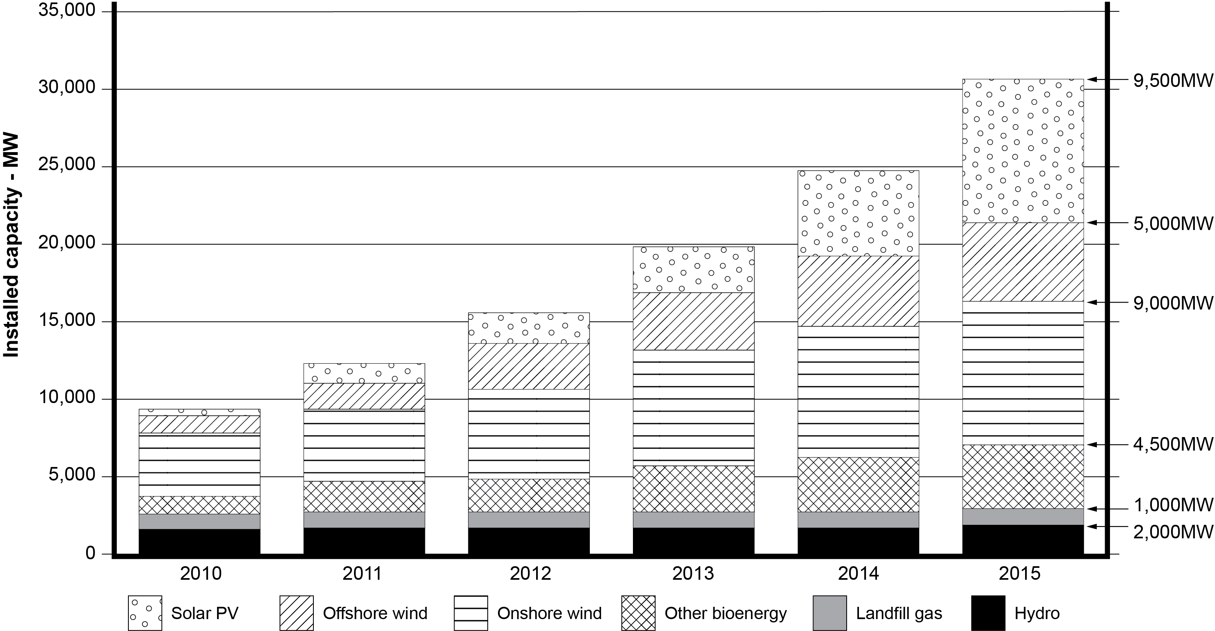
- Calculate the percentage of solar PV used in 2015. Round your answer to
the nearest whole number. [2 marks]
Solar PV

(b) Complete the pie chart below by adding the remaining data and labels for
PV solar and Offshore wind for the year 2015. [4 marks]

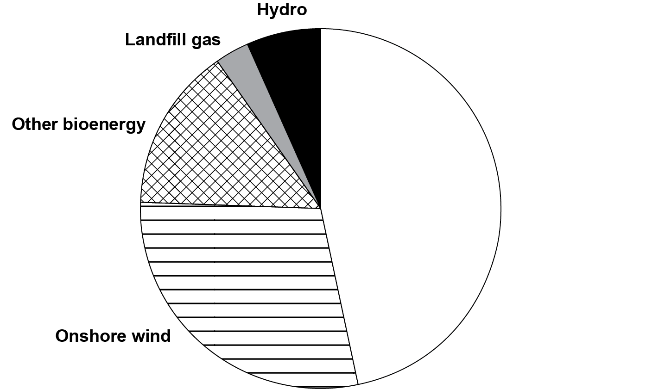

4. Study the picture below which shows an item of flat-pack bedroom furniture made from
manufactured boards.
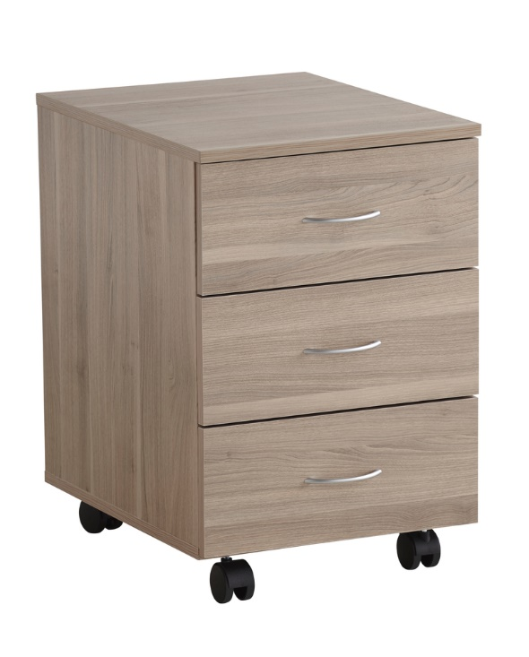
- Name one specific manufactured board in the construction of the
product above. [1 mark]
Manufactured board:

- Give the specific width and length of a standard full-size sheet of
manufactured board in millimetres. [1 mark]

(c) Describe one advantage of your chosen manufactured board in terms of
each of the requirements listed below: [4 marks]
Aesthetics:

User requirements:

5. Explain the meaning of the term 'thermoset polymer' and give one specific
example of a thermoset polymer in your answer. [3 marks]

6. Metals are tested to assess their different physical properties. Using notes and sketches, describe how the following tests would be carried out in a school workshop to assess the properties of a range of metal samples.
(a) Hardness [5 marks]

(b) Toughness [5 marks]

7. A lounge chair is to be manufactured by laminating seven layers of 1.5mm thick, 100mm wide ash veneer together to form each side of the chair frame.
Figure 1 below shows detail of the side profile for each side frame used in the assembly
of the chair.
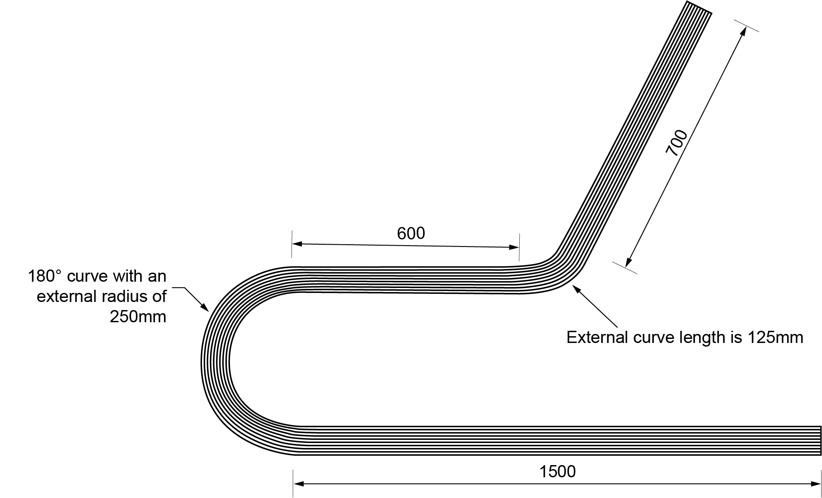
Curve A
Figure 1
(a) The manufacturer cuts all seven veneers to the same length; the sum of the chair’s three straight sections, added to the length of both external curves. Assume no excess will be needed for trimming on the width of the laminated framework.
i) Determine the length of the external curve A shown in Figure 1.
Give your answer to the nearest whole number. [3 marks]

ii) Determine the total length of veneer used in the construction of the
two side frames for the chair. [2 marks]

(b) Ash veneer for constructional purposes retails at £20.45 per metre square (m²).
Calculate the cost of the veneer needed to manufacture two side frames for
the chair. Include an additional 15% of veneer to allow for waste/trimming.
Give your answer in pounds and pence. [2 marks]

8. Name one application for each of the following smart materials and explain why
each is suited to the application suggested. [9 marks]
Piezo electric material

Shape memory alloy (SMA)

Photochromic glass

9. This question is about modern materials.
(a) Kevlar is used in the manufacture protective clothing.
State three properties of Kevlar and explain how each property makes it a
suitable material for protective clothing. You may use examples of products
to support your answers. [6 marks]
Property 1

Property 2

Property 3

- Define precious metal clay (PMC) and explain why manufacturers
must allow for shrinkage while using PMC to manufacture a product. [4 marks]

10. This question is about manufacturing processes used for polymers.
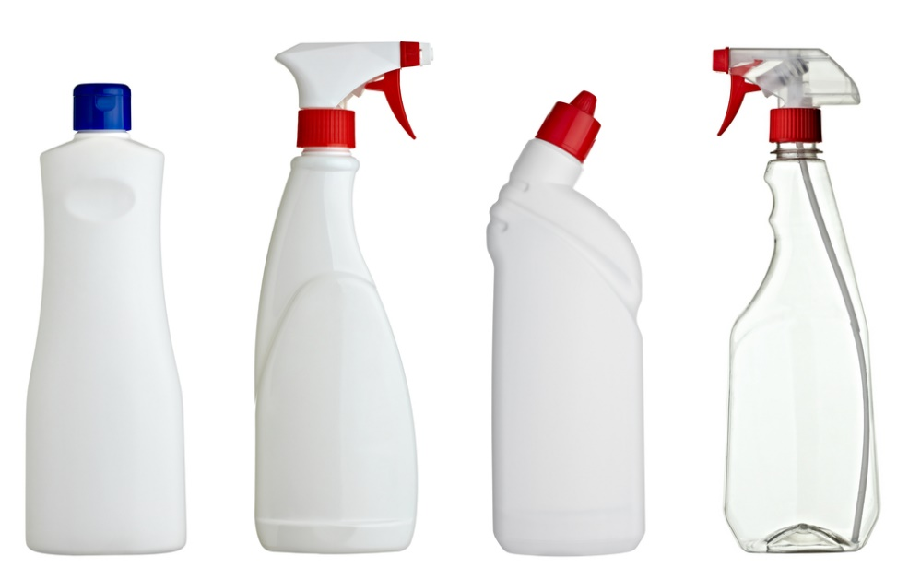
(a) Name the specific process used to manufacture the main body of the bottles
pictured above. [1 mark]

(b) Name one specific thermoplastic used for making the main body of bottles
used for cleaning products, such as those pictured above. [1 mark]

(c) Explain two reasons why thermoplastic polymers are used in the
manufacturing of plastic bottles. [4 marks]

(d) Describe how a series of bottles would be manufactured using the process
identified in question 10a. Use notes and diagrams in your answer. [6 marks]

11. Explain how computer systems are used to plan and control manufacturing,
reduce waste and respond quickly to consumer demand. [9 marks]

12. Name one biodegradable polymer and state two environmental conditions
which would enable a biodegradable polymer to degrade faster. [3 marks]

13. Explain two ways in which virtual modelling and testing are used in industry
prior to product manufacture. [4 marks]

14. Study the two types of child’s car shown below. [12 marks]
Figure 2 | Figure 3
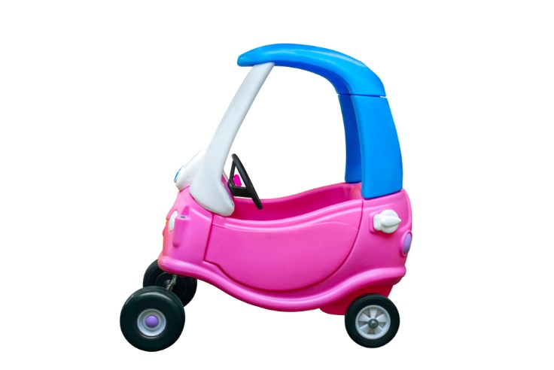 | 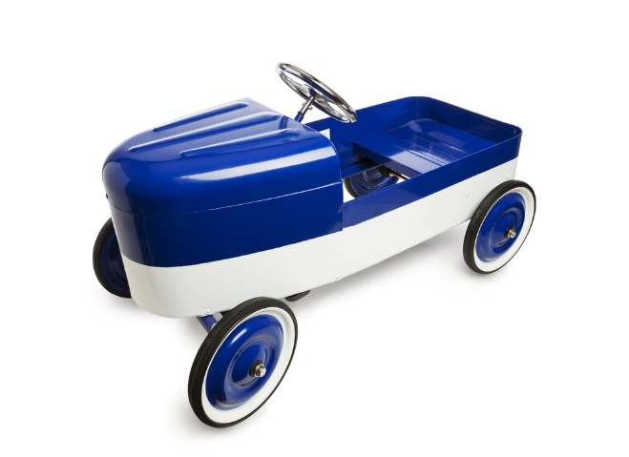
Polypropylene car manufactured using rotational moulding | Mild steel car manufactured using press forming and then powder coated
Compare and evaluate the suitability of the main fabrication and finishing process used to manufacture each product.
Refer to the following in your answer:
- Material properties and manufacturing processes
- How material choices affect the use, care and disposal of product

15. Figure 4 shows a bird table. The central stem has a series of additional struts added to improve stability in an outdoor environment. Figure 5 shows the side elevation of the top of the bird table. All dimensions in mm unless otherwise stated.
Central stem
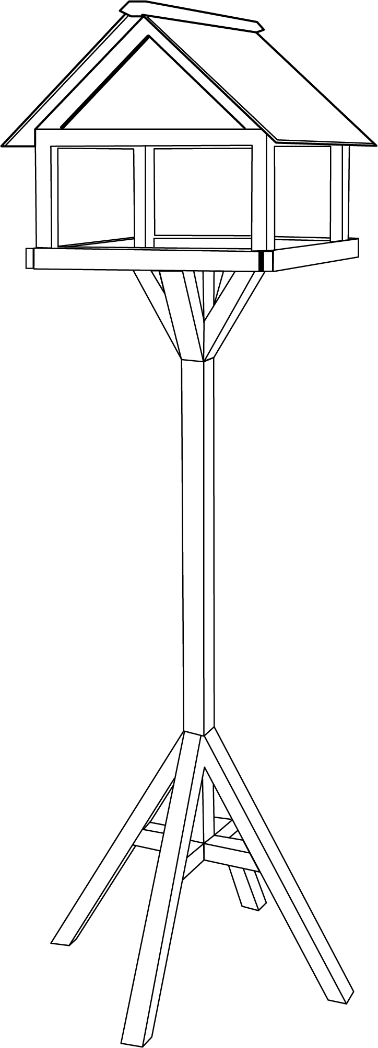  Struts | 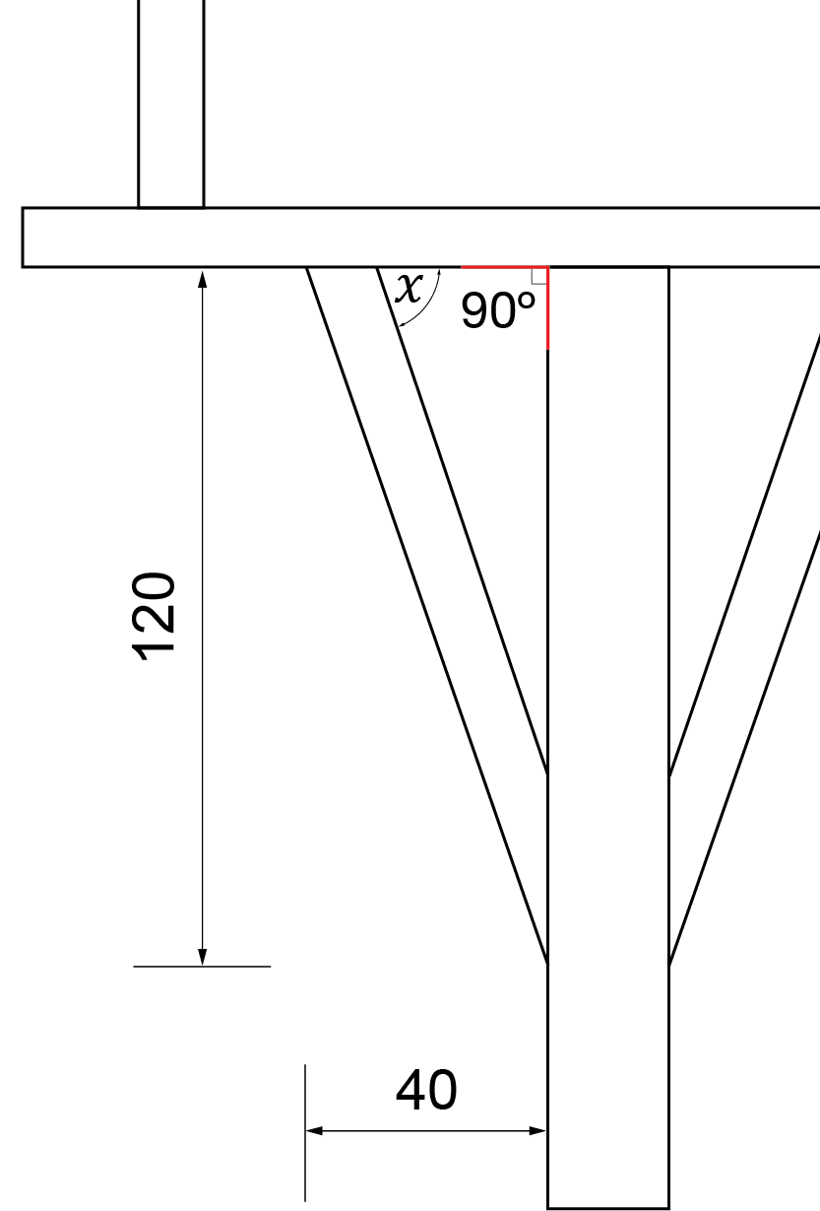
Figure 4 | Figure 5

(a) Calculate the overall length of material required to make one strut.
Round up to the nearest whole millimetre. [2 marks]

(b) Calculate angle $x$ shown in Figure 5 so the cut for the strut will fit precisely
to the underside of the bird table. Round up to the nearest whole degree. [3 marks]

(c) A series of jigs have been designed for the manufacture of the bird table.
Evaluate the advantages and disadvantages of using jigs for batch production
of the bird table in Figure 4. Use specific examples of how jigs could be used
for the bird table parts in your answer. [8 marks]

16. Define the term ‘vertical in-house production’ and explain one advantage and
one disadvantage of this production system. [6 marks]

END OF QUESTIONS

