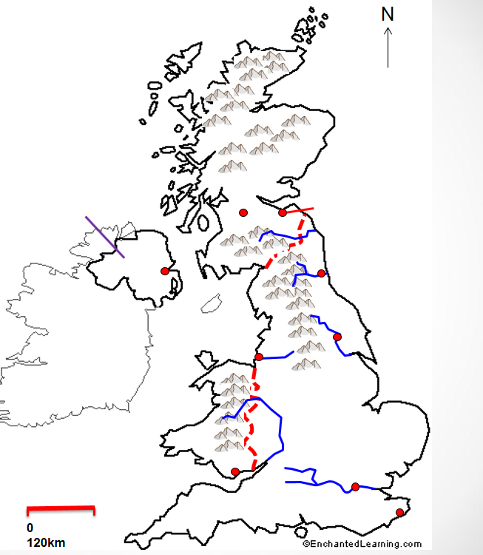
Revision questions for the British Isles
- Describe where the UK is in the world
- List the countries that make up Great Britain
- List the countries that make up the UK
- List the countries that make up the British isles
- On a map of the UK add some of the major Geographic features of UK such as cities, mountain ranges and rivers
- Add 10 major cities to a map of the UK
- Describe the major climate differences across the British isles
- Why is it wetter in the west of the UK than the East?
- Why is it warmer in the south of the UK than the North?
- Define the terms migration, immigrant, and emigrant
- Explain the reasons for migrants coming to the UK as Push and pull factors
- Explain the impacts migration has socially, economically and politically in the UK
- Describe what has happened to the UK’s population over time

- Explain what has happened to the UK’s population over time
- Where is population density highest in the UK? Why?
- Define primary, secondary, tertiary and quaternary industries
- Give an example of a job in primary, secondary, tertiary and quaternary industries
- What does the term employment structure mean?
- What has happened to the number of people working in the primary industry in the UK over time? Why?
- What has happened to the number of people working in the secondary industry in the UK over time? Why?
- What has happened to the number of people working in the tertiary industry in the UK over time? Why?
- What has happened to the number of people working in the quaternary industry in the UK over time? Why?
- List 5 ways how UK is linked to other places around the world
- What is the EU and how does it link to the UK?
- What is the Commonwealth and how does it link to the UK?

