A-level
ENGLISH LANGUAGE
(7702/2)

Paper 2: Language Diversity and Change

2015 Morning Time allowed: 2 hours 30 minutes
Materials
For this paper you must have:
• an AQA 12-page answer booklet
• Insert to accompany Section B (enclosed).

Instructions
• Use black ink or black ball-point pen.
• Write the information required on the front of your answer book. The Examining Body for this paper is AQA. The Paper Reference is 7702/2.
• There are two sections:
- Section A: Diversity and Change
- Section B: Language Discourses.
• Answer either Question 1 or Question 2 from Section A.
• Answer both Question 3 and Question 4 from Section B.
• Do all rough work in your answer book. Cross through any work that you do not want to be marked.

Information
• The maximum mark for this paper is 100.
• The marks for questions are shown in brackets.
• There are 30 marks for either Question 1 or Question 2, 40 marks for Question 3 and 30 marks for Question 4.
• You will be marked on your ability to:
– use good English
– organise information clearly
– use specialist vocabulary where appropriate.

Advice
• It is recommended that you spend about 45 minutes writing your Section A answer. You should spend 15 minutes preparing the material for and 45 minutes writing your answer to Question 3 and 45 minutes writing your answer to Question 4.

Section A

Diversity and Change

Answer one question in this section.

Either
01. Evaluate the idea that people are pressure to change their accents based on certain situations.
[30 marks]

02. Evaluate the idea that teen slang and text speak are signs of sloppiness and laziness.
[30 marks]

Section B

Language Discourses

Answer both Question 3 and Question 4 in this section.

03. Text A is the opening of an online article published on the BBC website. Text B is the opening of another online article, written by an Associate Professor of linguistics, John McWhorter and published on www.theatlantic.com.

Analyse how language is used in Text A and Text B to present views about different towards language use.
In your answer you should:

• examine any similarities and differences you find between the two texts
• explore how effectively the texts present their views.

[40 marks]

04. Write magazine article attitudes to language use in which you assess the ideas and issues raised in Text A and Text B and argue your own views.
[30 marks]

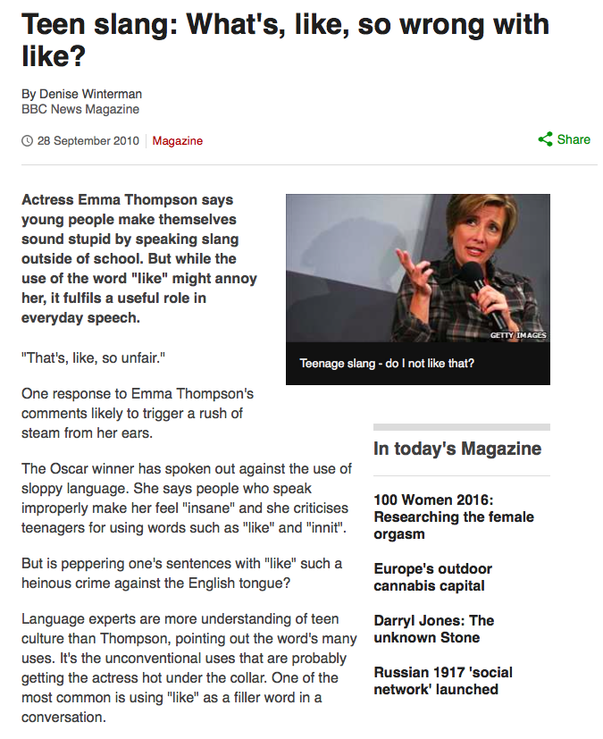
Text A

Text B

