A-level
ENGLISH LANGUAGE
(7702/2)

Paper 2: Language Diversity and Change

2017 Morning Time allowed: 2 hours 30 minutes
Materials
For this paper you must have:
• an AQA 12-page answer booklet
• Insert to accompany Section B (enclosed).

Instructions
• Use black ink or black ball-point pen.
• Write the information required on the front of your answer book. The Examining Body for this paper is AQA. The Paper Reference is 7702/2.
• There are two sections:
- Section A: Diversity and Change
- Section B: Language Discourses.
• Answer either Question 1 or Question 2 from Section A.
• Answer both Question 3 and Question 4 from Section B.
• Do all rough work in your answer book. Cross through any work that you do not want to be marked.

Information
• The maximum mark for this paper is 100.
• The marks for questions are shown in brackets.
• There are 30 marks for either Question 1 or Question 2, 40 marks for Question 3 and 30 marks for Question 4.
• You will be marked on your ability to:
– use good English
– organise information clearly
– use specialist vocabulary where appropriate.

Advice
• It is recommended that you spend about 45 minutes writing your Section A answer. You should spend 15 minutes preparing the material for and 45 minutes writing your answer to Question 3 and 45 minutes writing your answer to Question 4.

Section A

Diversity and Change

Answer one question in this section.

Either
01. Evaluate the idea that Standard English is a superior from of English.
[30 marks]

or

02. Evaluate the idea that the English language is in a constant state of positive evolution
[30 marks]

Section B

Language Discourses

Answer both Question 3 and Question 4 in this section.

03. Text A, printed on the insert, is an extract from an article from The Guardian Online. Text B, printed on page 5, is the start of an article from the BBC website which is part of the ‘100 women’ series of articles examining the role of women in 21st century Britain.

Analyse how language is used in Text A and Text B to present views about the nature of suggested sexism within the English Language. In your answer you should:

• examine any similarities and differences you find between the two texts
• explore how effectively the texts present their views.

[40 marks]

04. Write a blog post about language diversity in which you assess the ideas and issues raised in Text A and Text B and argue your own views.
[30 marks]

Text A:
Allow me to womansplain the problem with gendered language
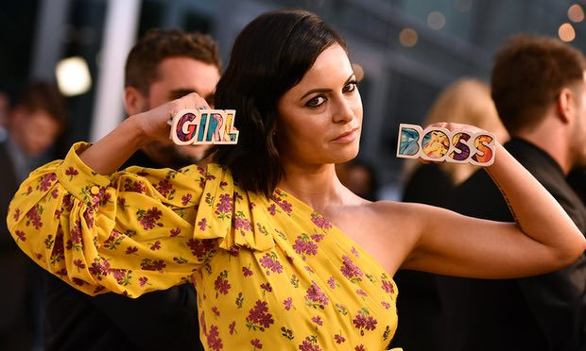
Arwa Mahdawi
Words such as ‘girlboss’ and ‘manspreading’ have gone from making an important point to reinforcing thifferences Sophia Amoruso, who popularised the term girlboss, at the premiere of Netflix’s Girlboss TV show. Photograph: Latour/Variety/Rex/Shutterstock

- She is a #Girlboss. She is a mumtrepreneur. She is a SheEO. He is a manterrupter. A mansplainer. A manspreader. He is always bropropriating women’s ideas. She is a feminazi. He’s got a dadbod and the man flu. What is it with the growing popularity of overtly gendered neologisms? From chick flicks to dick pics, from boss babes to guyliner, there has been a proliferation of his or hers portmanteaux.

Much of this is feminism’s fault, naturally. There has been more scrutiny of everyday sexism; words such as manspreading and manterrupting simply give a name to behaviour that was taken for granted before. There has also been more discussion of women in the workplace, leading to a rise in supposedly empowering labels such as girlboss, a term popularised by Sophia Amoruso, the founder of online retailer Nasty Gal. In 2014, Amoruso wrote a bestselling memoir/self-help book for entrepreneurially minded millennial women called #GIRLBOSS and the word entered the popular vernacular – it is now a Netflix show.

Neologisms such as girlboss and SheEO are supposed to be tongue-in-cheek, of course. They are supposed to illuminate the fact that words such as boss and CEO are not actually gender-neutral, but implicitly coded as male, that language is “man made”, as the feminist Dale Spender put it, and reinforces a male world view. However, I can’t help feeling that, when it comes to girlboss, that subtlety has been lost. There are 5,491,625 pictures tagged with #girlboss on Instagram. It has become a cutesy girl-power phrase that is less empowering than it is patronising. It doesn’t tear down the sexism encoded in language, it reinforces it.

The same is true of the manifold vocabulary for manshaming. Words such as manspreading or mansplaining are – or at least they were – useful. If you don’t have a name for something, then it is harder to talk about and it is taken less seriously. But mansplaining and the various other man-words have become overused and diluted. They have gone from making an important point to simply being lazy ways to reinforce gender binaries. Men are like this; women are like that.

Language reflects and reinforces social norms; ungendering language is an important part of solving sexism. And there has been some progress. As you might expect, much of this emanates from Sweden. In the 1990s, there was consternation among Swedes that there was a colloquial, non-sexual word for penis (“snopp”) but no female equivalent; a discrepancy with ramifications on how children view and learn about their body. So Anna Kosztovics, a social worker from Malmö, coined “snippa” in 2000 and started promoting it. The government encouraged her efforts. Apparently, nursery school teachers were encouraged to put up notes on their doors asking: “Have you said snippa today?” Snippa entered the Swedish dictionary in 2006 and is now widely used.

Earlier this year, Kosztovics called for the UK to follow Sweden’s lead in a video on the BBC. British English has the word “willy” but lacks a widely used non-clinical, non-sexual way to talk about the vagina. Kosztovics says this means “little girls grow up with the thought that there is something wrong between their legs”. She adds: “There are 360 million people who speak English and I think it’s time for you to discover your own word … I say let the best word win.”

Text B:

100 Women 2015: 'Stop the man's world of sexist words'

We are all 'just one of the guys' - or maybe not.

It turns out I have been unwittingly saying sexist things for years.

I have not been running around calling women "feminazis" and "bitches".

Unknowingly, though, I have been accidentally reinforcing gender stereotypes - by calling women "guys", describing my deputy as my "right-hand man" (she is definitely a woman) and suggesting my husband "call a man in" to fix a leaky tap.

That is despite editing Stylist, a feminist magazine which promotes equality in everything from sport to pay.

OK, so I feel a bit silly now, but it proves a point. There are many ways in which we use gendered language without a second thought.

It is those words and expressions, which we accept as normal, that are the concern.

Powerful words
From the innocuous sounding "hey guys", "manpower" and "oh, man", to the never-withering "mankind", our language is littered with expressions referring to men as the powerful collective.

Adjectives used to describe women play a part too.

Bridget Christie, or under her gendered title, The Feminist Comedienne Bridget Christie, writes of this in her autobiography, A Book For Her.

"When a female comic talks passionately about issues, she is perceived as "whingeing" or "moaning", she writes.

"A man doing the same thing is principled, committed and passionate."

She's right.

