1. Write a description suggested by this image.  Use the planning structure 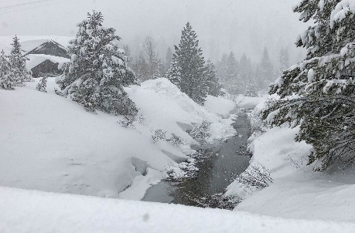 | 2. How does the writer use language to create a peaceful setting in this extract? (extract on back – Of Mice and Men)  - Please answer using full & complete sentences.  - Aim for 3 paragraphs  - Use clear quotes  - Subject terminology  - Explain the effect | 3. “Young people are too often and too easily blamed for everything that is wrong with society today”  Write an article for a newspaper to explain your point of view.  Use the planning structure | 4. A student having read this section of the text said, “The main character seems dislikeable in this extract. She doesn’t seem to care about much.” (extract on back – Hunger Games)  To what extent to you agree?  - Use clear quotes  - Subject terminology  - Explain the effect  - Evaluate the extent you agree with the statement. | 5. It was cold. The man shivered. He was worried about what had happened. He didn’t know what to do.  Write the opening of a story about this man. What has happened to him?
6. How does the writer use language to present the family relationships in this extract? (extract on back – Hunger Games)  - Please answer using full and complete sentences.  - Aim for 3 paragraphs  - Use clear quotes  - Subject terminology  - Explain the effect | 7. Write a description suggested by this image.  Use the planning structure | 8. The building started to collapse as the storm continued.  Write a short story about a storm. | 9. A student having read this section of the text said, “The setting almost seems too good to be true; it’s as though something bad is going to happen.” (extract on back – Of Mice and Men)  To what extent do you agree?  - Use clear quotes  - Subject terminology  - Explain the effect  - Evaluate the extent you agree with the statement. | 10. ‘School Uniform stifles individuality and should be scrapped.’  Write the text of a speech for an assembly to your peers in which you explain your point of view.  Use the planning structure
11. Create a Facebook profile for your favourite fictional character from a book.  Remember to include factual information (D.O.B, education, hometown) and also status updates of what they're thinking. | 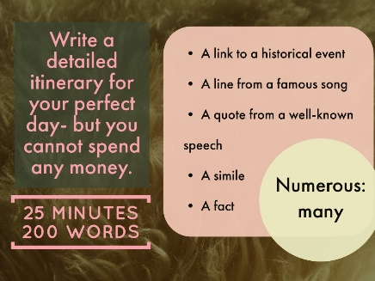  12. | 13. How does the writer structure the text to interest the reader? (Hunger Games extract)  - Aim for 3 paragraphs (focus on start, middle and end)  - Use clear quotes  - Subject terminology  - Explain the effect | 14. Write a newspaper article relevant to a novel you’ve studied this year: Monster Calls (Yr7), Of Mice and Men (Yr8) & Woman in Black (Yr9).  Include specific, accurate information, with correct English. You could include images and/or quotes. Have a look at a newspaper for some inspiration! | 15. ‘Slowly opening my eyes I seen something…”  Write a short story that starts with the above sentence.
16. Create your own superhero and write a story with them in it.  Finished? Draw a comic strip of what happened in your story. | 17. Write a description suggested by this image.  Use the planning structure | 18. Write your own story about anything you want.  It must:  - Have a clear structure  - Have interesting characters  - Use a range of language techniques.  - Use a range of punctuation. |   19. | 20.  ‘The arrival’  Write a film script using this title.  - Include stage directions  - Speech  - Set the location and what you expect the characters to look like at the start.

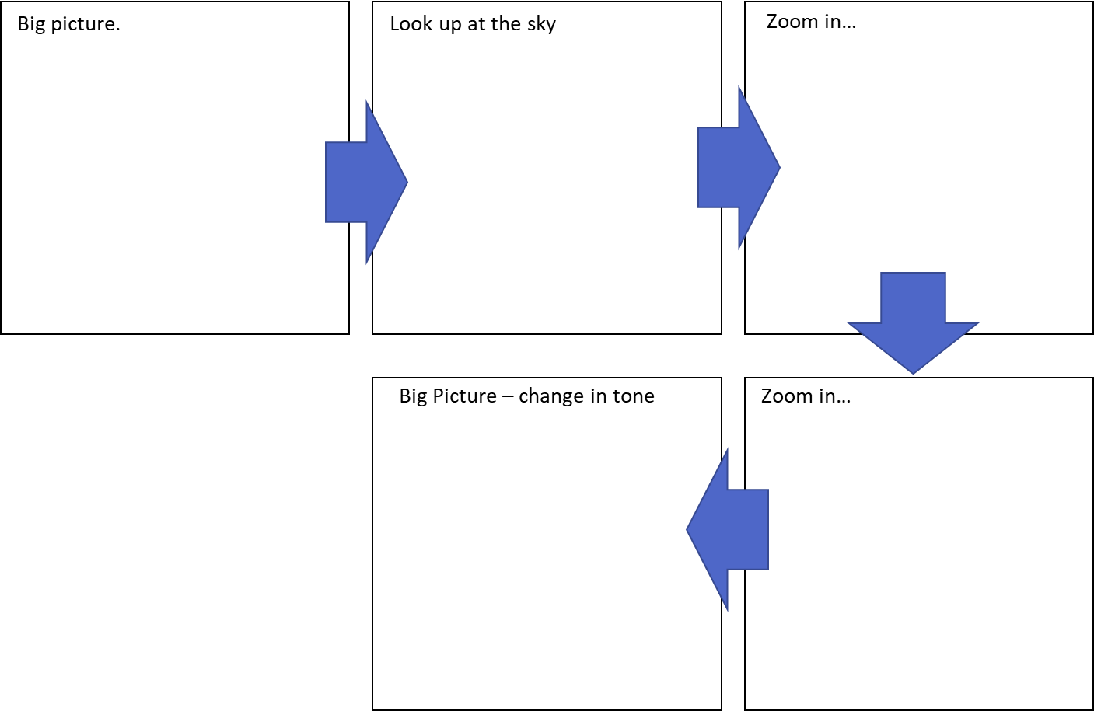
Writing to describe structure.
Extract from Of Mice and Men by John Steinbeck (1937)
A few miles south of Soledad, the Salinas River drops in close to the hillside bank and runs deep and green. The water is warm too, for it has slipped twinkling over the yellow sands in the sunlight before reaching the narrow pool. On one side of the river the golden foothill slopes curve up to the strong and rocky Gabilan mountains, but on the valley side the water is lined with trees—willows fresh and green with every spring, carrying in their lower leaf junctures the debris of the winter’s flooding; and sycamores with mottled, white, recumbent limbs and branches that arch over the pool. On the sandy bank under the trees the leaves lie deep and so crisp that a lizard makes a great skittering if he runs among them. Rabbits come out of the brush to sit on the sand in the evening, and the damp flats are covered with the night tracks of ’coons, and with the spread pads of dogs from the ranches, and with the split-wedge tracks of deer that come to drink in the dark.

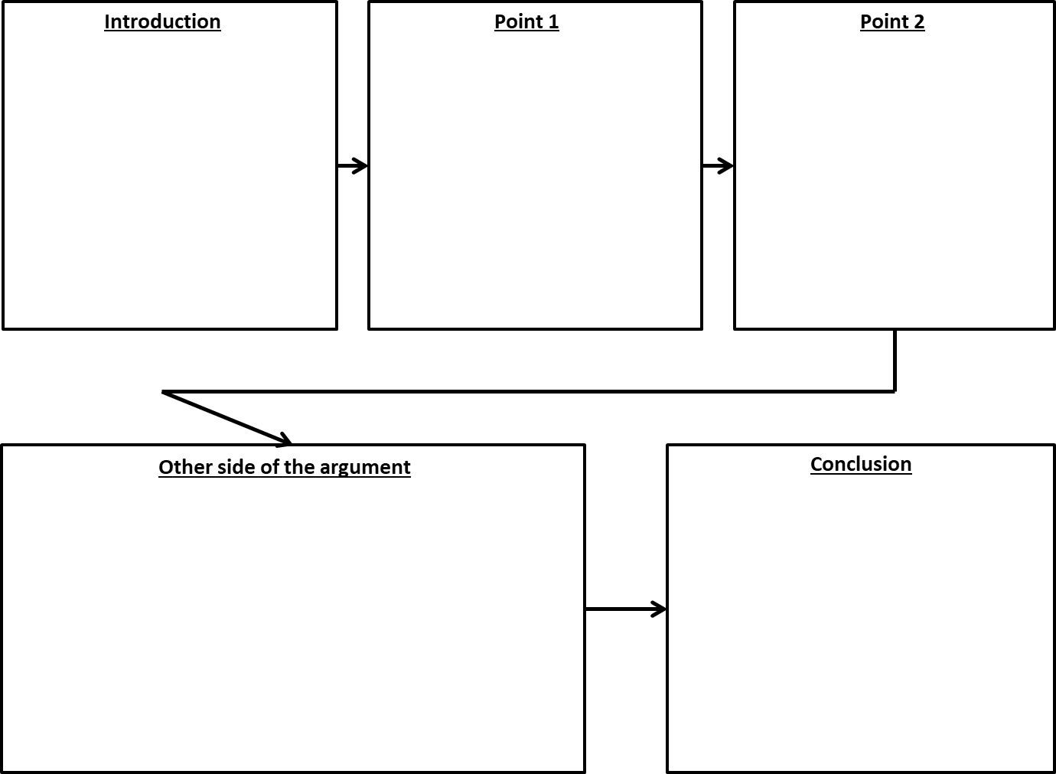
Writing your opinion structure.
Extract from The Hunger Games by Suzanne Collins (2008)
When I wake up, the other side of the bed is cold. My fingers stretch out, seeking Prim’s warmth but finding only the rough canvas cover of the mattress. She must have had bad dreams and climbed in with our mother. Of course she did. This is the day of the reaping. I prop myself up on one elbow. There’s enough light in the bedroom to see them. My little sister, Prim, curled up on her side, cocooned in my mother’s body, their cheeks pressed together. In sleep, my mother looks younger, still worn but not so beaten-down. Prim’s face is as fresh as a raindrop, as lovely as the primrose for which she was named. My mother was very beautiful once, too. Or so they tell me. Sitting at Prim’s knees, guarding her, is the world’s ugliest cat. Mashed-in nose, half of one ear missing, eyes the colour of rotting squash. Prim named him Buttercup, insisting that his muddy yellow coat matched the bright flower. He hates me. Or at least distrusts me.

