
BTEC TECH AWARD IN HSC
COMPONENT 1: HUMAN LIFESPAN DEVELOPMENT

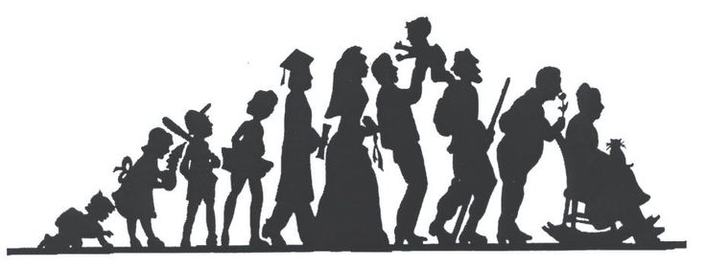

HOMEWORK BOOK
NAME:________________________
CLASS_________________________

HOMEWORK A
EARLY CHILDHOOD 3-8

Describe an activity you took part in while you were primary school age, i.e. between the ages of 5 and 11. Say what the activity was and how it helped meet your:
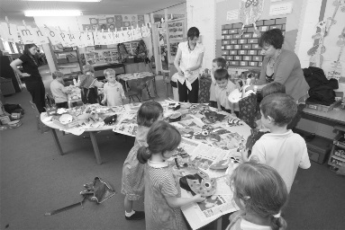
• Physical needs
• Intellectual needs
• Emotional needs
• Social needs
____________________________________________________________________________________________________________________________________________________________________________________________________________________________________________________________________________________________________________________________________________________________________________________________________________________________________________________________________________________________________________________________________________________________________________________________________________________________________________________________________________________________________________________________________________________________________________________________________________________________________________________________________________________________________________________________________________________________________________________________________________________________________________________________________________________________________________________________________________________________________________________________________________________________________________________________________________________________________________________________________________________
(PIES)
2. Think about a friend you made at the same time. How did your friendship with them help meet your PIES needs?
________________________________________________________________________________________________________________________________________________________________________________________________________________________________________________________________________________________________________________________________________________________________________________________________________________________________________________________________________________________________________________
3. Think of someone you didn’t like or get on with at that age. How did they make you feel? How did they affect your PIES needs?
________________________________________________________________________________________________________________________________________________________________________________________________________________________________________________________________________________________________________________________________________________________________________________________________________________________________________________________________________________________________________________
4. Draw up a table stating the good things and the not so good things about having a brother or sister. How did having a brother or sister, or not having a brother or sister, affect your PIES needs while you were this age?

Positives | Negatives

TEACHER FEEDBACK | STUDENT RESPONSE
Comment:  Signed:  Date: | Comment  Signed:  Date
________________________________________________________________________________________________________________________________________________________________________________________________________________________________________________________________________________________________________________________________________________________________________


HOMEWORK B
Adolescence
Growth and Development
Jessica is sixteen years old. She has many friends at school, although he group of friends and in particular her best friend can change often. She can have mood swings and this can make it difficult for her family and her teachers. She worries about her image and makes sure she has the right clothes or listens to the right music. She likes to smoke when she can although her parents do not approve. She has a boyfriend and he would like them to have a sexual relationship but she is afraid to do this.
Describe the physical development of an adolescent girl.

Why does she have arguments with her family?

Why do you think her friendships change often at this age?

What is peer pressure and how is it affecting Jessica?

How should Jessica handle her boyfriend’s request for a sexual relationship?

TEACHER FEEDBACK | STUDENT RESPONSE
Comment:  Signed:  Date: | Comment  Signed:  Date
Name three social changes that occur during adolescence

HOMEWORK C
DEVELOPMENT AND LIFESTAGES
Discuss what is happening in the four photographs below. Complete the sentences to show you understand the links to the relevant area of development and life stage.
Anna has been bullied at secondary school.
Photo 1 shows that Anna is feeling __________________________ . The area of development affected is _________________________ . The individual is in the ____________________________ life stage.

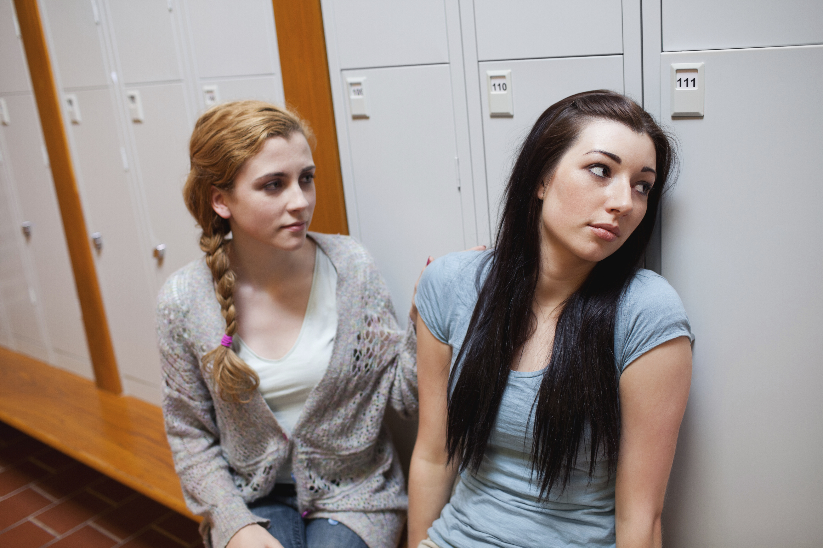

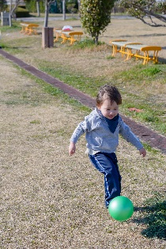
Tom has just started nursery. He loves to play outside.
Photo 2 shows that Tom is using _______________________ skills. The area of development being shown is _____________________. The individual is in the ____________________________ life stage.

Tina enjoys meeting up with friends after work.
Photo 3 shows Tina _____________________________________ . The area of development being shown is _____________________ . The individual is in the ____________________________ life stage.


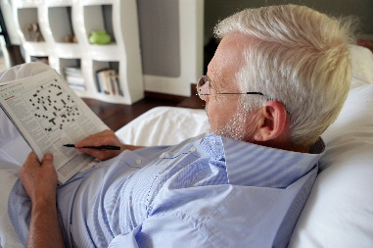
V
Sam enjoys completing puzzles in his newspaper
Photo 4 shows Sam using ____________________________ skills. The area of development being shown is _____________________ . The individual is in the ____________________________ life stage.
TEACHER FEEDBACK | STUDENT RESPONSE
Comment:  Signed:  Date: | Comment  Signed:  Date

HOMEWORK D

INTELLECTUAL DEVELOPMENT
1a. How many uses can you think of for a paper clip?

- ___________________________
- ___________________________
- ___________________________
- ___________________________
- ___________________________
- ___________________________
- ___________________________
- ___________________________
b. What intellectual processes have you used here?
____________________________________, _____________________, ______________________
2a. Can you divide a cake into eight equal slices using only three cuts? Use the cake diagram below to work out how it could be done.

TEACHER FEEDBACK | STUDENT RESPONSE
Signed:  Date | Signed:  Date

b. What intellectual process have you used here?

- ______________________________________________________
- ______________________________________________________

HOMEWORK E
BONDING AND ATTACHMENT
Case study: Callum
Callum is 9 months old and lives with his father, Paul. Paul has been offered a new job, which means Callum will be starting nursery next week.
- How is Callum likely to react when he is left at the nursery?
________________________________________________________________________________________________________________________________________________________________________________________________________________________________________
ii. Give a reason for your answer.
______________________________________________________________________________________________________________________________________________________________________________

- List four ways infants are dependent on their parent(s). One example has been given for you.
i. To bathe and keep them clean
ii. __________________________________
iii. __________________________________
iv. __________________________________
- List three ways infants and young children have developed their independence by the end of the infant stage.
A)________________________________
B)________________________________
C)________________________________

HOMEWORK F
EMOTIONAL SECURITY
Positive emotional development is dependent on our feeling of security and contentment.

1. Explain why security is an important emotional development. Then write a definition:
Security means ____________________________________________________________________
__________________________________________________________________________________________________________________________________________________________________
It is important because_______________________________________________________________
___________________________________________________________________________________________________________________________________________________________________________________________________________________________________________________
2. Think about what makes individuals feel secure or insecure, then complete the table below. Try to give one reason for each of the life stages. Some examples have been added for you.

Life stage | Secure | Insecure
Infant | Being cuddled by parent
Early childhood |  | Starting nursery/school for the first time
Adolescence

Early adulthood |  | Having a temporary work contract
Middle adulthood

Later adulthood | Having close relationship with family and friends
Marking feedback
Homework E: Bonding and Attachment
TEACHER FEEDBACK | STUDENT RESPONSE
Signed:  Date | Signed:  Date

Homework F: Emotional Security
TEACHER FEEDBACK | STUDENT RESPONSE
Signed:  Date | Signed:  Date

HOMEWORK G
SOCIAL DEVELOPMENT IN ADOLECENCE AND ADULTHOOD

Socialisation is the process of becoming a member of society. It means developing skills and abilities to build and maintain different types of relationships. Relationships may be informal or formal.

1. List the people you have informal relationships with. Then list the people you have formal relationships with.

i. Informal
_____________________________________

_____________________________________
_____________________________________
_____________________________________
ii. Formal
____________________________________
____________________________________
____________________________________
___________________________________

Scenario 1: Mila is 15. She goes to school with Harry, 16. They get on really well and spend time together every break. They like the same kind of films, so Harry has asked Mila to go to the cinema with him on Saturday.

What is Mila’s life stage? ___________________________________________________________
ii. What type of relationship have Mila and Harry formed? ___________________________________
iii. Why might Mila and Harry have formed a friendship?
___________________________________________________________________________________________________________________________________________________________________________________________________________________________________________________
iv. What social skills and abilities do Mila and Harry need to maintain a positive relationship?
______________________________________________________________________________________________________________________________________________________________________________________________________________________________________________________
Scenario 2: Rasheed is 35. He enjoys sport and has recently joined a squash club. He gets on really well with everyone at the club. He often stays after the game to have a coffee and chat with others. They chat about the game plus other interests.
i. What is Rasheed’s life stage? _______________________________________________________
ii. What type of relationship has Rasheed formed with the other club members? _________________
iii. Why might Rasheed have formed relationships with the other club members?
___________________________________________________________________________________________________________________________________________________________________________________________________________________________________________________
iv. What social skills and abilities does Rasheed need to maintain positive relationships with the other club members?
____________________________________________________________________________________________________________________________________________________________________________________________________________________________________________________________________________________________________________________________________
Scenario 3: Pauline is 82 years old. She has just returned home after a hip operation. The community nurse, Claire, visits her each day. She checks how Pauline is. She also checks her dressings and her mobility. Pauline discusses her worries with Claire. Claire gives her the help and advice she needs to help her progress. Pauline feels well supported and has formed a positive relationship with Claire.
i. What is Pauline’s life stage? _____________________________
ii. What type of relationship has formed between Pauline and Claire? __________________________
iii. What are the reasons for the developing relationship between Pauline and Claire?
___________________________________________________________________________________________________________________________________________________________________________________________________________________________________________________
iv. What social skills have helped Claire to form a positive relationship with Pauline? ___________________________________________________________________________________________________________________________________________________________________________________________________________________________________________________________________________________________________________________________________
Take it further
Can you think of other skills and abilities that help individuals to form relationships?
List them below.
____________________________________________________________________________________________________________________________________________________________________________________________________________________________________________________________________________________________________________________________________

HOMEWORK H
Mind Map
Choose one life stage to create a mind map in the space below, showing the key PIES changes they will experience during that stage.

Marking feedback
Homework G: Social development in Adolescence and Adulthood
TEACHER FEEDBACK | STUDENT RESPONSE
Signed:  Date | Signed:  Date

Homework H: Mind map
TEACHER FEEDBACK | STUDENT RESPONSE
Signed:  Date | Signed:  Date

