GCSE
Design and Technology:
Textiles Theory

Key Stage Four

Name:
Form:
Date:

From Fibre to Fabric

Fibres are the basis for all textiles. You need to know the difference between natural and synthetic fibres, how each fibre is used, and which fibres can be combined together.
Types of fibre
Textile materials are made in three stages:
- Spinning fibres into yarns
- Weaving or knitting yarns to make fabrics
- Finishing fabrics to make them more useful

There are two types of textile fibres: natural fibres, synthetic and regenerated.
Synthetic and regenerated fibres are continuous filament fibres, while natural fibres are usually short staple fibres. The exception to this rule is silk - a natural fibre whose continuous filaments are up to one kilometre in length!
Where fibres come from:-
- Natural fibres come from plants and animals: cotton from the cotton plant, linen from the flax plant, wool from sheep, silk from silkworms.
- Synthetic fibres are manufactured using plant materials and minerals: acrylic, nylon and polyester come from oil and coal.
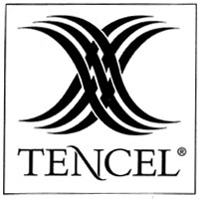
- Regenerated fibres come from pine trees and chemicals: Viscose uses wood pulp and caustic soda. Lyocell and Tencel are biodegradable and really strong so they are also used for non-woven fabric for wipes and swabs, disposable gowns for medical staff. Acetate uses wood pulp and acetone to make a lustrous fibre often used for lining and ball gowns. It’s crisp and taffeta like.
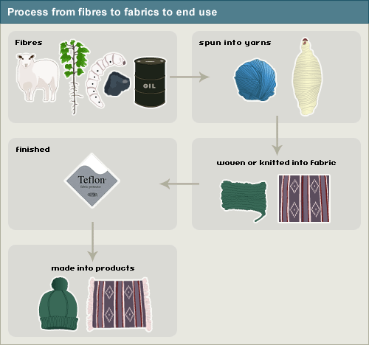

GLOSSARY
Handle | how a textile feels when touched such as soft, rough, smooth, warm or cool
Drape | the supple and flexible characteristics of a fabric - how it hangs or behaves when pleated or folded
Poor/ Good Absorbency | able to take in and hold moisture and consequently drying properties
Durable | able to withstand wear, especially as a result of weathering.
Breathable | Can let perspiration out and air in
Lustrous | A fabulous shine
Fibre | A fine hairlike structure in staple or filament form
Fabric | Is made from yarns either through knitting, weaving or bonding
Biodegradable | Can be broken down naturally through the action of bacteria
Bonded | Webs of fibre pressed together using adhesives or heat.
Closed-loop process | A manufacturing process where all waste is reused in the production system (used for Acetate for example)
Blended Fibre | Two or more fibres spun together to make a yarn
Mixed fabric (sometimes called fibre although that is wrong!) | Two or more yarns mixed together in the production of the fabric
Organic fibres | Fibres grown using natural fertilisers, pesticides and herbicides to protect the biodiversity of the environment and workers’ health
Recycled | The product has bee re-used in some form
Target market | The end-user or consumer group to whom the manufacturer aims to sell

Natural Fibres

1. Natural fibres from plants (cellulose):
- Cotton is used for making jeans, t-shirts and towels. It is cool to wear, has a soft handle, a good drape, and is durable. It can be washed and ironed, but it creases easily, is very absorbent and dries slowly.
- Linen is used for summer clothing, tea towels and tablecloths. It is fresh and cool to wear, has a stiffer handle, and a good drape. It is durable, but can be washed and ironed. It creases badly and is very absorbent, but is also fast drying.
2. Natural fibres from animals (protein):
- Wool is used for jumpers, suits and blankets. It is warm to wear, absorbent, dries slowly, is breathable, repels rain and can be soft or coarse to handle. It does not have good drape, and is not durable; however, creases tend to drop out. If it is not dry-cleaned it may shrink.
- Silk is used for evening wear and ties. It is warm to wear, absorbent, has a soft handle and a good lustre and drape. It is durable and creases drop out. It needs to be dry cleaned.

Fibre | Properties | Qualities | Fabrics Trade Name
Cotton  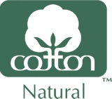 | - Very absorbent, dries slowly  - Durable  - Creases easily  - Wash and iron  - Sustainable  - Flammable | - Cool and comfortable to wear  - Soft handle  - Good drape |  | 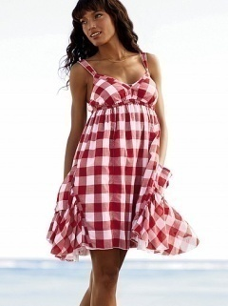  - Calico  - Denim  - Poplin  - Corduroy  - Drill  - Velvet
Linen   | - Absorbent  - Good drape Durable  - Creases badly  - Wash and iron  - Breathable | - Fresh and cool to wear  - Stiffer handle  - Dull lustre |  | 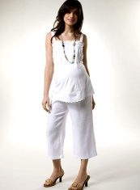  - Duck  - Huckabuck
Wool  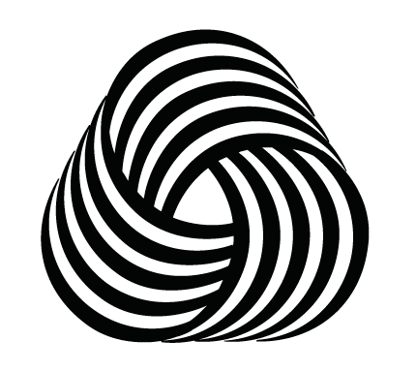 | - Can shrink, dry clean  - Durable  - Creases drop out  - Absorbent, dries slowly  - Breathable, repels rain  - Natural elasticity | - Soft or coarse handle  - Good drape  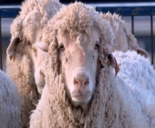  - Warm to wear |  | 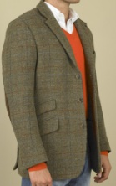  - Lambswool  - Merino  - Superwash  - Felt  - Tweed  - Gaberdine
Silk | - Absorbent  - Durable  - Weaker when wet  - Dry clean  - Creases easily | - Cool and Warm to wear (depends on weave or knit) Soft handle  - Good lustre and drape |  | 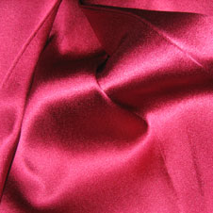  - Chiffon  - Crepe  - Dupion  - Duchess  - Organza  - Taffeta

Regenerated Fibres

The main regenerated fibres are:
- Viscose
- Acetate
- Lyocell and Tencel

Fibre | Properties | Qualities/Aesthetics | Trade Name
Viscose | - low warmth  - absorbent, dries slowly  - not durable  - creases easily  - easy care (wash & iron) | - soft handle  - good drape  - versatile | 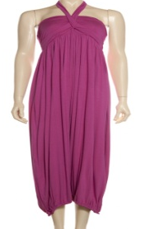
Acetate | - creases easily  - easy care  - breathable and absorbent  - durable | - stiffer handle taffeta  - good drape  - elegant drape  - lustrous | 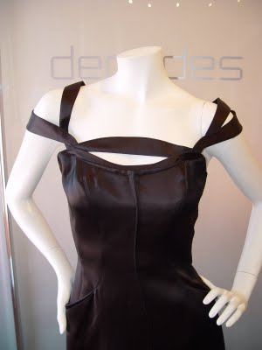
Tencel & Lyocell | - soft  - absorbent  - very strong when wet or dry  - resistant to wrinkles  - it can be machine- or hand-washed or dry-cleaned  - it can be dyed many colours | - drapes well  - can simulate a variety of textures like suede, leather, or silk | 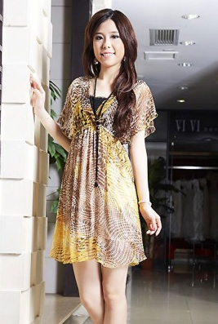
Rayon | - Dyes easily  - Poor insulator (ideal for hot weather  - Not very durability  - Lowest elasticity retention of any fibre  - Very high appearance retention  - Dry clean only | - versatile fiber can imitate silk, wool and cotton or even linen  - soft, smooth, cool, comfortable | 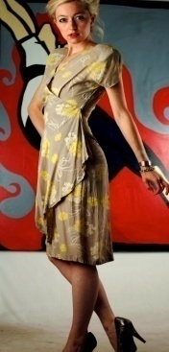
Synthetic fibres
The main synthetic fibres are:
- Acrylic is used for jumpers, fleece [fleece: fleece is a modern polyester fabric that is warm and easy care.] jackets and blankets. It is warm to wear, non-absorbent, and fast-drying, with a soft handle like wool, and a good drape. It is easy to care for, durable and crease-resistant.
- Polyester is used for raincoats, fleece jackets, children's nightwear, medical textiles and working clothes. It has a soft handle, a good drape, is very durable, crease-resistant, easy-care, non-absorbent, and fast drying. It can be recycled, but has low warmth.
- Nylon (Tactel) is used for active sportswear, fleece jackets, socks and seat belts. It has a soft handle, a good drape, is non-absorbent, fast drying, very durable, crease-resistant and easy-care. However it has low warmth.

Fibre | Properties |  | Qualities/Aesthetics | Trade name
Acrylic | - Warm to wear  - Non-absorbent, fast drying  - Crease resistant  - Weaker when wet  - Burns slowly then melts |  | - Good drape Durable  - Easy care  - Stiffer handle like wool | - Courtelle  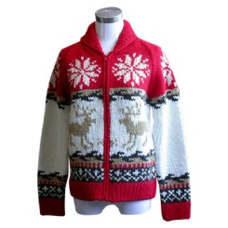  - Amicor
Polyamide | - Warm to wear  - Absorbent, dries slowly  - Breathable, repels rain  - Durable |  | - Soft or coarse handle Can shrink, dry clean  - Good drape  - Creases drop out | - Nylon  - Tactel  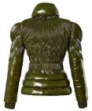  - Tactel Micro  - Aramids  Like  Kevlar &  Nomex
Polyester | - Low warmth  - Non-absorbent, fast drying  - Very durable  - Creases resistant  - Can be recycled  - Strong when wet  - Resists bacteria |  | - Soft handle  - Good drape  - Easy care  - Versatile | 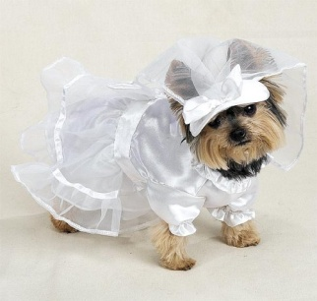  - Trevira  - Finesse  - Miratec  - Dracon  - Terylene  - Polyester fleece
Elastane | - Very elastic  - Lightweight  - Strong  - Resists sunlight and biological damage Medium to coarse filament fibres  - Used only as blend 2%-5%  - Very poor absorbency | - Blended to make clothes more comfortable (cotton and Lycra in Jeans for example) |  | - Lycra  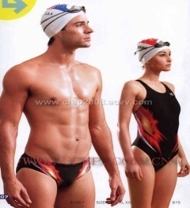  - Spandex

Modern fibres

Micro-fibres:  Polyester or nylon micro-fibres are 60-100 times finer than a human hair (the diagram below shows what they look like up close):  - Micro-fibres can be blended with other synthetic or natural fibres.  - Micro-fibres are used for outdoor-pursuits clothing and active sportswear.  - Thermoplastic polyester or nylon micro-fibres can be heat-treated to give them coils, crimps and loops, which makes these textured yarns stretchy and warm. They are used for underwear, sportswear, knitwear and carpets. | 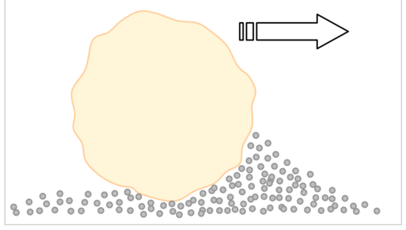  Cotton versus Tactel Micro

Speciality Fibres:

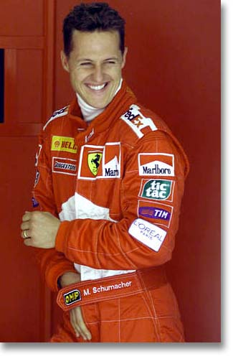
Polyethylene microfibers make the strongest fibres you can imagine. They are from the family of polyamides.
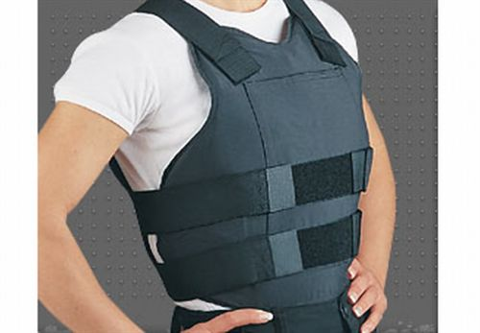
Nomex: Flame resistant
Kevlar: Bullet proof

BIO Fibres

In recent years, there has been much interest in looking at new ways to create fibres and fabrics which are environmentally friendly and made from renewable resources.
Synthetic fibres are usually made from crude oil which is a non-renewable resource.
Environmental and sustainable problems:
1) Oil used to make fibres is a non renewable resource – it cannot be replaced
2) The production of some chemical fibres pollutes the environment.
So scientists and technologists are developing new, more environmentally sustainable fibres which are
• developed from low cost natural resources using sustainable plants and trees
• produced by clean processes which are environmentally friendly.
Bio fibres include a range of fibres which have been developed and manufactured from natural resources. Most of these resources are renewable and include soya, sweetcorn, bamboo and wood.
• Sweetcorn fibre is a polylactic acid fibre (PLA) made by
fermenting the corn.
• Soya bean protein fibre is a type of regenerative plant fibre made by extracting then changing the protein, and wet spinning to make fibre.
• Milk fibre (casein fibre) is made from casein into a polyamide like nylon - but should milk protein be used for fibre?
• Bamboo fibre is a regenerated cellulose fibre

Fibre | Properties | Qualities | Uses
Sweet Corn Fibre  Polylactic acid fibres (PLA) | - High strength, high dimensional stability, and high resilience  - Resistant to ultraviolet light - more than most other synthetics  - Lightweight  - Good wickability  - Biodegradable  - Thermoplastic | 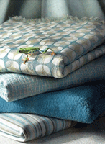  - Comfortable | Ingeo  - clothing,  - bedding  - household textiles items such as cleaning cloths.
Soya Bean Fibre | - Absorbs moisture similar to cotton  - Eco-friendly since  - it’s a renewable natural resource  - Filament | - Luxurious appearance and is soft, smooth and light  - Good anti-pilling and drape properties | - Used for spinning and knitting  - Mixing with other fibres  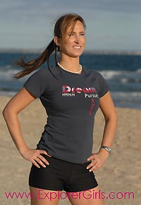
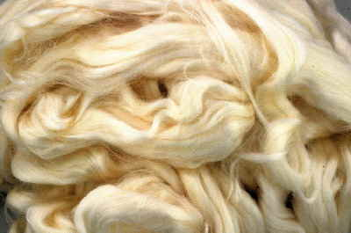  Bamboo Fibre | - It wicks away moisture from the body keeping you dry and comfortable  - Absorbent  - The fibre is naturally antibacterial  - Bamboo fibre is 100% biodegradable.  - Grows very fast hence its sustainable | - Bamboo fabric is smooth and very soft  - The fabric is 3-4 times more absorbent than cotton  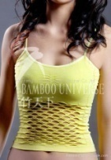 | - Mixed with cotton, hemp and silk  - Clothing  - Towels
Milk Fibres  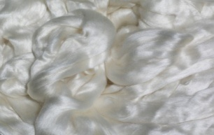  Protein fibre like silk and wool | Properties  - Smooth and soft  - Expensive as not much produced  - Durable | - Retains shape  - Very comfortable to wear | - Socks  - flannels  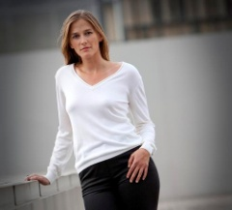  - Knit wear

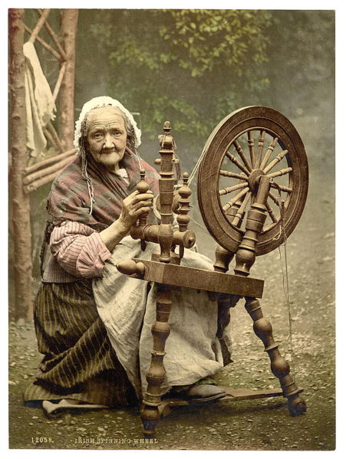
YARNS

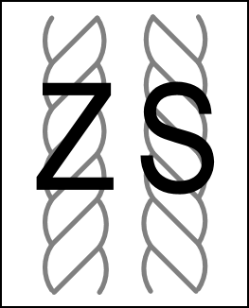
Yarn is a continuous length of fibres or filament, with or without twist. Fibres made from staple fibres like cotton are called staple yarns, the ones made from filament fibres, filament yarns! The twist makes yarns stronger and prepares them for their end use.
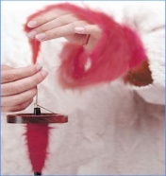

Fibres are often blended to:
- Improve in strength
- combine properties of each component fibre
- Create an effect (fancy or novelty yarns)
- Improve the appearance, performance, comfort and aftercare of fabric. A shirt made from polyester / cotton blend is more easy-care and crease-resistant than a shirt made from 100 per cent cotton.
- Reduce the cost of an expensive fibre.
Cotton / Lycra blend jeans are more comfortable, stretchy and fit better than cotton jeans. Acrylic / wool blend trousers are less expensive than 100 per cent wool trousers.
Examples of yarns:
Single yarn: One yarn is twisted around itself to make a yarn (cheaper yarns)
Ply yarns: Two or more yarns are twisted together (wool for suiting, fine cotton)
Core-spun yarn: A core spun yarn is a multi component yarn, in which the core stays at the centre of the yarn. (Fancy yarns like Bouclé, cotton Lycra mixes in denim)
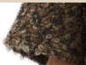
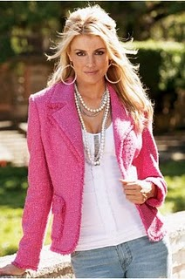
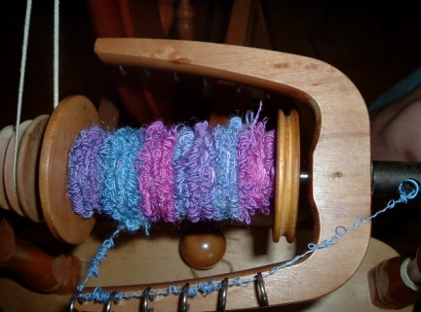

Bouclé

Exam tip
Make sure that you know the properties and end-uses of fibre blends such as polyester / cotton. You'll get extra marks for being able to a fibre's properties to the product it's used for.
Popular blends:
Elastane/Cotton
Nylon/Lycra
Polyester/Cotton
Cotton/Linen
Silk/Viscose

FABRIC CONSTRUCTION
Most fabrics are made by weaving or knitting yarns together. Non-woven fabrics are made by bonding or felting fibres together. A fabric's appearance, properties and end-use can be affected by the way it was constructed.

Woven fabrics  Woven fabrics are made up of a weft - the yarn going across the width of the fabric - and a warp - the yarn going down the length of the loom. The side of the fabric where the wefts are double back to form a non-fraying edge is called the selvedge.  Here are two of the main types of woven fabrics: | Plain-weave fabric  In plain-weave the warp and weft are aligned so that they form a simple criss-cross pattern. It is strong and hardwearing. It is used for fashion and furnishing fabrics. | 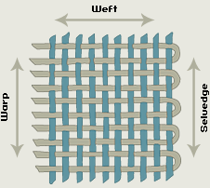
 | Twill-weave  In twill-weave the crossings of weft and warp are offset to give a diagonal pattern on the fabric surface. Twill weave is strong and drapes well. It is used for jeans, jackets and curtains. | 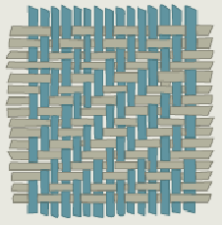

Knitted fabrics  There are two types of knitted fabrics weft-knitted and Warp-knitted.  Weft-knitted fabrics | Weft knitted fabric  Weft-knitted fabrics are made by hand or machine. Weft knits are used for socks, T-shirts and jumpers. Weft-knitted fabric is made by looping together long lengths of yarn. This makes the fabric stretchy and comfortable  The yarn runs in rows across the fabric. If a stitch is dropped it will ladder down the length of the fabric. | 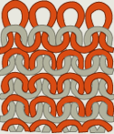
 | Warp-knitted fabric  Warp-knitted fabric is made by machine and is used for swimwear.  - Warp-knitted fabric is made by machine.  - The loops interlock vertically along the length of the fabric. Warp knits are slightly stretchy and do not ladder.  They are used for swimwear, underwear and geotextiles | 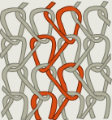

Non-woven fabrics
Non-woven fabric is made by bonding or felting:
- Bonded-fibre fabrics are made from webs of synthetic [synthetic: man-made - usually from chemical sources ] fibres bonded together with heat (using their thermoplastic properties) or adhesives. They are cheap to produce, but not as strong as woven or knitted fabrics. Bonded-fibre fabrics are mainly used for interlining [interlining: layer of fabric sown into the neck or armholes of a garment to protect and strengthen it. Also called interfacing. ]. They are easy to sew, crease-resistant, do not fray and are stable to washing and dry-cleaning.
- Wool felt is a non-woven fabric made from animal hair or wool fibres matted together using moisture, heat and pressure. Felt has no strength, drape [drape: the supple and flexible characteristics of a fabric - how it hangs or behaves when pleated or folded ] or elasticity but is warm and does not fray. Wool felt is expensive. It is used for hats and slippers and in handcrafts.

Fabric Finishes
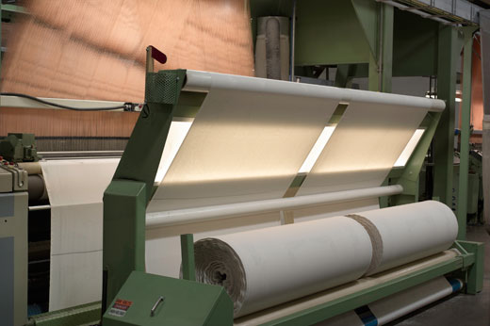
When a fabric is woven it’s usually some shade of beige or grey depending on the fibre. This is called the ‘greige’. It has to be treated to make it into a fabric ready for use. It can be washed ( to clean away impurities), bleached (to make the colour uniform) and mercerised (to make the fibres round and filled out).

Methods:

Piece Dyeing: A roll of fabric is dyed
Continuous Dying: fabric passes through a dye bath. The fabric is then squeezed between rollers to spread the dye evenly and remove excess dye. Continuous dyeing is used for colours that do not need to change too quickly with fashion.
Yarn Dying: The yarns are dyed before the cloth is woven (Gingham etc)
Over Dying: Different yarns are used in the fabric and when its dyed it reacts differently to the dye creating an effect.
Garment Dyeing/
Batch Dyeing: Items are dyed in a certain colour after they have been made. (T-Shirts for example) They are then dyed to order in large batches according to the colours required. Batch dyeing is used for colours that need to change frequently with fashion.

Printing
Fabrics are printed by block or screen printing:
- Block printing is done using metal or wooden blocks, one for each colour. The background shapes are cut away to leave a raised design on the block. Dye is applied and stamped onto the fabric. This is a very slow process used by specialised craft industries.
- In screen printing a pattern is printed onto fabric through a stencil held in place by a screen. Each screen prints one part of the design in one colour. After printing the dyestuff must be fixed using steam or dry heat.

Within screen printing are a whole range of options depending on purpose.

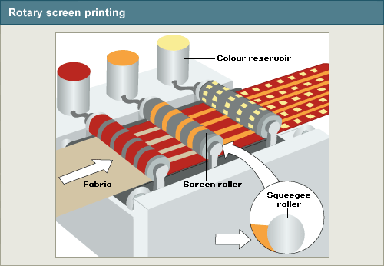
Printing Methods:
Rotary screen printing: The dye is applied through a roller. The ink is pressed from reservoirs inside the roller onto the fabric. It is fast and suited to continuous production.

Machine screen printing/
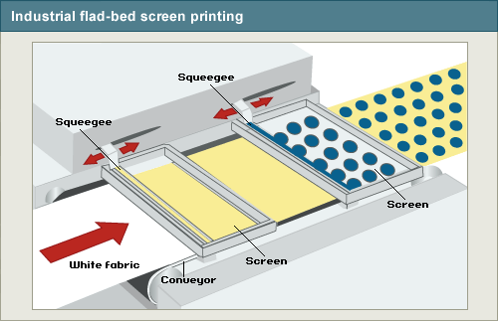
Flat-bed screen printing: Very detailed patterns, top of the range, very expensive. Fabric is moved along on a conveyor blanket and moved along the printing table. It accounts for 20% of the market

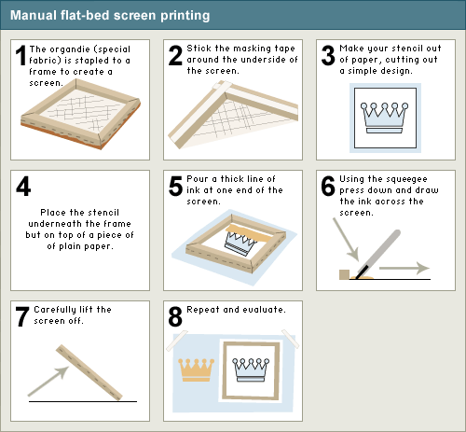

Manual flat-bed screen printing:

Designer and T-shirt prints mainly. Expensive.

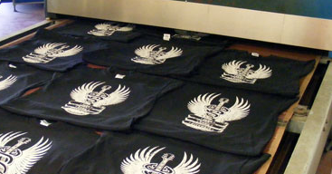
Discharge printing: A plain dyed fabric is printed with a resist paste which removes the colour and adds another. Most commonly used on dark fabrics (t-shirts)

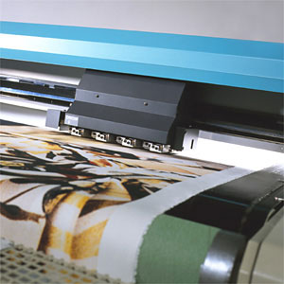
Digital printing: In this form of printing micro-sized droplets of dye are placed onto the fabric through an inkjet print head. This is the latest development in textile printing and is expanding very fast.

Finishes that enhance the Performance of Fabrics
A finish is always given to a fabric to give it certain properties that make it suitable for its end use.

Name | How it’s done | Different Types
Physical  Mechanical | 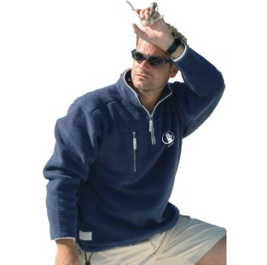  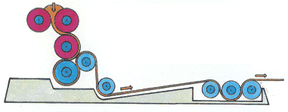  A machine or tool physically changes the fabric in some way. | - Brushing to create a raised nap (fleece)  - Calendering is a finish where the fabric is made smoother by heavy rollers pressing the surface.  This also creates a lustre or sheen. (Fashion & Interiors)  - Engraved calendar rollers are used to emboss relief patterns on the fabric surface. (Fashion)  - Pressing is used to smooth the surface of the fabric. This is done with most fabric products at some point to help improve the handle and aesthetic appeal of a product. (fashion & interiors)  - Heat-setting is used for thermoplastic fabrics (polyester and nylon). The fabrics are set in permanent shapes or pleats.
Chemical |   A chemical is used to alter or change the fabric in some way. | - Water repellent. To create this finish, silicone is sprayed on to the fabric’s surface  to repel water (sportswear).  - Flame resistance is important for all sorts of products (children’s wear, this often makes the fabric stiffer and weaker), (protective work wear).  - Smart Finish, a finish that can react to the environment (household, fashion, interiors)  - Bleaching, cotton and synthetic fabrics are bleached before dyeing. This makes it easier to dye pastel shades.  - Mercerising, cotton or linen fabrics using caustic soda. Mercerised fabrics are stronger, dye well and have improved lustre. Fibre is plumped up it expands and becomes rounder.  - Resin, cotton and viscose fabrics, crease-resistant finish. This makes them easy-care. They dry fast and smooth and need little ironing.  - Teflon/Silicone, wool, shrink-resist finish. This results in soft, smooth, lustrous yarns and fabrics that are machine-washable.
Biological | Bacteria and enzymes are used on plant-based fibres to change them in some way. | - Distressing (jeans)  - Bio stoning (stone wash)
Coated | Fabric is coated on one side with a layer of polymer to add a surface that might repel stains or water. | - Polyurethane coating is usually applied for water proofing or repelling (Awnings, swimming pools, raincoats)  - Teflon/Silicone, wool, shrink-resist finish. This results in soft, smooth, lustrous yarns and fabrics that are machine-washable.

Smart Fabric Finishes
Smart finishes are those that can react to the environment. Additives are added to microscopic (tiny) bubbles. These are added to the fibres.
There are three ways in which this can happen:
1. Embedded in fibre or fabric reacts to pressure | - Gives off aromatic scent  - Can reduces body odour  - Can provide vitamins or reduce skin irritation | - Underwear  - anti-bacterial socks  - medical textiles  - Outlast (absorbs and releases energy) 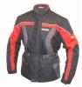
2. Thermochromic reacts to heat | 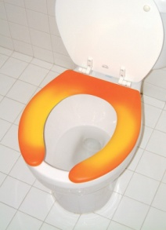  - Dye can change colour in response to heat. Lasts for 5-10 washes Gives off aromatic scent | - Children's clothes  - sports clothing  - fire-fighter's clothing  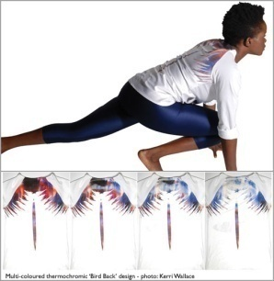
1.Photochromic reacts to light | - Smart pigments change colour in response to sun light | 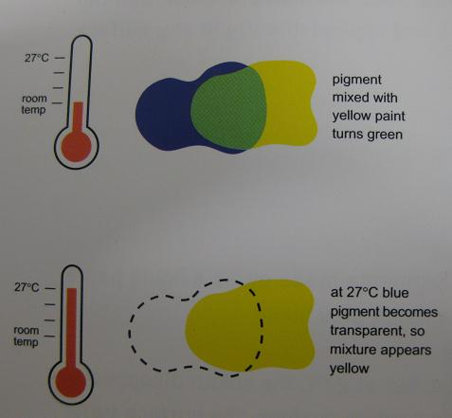  - T-shirts; military clothing

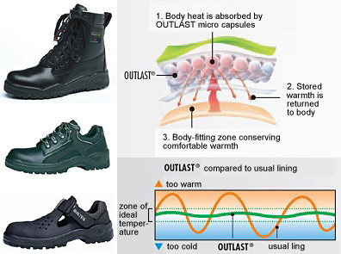
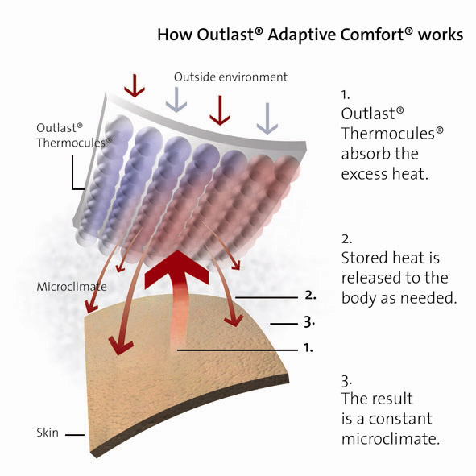

Smart Interactive Fabrics
ON THE FOREFRONT OF NEW TEXTILE TECHNOLOGY
These fabrics incorporate electronics that are activated by a power source. To be interactive you need electronics which need conductivity. It can either be the fabric by use of metallic thread or conductive printing inks. In the yarn by use ofconductive threads.

Example | How it works | Examples of fabrics using the technology
Gorix | Carbonised fibre with conductivity | - The life shirt which monitors blood pressure  - Tagging technology which can track a garment  - Heated gloves  - A track suit that monitors performance
Softswitch | Conductive threads

Modern Fabrics
Usually made from micro-fibres which are 60 times thinner than human hair. When they are closely woven they are already fairly windproof. However as in Gore-Tex if they are also laminated that makes them super fabrics for sports wear.

Fabric | Technology | Fabric properties | End-use
Polar fleece | Brushed  polyester  warp knit | Lightweight  soft  breathable  warm | - Fleece jumpers and jackets  - blankets
Gore-Tex | Teflon laminated membrane | - Breathable  - lightweight  - waterproof | - All-weather jackets and shoes

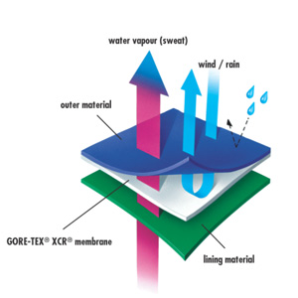

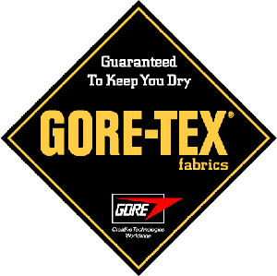

Computer-aided design (CAD)
The term computer-aided design includes all the computer applications and hardware devices that can be used to aid digital design. CAD speeds up the design process by making it quick and easy to test and modify ideas before production starts, thus reducing mistakes and cutting costs. Uses of CAD in textiles design include:
- Wire-frame modelling [wire-frame modelling: using a grid of lines to represent a 3D product on a computer screen. ], surface modelling [surface modelling : adding colour, shading and texture to the surface of a 3D virtual product to make it look realistic. ] or solid modelling [solid modelling: use of digital drawings based on geometric shapes, used for solid objects such as car components. ] can be used to texture map [texture map: a computer 'relief map' of a garment design, as if the fabric had been draped onto the design to show how the finished garment will look on screen ] or simulate virtual products [virtual products: 3D versions of products shown on a computer screen. ] in 3D, from which clients can choose one to be sampled in fabric. This saves the time and cost of sampling a large selection of real products.
- Graphics applications enable ease the production and storage of accurate working drawings [working drawings: an accurate line drawing to show the back and front views of a product, used on a manufacturing specification sheet. ] and lay plans [lay plans: the laying out of pattern pieces of a fabric to work out the quantity and cost of material required for a product. ]
- colour ways [colour ways: combinations of colours used in a fabric design. ] can be accurately modelled at the design stage
- Material quantities and costs and be easily calculated
- Computer networks improve communication between designers, clients and manufacturers - thus speeding up the design feedback loop.

Designing
Designing is about more than drawing a few products. It involves much knowledge and skills. The first thing is to understand who you are designing for, the target market and its needs. Secondly you have to consider the financial constraints on the product, profit to be gained and volume to be produced. All these considerations impact on the choices you make. When making fabric choices, ask your self the following questions:
- Fibre content - should you use natural [natural: derived from animal, vegetable or mineral sources ] or synthetic [synthetic: man-made - usually from chemical sources ] fibres?
- Fabric construction - should you use woven, knitted or non-woven?
- Manufacturing processes - should you use dyeing, printing, physical finishing [mechanical finishing: treatment of a fabric by a machine, using heat and pressure to improve the fabric's appearance. ] or chemical finishing [chemical finishing: applying a chemical solution or resin to improve the appearance, handle or performance of a fabric. ]?
- Maintenance. What are the aftercare [aftercare: how a textile should be washed, ironed, dried or dry-cleaned to maintain its properties. ] requirements of the product?
Combining Fabrics
Fabrics can be layered and combined to improve their handle, appearance or performance. For example:
- An interfacing fabric such as Vilene can be stitched or laminated to other fabrics. This reinforces, stiffens and gives strength to collars and cuffs and prevents the fabric from stretching or sagging.
- A quilted fabric has two or more layers sewn together to give an attractive appearance and added warmth.
- Gore-Tex can be laminated to another fabric using adhesive or heat. Gore-Tex is used for all-weather clothing and shoes because it is breathable and waterproof.

Aesthetics & Function
The fibre content, fabric construction and finishing processes determine the fabric's aesthetic [aesthetic: relating to shape, style, colour, pattern and other aspects of a product's visual appeal ], functional [functional: relating to the performance of a product - its 'fitness for purpose' ] and comfort properties.

Properties of fabric
Aesthetic properties | Functional properties | Comfort properties
- Handle [handle: how a textile feels when touched such as soft, rough, smooth, warm or cool ]  - Drape [drape: the supple and flexible characteristics of a fabric - how it hangs or behaves when pleated or folded ]  - Colour  - Appearance | - Strength  - Durability [durability: the ability of a material to withstand wear, especially as a result of weathering. ]  - Crease-resistance  - Flame-resistance [flame-resistance: the ability to resist catching fire ]  - Stain-resistance [stain-resistance: the ability to resist absorption of water-based or oil-based liquids. ]  - Water-resistance  - Aftercare [aftercare: how a textile should be washed, ironed, dried or dry-cleaned to maintain its properties. ]  - Cost |  | - Absorbency  - Breathability [breathability: the characteristic of allowing perspiration to evaporate ]  - Elasticity [elasticity: the ability of a fibre, yarn or fabric to stretch and return to its original shape. ]  - Softness  - Stretch [stretch: the ability to be pulled out of shape and then recover the original shape. Lycra is a stretch fabric ]  - Warmth

It is important to match fabric properties to the requirements of the product. For example:
- Cycling jackets need to be made from warm, breathable, elastic, windproof, water-resistant fabric.
- Children's jumpers need to be made from soft, colourful, stretchy, warm, easy-care fabric.
- Seat belts, airbags or conveyor belts need to be made from strong, durable, flame-resistant materials.
- Fire protective clothing needs to be strong, durable, flame- and water-resistant. It may also need to be breathable and elastic.
- Geotextiles [geotextiles: textile materials used in contact with soil or rocks in the construction of roads or embankments. They stabilise the land and enable water to filter through. ] need to be strong and durable so they stop embankments from slipping.

Product analysis and evaluation
Designers and manufacturers use product analysis to help them develop ideas for new or improved products. Products are evaluated using standard evaluation criteria for establishing how well a product's design meets the needs of its target market.

Evaluating the Success of the Product
When a product has been designed and prototyped it has to be tested to ensure its actually what the designer set out to do. As a consumer you are relying on their expertise when you buy the product.
Three questions to do just that!
- Is it fit for purpose?
- Does it meet the needs of the target market?
- How well is it designed and made?
Answering the three questions above will normally involve an evaluation of the following
criteria:
- the product's design specification. Does the product measure up to it?
- the product's target market. What are their needs?
- the product's performance, how suitable it is for its end-use, and what its aftercare requirements are
- the quality of the fibres, fabrics and manufacture. For example, how adequate is the stitch type or length, fastenings and seam allowance?
- the product's aesthetic appeal or stylistic qualities
- the product's price. Does it give value for money?
- any safety or moral issues there might be. Does the product conform to safety regulations? What is its impact on the environment?

Quality of design and manufacture  Among the most important design evaluation criteria are those of quality of design and quality of manufacture. These are not the same thing:  Quality of design refers to how attractive a product is to its target market, how well chosen its materials and components are, and how easy the product is to manufacture and maintain.  Quality of manufacture has a more specific meaning. Well-made textile products (ones with a high quality of manufacture) will have the following characteristics:  they use materials that are suitable for the end-use  they match the product specifications  they meet performance requirements | they are manufactured by safe production methods  they are made within budget limits  they sell at an attractive price, and  they are safe for the environment  The graphic shows some of the differences between a well-made and a badly-made garment (one with a low quality of manufacture).  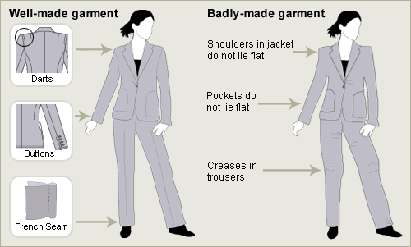

Quality Control & Quality Assurance

Quality assurance is a system of checks and inspections to ensure high standards throughout design and manufacture. QA involves quality control checks which take place a critical control points. Quality assurance assures the costumer that the product will be the same every time it’s bought. This is done through rigorous testing and quality checks.

Quality Control are the quality control checks which take place a critical control points. These involve

Critical control points
Quality-control checks take place at critical control points (CCPs) in a product's manufacture. The following are typical CCPs in textiles manufacture.
Raw materials: They are tested to make sure they are the correct width, colour, weight and fibre content. Depending on the product end-use, the fabric may be tested for strength, durability, crease-resistance, stretch, shrinkage or its water-repellent properties.
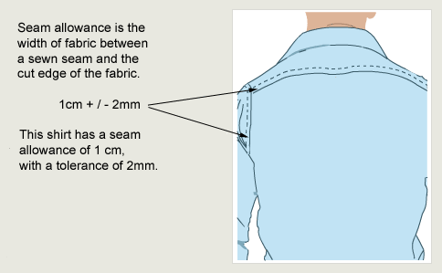
Prototype: This is a mock-up of the product used to trial a design or pattern, see how materials and components behave, try out an assembly process, work out costs, and test fitness-for-purpose in everyday use.
manufacturing specification.

Production: During production there will be checks for stitch and seam strength, and seam allowances are tested to check if they meet the tolerance stated in the specification
Final product. This is inspected for size and fit, and to see if the 'look' of the product meets the specification.

Exam tips
- Make sure you know what a product's design specification/ design criteria [design specification: document containing details of a product's required characteristics, and all the processes, materials and other information needed to design the product ] is - and the difference between this and its manufacturing specification [manufacturing specification: document containing clear and detailed instructions for the manufacture of a product. ]. This is a favourite question of examiners!
- You need to know the difference between quality assurance [Quality Assurance: procedures put in place at the very beginning of the design and manufacturing process - eg training staff, having common procedures and planning for quality checks - to ensure appropriate standards are met. ] and quality control [Quality Control: the checks made during manufacture to ensure that a product is being made to the appropriate standard. ]. Make sure that you can give examples of the use of quality control in textiles production.

CAD & CAM in Manufacture
ICT and computer-aided manufacture (CAM)
ICT and CAM play a vital role in modern textiles production. For example, they enable :
- designs to be sent electronically to the print manufacturer and stored on computer to ease repeat printing orders. The printing would be CAM.
- colours to be matched to the design, dyes weighed and dispensed and the fabric printed automatically. CAM
- ICT makes possible the just-in-time ordering of materials and components so they arrive at the factory as they are needed, ie just-in-time for production to start.
- ICT enables companies to transmit information between plants, and manufacture on a global scale.
- Electronic Data Transfer (EDT) such as Epos tills transmit what’s sold to central computer and reorders can be placed in an instant. It shortens the TTM time (time to market).
Computer Aided Manufacture CAM
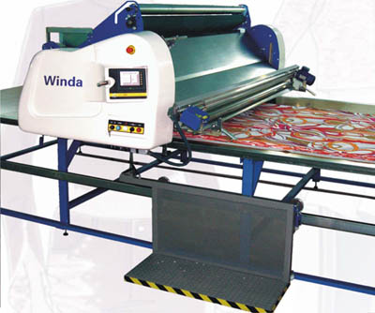
Computer-aided manufacturing involves the use of CAM machines for printing, cutting, joining and many other textiles processes. CNC-automated machines can repeat processes with accuracy and reliability, and are easily re-programmed when changes to design or production run are needed. The graphic shows some of the uses of CNC machines.
- Pick up fabric from the store room
- Spread and cut the fabric
- Label, bundle and transport cut-fabric pieces ready for assembly
- Move cut-fabric pieces around the factory on an overhead conveyor
- Automate processes like buttonholing, inserting pockets or embroidery

Computer-Integrated Manufacturing (CIM)
CIM systems integrate or link CAD and CAM systems. These combined systems link design development, production planning and manufacturing systems together. Companies that use CIM are able to design a product in one country and manufacture it overseas where labour costs are lower.

Computer-Aided Design (CAD)
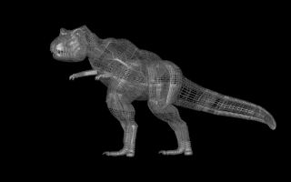
The term computer-aided design includes all the computer applications and hardware devices that can be used to aid digital design. CAD speeds up the design process by making it quick and easy to test and modify ideas before production starts, thus reducing mistakes and cutting costs. Uses of CAD in textiles design include:
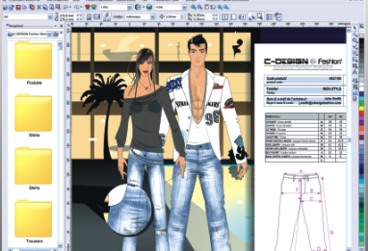
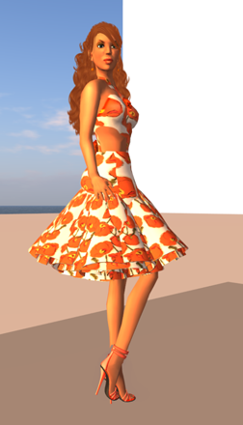
- Wire-frame modelling [wire-frame modelling: using a grid of lines to represent a 3D product on a computer screen. ], surface modelling [surface modelling : adding colour, shading and texture to the surface of a 3D virtual product to make it look realistic. ] or solid modelling [solid modelling: use of digital drawings based on geometric shapes, used for solid objects such as car components. ] can be used to texture map [texture map: a computer 'relief map' of a garment design, as if the fabric had been draped onto the design to show how the finished garment will look on screen ] or simulate virtual products [virtual products: 3D versions of products shown on a computer screen. ] in 3D, from which clients can choose one to be sampled in fabric. This saves the time and cost of sampling a large selection of real products.
- Graphics applications enable ease the production and storage of accurate working drawings [working drawings: an accurate line drawing to show the back and front views of a product, used on a manufacturing specification sheet. ] and lay plans [lay plans: the laying out of pattern pieces of a fabric to work out the quantity and cost of material required for a product. ]
- colour ways [colour ways: combinations of colours used in a fabric design. ] can be accurately modelled at the design stage
- Material quantities and costs and be easily calculated
- Computer networks improve communication between designers, clients and manufacturers - thus speeding up the design feedback loop.
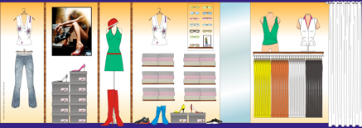

Health & Safety and Consumer Protection
Consumer rights
Consumers are influenced by a number of societal, cultural and moral factors, and textiles designers use market research to find out about the wants and needs of their target market. Consumers have rights in law, and you need to know what these are.
Textiles products need to be cared for, and manufacturers use standard symbols to show consumers how to do this. Health and safety are important to textiles designers and manufacturers, as all products must conform to safety standards to ensure they are safe to make and safe to use. Designers have to think carefully about the needs and wants of their target market, and investigating what consumer’s value and desire in a product is called market research.

Consumer choice and consumer rights

Type of legislation | How it protects you | Example
Trade Descriptions Act | Statements about the product must be true | A 'waterproof' product must not let in the rain
Sale of Goods Act | The product must be of satisfactory quality | The product must perform as expected, eg it should not fall apart after being worn only once
Consumer Safety Act | Nightwear Safety Regulations protect children between three months and 13 years old from fire hazards | Children's nightwear including threads and decoration must carry a permanent label to show that they meet the flammability standard

Textile product maintenance
A care label on a textile product gives the consumer useful information about product maintenance. Good labels provide details on:
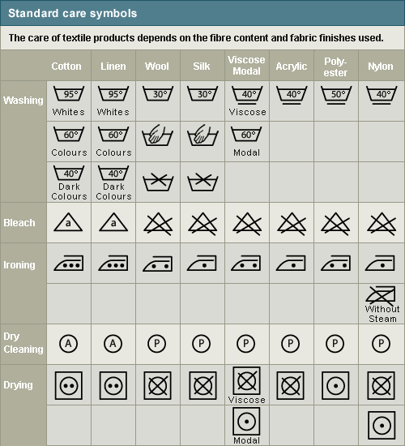
- Fibre content [fibre content: the percentage of each fibre used to make a fabric, e.g. 50% cotton, 50% polyester. ] (a legal requirement)
- Flammability [flammability: The extent to which something burns with a flame. ] (a legal requirement for children's nightwear)
- Standard care symbols (see diagram below)
- Standard size [standard size: standard measurements of the human body such as size 10, 12, 14, 16. ]
All manufacturers use similar symbols to tell you how to look after your product. The graphic shows these symbols.

- Washing instructions are shown as a washing bowl. Similar symbols are found on washing machines to show different cycles. The number in the washing bowl shows the maximum temperature; the line underneath the washing bowl tells you to use a special wash for synthetic [synthetic: man-made - usually from chemical sources ] fabrics. A hand in the bowl means you can only hand-wash the product.
- Bleaching instructions are shown with a triangle: a cross over the triangle means do not wash with bleach.
- Ironing instructions are shown by a picture of an iron. The dots on the iron show the maximum temperature at which it is safe to iron the product: three dots is very hot, one dot is pretty cool. A cross over the iron means do not iron.
- Dry-cleaning instructions: a circle symbol signifies that it's safe to dry-clean the product. The letter inside tells the dry-cleaners what method should be used. A cross over the circle means do not dry-clean.
- Tumble-drying instructions are shown by a square with a circle inside. The dots show the temperature at which it is safe to dry the product. A cross over the symbol means do not tumble dry.
Exam tip
Exam questions about care symbols are popular. Make sure that you can use the standard care label symbols to explain the aftercare for products made from natural and synthetic fibres.

Health and Safety at Work
The other aspect of safety you need to know about is the law covering the health and safety of those working in textiles production. The most important piece of legislation is the the Health and Safety at Work Act (1974).
The Act makes it a legal requirement for manufacturers to undertake a risk assessment of all the stages of product manufacture, to ensure the safety of workers and prevent industrial accidents. The Act specifies that
- safety procedures must be displayed for all to see
- workers must be trained to use machines and equipment
- appropriate protective clothing must be worn, and
- all risks must be controlled and monitored
How to stay safe in your school workshop
Safety with people | Safety with materials | Safety with machines
Follow safety rules | Wear protective gloves when using dyes | Keep hands away from sharp scissors
Tie back long hair | Take care with hot wax used for batik | Turn machines and the iron off after use
Wear safety goggles | Keep workshop clean and tidy | Put tools away after use

Social, Moral and Ethical Implications of Manufacture
Consumer values and choices are influenced by societal, cultural, moral and environmental issues.
Societal, cultural, and moral factors that impact on textile design.

Societal / cultural / moral factor | Impact
Lifestyle and fashion  Gender images and peer group pressure. Fashionable celebrities. Brand loyalty | Development of new street fashions, style and colour trends. Development of new marketing strategies
Globalisation  Availability of cheap labour in developing world. New global market for textile fashions. Increasing awareness of textiles from other cultures. Consumer reaction against 'corporate' trends | Textiles costs driven down in a global marketplace for textiles. Growing demand for traditional and 'ethnic' textiles as well as modern ones
Environmental concern  Worries about pollution of rivers and beaches from textile processes. Growing support for recycling | Development of new recycled fabrics (eg Polartec, Tencel). Preference for higher-cost traditional fabrics (eg wool) over synthetic ones. Enforcement of laws to protect the environment

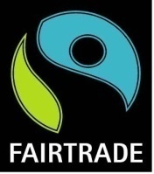
There are many companies developing ethical trading policies. That means they that the workers are treated fairly, paid a living wage and profit when a company does well. Traders that are ethical care about their workers.
Not all companies that have an ethical policy can also the fair trade label. That is restricted to the following:
It means someone checked that the company is treating their workers well that the conditions are as good as they can be. It ensures disadvantaged farmers and workers in developing countries get a better deal through the use of the international FAIRTRADE Mark. The FAIRTRADE Mark is a registered certification label for products sourced from producers in developing countries.
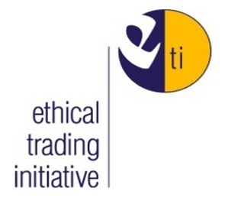
The ETI is an excellent website to find out about all the different initiatives and companies. You can also check out the folder with newspaper articles kept at school.

Systems and Practices

Industrial practices are designed to ensure that quality products are manufactured efficiently at a profit. They involve designers working together with clients and manufacturers - all of whom need to keep the needs of the consumer in mind. All production systems consist of inputs, processes and outputs, and there will usually be feedbacks and subsystems as well.
Production methods vary according to the scale and type of textile being produced and range from one-off to mass production, but they all need production plans and a work schedule. ICT and computer-aided manufacturing (CAM) play a vital role in modern textiles production.
Industrial practices
Industrial practices are the designing and manufacturing processes used by manufacturers to ensure that products are made efficiently and at a profit for satisfied consumers. Industrial practices bring together a number of different people and roles, and you need to understand what each of them does and how they relate to each other.
The Client
The client's role is to identify the need for a product (perhaps commissioning some market Research: Market research is the gathering of data or information concerning consumer opinions about a product or service), drawing up a design brief [design brief: a set of instructions given to a designer by a client. ] for the designer, setting production deadlines and the price of the product. The client is usually a manufacturer or retailer.
The designer
The designer's role is to agree the design brief, and then research market trends, fabrics and processes - taking into account any relevant societal, cultural, moral or safety issues to ensure the product is right. The designer will work to a design specification/criteria [design specification: document containing details of a product's required characteristics, and all the processes, materials and other information needed to design the product ], produce a costing for the product, and help plan the product's manufacture.

The manufacturer
The manufacturer's role is to look any models or prototypes [prototypes: one-off working models of a product to find out if the idea works. ] made by the designer, and work out the most efficient way of manufacturing the product. They will then produce a production plan and a work schedule [work schedule: a written breakdown of the processes needed to manufacture a product. ]. During manufacture their aim will be to keep material and labour costs down, while producing a high-quality, safe product on schedule in a safe environment.
The user/consumer
The user or consumer's role is to demand a high-quality, value-for-money product, which meets their requirements, is enjoyable to wear, and is safe. Oh yes - and to pay for it when it comes to market.

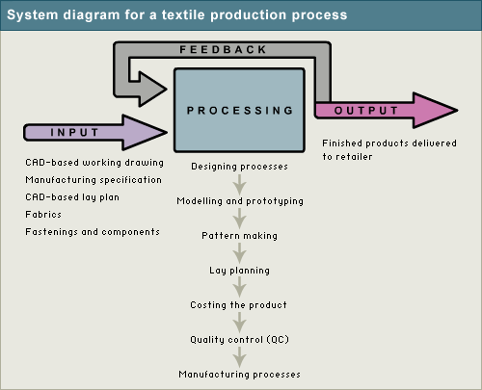
Systems in textile production
All production systems consist of inputs, processes and outputs. Usually there is a feedback loop as well, to enable the inputs and processes to be modified as a result of quality control checks or feedback from customers. Production systems can be modelled with a system diagram like the one opposite.

Systems and sub-systems
In a production system, a number of different designing and manufacturing processes or sub-systems take place at the same time. Examples of sub-systems are:
Lay-planning is the laying out of pattern pieces of a fabric to work out the quantity and cost of material required for a product.
Costing is working out how much each product costs in terms of including materials, labour, rent and energy costs.
Quality control refers to the checks that take place at all stages.
Some of these sub-systems take place in turn - lay-planning usually takes place before costing, for example - while others will overlap. The entire processing depends on each of these processes being completed correctly, so if one goes wrong the whole system may break down and production may be held up.
Clearly complex production systems need to be controlled, and in textile manufacturing systems control can be carried out with the help of mechanical, electric, electronic or computer control devices.

Production methods
Different scales of textiles production call for different production methods. The main ones are:
One-off production
One-off production is designing and making a single textile product to a client's specification. The garment design is developed from a basic block pattern [basic block pattern: pattern made with standard-sized pattern pieces ], with a prototype [prototype: a one-off working model of a product to find out if the idea works. ] made from inexpensive fabric to test the drape [drape: the supple and flexible characteristics of a fabric - how it hangs or behaves when pleated or folded ], fit and assembly [assembly: the process of joining pattern pieces together to make a product. ] of the garment.
Batch production is manufacturing set quantities of a textile product to order. The prototype is made up in a medium size from the intended fabric. The prototype is checked for quality of design and manufacture, then put into production in a range of standard sizes [standard sizes: standard measurements of the human body such as size 10, 12, 14, 16. ]. The quantity of products can vary from a set of four cushions made by a designer-maker, to 20,000 jumpers made for a department store.
Mass production is industrial-scale manufacture of large quantities of products, usually on a production line. Mass production is suitable for products that seldom need to be redesigned and are needed in very large numbers, eg socks or jeans.

The following table explains how these production methods are used in the textile industry:

system | Product market | Design and production | Skill level and cost
One-off | Made-to-measure, eg suit, wedding dress; | Made-to-measure garments are made to fit the measurements of an individual client [client: person or organisation that wants a product manufactured - eg a retailer. ]; the garment design is developed from a basic block pattern [basic block pattern: pattern made with standard-sized pattern pieces ] and a toile [toile: a prototype garment made from low-cost fabric. ] is made to test the fabric drape, the fit [the fit: how well the size and shape of a garment fits a human body. ] and order of assembly | Very high-level skills in design and manufacture; high-cost materials; high labour costs
One-off | Haute Couture, eg made by fashion houses | Fashion designers such as John Galliano design Haute Couture garments for individual clients | Very high-level skills in design and manufacture; high-cost material and labour costs
Batch production | Ready-to-wear (RTW) designer label, eg Designers at Debenhams | Garments are designed to fit a range of standard sizes and shapes. Garment patterns are developed from a basic block using CAD: Computer Aided Design - a system which helps the user produce accurate drawings.. A sample garment is made up in a medium size, from the intended fabric. Once the design has been approved it is put into production in a range of standard sizes. They are sold through up-market retailers. | High-level design, pattern making and sampling skills; cost-effective materials and lower manufacturing costs
Mass production | Mass-market retailers, eg Top Shop | Similar production methods to batch production: garments produced in limited range of sizes; standardised production methods are used to produce a wide range of styles. Most fashion products are batch produced in large batches eg 20,000. Some classic products like jeans are mass produced for a world market. | High-level design, pattern making and sampling skills; cost-effective materials; products often made overseas where labour costs are low

Production planning
Production plans and work schedules are important planning tools in batch and mass production.
The production plan should set out information about all the stages of production, so that every product is made to the same quality. See example below:
The manufacturing specification
The pattern pieces
The lay plan
Work schedule
A flow diagram to show where and how to check for quality
Each production plan should include the following stages:
- The preparation stage details the amount of materials to buy-in, preparation of garment patterns [garment patterns : the separate pattern pieces of a garment such as the back, front and sleeves ], templates [templates: making aids which help you put the same things in the same place on each item. They can be cut out of wood, card or other materials. In textiles for example a template will help you place buttons. ] and lay plans [lay plans: the laying out of pattern pieces of a fabric to work out the quantity and cost of material required for a product. ].
- The processing stage details the fabric spreading [fabric spreading: spreading out fabric in layers ready for cutting. ], cutting, labelling and bundling [bundling: putting cut fabric pieces into identical bundles ready for assembly. ] of the fabric pieces.
- The assembly stage contains instructions for fusing [fusing: a method of joining two materials together. In textiles this involves joining fabrics together using an adhesive resin. ], joining [joining: attaching to materials together. In textiles this involves stitching, fusing or heat-sealing the materials together. ] and pressing [pressing: using dry heat or steam to shape, stabilise and set textile materials. ] the separate product parts.
- The finishing [finishing: final processes in garment manufacture - including overlocking, pressing, and decoration ] stage gives instructions for decorative/functional finishing and final pressing.
- The packaging stage explains how to label, hang, fold, and cover the product ready for transport to the retailer.

Some manufacturers use computer software to handle the detailed information in the production plan. Any changes made to the plan are quickly available to each member of the production team.
Work schedule:
A work schedule sets out instructions about the order of assembly [assembly: the process of joining pattern pieces together to make a product. ], the stitch type, the processes to be used, the time each process will take and the seam allowance [seam allowance: the amount of material between the edge of a fabric and the seam line. ]. See the example of a work schedule below:
Work schedule below for a skirt
Order of assembly | Stitch type | Process | Process time in minutes | Seam allowance
1 | Lockstitch | Stitch pockets | 2.00 | 1.00cm
2 | Lockstitch | Stitch pockets to front | 2.00 | 1.00cm
3 | Overlock | Join back seam | 1.00 | 1.00cm
4 | Lockstitch | Insert zip | 2.00 | 0.20cm
5 | Overlock | Join side seams | 1.50 | 1.00cm
6 | Lockstitch | Join waistband to top | 2.50 | 0.60cm
7 | Blind hemming | Turn up hem | 1.50 | 0.20cm
N/A | N/A | Total process time | 12.50 | N/A

Industrial sewing machines
In industry a range of different sewing machines are used for stitching seams, embroidery, buttonholes etc. The main ones are listed in the table below:
Machines and there uses
Industrial machine | Method of control | Joining process | Used for
Lockstitch | Electric | Lockstitch | Straight seams
Lockstitch | Electric | Zigzag stitch | Stretchy knits; finishing edges
Overlocker | Electric | Stitches, cuts and finishes seams in one process | Non-fraying seams; stretchy seams
Seamcover | Electric | Flat seam | Knitted hems; belt loops on jeans
Linking | Electronic; CAM | Joins knitted fabric stitch by stitch | Knitted seams
Automatic buttonhole | Electronic; CAM | Lockstitch; chainstitch | Buttonholes
Computer Numerically Controlled (CNC) | Computer software; Electronic; CAM | Lockstitch; zigzag; embroidery | Making collars; labels; logos; embroidery

Pressing
Pressing is done to shape, stabilise and set textile materials using dry heat or steam. In industry pressing can be done using specialist equipment or by hand. The main methods for pressing are outlined in the table below:
Methods for pressing
Stage of manufacture | Pressing operation | Equipment | What it does
Product assembly | Under pressing | Pressing unit | Reduces shrinkage; removes creases; makes sewing easier
Product assembly | Moulding | Pressing unit; ironing and sleeve boards | Stretches and sets 3D shapes in fabrics eg at top of sleeve
Product assembled | Top pressing | Steam dolly; tunnel finisher; flat-bed press for trousers | Final pressing makes the product ready for sale

Methods of joining Materials
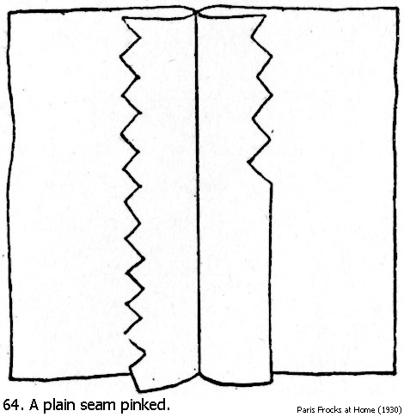
There are different seams to join materials. Some materials like wetsuits are actually heat sealed through their thermoplastic properties. Most things still require the sewing machine. Depending on the thickness of material you can use:
Plain or flat seam: For most fabrics lightweight to heavy weight. Most commonly used seam. It’s also the fastest and hence the cheapest.

French seam: For very light fabrics that tend to fray such as chiffon
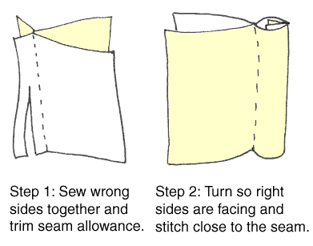

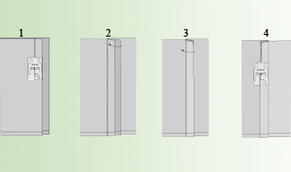
Flat fell seam: Gives strength to a heavier weight product such as denim.

You can neaten seams using the over-locker, zigzag stitching or pinking with pinking shears. The seam allowance is vital to make an accurate product and describes the distance from the edge of the fabric to the stitching line.
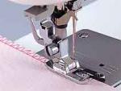
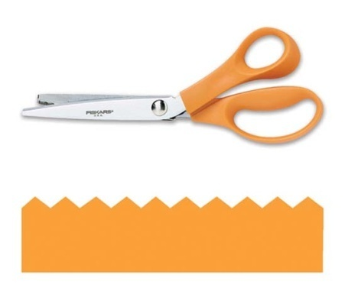
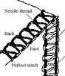
Shaping Techniques
Fabric is shapeless, you give it shape! How?
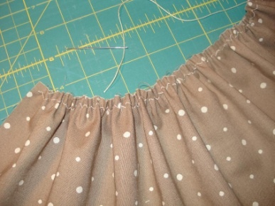
Darts, pleating, gathering that’s it, easy!
