Task 1
Why you should grow your own veg?
https://www.lyliarose.com/blog/read_176752/6-benefits-of-allotment-gardening.html
Allotments all over the UK are extremely popular and waiting lists are long. In a recent survey, a quarter of people said they had an allotment for growing food that’s fresh and tastes better, for the exercise in digging, planting and weeding, and to socialise with other like-minded people. As you can see, there are wide ranging benefits to allotment gardening.
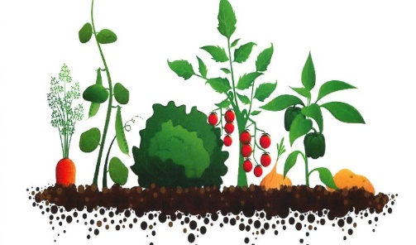
- Eating healthily
Of course, an obvious benefit of growing your own fruit and veg is that you eat more healthily. Not only are you more likely to eat the vegetables and salads you grow, but you’re the one who decides what to grow them with (or without). Your choice to use no chemicals or sprays, for example, means you’ll be able enjoy fresh organic fruit and vegetables without the hefty ‘organic’ supermarket price tag.
- Saving you money
If you have green fingers, your allotment will be able to produce enough fresh vegetables and salads to supplement your entire family’s weekly shop. Just imagine – fresh fruit and vegetables throughout the year! Yes, it can be hard work, but even if you only grow a small crop of vegetables, a large part of the reward is the money saved that you would have otherwise spent at the shops.
- Sunlight keeps you healthy
If you’re a light-skinned individual, then spending around 15-20 minutes a day out in the summer sunshine will help you build up your levels of vitamin D, which is important to your health. If your skin is naturally darker, you can spend around 60-90 minutes in the sun to raise your vitamin levels.
Gardening outside in sunlight can make a difference to your wellbeing too – sunlight can help to ward off certain illnesses and raise your levels of serotonin, the vitamin in your body that makes you happier and healthier.
- Burning up the calories
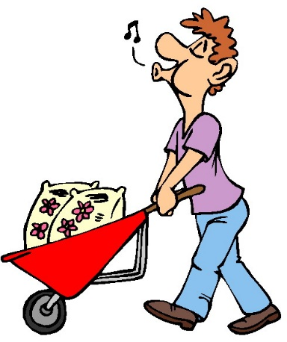
By doing just 30 minutes of gardening on your allotment, you can burn around 150 calories, which is just as good a low-intensity workout at the gym, or doing low impact aerobics. People of all ages and abilities can get involved. It’s wonderful exercise with the added bonus of putting delicious greens and vegetables onto the dinner table.
Moderate activity like gardening can help prevent heart disease, obesity, brittle bones, arthritis, mild depression and non-insulin dependent diabetes. Allotments first came into being as means to feed the rural poor, but over the years, they’ve become a popular hobby among people from all over the UK.
Those who work allotments are healthier because of the exercise and much needed ‘fresh-air’. So, why don’t you contact your local council today and add your name to the waiting list.
- Meeting like-minded people
Your local allotment is a fantastic place to meet people in your neighbourhood and form great friendships. All of you share a common interest and most allotment gardeners are only too happy to lend a hand and offer advice.

- Supporting natural habitats and open spaces
Traditionally, allotments are located near housing developments, and are therefore essential areas to provide habitats for all forms of wildlife. By cultivating and planting an allotment, you’ll be doing your bit to keep biodiversity levels on the up.
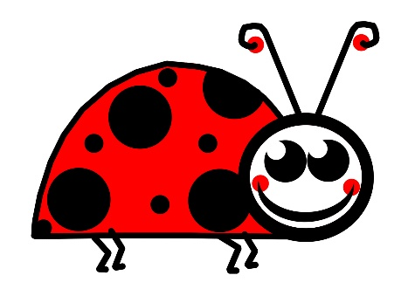
Without these wonderful ‘green spaces’, all sorts of wildlife would be under threat, the ecosystem would suffer, crop yields would fall and your neighbourhood’s open spaces would become a much poorer place.
It’s a fact that just one square metre of land can support hundreds of species of insects, frogs, spiders, hedgehogs, and many other kinds of wildlife. Allotments provide local wildlife with sustainable habitats, and these include birds, foxes, badgers, bees, butterflies, slow-worms and many others. You’ll be amazed by what you see while working at your plot.
_____________________________________________________________________________
Task
On a sheet of lined paper, you will now need to answer and complete the following tasks/questions. This needs to be done neatly and in full sentences, please also write out the question before you answer.
- In the article above there are several words highlighted in red, these are key words and it is important you understand what they mean. Using a dictionary, find the definitions of the words in red.
- What is meant by the term ‘organic’?
- Why does the writer refer to allotments as being hard work?
- How many calories can be burnt during 30 minutes of work at an allotment?
- How many calories would be burnt if a person spent 3 hours and 45 minutes a week at the allotment?
- Why might an allotment be beneficial to someone who lives alone or new to an area?
- Apart from the benefits to humans, how else can an area of allotments be helpful to the local living area? Give at least 3 examples.

Task 2
Exclusive Offer

The local council have announced that they are planning on opening up 50 allotment plots in the local area. They have asked you to produce either a leaflet or webpage explaining some of the benefits of having an allotment. The allotment plot will cost £30 per year and will be 8 meters wide and 13 meters long, this information will need to be included in your work.
This needs to be completed on plain paper, pictures drawn in pencil and written work completed in pen. Please ensure this information is bright and colourful so people will be more inclined to read it.

Task 3
Gordon Ramsay

Chef Gordon Ramsay has dismissed controversy in Australia over his bad language on TV, saying he has no intention of changing his style.

"It's high pressure, high energy and more importantly, real. That's how we keep it each and every day," Ramsay told the country's Nine Network. An inquiry was initiated by Liberal senator Cory Bernardi, after he watched Ramsay's Kitchen Nightmares.

The chef is in Australia for a series of cooking shows in Sydney. Ramsay said his television shows, Kitchen Nightmares and Hell's Kitchen - both broadcast on Channel Nine - demonstrated the real pressures of working in a restaurant kitchen. "I want to run a proper kitchen... not stand there and wish everybody a Merry Christmas and pat them on the back every time they do a good job," he said. Ramsay added that the easiest way to avoid his cursing would be to change the channel. "Turn over. Isn't it easier?" he said.
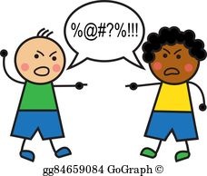
Both series have proved to be ratings winners with audiences in Australia. "I'd like to give Channel Nine a big telling-off for making my name bad in Australia," joked Ramsay. "Has no-one got an edit suite and not broadcasting those naughty words before nine o'clock? "I'm getting the flak for it everywhere I go." The Senate inquiry was prompted by one episode aired earlier this year, in the 20:30 time slot, in which Ramsay used a four-letter expletive more than 80 times in 40 minutes. Mr Bernardi said there was "no excuse for gratuitous bad language to be broadcast repeatedly" when it could be "beeped out". But senators stopped short of imposing an outright ban on swearwords, citing a lack of an "overwhelming community consensus" in favour of such a ban.

Complete
On a sheet of lined paper, you will now need to answer and complete the following tasks/questions. This needs to be done neatly and in full sentences, please also write out the question before you answer.

- In the article above there are several words highlighted in red, these are key words and it is important you understand what they mean. Using a dictionary, find the definitions of the words in red.
- Why did the senators not vote for a total ban on swearwords?
- Resturant – This word is spelt wrong please find the correct way to spell it.
- Audiances – This work is spelt wrong please find he correct way to spell it.
- Gordon Ramsay said viewers could avoid his cursing by doing what?
- Do you think Gordon Ramsay was right say this? Explain you answer.
- How could the views of Mr Berndi be summarised?
- Below is a table of words from this article. You need to find an alternative word with the same meaning. (Please draw out the table)

Original Word | Replacement Word
Importantly
Initiated
Demonstrated
Real
Avoid
Cursing
Flak
Gratuitous
Imposing
Outright
Consensus

Task 4
Government proposes energy drinks ban for children
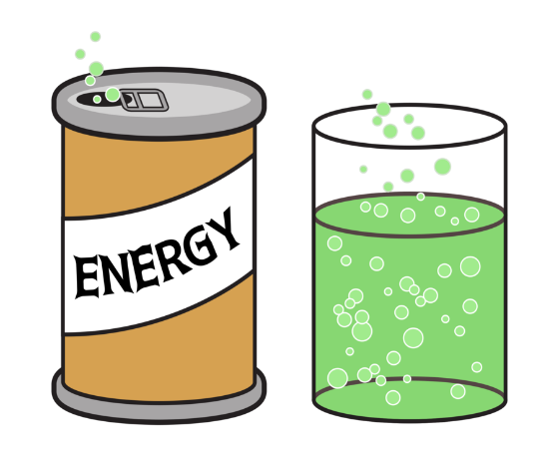
https://www.bbc.co.uk/news/health-45342682

The sale of energy drinks could be banned in England to anybody under 18, amid fears they are damaging children's health, the prime minister has said. The government has launched a public consultation on its plans to make it illegal to sell the drinks to children. Energy drinks contain high levels of sugar and caffeine and have been linked to obesity and other health issues. The government is asking for views on what age the ban should apply to, but gave under 16 and under 18 as options.

'Worrying links'
UK youngsters are among the highest consumers of energy drinks in Europe, research has previously suggested. The drinks contain high levels of caffeine and sugar, often much more than those of standard soft drinks. Excessive consumption has been linked to a range of health issues in children, from obesity, tooth decay, headaches and sleep problems to stomach aches and hyperactivity.
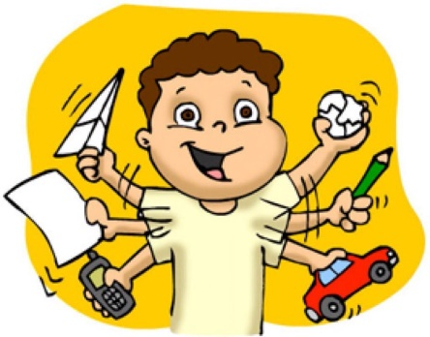
Surveys from teacher’s unions have also suggested that they contribute to poor behaviour in classrooms, although claims they can alter behaviour have been contested. The ban would apply to drinks containing 150mg of caffeine or more per litre.
Many shops already have their own voluntary bans in place for under-16s, but it is still possible for children to buy the drinks from some retailers and vending machines. Public Health Minister Steve Brine said: "We all have a responsibility to protect children from products that are damaging to their health and education, and we know that drinks packed to the brim with caffeine, and often sugar, are becoming a common fixture of their diet.
"Our children already consume 50% more of these drinks than our European counterparts, and teachers have made worrying links between energy drinks and poor behaviour in the classroom."

Reality Check: Is caffeine bad for your health?
The two main ingredients of concern in energy drinks are sugar and caffeine. We know having a diet too high in sugar risks weight-gain, which is in turn is linked to heart disease, some cancers and type 2 diabetes. But how much do we know about what caffeine does to young people's bodies in the short and longer-term?
For example, there's plenty of evidence linking disturbed sleep to a range of negative health consequences, including weight gain. One study linked energy drinks to "poor quality or reduced sleep, headaches, risk-seeking behaviour and depressive symptoms".
The maximum recommended intake of caffeine for children is lower than for adults - no more than a daily serving of 2.5mg for every kg a child weighs - meaning it's easy for a young person to over-consume caffeine if they drink energy drinks.

The Prime Minister View
Prime Minister Theresa May said: "Childhood obesity is one of the greatest health challenges this country faces, and that's why we are taking significant action to reduce the amounts of sugar consumed by young people and to help families make healthier choices.
"With thousands of young people regularly consuming energy drinks, often because they are sold at cheaper prices than soft drinks, we will consult on banning the sale of energy drinks to children.
"It is vital that we do all we can to make sure children have the best start in life and I encourage everyone to put forward their views."

Task
On a sheet of lined paper, you will now need to answer and complete the following tasks/questions. This needs to be done neatly and in full sentences, please also write out the question before you answer.
- In the article above there are several words highlighted in red, these are key words and it is important you understand what they mean. Using a dictionary, find the definitions of the words in red.
- What two ingredients are energy drinks high in?
- What are the two ages that the government have mentioned for the ban to apply to?
- What have teachers argued are the effects of drinking energy drinks on pupils?
- What percentage of energy drinks do UK children consume more than other European children?
- What are the negative health consequences of consuming energy drinks?
- The average teenager weighs between 30kg and 50kg – how much caffeine can they safely consume a day?
_____________________________________________________________________________

Task 5
Letter to the Prime Minister

In the final sentence of this article the Prime Minister is encouraging everyone to put forward their views about energy drinks. On a new sheet of lined paper, write a formal letter to the Prime Minister stating your views about energy drinks.
In the letter, you must present a balanced argument, both for and against children consuming energy drinks. Support your letter with facts, whilst also including your own opinions. If you have energy drinks, do you think they affect you? If you don’t, do you notice changes in your friends when they drink them?

Task 6
Is Eating Insects the Answer to Global Hunger?
https://www.bbc.co.uk/newsround/45899417

Would you swap your steak and chips with a plate of mealworms to help combat the challenges of climate change?
By 2050, the world's population is likely to increase to 9.7 billion, so current food production will need to double. But droughts around the globe, linked to climate challenge, are putting food production at risk. Reducing the amount of meat, we eat is important because food production accounts for about a quarter of all human-related greenhouse gas emissions, and is predicted to rise.
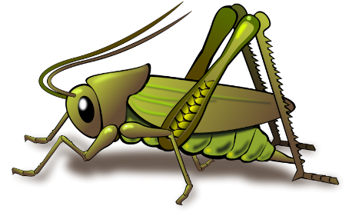
In western countries, this could mean eating 90% less beef and five times as many beans and pulses. But some scientists are also encouraging us to eat some creepy crawlies too. They believe insects could help fight world hunger and malnutrition because they are abundant, healthy, and have less of a carbon footprint.
Eating insects is an ancient tradition which still happens today. Two billion people, more than a quarter of the world's population, eat insects.
Here are 4 reasons why we should eat insects:
Healthy
Insects are filled with lots of good nutrients, including amino acids and protein. Crickets, grasshoppers, and mealworms contain more copper, zinc, magnesium and calcium than beef!

There are loads
There are a LOT of insects in the world. Some people put the number at 10,000,000,000,000,000,000... which is 10 quintillion!
Better for the environment
Agriculture produces a lot of greenhouse gases and farming insects doesn't require as much land and water as traditional agriculture does. Insect farming is already happening in Africa.

Money makers
Insects provide an opportunity for new ideas in business and the technology and scale of edible insect farming is improving. Insects can be eaten raw or processed into powders. Several new businesses in the Netherlands, South Africa and Kenya have been set up to focus on making insects for human food.

Task
On a sheet of lined paper, you will now need to answer and complete the following tasks/questions. This needs to be done neatly and in full sentences, please also write out the question before you answer.
- In the article above there are several words highlighted in red, these are key words and it is important you understand what they mean. Using a dictionary, find the definitions of the words in red.
- Give 5 examples of “western countries” that this article might be referring to and why.
- Why does rearing animals for meat cause so much greenhouse gas emissions?
- What are your views? Could you possibly eat insects? Explain your answer.


Internet Research

This article states that there are many countries from around the world that eat insects as part of their regular diet. You need to find and research two countries that use insects in their diets. The following information will need to be displayed on one PowerPoint slide per country.

- Name of the country.
- Miles from UK.
- Population of country.
- Types of insects eaten.
- How long they have been eating insects.
- A least two pictures of dishes that contain insects from each country.

Task 7
Kitchen Workplace Safety
http://www.workplacesafetyadvice.co.uk/kitchen-workplace-safety.html

Kitchen Workplace Safety Common
The Health and Safety Executive (HSE) is responsible for enforcing commercial catering health and safety regulations which can cover a wide ranging spectrum of businesses including pubs, hotels, restaurants, cafes, fast food outlets, bistros, contract caterers and others where food and drink is prepared and served for the general public. Many accidents occur in kitchens every day and it is the HSE’s responsibility to ensure that regulations are adhered to in order to minimise the risks. Of course, hygiene in the kitchen is also an integral part of kitchen workplace safety but that is the responsibility of the Environment Health Department which will be covered in a separate article contained on this website.

Common Causes of Accidents in the Kitchen
The predominant causes of injury in a commercial kitchen are from slips, trips and falls, manual handling which can result in musculoskeletal injuries and exposure to hot or harmful substances.

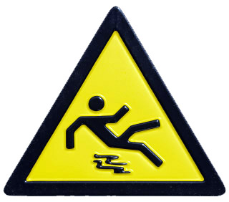
Slips, Trips and Falls
Most slips, trips and falls in kitchens occur due to wet floors so it’s important to wipe up any spillages that occur immediately and to dry the floor. Warning signs saying ‘wet floor’ and even cordoning off certain areas are actions which should also be taken after spillages or after mopping the floor during cleaning until it is dry. Often, it’s an uneven floor or loose or damaged floor tiles which are responsible for slips and trips so it’s necessary to keep floors well maintained as well as clean and passageways or any areas where staff might walk should be kept free from any obstructions or obstacles.
Manual Handling
You need to pay great attention to things which you lift in the kitchen, especially as certain items can be extremely heavy and/or difficult to manoeuvre. Never push, pull or drag heavy items as you might suffer from a musculoskeletal injury. Where items are heavy, ask a colleague to help you lift them and, if it’s still too heavy, use a lifting device in addition to following basic health and safety guidelines on how to lift objects.
Cuts
You need to take great care when using knives in the kitchen and also beware of glass objects. You need to follow safe procedures when using knives and other sharp kitchen utensils and when handling items made of glass as both can cause severe damage in the form of cuts.

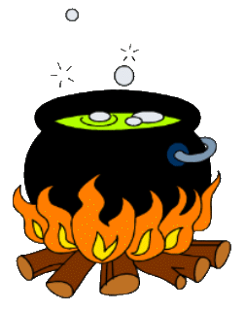
Exposure to Hot and Harmful Substances
Oil and other fluids such as water are commonplace in kitchens and it’s important that you take extreme care when working with or in close proximity to hot liquids. Always ensure they are covered when not directly working with them and be careful when carrying any pans or containers with hot liquids in which could splash and scald either yourself or fellow workers. The HSE also publishes safe procedures for things like opening steam doors and the draining and cleaning of fat fryers, for example. Other substances which can be harmful are cleaning materials which, if handled incorrectly, can cause skin rashes and conditions such as dermatitis. Even handling certain foods can cause dermatitis and other skin conditions such as eczema and these are some of the more common causes of absenteeism within the catering and hospitality industry.
_____________________________________________________________________________
Task
On a sheet of lined paper, you will now need to answer and complete the following tasks/questions. This needs to be done neatly and in full sentences, please also write out the question before you answer.
- In the article above there are several words highlighted in red, these are key words and it is important you understand what they mean. Using a dictionary, find the definitions of the words in red.
- Who is responsible for enforcing the health and safety regulations?
- State 3 businesses that need to follow the health and safety regulations?
- What is the most common injury in a kitchen and why?
- What sign should be placed on a wet floor and why?
- What should you never do with heavy items and why?
- What two cutting methods should be used to reduce the risk of injury?
- Explain the bridge and claw methods when chopping foods.

Task 8
Health and Safety Leaflet

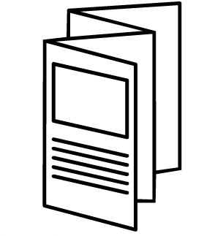
The head chef at your workplace has noticed that there have been more recorded accidents in the past few months. He thinks that the staff need reminding how to stay safe within the kitchen, however, it is struggle to find time to hold a staff meeting. He has asked that you produce an information sheet about potential hazards in the kitchen and how to avoid them.

He has asked that the leaflet look professional so will need to be done on a piece of plain paper, folded in half to make as small booklet. The written work needs to be completed in pen and supporting pictures to be drawn in pencil and coloured in.

Task 9
Nutrition

Everyone eats food. Some people eat lots of fruit and vegetables, others may eat more or less meat, and some people may eat healthy, but others do not. All of it is related to nutrition. Nutrition is the process of how people get the food that is needed to grow strong and healthy along with obtaining the necessary vitamins and nutrients to help bodies grow and function.
For children, good nutrition is especially important and it is necessary to eat healthy foods because kids are constantly growing. Good nutrition will lead to healthy bones and muscles, and without receiving the correct vitamins and nutrients while growing, a child will not grow as tall and as strong as they could be.
There are many aspects of nutrition including knowing about the different food groups, understanding calories, and learning about the different vitamins, nutrients, and minerals a body needs, and what to avoid.
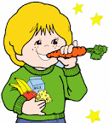
There are five main food groups that should be eaten each day. Eating a variety of foods in each group will lead to receiving most important nutrients to remain strong and healthy. The first food group includes grains such as breads, cereals, pasta, and rice. The second food group is dairy, which includes milk, cheese, yogurt, and other dairy products. Apples, oranges, grapes, bananas, and much more are a part of the third food group, fruits. Of course, vegetables is in its own food group as well. There are many, many vegetables available to eat including beans, broccoli, peas, carrots, corn, and others. Finally, the fifth and final food group is protein, which can be found in beef, chicken, eggs, nuts, fish, and pork.
The portion size of each food group is not the same. For example, it is recommended that a person eat slightly more vegetables and grains than fruit and protein for each meal. There are also other guidelines on how to eat healthier, some of which includes drinking skim milk instead of whole milk, water instead of sugary drinks, and eating wheat bread instead of white bread.
Calories are a measure of the amount of energy in food items. Calories are necessary to eat to get the energy needed to play, work, and move around. The calories get burned off during movement, so eating will replenish them. But if a person eats more calories than they burn, the excess is stored as fat. There are also some foods that contain empty calories, meaning they have very little nutritional value such as solid fats and sugars.
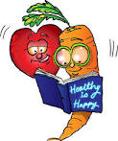
There are many healthy foods to eat in order to receive the vitamins and minerals needed. For example, vitamin A is found in milk and helps keep the immune system healthy; Vitamin C is found in oranges and other vegetables, which is good for blood vessels, teeth, healing, and the brain. Vitamin D and calcium is great for healthy bones and can be found in milk. Iron is needed for the blood and is available in red meat, poultry, fish, and leafy vegetables. These are just a few of the minerals and vitamins that keep a person heathy.
In summary, good nutrition leads to good health. When a person wants to lose weight, it can be done by eating healthier and exercising regularly. Nearly all foods contain some of the vitamins and minerals needed for the body, but it is also important to eat the right amount of foods from the five food groups: grains, dairy, fruits, vegetables, and protein.

_____________________________________________________________________________
Task
On a sheet of lined paper, you will now need to answer and complete the following tasks/questions. This needs to be done neatly and in full sentences, please also write out the question before you answer.

- In the article above there are several words highlighted in red, these are key words and it is important you understand what they mean. Using a dictionary, find the definitions of the words in red.
- Why is it most important for children to eat healthily?
- State the five main food groups and give 6 examples of foods from each.
- Which two food groups are needed in the largest amounts?
- How is the energy in food measured?
- What happens when more calories are eaten than burned off?
- What is needed for good bones and teeth? And why?

_____________________________________________________________________________

Task 10
Board Game
On a sheet of plain paper, design a board game that would encourage a group of primary school children to eat healthier. The board game needs to be;
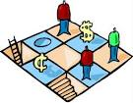
- Easy to play
- Bright and colourful
- Inform the children about the function of different vitamins and minerals.
- Have at least 4 different food based characters with superpowers – produce an information profile about each character explaining their powers and why.
- Bonus points / moves when someone does something healthy and sanctions for being unhealthy.

In addition, you will need to produce a set of rules on an additional sheet of lined paper.

Task 11
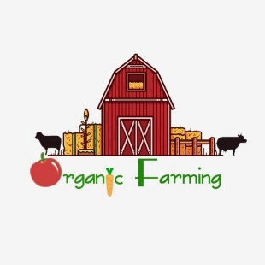
Organic Food
Below is an article from BBC website; http://news.bbc.co.uk/1/hi/health/8174482.stm
Organic food is no healthier than ordinary food, a large independent review has concluded.
There is little difference in nutritional value and no evidence of any extra health benefits from eating organic produce, UK researchers found. The Food Standards Agency, which commissioned the report, said the findings would help people make an "informed choice". But the Soil Association criticised the study and called for better research.
Researchers from the London School of Hygiene and Tropical Medicine looked at all the evidence on nutrition and health benefits from the past 50 years. Among the 55 of 162 studies that were included in the final analysis, there were a small number of differences in nutrition between organic and conventionally produced food but not large enough to be of any public health relevance, said study leader Dr Alan Dangour.
Overall the report, which is published in the American Journal of Clinical Nutrition, found no differences in most nutrients in organically or conventionally grown crops, including in vitamin C, calcium, and iron. The same was true for studies looking at meat, dairy and eggs.
Differences that were detected, for example in levels of nitrogen and phosphorus, were most likely to be due to differences in fertiliser use and ripeness at harvest and are unlikely to provide any health benefit, the report concluded. The review did not look at pesticides or the environmental impact of different farming practices.
Gill Fine, FSA director of consumer choice and dietary health, said: "Ensuring people have accurate information is absolutely essential in allowing us all to make informed choices about the food we eat.
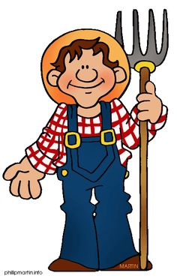
"This study does not mean that people should not eat organic food. "What it shows is that there is little, if any, nutritional difference between organic and conventionally produced food and that there is no evidence of additional health benefits from eating organic food."
She added that the FSA was neither pro- nor anti-organic food and recognised there were many reasons why people choose to eat organic, including animal welfare or environmental concerns.
Dr Dangour, said: "Our review indicates that there is currently no evidence to support the selection of organically over conventionally produced foods on the basis of nutritional superiority." He added that better quality studies were needed. Peter Melchett, policy director at the Soil Association said they were disappointed with the conclusions. "The review rejected almost all of the existing studies of comparisons between organic and non-organic nutritional differences. "Although the researchers say that the differences between organic and non-organic food are not 'important', due to the relatively few studies, they report in their analysis that there are higher levels of beneficial nutrients in organic compared to non-organic foods. "Without large-scale, longitudinal research it is difficult to come to far-reaching clear conclusions on this, which was acknowledged by the authors of the FSA review. "Also, there is not sufficient research on the long-term effects of pesticides on human health," he added.
Advantages and Disadvantages of Organic Farming
Advantages | Disadvantages
- Fewer chemicals are used, so less risk of toxic chemicals remaining on food  - Less chance of river pollution with fertiliser  - No pesticides are used, so doesn't disrupt wildlife  - Treatment of animals is ethical (no battery farming)  - More labour intensive, so creates jobs | - Takes up more space than intensive farming (more land has to be farm land, rather than being set aside for wildlife or other uses  - More labour intensive, so makes food more expensive  - Crop yields are lower

Task
On a sheet of lined paper, you will now need to answer and complete the following tasks/questions. This needs to be done neatly and in full sentences, please also write out the question before you answer.
- In the article above there are several words highlighted in red, these are key words and it is important you understand what they mean. Using a dictionary, find the definitions of the words in red.
- What differences were found between conventionally produced and organic foods?
- Why, according to Gill Fine, is accurate information essential?
- What was the reaction from The Soil Association to the findings?
- What does The Soil Association feel could perhaps shed more light on this claim?
- According to Dr Dangour, why should organic food not be chosen over conventionally produced food?

Task 12
Write A Letter Your Local MP!
It’s time for you to pick a side. Using the information above, you need to write a letter to your local MP either supporting or opposing organic farming.
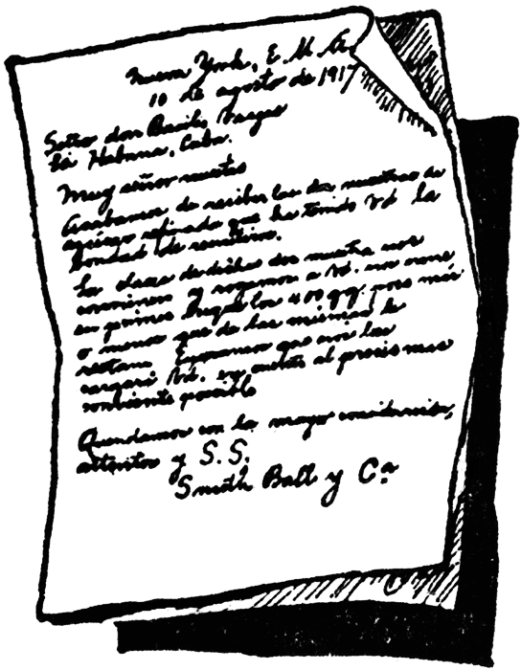
To Do;
- Find out who your local MP is.
- Decide whether you support or oppose organic farming.
- Draft down some reasons to support your argument.
- This piece of work needs to be written as a formal letter.
- You need to show an awareness of both points of view towards organic farming.
- The final draft needs to be completed on a new piece of lined paper.

Task 13
What are Food Miles?
https://www.foodmiles.com/food/kids

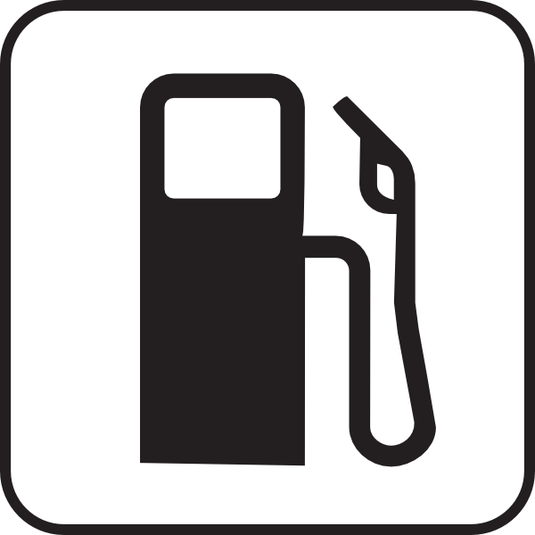
Food miles are a way of attempting to measure how far food has travelled before it reaches the consumer. It is a good way of looking at the environmental impact of foods and their ingredients. It includes getting foods to you, but also getting waste foods away from you, and to the landfill!

What Does That Mean?
It means that it is time to think about where your food has come from and what environmental effects this has had.

What Are The Effects?
The effects of food miles can be measured in the pollution that is caused. Think about the distance travelled, then think about how that distance was covered. Was it by Plane? Boat? Road?

What Can I Do?

Buy Local! That's the key. This means supporting local growers. It’s much better for the environment growing and buying organic, but what if that organic product has come from, say Chile? That's a long haul journey for your apples to go! It’s better to go down the road (on a bicycle) and buy from your local farmer, or grower.
Beware though, even some foods that may appear to be from local suppliers, if bought is supermarkets, have probably toured the country between depots before arriving back in the shop.
Why not walk to the local shop or get the bus? This all helps to reduce the "food mileage" effect. Composting packaging, where possible, is another way of reducing the environmental effects of our food. This reduces the amount of waste that needs to be taken to the landfill sites and again helps to cut pollution.
Task
On a sheet of lined paper, you will now need to answer and complete the following tasks/questions. This needs to be done neatly and in full sentences, please also write out the question before you answer.
- In the article above there are several words highlighted in red, these are key words and it is important you understand what they mean. Using a dictionary, find the definitions of the words in red.
- Define the term “Food Miles”
- What does ‘buy local’ mean? Please explain your answer and give examples.
- Why is a long haul journey bad for the planet?
- How many different modes of transport would be needed to get a food product to the UK from Brazil?
- How many different modes of transport would be needed to get a food product, from a farmer, 5 miles away from your house?
- Getting food imported from abroad is a lengthy process, approximately how many hours would it take to get a bag of apples from New Zealand to a UK supermarket? Don’t forget to include getting the apples from the tree. Explain your answer.
- Approximately, how long would it take to get a bag of apples from the local farmer 5 miles away? Explain your answer.
________________________________________________________________
Task 14
A Label for Food Miles
The UK government are considering introducing a label on all food products, that indicates how far it has travel to the UK. They believe this will encourage to buy more local food products, which in turn will reduce pollution levels.
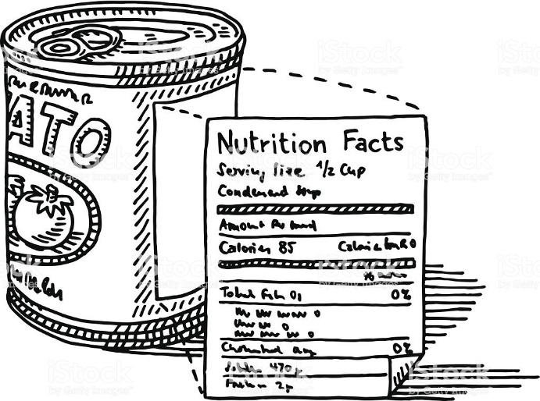
Task
- They have asked that you design a possible example of the label that will be used. They have requested that it is of a reasonable size and will be eye catching enough for people to see it.

- Would seeing how far a food product has had to travel make you think twice about buying a product? Would you try and buy a food product that was produced nearer to or in the UK?

Task 15
What is Food Poisoning

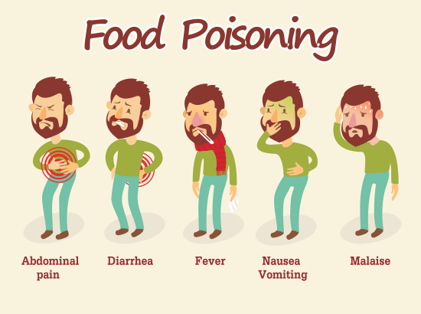
Listen to the news these days and, more often than we’d care to hear, some food product is being recalled by the manufacturer due to the possibility of contamination by bacteria. Contaminated food is the cause of food poisoning and the most frequent bacterial contaminants are E. coli, the abbreviation for the full scientific name Escherichia coli, and Salmonella. The bacteria name of Salmonella is the straight line behind old jokes about eating at Sam and Ella’s café.
Food poisoning is a serious illness, especially for children and the elderly. While mild food poisoning caused by ingesting just a small amount of bacteria results in an upset stomach and a bit of diarrhoea, a severe case of food poisoning also includes abdominal cramps and vomiting.
Once the bacteria multiply in a person’s body, the individual gets sicker and prolonged vomiting and diarrhoea result in dehydration, a life-threatening condition, and the loss of critical tissue salts. Individuals usually require hospitalisation, intravenous (I-V) fluids and antibiotics. Food poisoning can be fatal; the news will report the number of fatalities associated with an outbreak of food poisoning. The bacteria that cause food poisoning naturally live with farm animals without causing any harm. The possibility of food poisoning from Salmonella inside eggs has risen in the past decades. Researchers have discovered that hens are transmitting the bacteria to their eggs, which did not occur as often in the past. If meat, poultry and eggs are not properly refrigerated and cooked thoroughly enough to kill existing bacteria, live bacteria enter the human body when the food is ingested.
Humans rely on certain helpful strains of E. coli bacteria living in the intestines to maintain a healthy digestive system. However, harmful animal strains of E. coli cause illness when they reach the human intestinal tract and multiply. These harmful bacteria lodge in the human intestinal wall, attaching to human cells with their special surface proteins. The capsule-shaped bacteria also secrete a poison and damage the cells to which they are attached. Bloody diarrhoea results as the affected intestinal cells die.

Preventing Food Poisoning.
Food poisoning can be prevented in the following ways;
- Carefully wash your hands often, and always before cooking or cleaning. Always wash them again after touching raw meat.
- Clean dishes and utensils that have had any contact with raw meat, poultry, fish, or eggs.
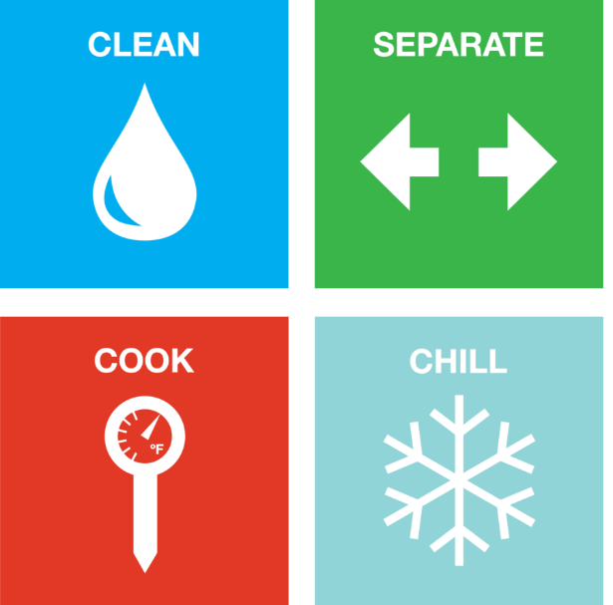
- Use a thermometer when cooking. Food should be cooked and hold a temperature of at least 72c for 2 minutes.
- DO NOT place cooked meat or fish back onto the same plate or container that held the raw meat, unless the container has been completely washed.
- Refrigerate any perishable food or leftovers within 2 hours. Keep the refrigerator set between 0 and 5 degrees and your freezer at or below 0°F (-18°C). DO NOT eat meat, poultry, or fish that has been refrigerated uncooked for longer than 1 to 2 days.
- Cook frozen foods for the full time recommended on the package.
________________________________________________________________
Your Task
On a sheet of lined paper, you will now need to answer and complete the following tasks/questions. This needs to be done neatly and in full sentences, please also write out the question before you answer.

- There are several words in the above article that have been highlighted in red, these are key words; you will need to define these words.
- What causes food poisoning?
- Explain the symptoms of food poisoning?
- What could be a consequence of severe food poisoning?
- According to the article there has been a recent rise in the threat of food poisoning from which item and why?
- What are the different types of bacteria that causes food poisoning?
- Explain the best way of preventing of food poisoning.
- A single cell of bacteria splits into two every 20 minutes. This is a process called binary fusion. The table below contains a series of times; you need to calculate how many bacteria cells would be present at each point.
Copy and complete the table onto your paper.
0 minutes |  | 5 hours
1 hour |  | 5 hours 40 minutes
1 hour 40 minutes |  | 7 hours 20 minutes
3 hours 20 minutes |  | 8 hours

- On a sheet of plain paper, design a sticker that could be stuck onto fridges in a professional kitchen to warn and advise people about food poisoning.

