St Mary’s Catholic School
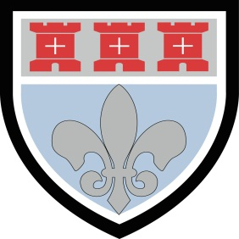

EDEXCEL BTEC Tech Award Health & Social Care

Component 1:

Human Lifespan Development

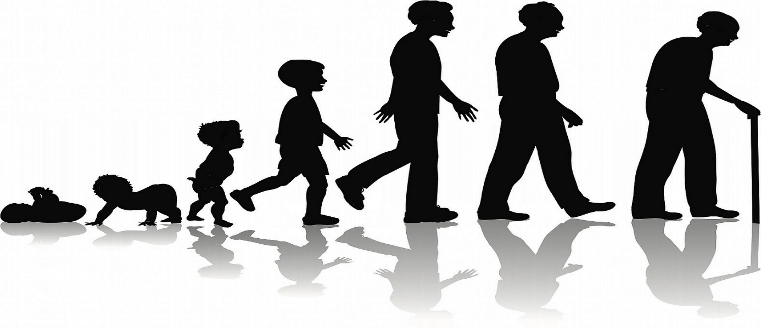

Sept 2016 – June 2017

NQF Level: 2 GLH: 30 Unit type: Core Assessment type: External

Candidate: ___________________________ Candidate Number: ___________________
Teacher: Mrs Rutherford
Introduction
This component provides you with the opportunity to explore how we grow and develop throughout our lives, and to investigate the factors that affect this growth and development. You will go on to consider how these factors are interrelated.

There are four distinct aspects to human growth and development, usually classified as physical, intellectual, emotional and social development. These four aspects are closely related to each other, and a change in one can affect some, or all, of the other areas.

Life events have an impact on how we grow and develop. People experience many different types of life events; some are expected and some are unexpected. Being able to manage and handle these events is an important skill in health and social care professions. In this unit you will explore the impact of these life events and the types of support available to help people manage them. Understanding and recognising the impact of these major life events is an important part of a number of roles in the health and social care sector.

In this component, you will gain an understanding of lifespan development, which is essential when working in health and social care, as you will be able to appreciate the care needs of individuals at different life stages. This understanding is required for a wide range of health and social care roles including nursing, social work, occupational therapy, physiotherapy and dieticians.

In this unit you will:

- Explore human growth and development across life stages

- Investigate factors that affect human growth and development and how they are interrelated.

Learning aim A:

Explore human growth and development across life stages

- Did you know that there are different life stages people pass through during the life course:

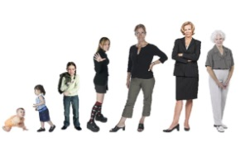
● Infancy (0–2 years)

● Early childhood (3–8 years)

● Adolescence (9–18 years)

● Early adulthood (19–45 years)

● Middle adulthood (46–65 years)

● Later adulthood (65+).

2. You must understand the key aspects of human growth and development at each life stage (Think PIES!):

Physical– physical growth and physiological change across the life stages:

Intellectual - developing thinking and language skills and common activities that promote them.

Emotional- developing feelings about self and others

Social - forming relationships

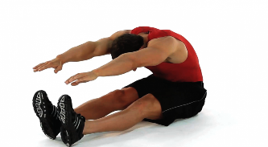

Physical Development

Life Stage | Physical Development
Infancy | - Fine Motor skills begin to develop through infancy. These help to control movement of the hands and fingers. By 4 months - Can grasp objects with whole hand  - Gross motor skills is the ability to control and coordinate the movement of the large limbs of the body. By 8 months – Can start to crawl.18 months – Can climb stairs but often falls. 2 years – Can control big muscles which allows for toilet training.
Early Childhood | - 5 years – independently walk upstairs, hold a pen to draw or write.  - 8 years – can catch or throw quite well and have a good sense of balance, good hand and eye coordination.
Adolescence | - Puberty commences during this stage; this is when there is a release of chemicals called hormones.  - During puberty the hormones cause the sexual and reproductive organs to mature.  - In girls the oestrogen hormone causes the uterus and vagina to grow and ovulation and menstrual periods begin. There will be growth of breast tissue, pubic hair and more fat will be deposited around the hip area.  - In boys the testosterone hormone causes the testes to enlarge and sperm to be produced. It also causes growth of facial hair, increased muscle strength and the voice box deepens.  - Both boys and girls have a rapid increase in height during this time, that is referred to as a ‘growth spurt’.
Early Adulthood | - Reach their peak of physical development.  - This is when an individual is at their physically strongest.  - Towards the end of this period this is when physical capabilities start to diminish and fertility levels also being to fall.  - Sperm count in men also begins to fall towards the end of this life stage.  - At the end of this life stage peoples metabolism begins to fall, they burn fewer calories and can begin to put on weight.
Middle Adulthood | - Physical capabilities start to decline.  - Lower energy levels.  - Skin loses elasticity.  - Hair becomes grey.  - Men can become bald.  - Wrinkles appear.  - Hearing and sight can start to decline.  - During this stage most women go through the menopause. (Age 45-55)  - Symptoms of the menopause are:  - mood swings  -sudden feelings of heat known as ‘hot flushes’  - night sweats,  - hair loss / hair thinning  -difficulty sleeping
Later Adulthood | - Skin is thinner  - Joints are stiffer.  - Muscles are weaker.  - Start to decline in mobility.  - Disease begin to increase such as heart disease, cancers, diabetes and dementia.  - Loss of fine motor skills.  - Loss of sensation.

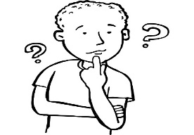

Intellectual Development

Life Stage | Intellectual Development
Infancy | - Babies respond to the world through their senses and communicate mainly through sound.  - Smiles and noises become the main way of communicating with carers.  - Words are formed about the age of 1.  - By 18 months they can say 6 words.  - By 2 years old they can say a simple sentence.  - Babies are egocentric and only see the world from their own viewpoint.
Early Childhood | - Able to speak in full sentences and have a good vocabulary.  - They start school and develop an understanding of numbers.  - They begin to think about things that happen to them.  - They continue to be egocentric.
Adolescence | - Development of abstract thinking. They are able to use concepts and ideas, not just what they can see.  - They can make numerical calculations in their heads.  - Enjoy problem solving.  - Begin to empathise – seeing things from another person’s perspective (not just centred on them).  - Develop their own morals and ideas about what is right and wrong.
Early Adulthood | - Many people carry on education after school.  - Gain new skills and better qualifications to improve their career prospects this is often referred to as ‘lifelong learning’.
Middle Adulthood | - Our ability to learn is not as quick.  - Ability to recall memories gets slower.  - Some adults continue to learn and gain more qualifications.
Later Adulthood | - Speed of thinking and memory decline.  - Some older people may experience dementia.


Emotional Development

 | Emotional Development
Infancy | - During the first two years of life infants bond with those who care for them.  - Between 7 and 12 months’ infants form a strong bond with their main carers and will be very wary of strangers.  - From 12 months’ infants are able to start forming bonds with others. This is known as attachment process.  - It is important that infants receive love and affection during the attachment process as this influences emotional development throughout the future life stages.
Early Childhood | - They begin to learn how to handle their feelings.  - They begin to learn to share and cooperate with others.  - They develop their own self- concept.
Adolescence | - Due to large hormonal changes, teenagers experience mood swings, frustrations, insecurities and confusion.
Early Adulthood | - Develop close and intimate relationships with others, and some choose to marry.  - Some people start a family and enjoy close bonds with their children.
Middle Adulthood | - Due to hormone changes (the menopause) they may experience anxiety or feel depressed.  - Some try to recapture their youth and may start dressing or acting younger, this is often referred to as a ‘midlife crisis’.
Later Adulthood | - They enjoy being with their family and feel content and happy.  - Sometimes they can be distressed, lonely or feel isolated due to loss of loved ones.

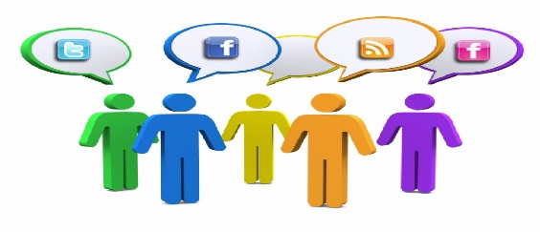
Social Development

 | Social Development
Infancy | - Main relationship they have is with their parent, carer, brothers and sisters.  - A great deal of social learning comes through play.  - Solitary Play 0-2 years play alone using their imagination and do not interact with other children.
Early Childhood | - Begin to widen their social group and form friendships with others.  - Parallel Play 2-3 years – they play alongside each other but not together. Toys are not shared cooperatively.  - Social Play3-8 years – they play with others and share their toys. They will engage in quite complex games.
Adolescence | - Socialise more and have more independence and freedom.  - Greatly influenced by the behaviour and opinions of their peers, this is known as peer group pressure.
Early Adulthood | - Active social life and make lots of new friends.  - Many people get married and have a family.  - Some people struggle to juggle work life, family life and a social life.
Middle Adulthood | - As children have grown up they often have more time on their hands and more money to spend.  - They may travel more and have more quality time with their family.  - Often they will help support with looking after their grandchildren.
Later Adulthood | - Often split into two parts. First 65-75 where they are still very active and have a good social life. The second part is 75+ where they slow down and might not socialise as much.

Learning aim B:

2. You also need to consider the physical factors that affect human growth and development

● Genetic inheritance

Each cell in the body contains 23 pairs of chromosomes. One chromosome from each pair is inherited from your mother and one is inherited from your father. The chromosomes contain the genes you inherit from your parents.

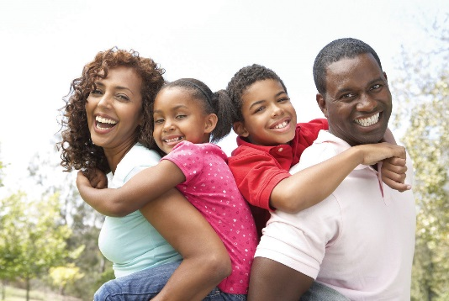
Physical Features:

Children inherit physical features from their parents
such as height: eye colour and facial features.

Some people argue that skills, talents and personality
are also linked to our genes.

Genetic Conditions:
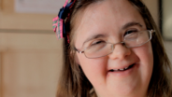
Some people inherit adverse genetic conditions,
which they will live with throughout their life.
Down’s Syndrome is one example of a genetic
condition that can be inherited.

Lifestyle choices:

The lifestyle choices we make in life will impact our growth and development. Such as:
- Diet
- Exercise

- Smoking
- Alcohol
- Drug use

For example, if a person is over-weight this can
affect their risk of joint pain, heart disease,
certain cancers and type 2 diabetes.

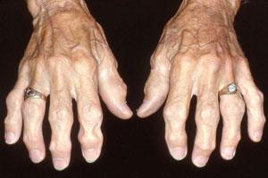
Illness and disease: (general effects on growth and development)

As we age, we can also suffer from degenerative diseases
such as osteoarthritis (inflammation of the joints) that can
impact on how we deal with everyday life.

Environment:
Where we live can impact upon on health and well-being. For example, poor or over crowded housing can lead to ill health such as chest complaints. Individuals can also suffer from mental health issues if they are living in poor housing or if they don’t have access to recreational areas for walking and playing.

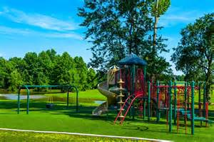



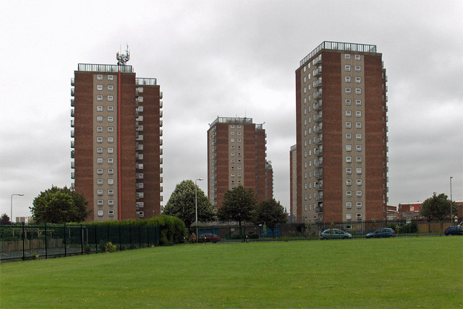



Look at these images. How do you think these environments can affect an individual’s development?

3 Our development is also influenced by social, cultural and emotional factors that affect human growth
and development

Influence of play:
During the first year of life infants tend to play alone. This is called solitary play.
By the age of two most children are involved in parallel play that involves playing alongside other children but not with them. Later they move on to social play, which involves playing with others. This is sometimes called cooperative play. Children at this age like to dress up and learn about the different jobs people have.
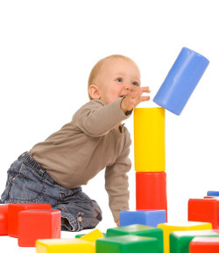

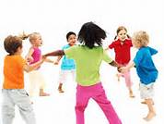
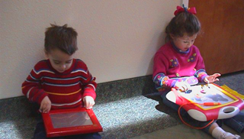

Culture
We develop through the influence of the people we live with and the community that we live in. Religion can greatly influence how we live our life, the food we eat and many life choices that we make.

It is very important that whatever community or family that we are brought up in that we feel accepted, wanted and valued. Unfortunately, sometimes people do not feel accepted or valued because of their lifestyle choice or religious beliefs and this can have a negative impact on their development.


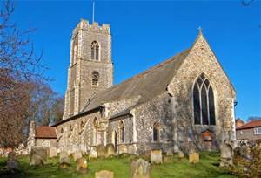


Gender:

In the past there was very separate gender roles for men and women. Traditionally men went out to work and women stayed at home to look after the children. However, this has now changed for many communities, with women going back to work after having a baby and continuing to develop a career. Childcare is now shared with the father, or maybe grandparents and childminders.

Traditionally men in this country were always paid more than women as they were seen as the ‘providers’ for the home. However, due to legislation being introduced the government have aimed to promote equality and pay women fairly. Likewise, there is also a movement not to discriminate women from job opportunities because of their sex. Women are now offered jobs in senior roles or perhaps roles that were not traditionally associated with women; such as fire fighters and even the Prime Minister position.

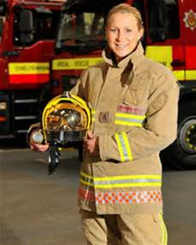
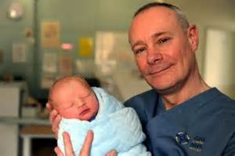

Influence of role models:

As we grow and develop we are influenced by the people around us. These people act as a role model. A role model is someone who’s behaviour or skills we try to copy because we admire them. It is important that children have good role models in their life as this can have a positive effect on how they develop and behave within society. Many teenage boys look to football hero’s as their role model.

Influence of social isolation:

Social isolation can occur when an individual feel that they do not fit in with the rest of their community. This can occur due to differences in their values, religion or even how they dress. Some individuals feel isolated because they have been bullied and have very low self-esteem. They may feel too intimidated to join in with activities or the wider community.

Social isolation can also occur in the elderly because of ill health and poor mobility. As their health declines they are unable to participate with events, and may find it difficult to get out to see their friends and family. Often older people struggle to use modern technology, and are unable to keep in contact through social media methods.

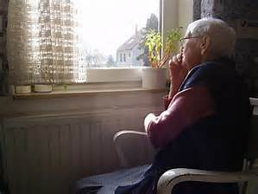

4. Economic factors that affect human growth and development

How the following economic factors can affect human growth and development:

Income/wealth:
Being employed brings an income that allows an individual to buy what is needed for their family. The money gained from working can help an individual and their family to develop physically as they can buy better food, live in good housing, take holidays and engage in social activities such as going to the gym. It also promotes their emotional development as they feel better about themselves, have increased self-esteem and self-image.

Occupation:

People who do manual work requires them to do physical skills such as a brick layer or painter and decorator. People who do non-manual work requires the individual to use their mental skills such as a banker or a teacher. Non-manual workers tend to be paid more than manual workers.

Manual workers can develop physical disabilities and illnesses due to the physical demands of their job. For example, builders are prone to back or joint injuries due to the physical exertion of their job. However, non-manual workers are prone to mental health issues such as stress, due to the demands placed on them to achieve results.

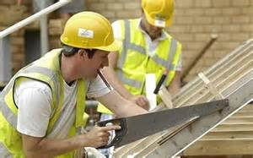

Unemployment / not in education:

Unfortunately, some people are unemployed and unable to find a job to match their skills. This can have a significant impact on their self-esteem and self-image. This can also lead to stress and anxiety as they may not feel that they are contributing to their family or the wider community.

5. Physical environment factors that affect human growth and
Development

Influences of where you live:
Where you live and work can have a significant impact on your development. City centres can be noisy and crowded with many health risks caused by busy roads, noise and air pollution. Research has clearly shown that air pollution is linked to an increased risk of asthma.

Living in rural areas (such as countryside) provides families with more green spaces so children can play outside more and have more freedom. However, getting access to jobs and healthcare services is more difficult in rural areas. This is why young people often choose to move to the city so they have more opportunities for work.

6. Psychological factors that affect human growth and development

How the following psychological factors can affect human growth and development:

Relationships with family members including unconditional acceptance.

Our relationships are often split into three main areas:
- Family
- Friends
- Personal relationships with husband / wife / partners

It is very important that we have support from family and friends to help us deal with the problems we face. It is important that we feel unconditionally accepted and this will help them feel safe and secure.

As we progress into adolescence we begin to be influenced more by our friends. Having a good network of close friends can lead to the development of a good self-image and high self-esteem.


7.The expected life events that can affect human growth and development and the positive and negative effects of the events on growth and development:

As we pass through our life we experience a range of events that will influence our growth and development. This includes:

Expected Life Events:

● starting, being in and leaving education

● moving house/location

● entering and being in employment

● living with a partner/marriage/civil ceremony

● parenthood

● retirement.

Unexpected life events:

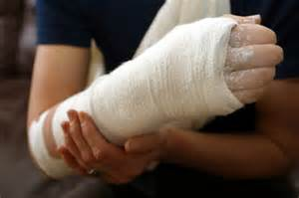
● death of a partner, relative or friend

● accidents and injury, ill health

● exclusion, dropping out of education

● imprisonment

● promotion/redundancy/unemployment.

Understanding how to manage the changes caused by life events:
Managing the changes and challenges we face in life can be difficult. It is important to seek the help of others when needed. The support people can access can be split into two main types.

- Formal Support

Skilled help offered by professionals who have been specially trained to help you deal with issues. People who offered formal support are paid and have lots of experience and knowledge to support individuals. Formal support can be offered by people such as a nurse, doctor, teacher or youth worker.
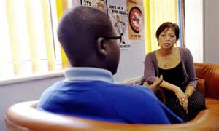

- Informal Support

This comes from the care, support and love from family, friends and peers. They may help you with cooking, cleaning, shopping or just there to listen to your problems. Other forms of informal support may also come from local churches, community groups or voluntary organisations.

Did you know that many children in the UK under 16 years old are informal carers, being the main carer for family members who are housebound or going through a difficult time.
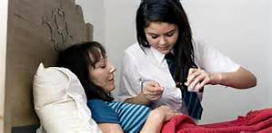

Remember formal support is paid for but informal support is un-paid.

KEY TERMS YOU MUST REMEMBER!
Key Terms | Definition
Gross motor skill | The ability to control and coordinate the movement of the large limbs of the body (arms; legs) e.g. crawling, walking, running
Fine motor skill | The ability to control and coordinate the movements of the hands and fingers e.g. writing; painting; tying shoelaces; holding a spoon/knife/fork.
Language Development | The process that children go through as they learn to communicate with others, using words and speech.
Egocentric | Seeing things from only your own perspective or viewpoint
Bond | To form an attachment with a parent or carer

Key Terms | Definition
Oestrogen | A hormone produced in a woman’s ovaries that  - controls the development of sexual characteristics  - stimulates changes in the reproductive organs
Testosterone | A hormone produced by the testes that controls the development of male sexual characteristics
Abstract thinking | The ability to think about something that might not be there or even exist
Peer group | The social group a person belongs to which influences beliefs and behaviour
Menopause | The natural and permanent stopping of menstruation (periods), occurring usually between the ages of 45-55 years
Mid-life crisis | A dramatic period of self-doubt, caused by the passing of youth and the move into late adulthood
Dementia | An illness that affects the brain and memory and makes you gradually lose the ability to think and behave normally

Key Terms | Definition
Role Model | Someone whose behaviour and/or attitudes people try to copy because they admire them
Gender role | A role that is determined by a person’s gender
Manual work | Work that requires the use of PHYSICAL skills
Non-manual work | Work that depends upon mainly MENTAL (intellectual) skills

