Component 1 Human Lifespan Development
Mrs. Rutherford

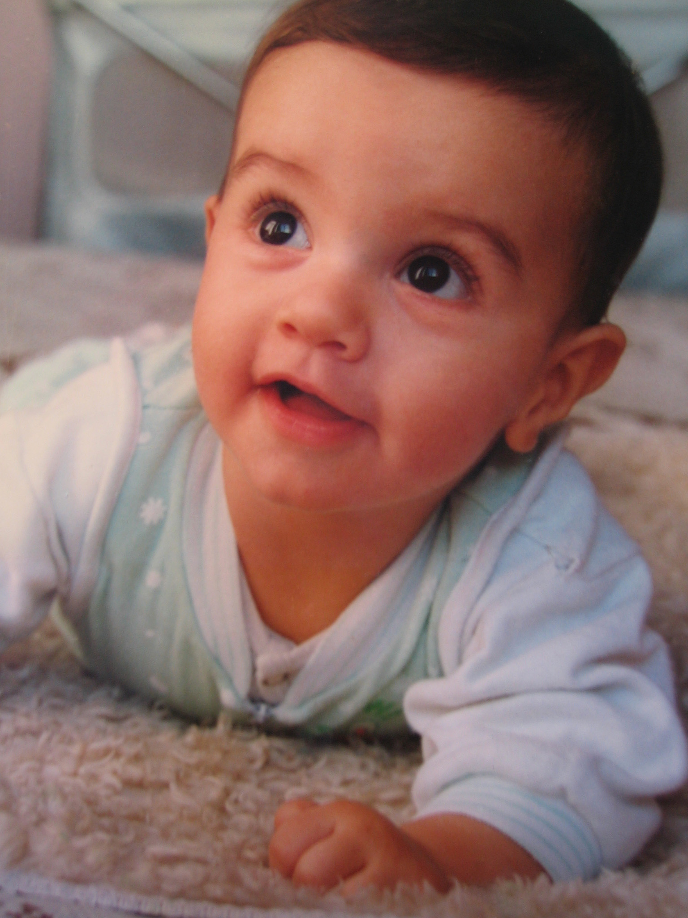
- Describe the term ‘fine motor skill’ and give examples.
____________________________________________________________________________________________________________________________________________________________________________________________________________________________________________________________________________
- Describe the term ‘gross motor skill’ and give examples.
____________________________________________________________________________________________________________________________________________________________________________________________________________________________________________________________________________

- Explain the intellectual development of an infant aged 0-2 years.
_________________________________________________________________________________________________________________________________________________________________________________________________________________________________________________________________________________________________________________________________________________________________________________________________________________________________________________________________________________________________________________________________________________________________________________________________________________________________________________________________________________________________________________________________________________________________

- Why is bonding important for emotional development in infants?
________________________________________________________________________________________________________________________________________________________________________________________________________________________________________________________________________________________________________________________________________________________________________________________________________________________________________________________________________________________________________________________________________________________
- A great deal of social development occurs through play during infancy. Can you give some examples of play activities that would be beneficial for an infant?
___________________________________________________________________________________________________________________________________________________________________________________________________________________________________________________________________________________________________________________________________________________________________________________________________________________________________________________________________________________________________________________________________________________________________________________________________________________________
- Describe what you think each key means in the box provided:

Language Development
Egocentric
Bond
Solitary Play

