Challenge of Natural Hazards Homework Booklet
 | Topic area | Score | Comments | Tick if Target
Natural Hazards | 1.01 Types of Natural hazard.  1.02 Factors affecting hazard risk. |  | Have another look at how natural hazards and events are not the same
Natural Hazards |  |  | Try to give a wider range of examples of hazards
Natural Hazards |  |  | Try to explain your ranking in more detail
Tectonic Hazards | 1.03 Global distribution (where they are) of earthquakes and volcanic eruptions |  | Each layer of the Earth needs a separate fact
Tectonic Hazards |  |  | Correct your definitions/develop them further
Tectonic Hazards |  |  | Give another difference between types of crust
Tectonic Hazards | 1.04 The physical processes taking place at different types of plate boundaries (constructive, destructive and conservative) that lead to earthquakes and volcanic activity. |  | Flow chart must use all key terms
Tectonic Hazards |  |  | Explanation needs more detail – remember we should not be able to write so/why/how on the end of your point
Tectonic Hazards | 1.05 Contrasting tectonic hazard case studies |  | Need to include a wider range of evidence (facts) for each case study as it is too generic e.g. people killed
Tectonic Hazards | 1.06 Reasons why people continue to live in areas at risk from tectonic hazards.  1.07 How monitoring, prediction, protection and planning can reduce the risks from a tectonic hazard. |  | Give a wider range of factors for social / economic / environmental
Tectonic Hazards |  |  | Justify (explain) your points in more detail
Tectonic Hazards |  |  | Give evidence (facts) to support your points
Weather Hazards | 1.08 Global atmospheric circulation.  1.09 Tropical storms – what, where and why. |  | Make sure to use key words more
Weather Hazards |  |  | When describing try to use the names of nearby features e.g. oceans, countries continents and compass bearings e.g. N, S, E, W etc
Weather Hazards |  |  | Try to refer to the characteristics of a tropical storm e.g. temperature of ocean and link this to the UK
Weather Hazards | 1.10 How climate change might affect the distribution, frequency and intensity of tropical storms. |  | Pay attention to the help boxes – they tell you how to work it out
Weather Hazards |  |  | You must use data (numbers) from table to answer the questions
Weather Hazards | 1.11 A case study of a tropical storm Haiyan |  | Take care when calculating data – you have made some silly errors
Weather Hazards | 1.11 A case study of a tropical storm Haiyan |  | Try to refer to the data from the table. How might the GDP of the Philippines impact on the number killed? Number of doctor? Literacy rate?
Weather Hazards | 1.12 Types of weather hazard experienced in the UK – Depressions |  | Make more use of key terms in your answers
Weather Hazards | 1.13 Evidence that weather is becoming more extreme in the UK. 1.14 Extreme weather event in the UK – St Jude storm of 2013 |  | Must use more data from the graph in your response
Weather Hazards |  |  | Case study needs more facts – too generic
Climate Change | 1.15 Evidence for climate change  1.16 Natural and human causes of climate change |  | Remember global warming is a part of climate change – think about this when describing the differences
Climate Change |  |  | Justify (explain) your points in more detail trying to use evidence where possible
Climate Change | 1.17 Managing the impacts of climate change: MITIGATION & ADAPTATION |  | Make sure to use evidence from the graph when describing
Climate Change |  |  | Explain how your actions would help us as a country deal with climate change e.g. how would flood walls help?
Remember to read the relevant pages in your cool geography textbook or on the website BEFORE you do your homework

  - Types of Natural hazard and
  - Factors affecting hazard risk.
- Read pages 2 to 4 of the Challenge of Natural Hazards textbook
- Distinguish between a natural hazard and a natural event
- Try to make a list of the types of hazards the UK could face in the table below;
Tectonic hazards | Geomorphological hazards | Atmospheric hazards | Biological hazards

- Rank the 8 factors that affect the amount of damage created by a hazard from 1, most hazardous, to 8 least hazardous, in the table. Justify your top ranked item and your lowest ranked item.
Factor | Rank (1 to 8)
Natural factors like rock type
Magnitude
Frequency
Population density and distribution
Level of development
Management (prediction, preparation, prevention)
Education
Time

My top ranked factor is because
10
9
8
7
6
5
4
3
2
1
0
My lowest ranked factor is because

  - Global distribution (where they are) of earthquakes and volcanic eruptions
Read pages 5 to 6 of the Challenge of Natural Hazards textbook
- Draw a simple copy of figure 4 then add one fact about each zone of the Earth’s Structure

- Define the terms;
- Tectonic Plate
- Plate margin
- Contrast the characteristics of continental and oceanic crust
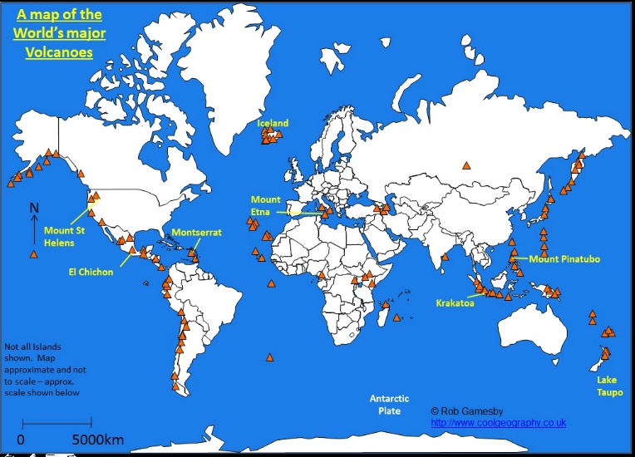
- Make a bullet pointed list of where we get volcanoes around the world. Contrast this with the plate margin map on page 6
10
9
8
7
6
5
4
3
2
1
0

  - The physical processes taking place at different types of plate boundaries (constructive, destructive and conservative) that lead to earthquakes and volcanic activity.
- Read pages 7 to 8 of the Challenge of Natural Hazards textbook
- Complete the flow chart below to explain exactly what happens at Destructive plate margins. Mention subduction, oceanic crust, continental crust, earthquakes and volcanoes in your flow chart.

- Explain why we get earthquakes but not volcanoes at CONSERVATIVE plate margin
10
9
8
7
6
5
4
3
2
1
0

  - Contrasting tectonic hazard case studies
- Read pages 13 to 16 of the Challenge of Natural Hazards textbook
- Complete the case study table to summarise the ESSENTIAL information about the Kobe and Haiti earthquakes;
 |  | Kobe (HIC) | Haϊti (LIC)
Background (where, when, size)
Causes
Effects | Short term
Effects | Long term
Responses | Individuals
Responses | Agencies
Responses | Governments
- Complete the Venn diagram below to compare the similarities and differences between the Haïti and Kobe earthquakes
10
9
8
7
6
5
4
3
2
1
0
Kobe
Haïti

  - Reasons why people continue to live in areas at risk from tectonic hazards and
  - How monitoring, prediction, protection and planning can reduce the risks from a tectonic hazard.

- Read pages 17 to 19 of the Challenge of Natural Hazards textbook
- Classify the reasons people live close to volcanoes into social, economic and environmental factors.
Social Reasons | Economic Reasons | Environmental Reasons

- Is it sensible for people to continue to live in zones with earthquake risks? Fully justify your response using evidence from the 2 pages in the textbook.
10
9
8
7
6
5
4
3
2
1
0

  - Global atmospheric circulation and
  - Tropical storms – what, where and why.
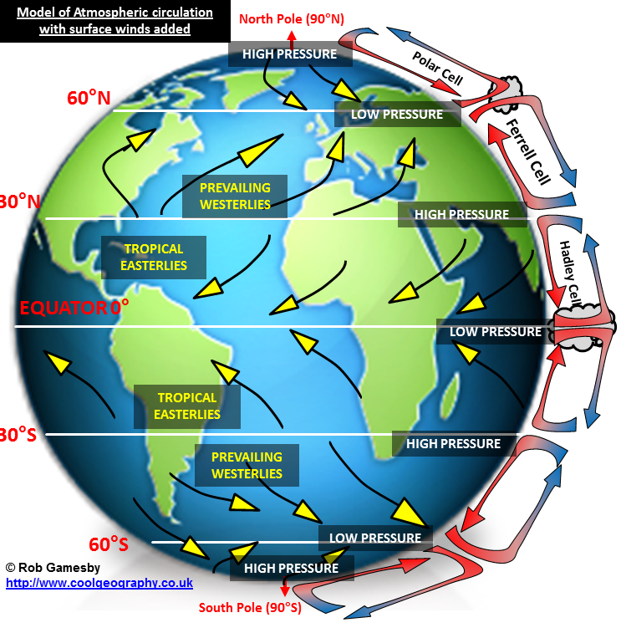
- Read pages 20 to 22 of the Challenge of Natural Hazards textbook
- Describing how air moves within the Hadley cell as shown opposite
- Using the model explain why the UK often gets wet and windy weather
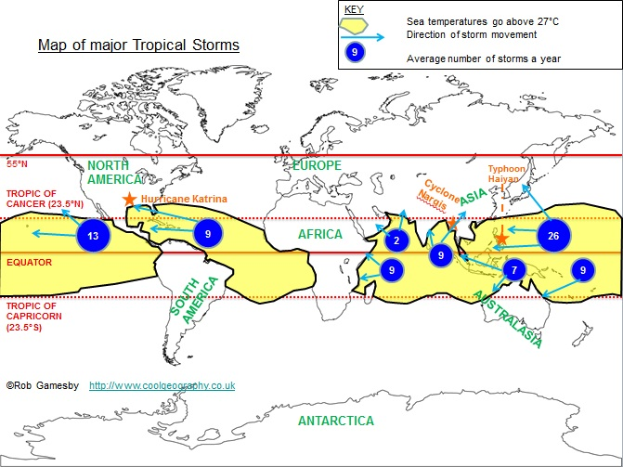
- Describe where tropical storms can be found using the map opposite.
10
9
8
7
6
5
4
3
2
1
0
- Why don’t we get tropical storms in the UK?

  - How climate change might affect the distribution, frequency and intensity of tropical storms.
- Read page 23 of the Challenge of Natural Hazards textbook
Year | Number of moderate to long lived storms adjusted for missing storms | Number of short duration storms
1880-84 | 41 | 3
1885-89 | 64 | 2
1890-94 | 47 | 3
1895-99 | 43 | 3
1900-04 | 43 | 3
1905-09 | 45 | 1
1910-14 | 25 | 3
1915-19 | 42 | 1
1920-24 | 36 | 4
1925-29 | 30 | 3
1930-34 | 54 | 2
1935-39 | 39 | 7
1940-44 | 48 | 4
1945-49 | 44 | 9
MEAN
RANGE
1950-54 | 50 | 6
1955-59 | 37 | 13
1960-64 | 36 | 9
1965-69 | 37 | 12
1970-74 | 35 | 14
1975-79 | 33 | 13
1980-84 | 34 | 12
1985-89 | 36 | 11
1990-94 | 32 | 12
1995-99 | 54 | 12
2000-04 | 54 | 19
2005-08 | 47 | 22
MEAN
RANGE

SKILLS EXERCISE
Hypothesis: Hurricanes in the North Atlantic pose more of a risk between 1950 to 2008 than from 1880 to 1949
- Calculate the mean and range for data opposite. Put the figures in the empty cells in the table.
Help Box
Measures of central tendency
Mean – add all of the values in the column together and divide by the number of results, in the case 15
Range – subtract the smallest value from the largest value.

- Complete the simple bar graph to show the mean and the range for both time periods.

- Respond to the hypothesis: Hurricanes in the North Atlantic pose more of a risk between 1950 to 2008 than from 1880 to 1949. Is this true or false? Use data to support your answer
10
9
8
7
6
5
4
3
2
1
0

  - A case study of a tropical storm Haiyan
- Read pages 24 to 26 of the Challenge of Natural Hazards textbook
- Look carefully at the data on the table below.
- Calculate a percentage difference between the 2 countries in the column provided

Facts about the Philippines & UK (from CIA Fact book 2014)
Indicator | Philippines | UK | Difference (D)  Philippines value – UK value | Average of 2 values (A)  Philippines + UK values divided by 2 | Percentage difference  (D /A) X 100
Population | 108 million | 64 million | 108-64 = 44 | 108+ 64 = 172 = 86  2 2 | (44/86) x 100  0.51X100 = 51%
GDP per capita PPP | $4700 | $37,700
People Living in Poverty (less than $2 per day) | 27% of the population | 16.2%
Life Expectancy | 72 years | 80.4years
Literacy Rate | 48.7% | 99
People Per Doctor | 1.15 doctors per 1000 people | 2.81 doctors per 1000 people

- Using the data and the information in the textbook, why did the Philippines suffer so badly during Typhoon Haiyan?
10
9
8
7
6
5
4
3
2
1
0

  - Types of weather hazard experienced in the UK – Depressions
Read pages 27 to 29 of the Challenge of Natural Hazards textbook
- List all of the extreme weather events that affect the UK that you can think of
- Explain fully how a depression forms.
- Contrast a depression weather system with an anticyclone
10
9
8
7
6
5
4
3
2
1
0
  - Evidence that weather is becoming more extreme in the UK and
10
9
8
7
6
5
4
3
2
1
0
  - Extreme weather event in the UK – St Jude storm of 2013
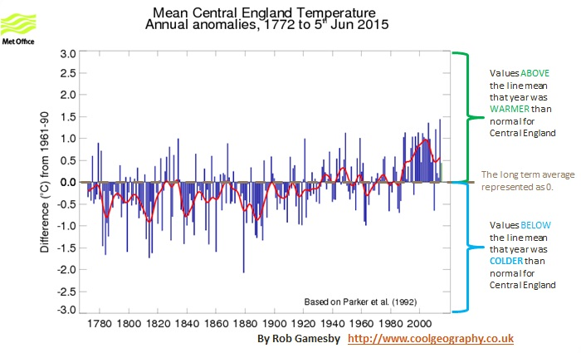
- Read pages 30 to 33 of the Challenge of Natural Hazards textbook
- Look carefully at the graph below. What evidence does it provide for weather in the UK becoming more extreme? Quote figures from the graph in your response.
- Draw then complete the case study table to summarise the ESSENTIAL information about this storm;
Background (where, when, size)
Causes
Effects | Short term
Effects | Long term
Responses | Individuals
Responses | Agencies
Responses | Governments

  - Evidence for climate change and
  - Natural and human causes of climate change
- Read pages 34 to 36 of the Challenge of Natural Hazards textbook
- Distinguish between climate change and global warming
- Rank the causes of global warming in an order of importance. Include both physical and human causes in the table opposite.

Factor | Rank
Physical: Volcanoes
Physical: Sunspots
Physical: Changes in Earth’s orbit
Human: Agriculture
Human: Fossil Fuel use
Human: Deforestation

- Justify your ranking in exercise 2

- Does the evidence suggest that humans or nature is to blame for our changing climate? Justify your view.
10
9
8
7
6
5
4
3
2
1
0

  - Managing the impacts of climate change: MITIGATION & ADAPTATION
Read pages 37 to 42 of the Challenge of Natural Hazards textbook
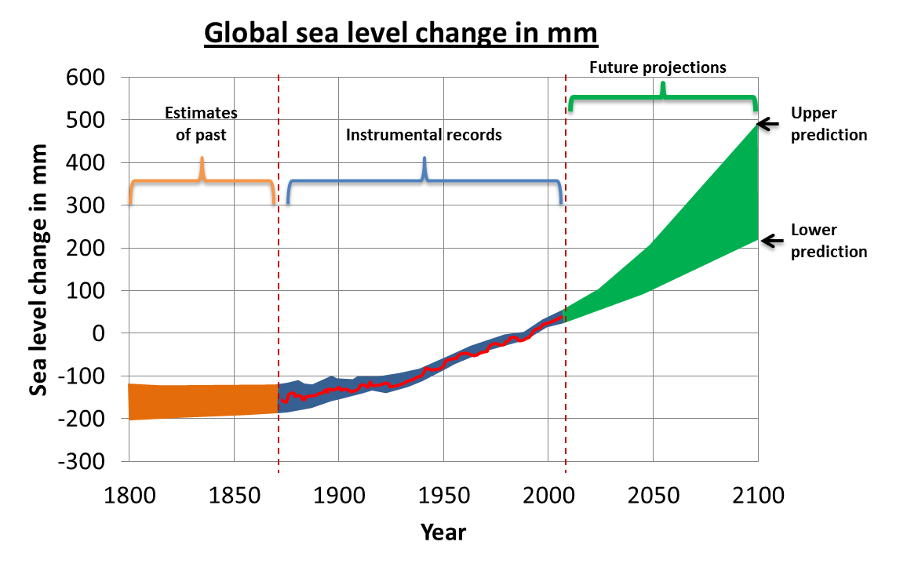
- Describe the changes in sea level predicted on the graph above. Ensure that you include data in your answer.
- Read through all of the options to mitigate and adapt to climate change.
- Produce a clear 4-point plan for the UK government on the KEY things we should do as a country to cope with climate change. Your plan should be in the form of a catchy poster.

10
9
8
7
6
5
4
3
2
1
0

