Worksheet 3: Manufacturing and finishing
Task 1
The two commercially produced benches below are very similar in design however the bench in figure 1 is made from the softwood pine and the bench in figure 2 is made from the hardwood oak.
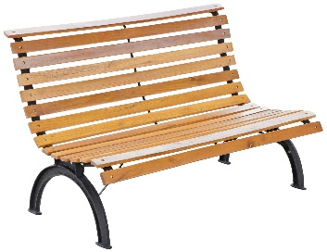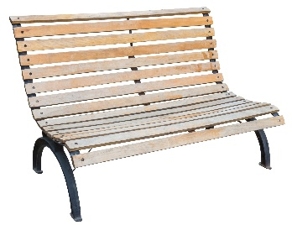
Figure 1 Figure 2
State two advantages of using pine to manufacture this bench?

Name one disadvantage of using pine.

List two advantages of using oak to manufacture this bench?

List one disadvantage of using oak.

Task 2
The billiard table is made from natural timber.
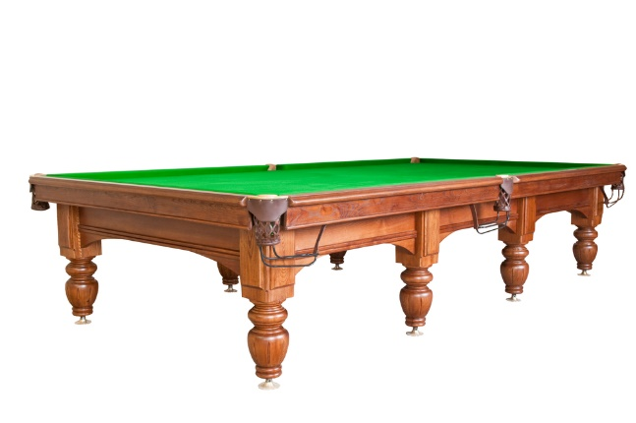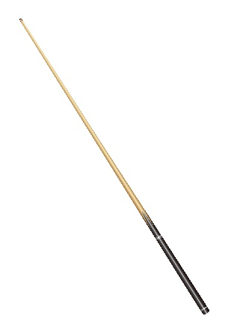
Suggest suitable commercial manufacturing techniques for finishing the detail on the sides of the table, and for producing the legs and the cue.

Reason for choice:

What would be a suitable method of finishing and protecting the table?

Reason for choice:

Extension task
The wooden clock has been commercially made.
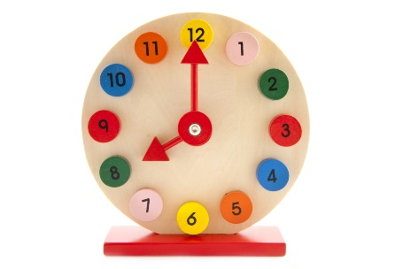
Why do you think that bright colours have been used for the numbers and hands on
this clock?

What are the risks of using paint on a child's toy?

What can the manufacturer do to ensure the clock is safe?

Task 3
Manufactured board is often used in the production of flat pack furniture.
Give two advantages and two disadvantages of using manufactured board instead of a natural timber.
Advantages | Disadvantages

