Worksheet 3: Manufacturing and finishing Answers
Task 1
The two commercially produced benches below are very similar in design however the bench in figure 1 is made from the softwood pine and the bench in figure 2 is made from the hardwood oak.
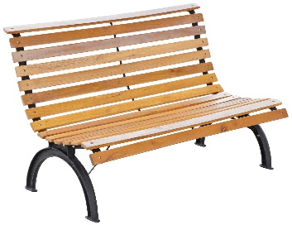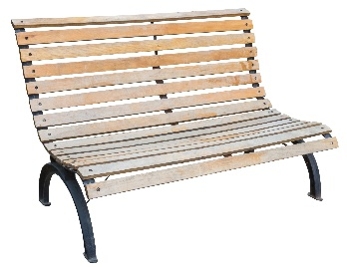
Figure 1 Figure 2
State two advantages of using pine to manufacture this bench?
Advantages: Low cost, readily available, can easily be stained or painted.
Name one disadvantage of using pine.
Disadvantages: Must be finished to protect the timber, less robust than oak, not water resistant.
List two advantages of using oak to manufacture this bench?
Advantages: Hard wearing, aesthetically pleasing, less prone to rotting.
List one disadvantage of using oak.
Disadvantages: Expensive, some types prone to splitting along grain, hardwood can blunt tools more quickly.

Task 2
The billiard table is made from natural timber.
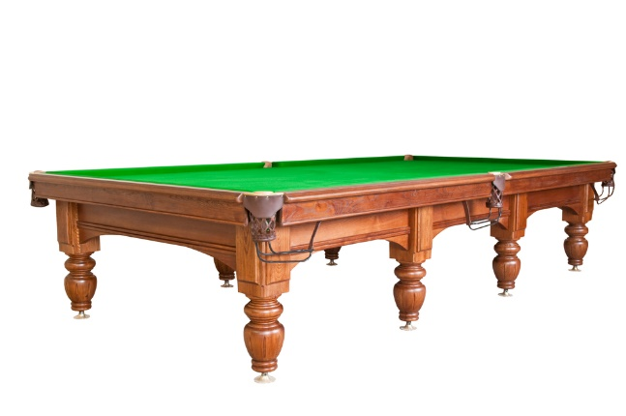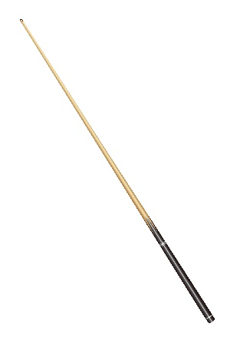
Suggest suitable commercial manufacturing techniques for finishing the detail on sides of the table, and for producing the legs and the cue.
Routing for the detail around the table, turning for the legs and cue.
Reason for choice:
Routers to accommodate large sheets, quick, accurate, incorporate extraction to remove harmful dust.
Lathe (possibly CNC) able to accept large and long sizes of wood.
What would be a suitable method of finishing and protecting the table?
Stain and varnish / lacquer. Bespoke polishes may be applied.

Reason for choice:
Stain to enhance the wood grain, clear varnish, available in gloss or matt finish, for protection.

Extension task
The wooden clock has been commercially made.
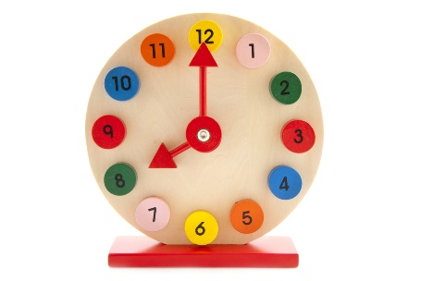
Why do you think that bright colours have been used for the numbers and hands on this clock?
To make the clock appealing, to highlight the numbers, to make the clock more fun.

What are the risks of using paint on a child's toy?
Younger children might chew smaller parts, some paints are toxic.
What can the manufacturer do to ensure the clock is safe?
Ensure all paints are non-toxic, ensure parts are either fixed or not small enough to be swallowed.

Task 3
Manufactured board is often used in the production of flat pack furniture.
Give two advantages and two disadvantages of using manufactured board instead of a natural timber.
Advantages | Disadvantages
Compact for easy transportation | Not as robust
Low cost production | Can chip and break easily
Easy assembly | Easily damaged by moisture
Choice of styles and colours | Self-assembly may be complex

