Homework 3: Manufacturing and finishing

1. Give four advantages to a manufacturer of using CNC machinery to produce a
range of timber based products. [4]

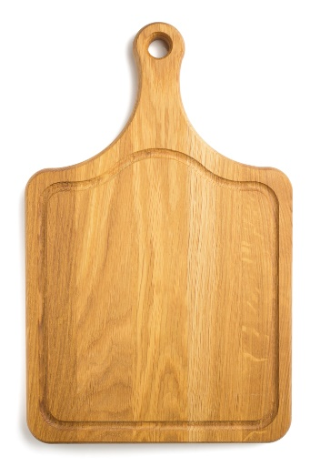
2. A mass produced breadboard has been produced using a CNC router.
(a) Describe two factors that make the board suitable for CNC manufacture. [2]

(b) What quality control measure could a manufacturer use to ensure that all the hole cut in the board is within a specific tolerance? [1]

(c) In the space below, design and annotate a component to explain your answer
to part (b) above. [4]

3. Give two reasons why a manufacturer uses systems to ensure the accuracy
of their products. [2]

4. A company manufacturing children’s furniture wants to extend their range to include high quality educational toys.
Name one suitable material that you would recommend to manufacture the toys from. [1]

6. Which one of the finishes below is not suitable for use on an external window frame? [1]
⬨ Varnish
⬨ Wax
⬨ Paint
⬨ Stain
⬨ Wood preservative

7. When purchasing rough-sawn timber for outdoor use, you may opt to have
tantalised timber.
(a) Explain the process of tanalising. [3]

(b) State two advantages of tanalising timber. [2]

Total 20 marks

