Homework 3: Manufacturing and finishing Answers

1. Give four advantages to a manufacturer of using CNC machinery to produce a
range of timber based products. [4]
CAD software allows them to plan layouts, minimises waste, fast and efficient, accurate, doesn't require a skilled craftsman, cost effective after set up costs are paid off, all processes can be completed in one go.

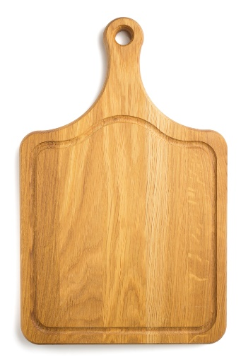
2. A mass produced breadboard has been produced using a CNC router.
(a) Describe two factors that make the board suitable for CNC manufacture. [2]

Identical shaped and sized products are produced in large batches, the board and the hole can be cut in one go and this can be repeated, CNC machine can change its tools to produce each hole, cut or groove, precision is required and CNC routers can run consistently and repetitively.
(b) What quality control measure could a manufacturer use to ensure that all the hole cut in the board is within a specific tolerance? [1]
A go/no go fixture / gauge.
(c) In the space below, design and annotate a component to explain your answer
to part (b) above. [4]
Award marks for the right tool, for pictorial/annotated explanation of use, mention of tolerance/dimensions, care taken over the drawing.

3. Give two reasons why a manufacturer uses systems to ensure the accuracy
of their products. [2]
To ensure consist high quality, to ensure parts fit / work / don’t break. Fewer faulty products. Fewer returns. Improves consumer satisfaction, saves money and waste, increases sales with greater reputation.
4. A company manufacturing children’s furniture wants to extend their range to include high quality educational toys.
Name one suitable material that you would recommend to manufacture the toys from. [1]
Suitable material – Beech or other suitable hardwood.

6. Which one of the finishes below is not suitable for use on an external window frame? [1]
⬨ Varnish
⬧ Wax
⬨ Paint
⬨ Stain
⬨ Wood preservative
7. When purchasing rough-sawn timber for outdoor use, you may opt to have
tantalised timber.
(a) Explain the process of tanalising. [3]
Timber is immersed in a preservative; which is forced into the wood; under high pressure.
(b) State two advantages of tanalising timber. [2]
Helps delay the rotting process; protects against insect / fungal attack.

Total 20 marks

