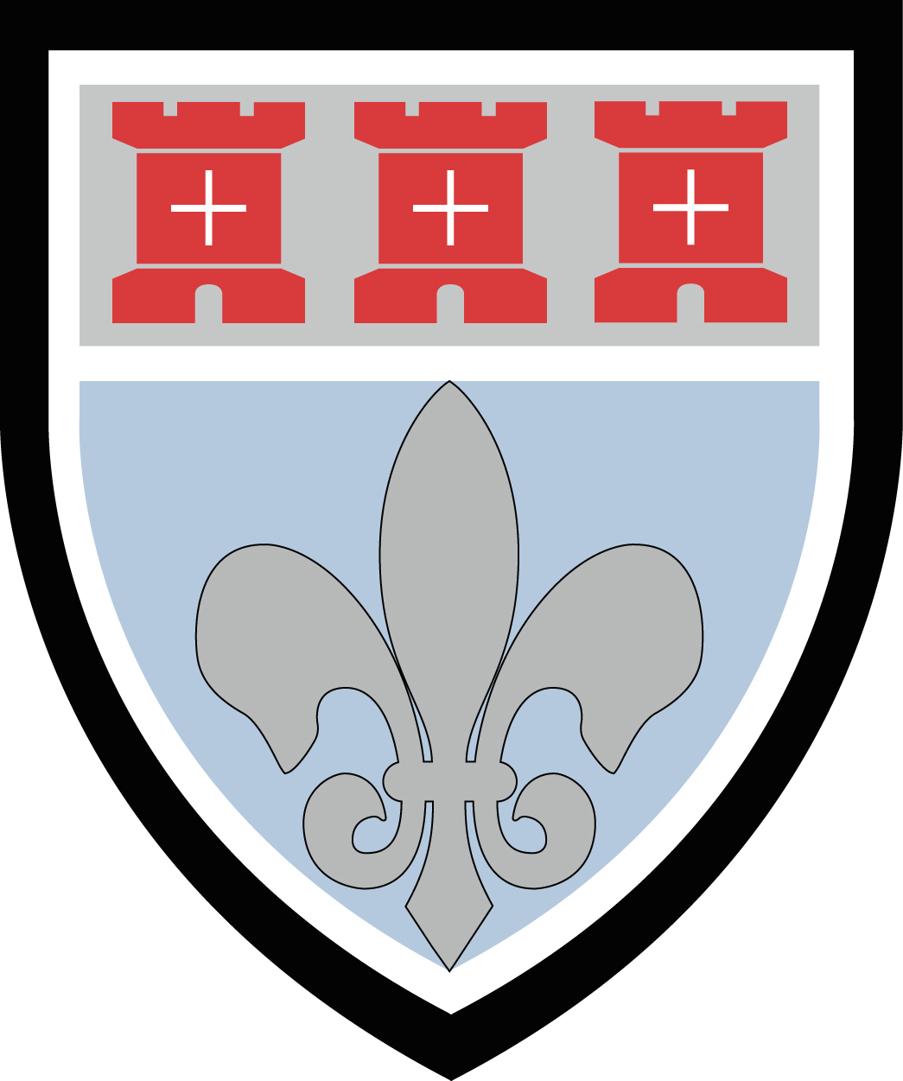
St Mary’s Catholic Sixth Form
Application for Entry 2020: External Students Only
Benton Park Road, Newcastle upon Tyne, NE7 7PE
Your details

Surname |  | Date of Birth
Forename(s) |  | M/F
Home Address  Postcode |  | Home tel
Parent/Guardian (Mr & Mrs/Mr/Mrs/Ms/Dr) |  | Mobile
Parent email
Present school  Postcode | Named school referee & position held  Tel  Email
Did you attend our Open Evening? (Yes or No)

Personal Statement

Please write a statement about your reasons for applying to St Mary’s Sixth Form. This can be handwritten or attached as a word processed document. This should be completed by the student wishing to attend the Sixth Form.

Signature of student | Date
Signature of parent/carer | Date

Please return your form to Mrs McEwan, Key Stage 5 Leader, at the Sixth Form or by email to admin@st-marys.newcastle.sch.uk

What are your predicted GCSE grades?

Subject | Predicted Grade

What subjects would you like to study in the Sixth Form?
Students should pick 3 subjects. Students can only choose one from each of the 4 blocks
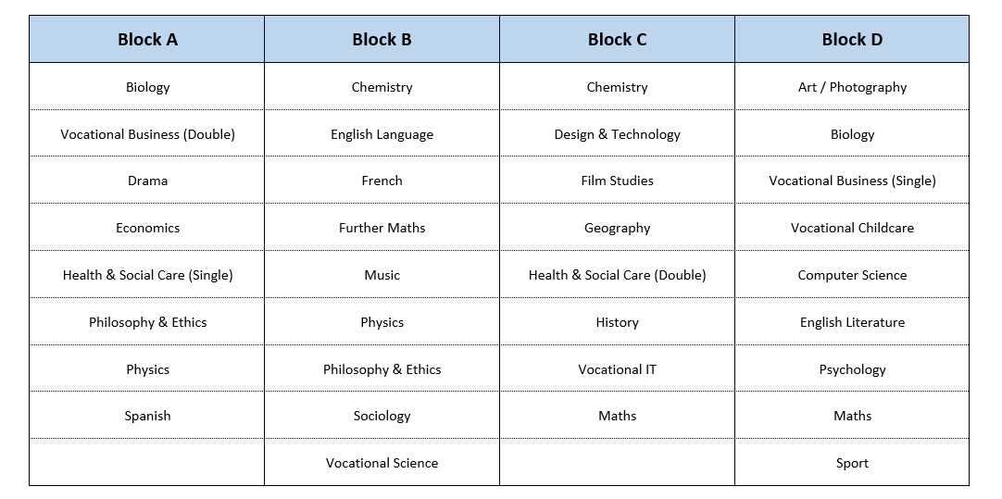

Deadline for Applications is 7th February 2020

