A Level English Language – Summer Work 2019
This work prepares you for the requirement to demonstrate knowledge of new ideas about language.
You must:
- Read the definitions of Prescriptivist and Descriptivist attitudes towards language in the table below.
- Read the New York Times article below featuring David Crystal.
- Answer the question: David Crystal is a descriptivist. What evidence is there for his descriptivist views in the New York Times article? This answer should be 500 words.
Prescriptivism | Descriptivism
….is the practice of elevating one variety or manner of language use over another. It may imply some forms are incorrect, improper, illogical, lack communicative effect, or are of low aesthetic value.  Prescriptivism may address such linguistic aspects as spelling, grammar, semantics, pronunciation, and syntax. It may also include judgments on socially proper and politically correct language use.  Linguistic prescriptivism may aim to establish a standard language, teach what a particular society perceives as a correct form, or advise on effective communication. Prescription might appear resistant to language change. | In the study of language, description or descriptive linguistics is the work of objectively analysing and describing how language is actually used (or how it was used in the past) by a group of people in a speech community.  All scholarly research in linguistics is descriptive; like all other sciences, its aim is to observe the linguistic world as it is, without the bias of preconceived ideas about how it ought to be.  Linguistic description is often contrasted with linguistic prescriptivism.

Period. Full Stop. Point. Whatever It’s Called, It’s Going Out of Style
By DAN BILEFSKYJUNE 9, 2016

“We are at a momentous moment in the history of the full stop,” said David Crystal, who has written more than 100 books on language

One of the oldest forms of punctuation may be dying
The period — the full-stop signal we all learn as children, whose use stretches back at least to the Middle Ages — is gradually being felled in the barrage of instant messaging that has become synonymous with the digital age
So says David Crystal, who has written more than 100 books on language and is a former master of original pronunciation at Shakespeare’s Globe theater in London — a man who understands the power of tradition in language
The conspicuous omission of the period in text messages and in instant messaging on social media, he says, is a product of the punctuation-free staccato sentences favored by millennials — and increasingly their elders — a trend fueled by the freewheeling style of Facebook, WhatsApp and Twitter
“We are at a momentous moment in the history of the full stop,” Professor Crystal, an honorary professor of linguistics at the University of Wales, Bangor, said in an interview after he expounded on his view recently at the Hay Festival in Wales
“In an instant message, it is pretty obvious a sentence has come to an end, and none will have a full stop,” he added “So why use it?”
In fact, the understated period — the punctuation equivalent of stagehands who dress in black to be less conspicuous — may have suddenly taken on meanings all its own
Increasingly, says Professor Crystal, whose books include “Making a Point: The Persnickety Story of English Punctuation,” the period is being deployed as a weapon to show irony, syntactic snark, insincerity, even aggression
If the love of your life just cancelled the candlelit, six-course, home-cooked dinner you have prepared, you are best advised to include a period when you respond “Fine.” to show annoyance
“Fine” or “Fine!,” in contrast, could denote acquiescence or blithe acceptance
“The period now has an emotional charge and has become an emoticon of sorts,” Professor Crystal said “In the 1990s the internet created an ethos of linguistic free love where breaking the rules was encouraged and punctuation was one of the ways this could be done”
Social media sites have only intensified that sense of liberation
Professor Crystal’s observations on the fate of the period are driven in part by frequent visits to high schools across Britain, where he analyzes students’ text messages
Researchers at Binghamton University in New York and Rutgers University in New Jersey have also recently noted the period’s new semantic force
They asked 126 undergraduate students to review 16 exchanges, some in text messages, some in handwritten notes, that had one-word affirmative responses (Okay, Sure, Yeah, Yup) Some had periods, while others did not
Those text message with periods were rated as less sincere, the study found, whereas it made no difference in the notes penned by hand
Geoffrey Nunberg, a linguist who teaches at the University of California, Berkeley, noted that the 140-character limit imposed by Twitter and the reading of messages on a cellphone or hand-held device has repurposed the punctuation mark
“It is not necessary to use a period in a text message, so to make something explicit that is already implicit makes a point of it,” he said “It’s like when you say, ‘I am not going – period’ It’s a mark It can be aggressive It can be emphatic It can mean, ‘I have no more to say’
Can ardent fans of punctuation take heart in any part of the period’s decline? Perhaps.
The shunning of the period, Professor Crystal said, has paradoxically been accompanied by spasms of overpunctuation
“If someone texts, ‘Are you coming to the party?’ the response,” he noted, was increasingly, “Yes, fantastic!!!!!!!!!!!”
But, of course, that exuberance would never be tolerated in a classroom
At the same time, he said he found that British teenagers were increasingly eschewing emoticons and abbreviations such as “LOL” (laughing out loud) or “ROTF” (rolling on the floor) in text messages because they had been adopted by their parents and were therefore considered “uncool”
Now all we need to know is, what’s next to go? The question mark

2. You should:
Read the opening of the Daily Mail article below. Write an entertaining opinion piece for a broadsheet newspaper in which you argue for or against the headteachers’ actions in this case. Your writing should be witty but should also clearly set out your opinion on the matter. This should be around 750 words.

Primary school tells parents to stop children using slang phrases as it is preventing them from learning 'standard' English
Headmistress at Sacred Heart school in Middlesbrough said pupils will suffer in the world of work if they do not learn to adapt their language
By OLIVIA WILLIAMS

Parents have been sent letters from a school urging them to stop their children using phrases such as 'it's nowt' and 'gizit ere'.

Sacred Heart Primary School, a Roman Catholic Voluntary Aided school, warned against 'problem' phrases and criticised children using pronunciations, such as 'free' and 'butta' instead of 'three' and 'butter'.

The letter spells out 11 'incorrect' phrases. 'I done that' and 'I seen that' were blacklisted, and parents were reminded that 'yous' should not be permitted because 'you is never a plural'.
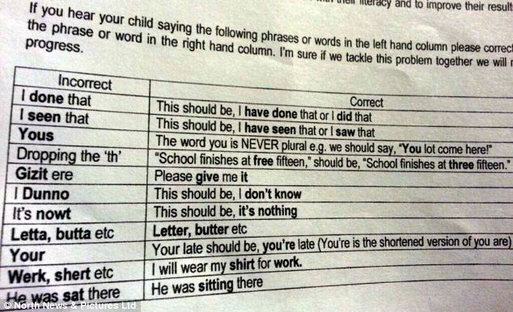
Minding your Ps and Qs: This letter was sent to parents from the Sacred Heart School as part of its clampdown on colloquial terms and Teesside pronunciations

3. You could:
Carry out your own research project on one of the following areas:
- the use of punctuation in digital communication such as texts
- the use of slang
You can collect this data from your own friends and family. You could collect data by transcribing conversations and texts to see what kind of linguistic behaviour is shown amongst your participants. You could also design a questionnaire to explore attitudes towards these linguistic issues. You should summarise your findings and be prepared to share them with your A Level class.

