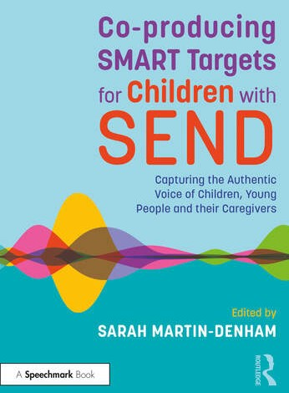
Book Launch
Date: Thursday 7th July Time: 3:30pm - 5:00pm Venue: University of Sunderland, St Peters Campus, downstairs in the
Prospect Building Booking: lynn.carr@sunderland.ac.uk
20% Book Discount Available for attendees Refreshments available

