SENCO Conference
Effecting change
Date: Thursday 7th July Time: 10-3 pm
Venue: University of Sunderland, St Peters Campus and on Teams Booking: lynn.carr@sunderland.ac.uk
Cost: Free

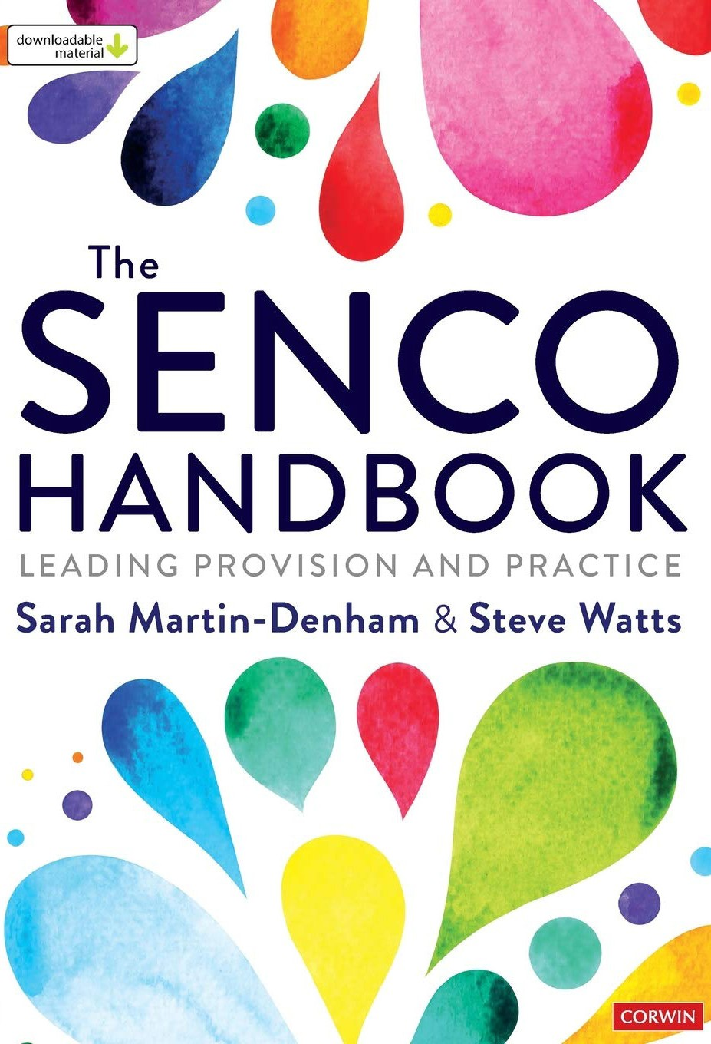
Sarah Martin-Denham: Research findings: Risk and protective factors for school exclusion

Elly Chapple: Effecting change - why do we need to #FlipTheNarrative?

Jane Pickthall (MBE): Graduated response to trauma

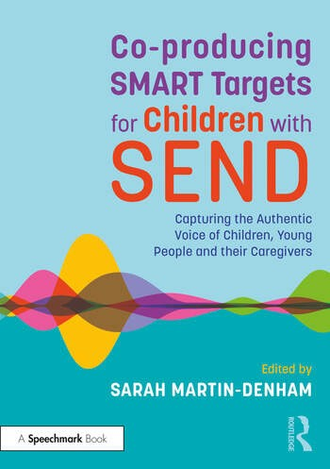
Donna Walker and Denise Taylor: Effecting change through alternative provision

Catherine Landucci: Experiences of a foster carer

Kerrie Whelan and Dominic Gray: Authentic family leadership in schools

