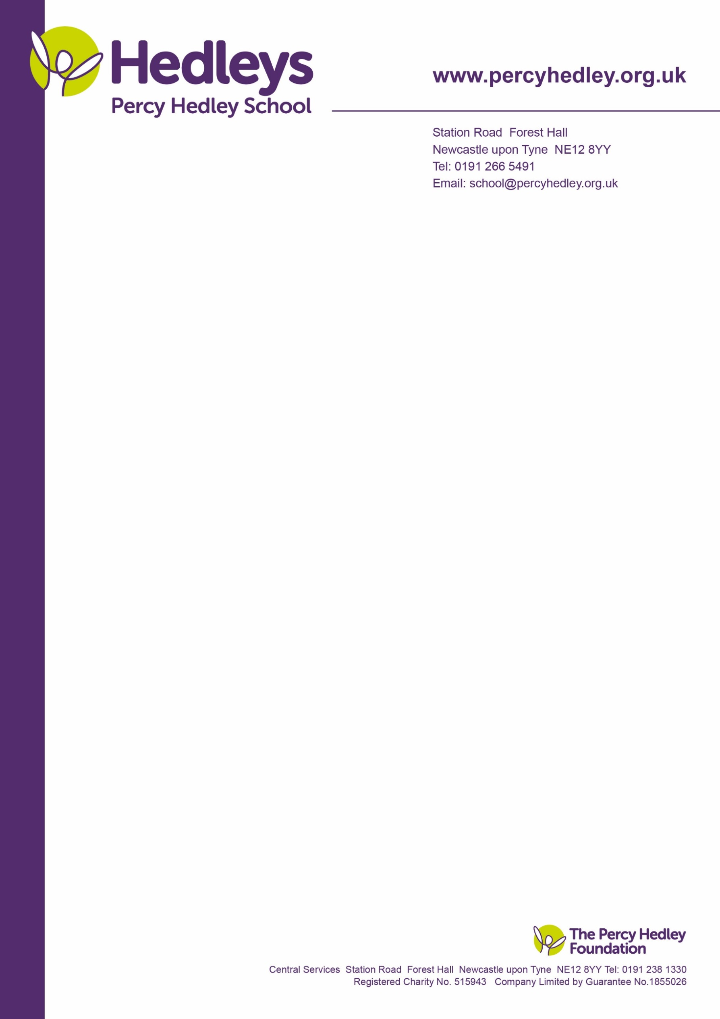

7th November 2022

Dear Parents/Carers

As Remembrance Sunday is drawing closer, school are selling poppies on behalf of the Royal British Legion.

We also have loads of other goodies, which includes rulers, pencils, pens, rubbers, wrist bands, clip-on poppies and bracelets, ranging from 50p to £1 donation.

All money we raise goes towards helping to support the serving and ex-service community and their families.

If you or your child would like to purchase any of the above, please send a donation into school before Friday.

Thank you.

Yours faithfully

**Dr John Steward**

**Headteacher**

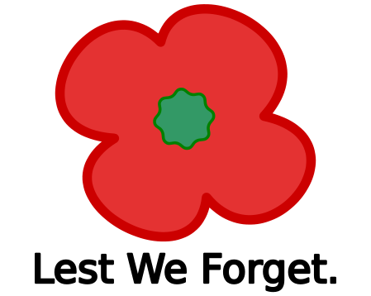

West Lane, Killingworth

Newcastle upon Tyne, NE12 7BH

Tel: 0191 216 1811

Email: school@percyhedley.org.uk