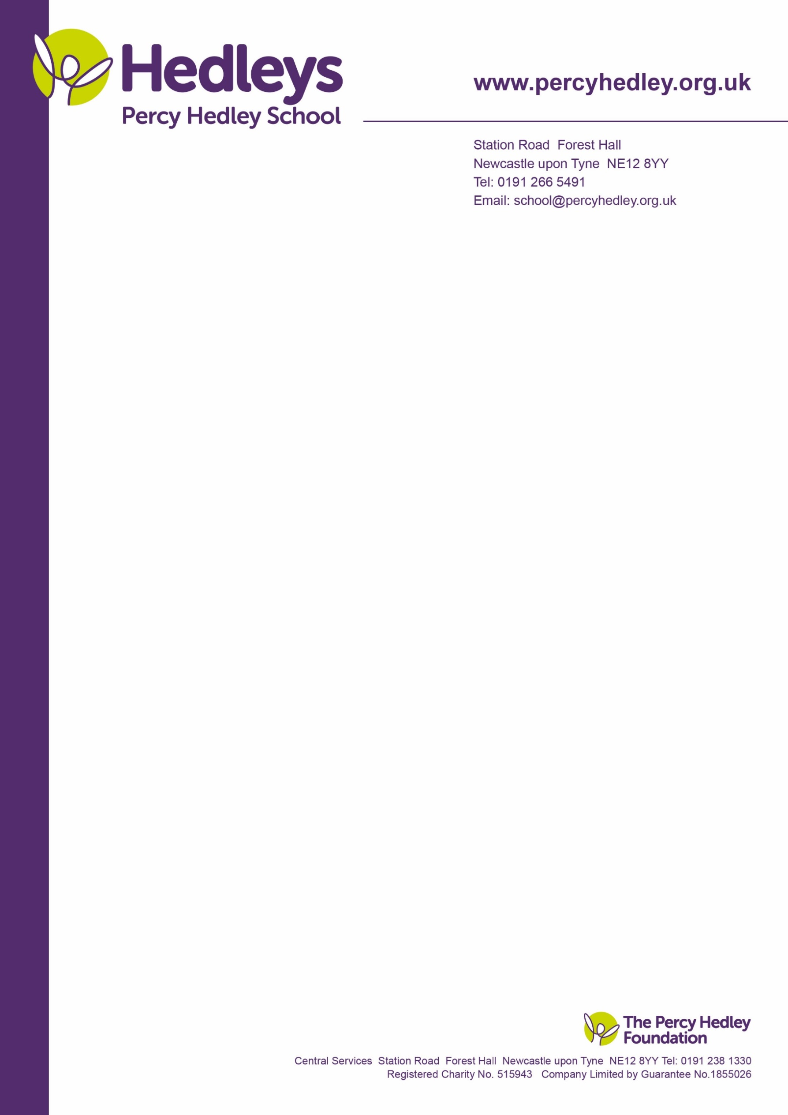

5th October 2022

Dear parent/carer,

We have an opportunity for parents/carers to come into school to make Christmas wreaths with an external florist. This offers parents a nice option to get together to chat and carry out an activity together, without students present. This will be on **Thursday 1st December from 13.30-15.30.**



Numbers are limited to 30, with a minimum uptake of 10 needed for it to go ahead. Cost will be £40, with a deposit of £10 required to book your place. Money will not be paid to school, but to the provider and details of how to pay will be shared with those who plan to join.

We will provide refreshments and mince pies. Let us know in comments if you have food allergies/intolerances.

Please could you complete and return the slip below to me by Monday 17th October

Yours sincerely

Eileen Robinson

Family Liaison Officer

Email: [e.robinson@percyhedley.org.uk](mailto:e.robinson@percyhedley.org.uk)

Telephone: 0191 2161811 ext 3260.

------------------------------------------------------------------------------------------------------------------------------------------------

Please cut on dotted line and return fao E Robinson by Monday 17th October. Alternatively email me.

Names of parent/carers who will be attending:

_______________________________________________________________________________________

Your child/young person’s name and class: ________________________________________________________

Your contact details:

Email:_________________________________________________________

Telephone: ___________________________

Any comments:

West Lane, Killingworth

Newcastle upon Tyne, NE12 7BH

Tel: 0191 216 1811

Email: e.robinson@percyhedley.org.uk