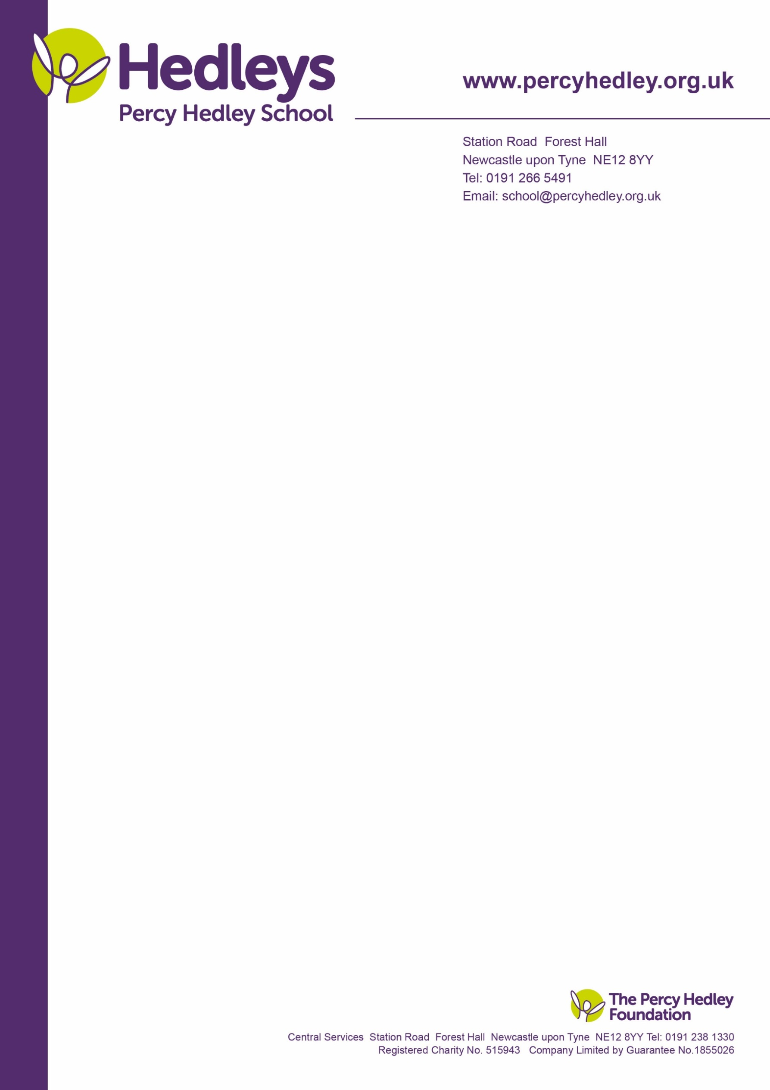

Dear parent/carer,

**Pupil premium and free school meals**

If your child is eligible for ‘free school meals’ and you register them for this, we’ll receive extra funding called ‘pupil premium’. We use this extra money to improve the educational provision and resources at the school.

**What is pupil premium funding?**

Pupil premium funding from the government is given to schools to help pupils reach their full potential, regardless of their background or financial situation. It’s provided for pupils who:

* Are registered for free school meals
* Have been registered for free school meals at any point in the past 6 years
* Are, or have been, in care
* Have parents in the armed forces

At Percy Hedley School we get an extra £1,385 for primary pupils and £985 for secondary pupils who are eligible and registered for free school meals. This extra money could make a real difference to your child when they are in school.

For example, we have been able to use pupil premium to help fund:

* PBS (Positive Behaviour Support). PBS trained staff developing practice across the school. Students, families, and friends are provided with the right support to help people lead a meaningful life and learn new skills without unnecessary restrictions.
* MOVE. Students develop the skills and abilities to gain independent movement.
* Emotional Well-Being and Resilience. The principles of well-being and resilience are fully embedded across all areas of the school and its curriculum.
* Engagement Model: Students working below the standard of the national curriculum assessments access an engagement model with accurate assessment.

**Is my child eligible for free school meals?**

Your child might be eligible if you access:

* Income Support
* Income-based Jobseeker’s Allowance or Employment and Support Allowance
* Support under part VI of the Immigration and Asylum Act 1999
* The guaranteed element of Pension Credit
* Child Tax Credit (provided you’re not also entitled to Working Tax Credit and have an annual gross income of no more than £16,190)
* Working Tax Credit run-on
* Universal Credit, provided you have an annual net earned income not exceeding £7,400 (£616.67 per month)

3rd October 2022

West Lane, Killingworth

Newcastle upon Tyne, NE12 7BH

Tel: 0191 216 1811

Email: e.robinson@percyhedley.org.uk

**Universal infant free school meals**

Currently, pupils in reception, year 1 and year 2 are entitled to a free school meal thanks to a different government funding scheme known as universal infant free school meals (UIFSM). You shouldn’t confuse UIFSM with free schools meals and the pupil premium.

If your child is in reception, year 1 or year 2 and is eligible for free school meals according to the criteria above, you should still register because we’ll receive the extra pupil premium funding.

**Does my child have to eat the free school meals?**

No. Pupils who are registered for free school meals don’t have to eat them. If you’re eligible but you want your child to have packed lunches you should still register because the school will receive the funding which can support your child in other ways. If you are not eligible for free school meals please don’t forget that your child still have access to a free lunch whilst at Percy Hedley School.

**How do I register?**

You only need to register once at the school, if you are already in receipt of free school meals then you do not need to reapply.

To register, please complete the attached form.

**More information**

For more information about pupil premium go to our website, which contains details of how the pupil premium has been spent in the past academic year and how it will be spent this year.

If you have any questions or specific concerns, please contact

Eileen Robinson on 0191 2161811 ext. 3260/ [e.robinson@percyhedley.org.uk](mailto:e.robinson@percyhedley.org.uk) in the first instance.

Best wishes,

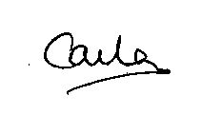

**Carla Maley**

**School Business Manager**



## Application for free school meals

Top of Form

**Your details (the parent or guardian)**

Name (Required)

|  |  |  |  |
| --- | --- | --- | --- |
| First name: |  | Surname: |  |
| Previous surname (if applicable): | |  | |

Below info is required:

|  |  |
| --- | --- |
| Address |  |
| Date of birth |  |
| Email address |  |
| Telephone number |  |
| Mobile number |  |
| Your relationship to child: | Father  Mother  Guardian |
| Have you applied for free school meals before? | Yes  No |

**About your child(ren)**

**Child 1:**

|  |  |  |  |
| --- | --- | --- | --- |
| First name: |  | Surname: |  |
| Date of Birth:: |  | Year Group |  |

**Child 2:**

|  |  |  |  |
| --- | --- | --- | --- |
| First name: |  | Surname: |  |
| Date of Birth:: |  | Year Group |  |

**Child 3:**

|  |  |  |  |
| --- | --- | --- | --- |
| First name: |  | Surname: |  |
| Date of Birth:: |  | Year Group |  |

**Tell us how you qualify for free school meals**

Your child is eligible for free school meals if they are in Key Stage 1 (Reception, Year 1 or 2) or if you are in receipt of any one of the benefits listed below. Please tick all that apply.

Benefit (Required)

We will need to have sight of this benefit for your application to be processed.

* My child is Key Stage 1
* Support under part VI of the Immigration and Asylum Act 1999
* The guaranteed element of Pension Credit *
* Income Support *
* Income-based Jobseeker’s Allowance or Employment and Support Allowance *
* Child Tax Credit (provided you’re not also entitled to Working Tax Credit and have an annual gross income of no more than £16,190) *
* Working Tax Credit run-on *
* Universal Credit, provided you have an annual net earned income not exceeding £7,400 (£616.67 per month) *

*  *For any families eligible for this benefit, you will also be eligible for school holiday vouchers*

**Declaration**

I wish to apply for school meals in respect of the named children. I certify the information I have provided and the benefit I am claiming is correct. I will notify Student Support immediately of any change in circumstances. I agree for you to use the information I have provided to process my claim for free school meals and will contact other sources as allowed by law to verify my initial and ongoing entitlement. I understand that the information contained in this form may be passed to a third party if they are involved in the provision of free school meals.

Bottom of Form

|  |  |
| --- | --- |
| Name: |  |
| Signed |  |
| Date: |  |

**Please return the completed form to the School Office.**