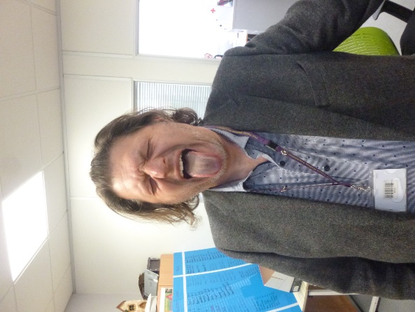 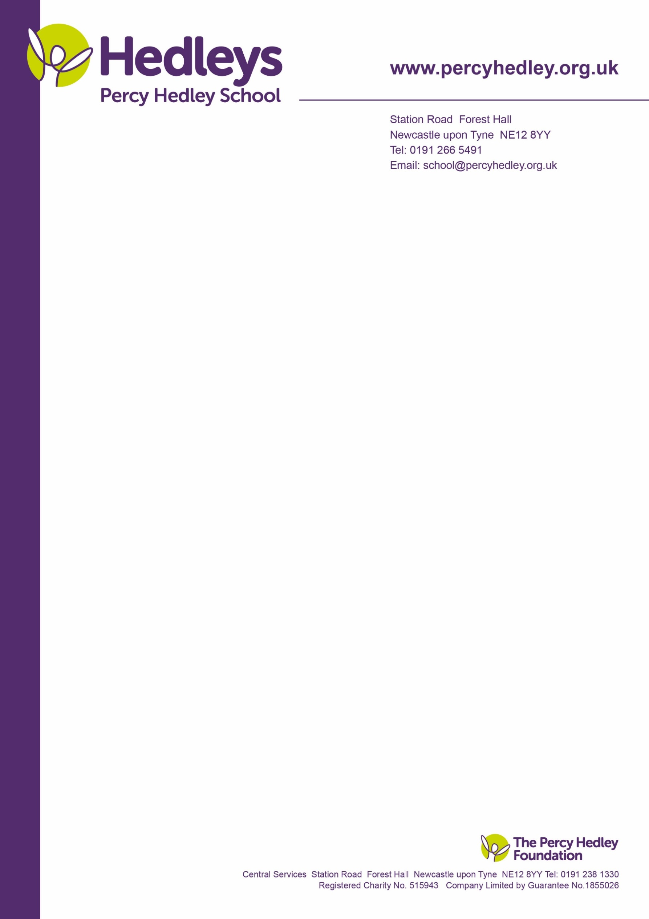

15th March 2022

Dear Parents/ Carers,

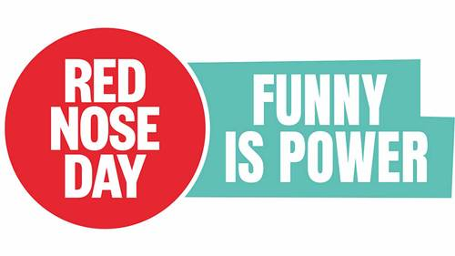 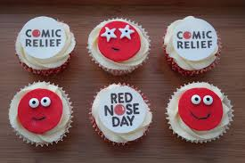

On **Friday 18th March 2022** we will once again be celebrating the cheerful event that is Comic Relief. The lower school (Green Bubble) will be holding a bake sale to raise money and there will be red noses on sale at a cost of £1.50. We invite students to come into school dressed in their most cheerful outfits, wear something red or fancy dress, as always these are optional.

Any **nut free** contributions to the cake sale would also be fantastic and very much appreciated.

Our KS 4 and Post 16 Enterprise students have been busy planning and preparing activities for the day. The students have worked hard to come up with some fun activities that everyone can take part in including Guess how many jellybeans in the jar and baby staff- match the photos to the staff. A voluntary donation of £1 to take part in the activities will go towards the school fundraising effort.

Thank you for all your support. Please contact your child’s class team if you have any questions related to the day.

Sarah Hamlin

ELTBA pathway lead



West Lane, Killingworth

Newcastle upon Tyne, NE12 7BH

Tel: 0191 216 1811

Email: school@percyhedley.org.uk