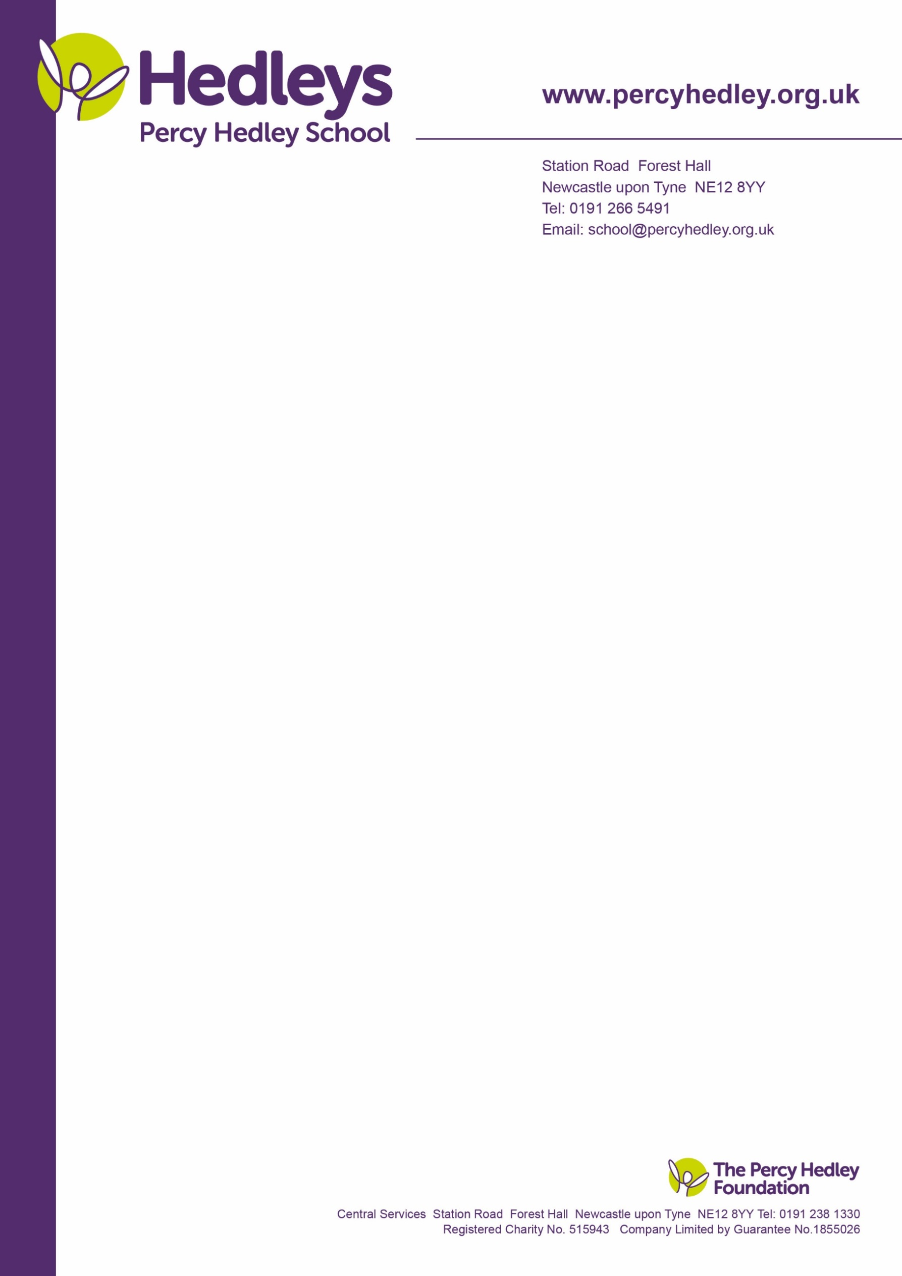

Dear Parent/carers,

After the half term we will once again be celebrating in the cheerful event that is Comic Relief on Friday 18th March. We invite students to come into school dressed in their most cheerful outfits or fancy dress if they so wish.

To add more fun to the day, our KS 4 and Post 16 Enterprise students have been busy planning and preparing activities for the day. The students have worked hard to come up with some fun activities that everyone can take part in. This year we have decided to use a ticket system so that students can take part in more activities whilst contributing to fundraising. You can buy as many sets of tickets as you wish and spend them on the different activities the students have planned!

|  |  |
| --- | --- |
| £1 = 6 tickets to use for the following items; | |
| Sponge the teacher | 3 tickets for 2 throws |
| Baby teachers – match the photos | 6 tickets – prize to be won |
| Lunch time Blind maze challenge (30 minutes) | 6 tickets – prize to be won |
| Guess how many jellybeans in the jar? | 3 tickets – prize to be won |

*Just for fun!*

Best caption wins a prize.

What is John thinking? Send your comedy caption in to enter the competition.

Name:__________________________ Class:_____________

West Lane, Killingworth

Newcastle upon Tyne, NE12 7BH

Tel: 0191 216 1811

Email: school@percyhedley.org.uk

***With cheerful gratitude,***

***The Post 16 Enterprise group***