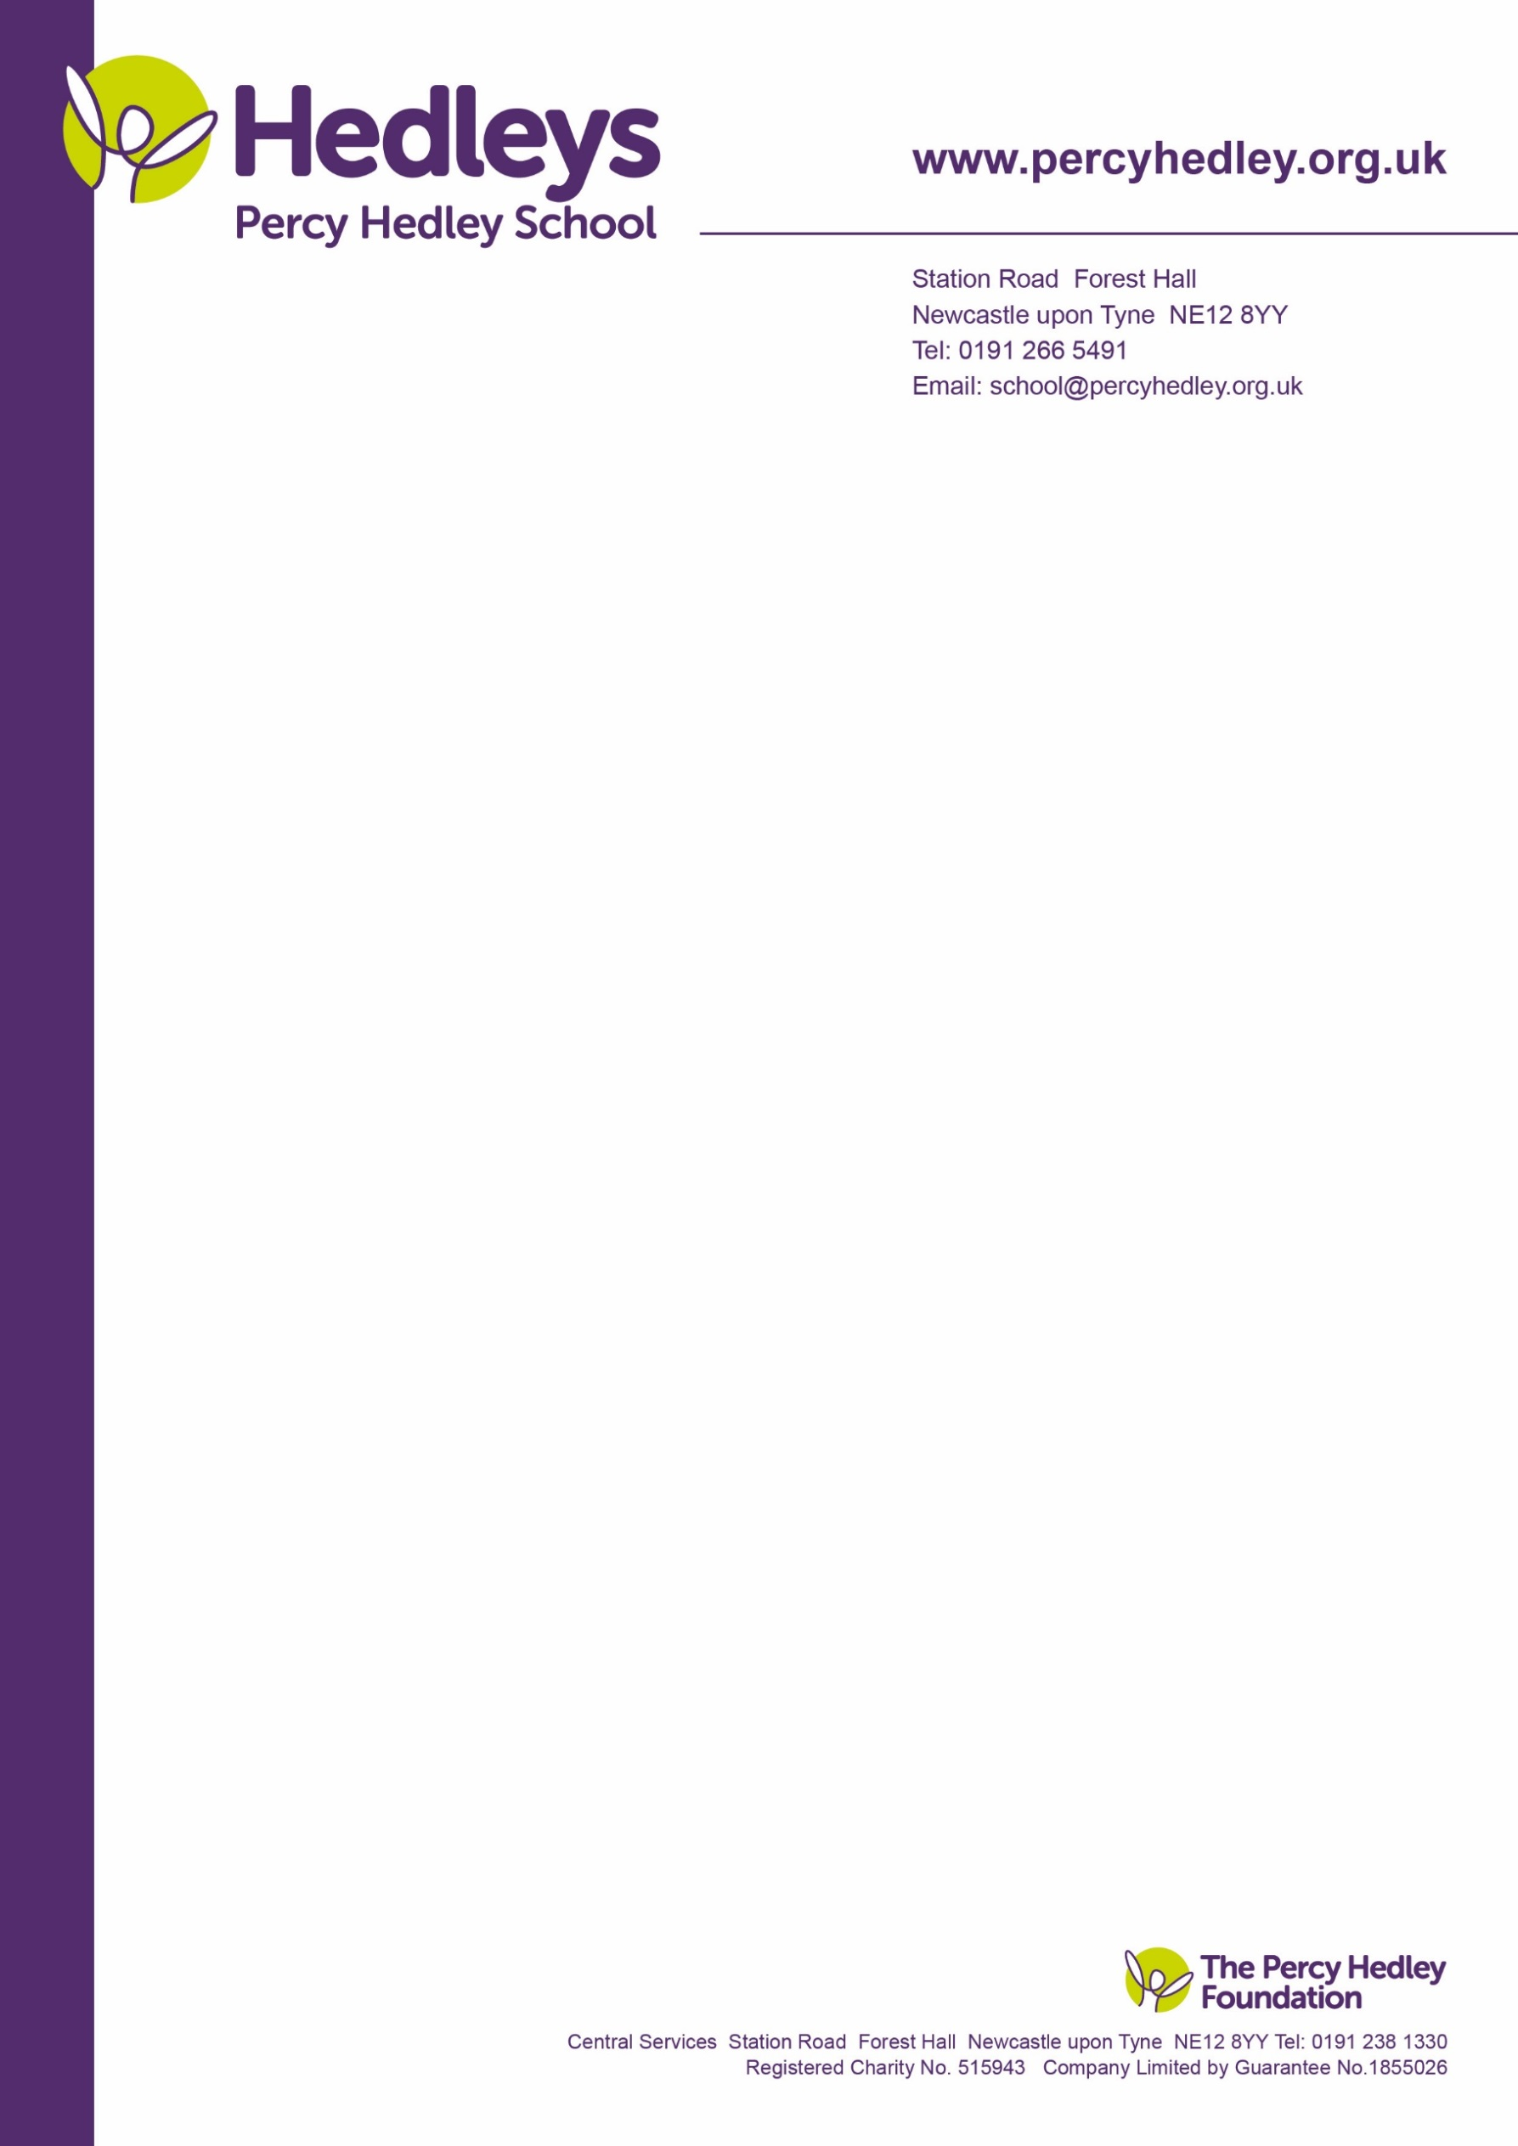

17/02/22

Dear Parents and Carers,

Please find attached a link below to a Teams meeting to be held on Tuesday 1st March at 3.30pm to discuss the residential visit to Keswick. The link will also be sent through the text to parents service.

it.ly/3gRi7pB

The following staff will be attending to answer any questions you may have:

Louise Finlay – Lead Teacher

Linda Clay – Residential visit organiser

Physio

SaLT

OT

Actual attendees TBC.

If you have any questions, please forward them in advance via email and we’ll try our best to answer them all.

Kind Regards.

Louise Finlay

On behalf of the Post16 team

West Lane, Killingworth

Newcastle upon Tyne, NE12 7BH

Tel: 0191 216 1811

Email: school@percyhedley.org.uk