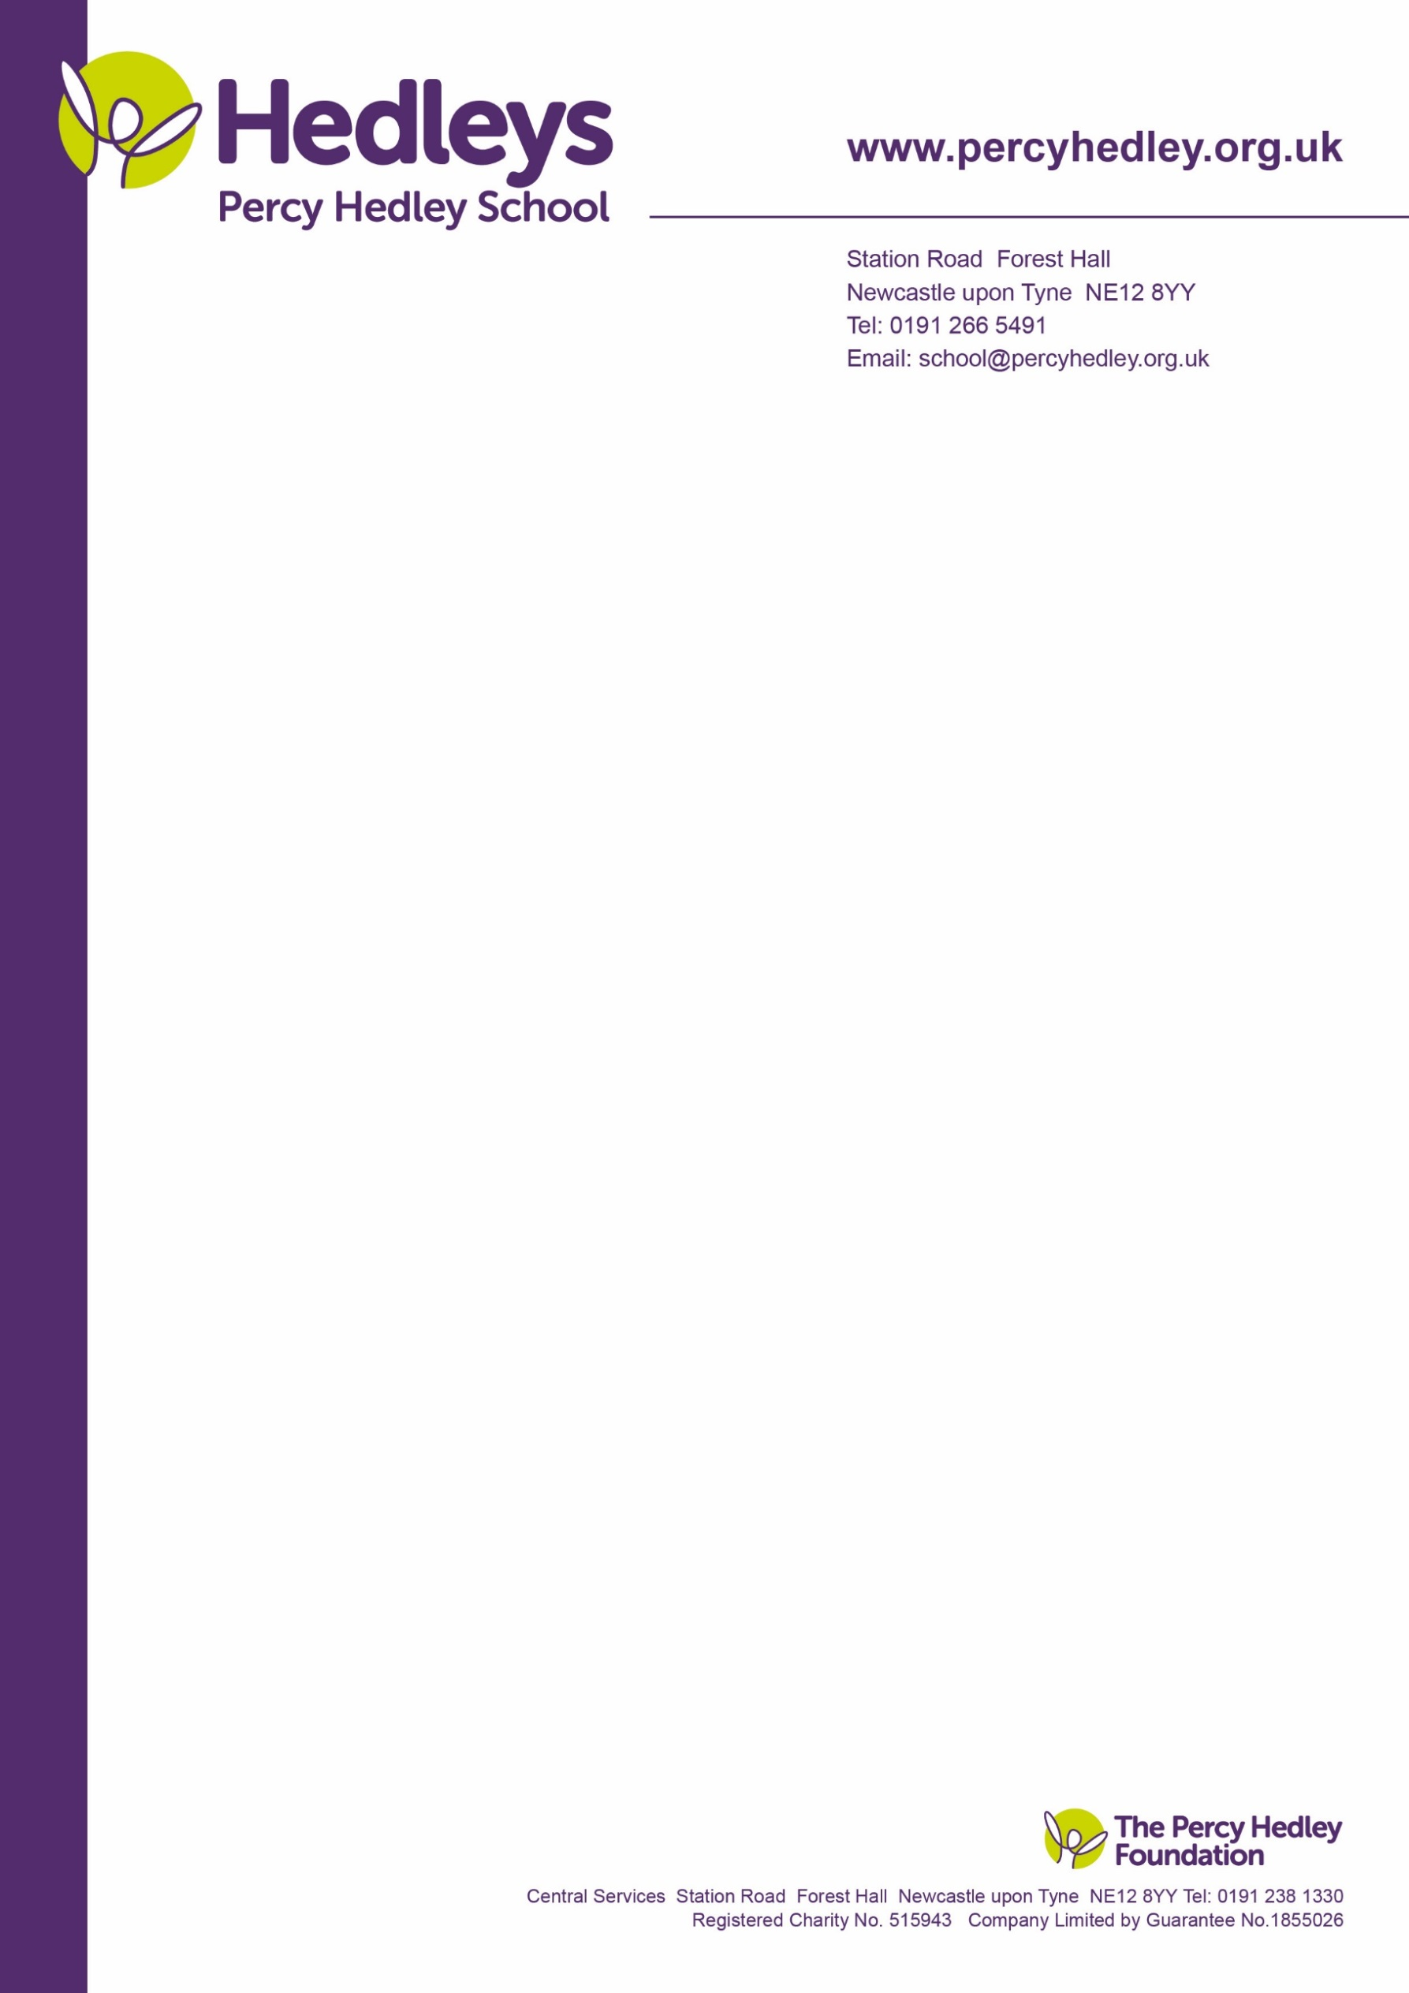
31 January 2022

Dear Parent/Carer,
We would like to invite you to attend the AGM, which will be held on Thursday 10th March 2022 from 13.30-15.00. More information on roles is available on the school website under the heading “Parents and Families”. You will need to log in to access.

The PTA main roles are to:
- foster better relationships between school and home
- raise funds for additional resources, in school events, toys and support the cost of some school trips which are not covered by school fees. These enhance the learning environment and experience for students.
- facilitate communication links between school and home, providing input to specific policies as requested.

Who are the PTA members?
ALL parents, carers and student linked school staff are automatically members of the PTA. Everyone is encouraged to get involved, supporting fund-raising, joining the 100 Club, attending meetings, and sending in suggestions. Meetings are currently held virtually, and the plan is that this will continue alongside face to face when in school meetings resume.
We are required to hold an AGM and elect main committee members once a year. We are members of Parentkind and have adopted their constitution. The committee ensures that the PTA operates in a business-like way and that decisions made consider member views and input.

Why is it important to involve parents/carers in the AGM?
The AGM is an important meeting, where the committee is elected, and accounts are approved. It also provides an opportunity to reflect on the previous year’s activity and plan for the following year. The PTA will best meet it’s objectives with involvement of the wider school/home community, and this does not have to be in person.

Format for the meeting:
The meeting will open at 13.30, with an opportunity to meet the committee and other parents, with business commencing promptly at 14.00 with a formal set agenda. This will include:
- Treasurer’s report: funds raised and how the school has benefitted from these funds.
- Chair’s report; summary of PTA activity and achievements over the past year.
- Election of Officers: Chair, Secretary, Treasurer and Student Liaison Officers. Other committee posts may be filled too.
- Outline of plans for the year ahead.

We would really appreciate your involvement, in whatever capacity possible to make the PTA a success.
- Could any parent/carer who would like to be considered for committee/officer roles please advise us using the slip attached?
- We will facilitate voting by those who are not able to attend meetings; you are required to notify the Chair of your wish to have a postal vote no later than Wednesday 16th February 2022
- Once we have collated information, we will advise members of the candidates and results will be announced at the AGM. If you have not heard from us by Thursday 17th February, you can assume that we have not received multiple volunteers/nominations and election will take place during the AGM.
- Proxy/postal votes will only be necessary should there be more than 1 person nominated for or putting themselves forward for a specific committee role.

PTA

West Lane, Killingworth
Newcastle upon Tyne, NE12 7BH
Tel: 0191 216 1811
Email: school@percyhedley.org.uk

Meetings offer the opportunity to meet other parents and staff, share thoughts and ideas and help the school. However, any matters relating to individual children/young people should, in the first instance be directed to the class team. Without support from families, we will be limited in the support we can offer classes.

We look forward to seeing as many of you as possible on 10th March. In the meantime, please contact Eileen Robinson if you would like additional information about the PTA or what is involved in any of the committee roles. If you prefer to liaise directly with the Chair, her email is below. We are aware of the additional demands on our families, both in terms of distance from school and meeting the needs of their children. Input can be by email, telephone or letter and any suggestions are shared at meetings. A Teams invite will be sent nearer the time.

Yours sincerely

Eileen Robinson. Family Liaison Officer
On behalf of Donna Jones; Chair PTA. Email: Djpercyhedley@gmail.com
Percy Hedley School,
West Lane, Killingworth, Newcastle upon Tyne NE12 7BH
Telephone: 0191 2161811 ext 3260
Email: e.robinson@percyhedley.org.uk
Please return reply slip below FAO Eileen Robinson no later than Wednesday 16th February
-----------------------------------------------------------------------------------------------------------------------------------
I would like to be considered for a committee role (please specify which role) ________________________
I would like a postal vote: (please delete as appropriate) Yes/No
I will be attending the AGM (please delete as appropriate) Yes/No
My contact details including name, email address, child’s name and class:
Name: __________________________________ Telephone number: _________________________
Email address: ________________________ Child’s name and Class:_________________________
Please use comment box below for anything else you would like to share with the committee.

