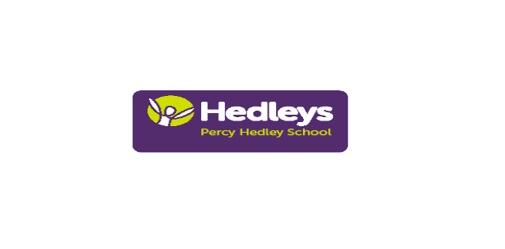PERCY HEDLEY SCHOOL

PTA 100 Club

Percy Hedley PTA 100 Club - £12 per number

CHEQUE/CASH
I would like to subscribe to .............. number(s) for the 2020/21 school year and enclose a cheque/cash for £............ (cheques to Percy Hedley Foundation). If you would prefer a specific number please write this down here.....

Please put your (child’s) name & class on the back of cheque. Send this to: Eileen Robinson PTA to make sure you are included in the draws.

There will be 1 draw each month with 50% of takings go to the winner & 50% to PTA funds. Total cost for the year is £12. These will be drawn at AGM and end of school year

Last year we raised £450 for the PTA. All funds raised by/donated to the PTA are spent on class trips/resources not normally funded by school fees. They benefit all students. If you have friends or family who would like to join, please share this with them. Please email me if you would like additional information or forms. Thank you.
Eileen Robinson. Email: e.robinson@percyhedley.org.uk

N.B: PLEASE ENSURE THAT ANY CHEQUES/CASH ARE HANDED TO A MEMBER OF STAFF BY YOU or your CHILD’S ESCORT & ARE CLEARLY LABELLED.

Signature ................................................ Date.....................................

Name:..................................................................................
Please note name above is what we will use to write winners cheque

Address:......................................................................................................

…………………………………………………………………………….............

…………………………………………………………………………………….

E Mail:.........................................................................................................
Tel no:……………….
Child’s name: …………………………………….. Class: ………

