Family Information blog. 10/09/2021
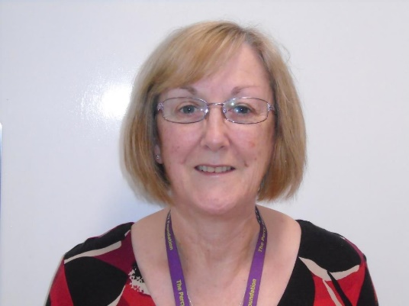
Welcome back:
I would like to introduce myself to our new starter families. I am the Family Liaison Officer and have worked here for 10 years. My 23-year-old son Niall attended this school, then Hedley’s College. He was in the Speech and language side of school. I like to think that this helps me to see things from a parental perspective.
In a nutshell my role is:
To act as a point of contact for families within our school community in need of support, advice and information.
This is a balance between my role in school where I attend and arrange in school events. At present this is difficult as we are still in the midst of a pandemic. You would normally see me at coffee mornings, workshops and PTA meetings. I hope to arrange online workshops in the near future and will share plans with you soon. If there is something you would like covered, please let me know.
I am a point of contact for advice and support for your family on matters external to school including social, activities and workshops.
I can provide some support on DLA, PIP and Universal Credit (work access). I have information on grants and funds. I can also signpost and guide families to charities and agencies who provide support on a range of matters.
Over the next few weeks I will share some of the information I have available and invite families to share what they know with me.
I am sometimes invited to attend meetings by school staff if they feel I can support.
I am also the main point of contact in school for the PTA.
I very much look forward to meeting families face to face, but until this is safe I am open to online ones via Microsoft teams.
My contact details are:
0191 2161811, and email address is e.robinson@percyhedley.org.uk

PTA:
We have an active PTA and a Facebook page.
Our PTA was set up in March 2013 following meetings between interested parents/carers and school staff. Our purpose is to:
- foster better relationships between home and school.
- raise funds for equipment, resources, toys, contribute towards school trips, all of which enhance the learning experience/environment for students. These are extras, not normally funded via school fees.
- facilitate communication links between home & school, involving Parent Governors & providing input, as requested to specific school policies.
- arrange occasional Social events for families.
Meetings are held via Microsoft teams at present, but we hope to resume face to face meetings when it is deemed safe to do so. We will continue to offer an online option to encourage as many families as possible to engage and support. We have a 100 Club, which costs £12 per annum. 50% of takings go to the PTA fund, the remainder is distributed to the winner of the draw. There is 1 draw per month. The link to the subscription form is on the website.
Our preferred method of communication is email. To be added to this list please contact the current chair, Donna Jones via Eileen Robinson on e.robinson@percyhedley.org.uk. Telephone 0191 2161811

The link to the facebook page is: https://www.facebook.com/groups/828431667660413
Please remember to answer the questions as this is a closed group.
Next weekend, on Saturday 18th July we are holding a delayed Summer fayre. We hope to see lots of families there and it promises to be a fun filled day.

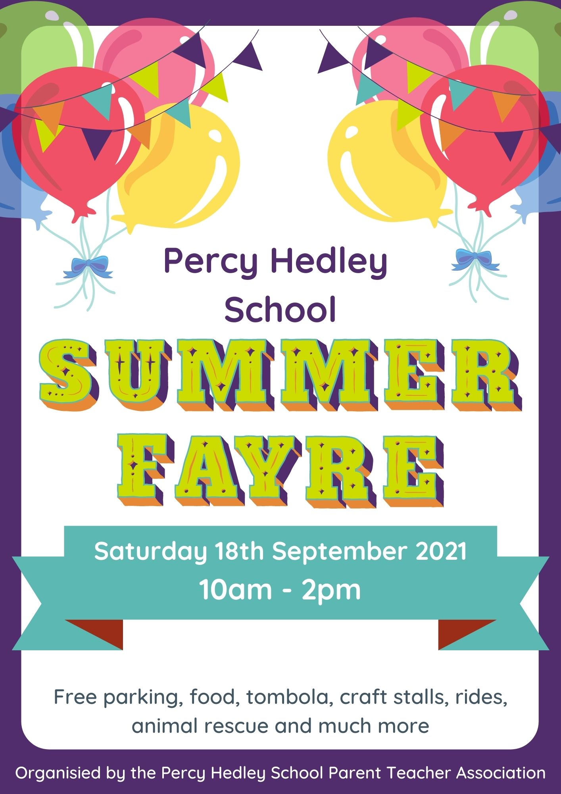

We need your support to make this a huge success and are very much looking forward to seeing families face to face. Thanks to all who have generously sent in donations for the fayre.
Next week, from Wednesday onwards we would appreciate cakes, slices etc to sell at our cake stall.
My lovely husband and daughter are taking on the Great North Run this weekend with all sponsorship coming to the PTA. I would greatly appreciate support to enable them to achieve their target.
Niall and I will be assisting at the charity village, welcoming our runners back so if you are there please drop in and say hello.
The link to their page is below:
http://www.justgiving.com/Richard-Robinson55

