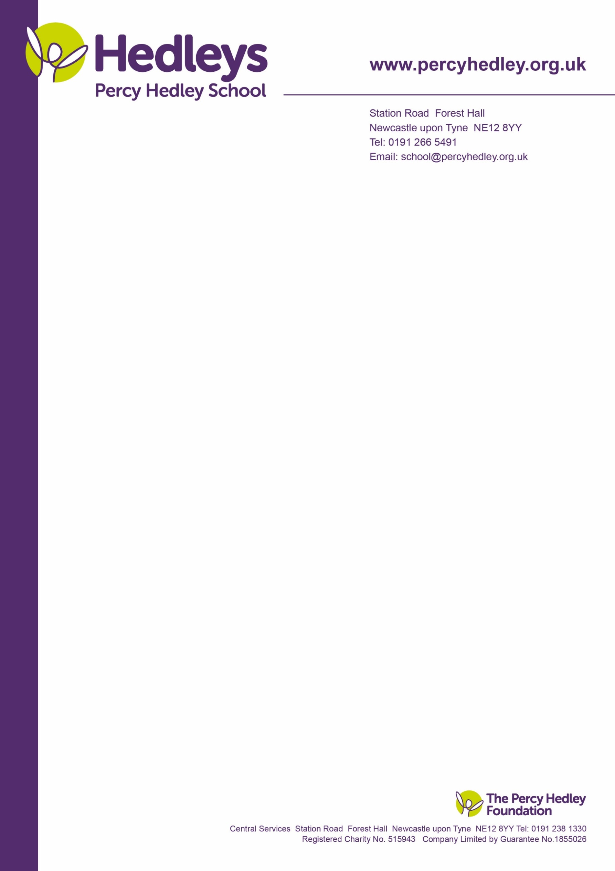

10th March 2021

Dear Parents and Carers

As everyone starts to come back into school and we start gradually doing things we love over the coming months, we thought it would be a nice start to help your son or daughter celebrate mothers day with a cute gift, symbolling new beginnings.

We won’t say anymore, as everyone likes a surprise. We are asking for a contribution of £3 and you can buy more than one if you wish.

Please send money into school on Thursday, so we have sufficient time to put together the gift and follow Covid rules so they can come home with the child on Friday.

All monies raised will go towards PTA funds and help with some future fun filled events.

Yours sincerely

**PTA Team**

**Percy Hedley School**



West Lane, Killingworth

Newcastle upon Tyne, NE12 7BH

Tel: 0191 216 1811

Email: school@percyhedley.org.uk