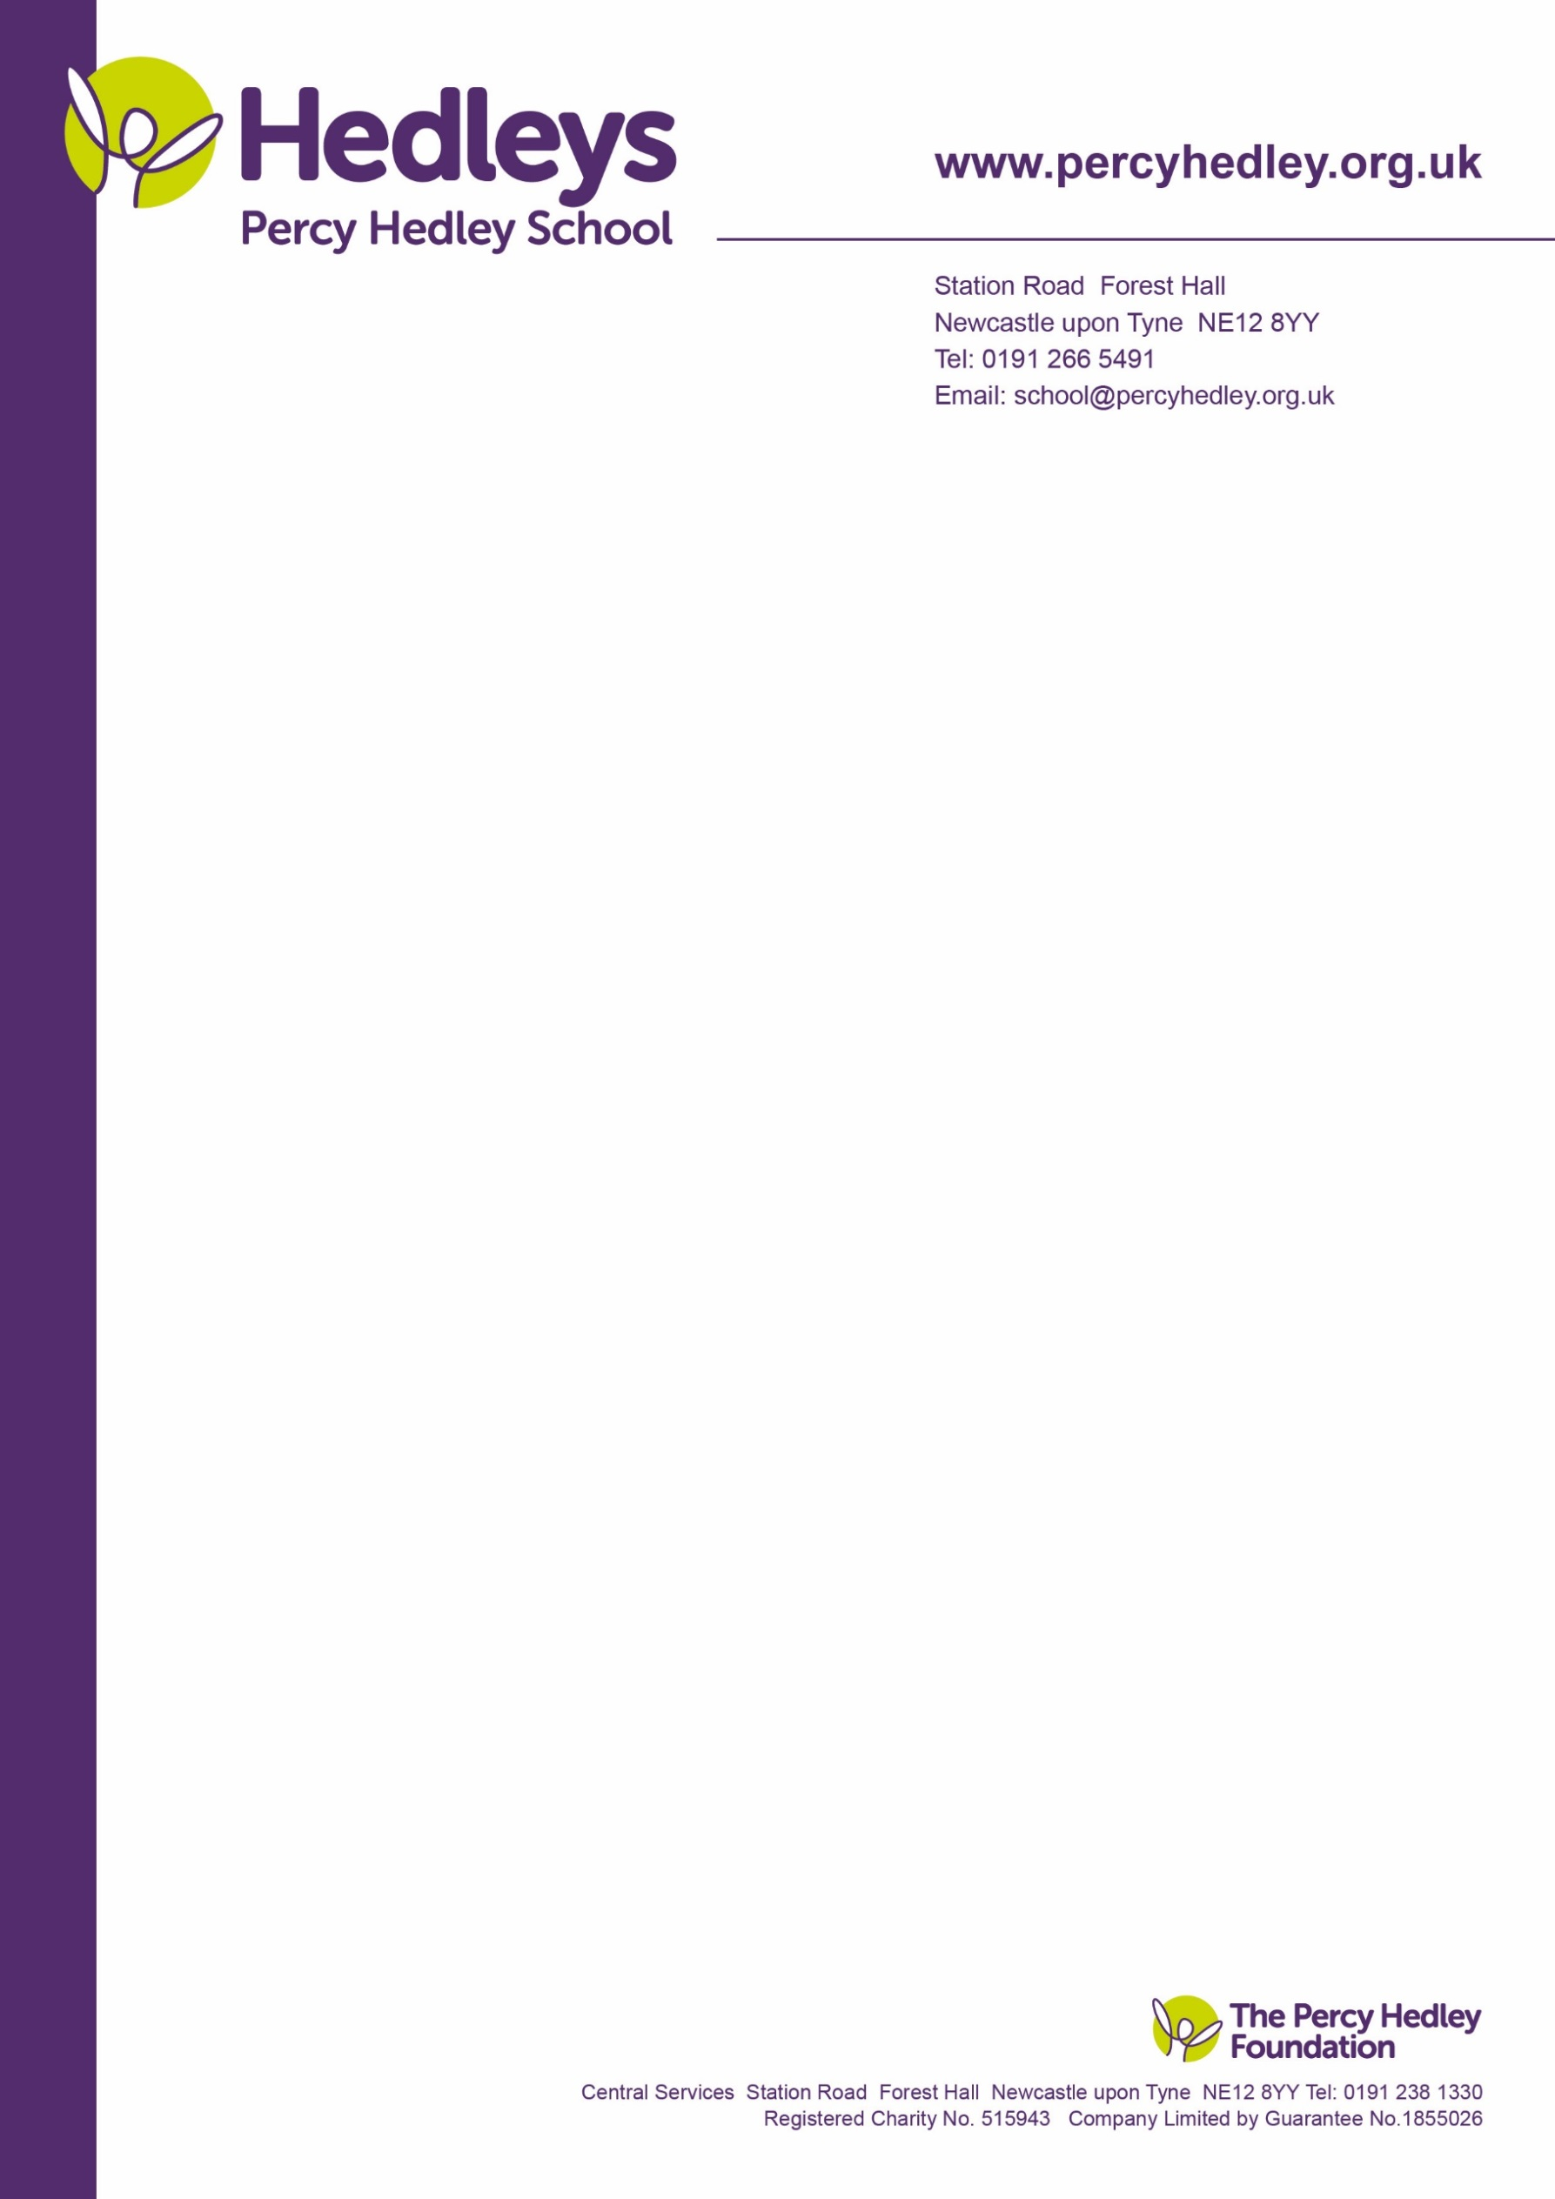

Dear Parent/carer,

We would like to invite you to a workshop many of you requested on:

**Personal Independence Payments** (PIP).This will be held on - **Monday 14th January 2019,** **10-12:00.** Refreshments will be served between 9:30 and 10:00 a.m. with the Workshop commencing at 10:00 a.m. promptly

This will be delivered by Rachael Turnbull, Parent Advisor, Finance and Welfare of Contact-for disabled children.

A minimum of 10 people are required for this to go ahead.

You may park at the drop off/collection point for students on the West Lane site which is located in front of the reception area. This helps reduce congestion on the busy road outside of school.

Please contact me for further information if required. My normal work days are Tuesday and Thursday.

Best wishes

Eileen Robinson

Family Liaison Officer, Family Liaison Officer, Percy Hedley School.

[e.robinson@percyhedley.org.uk](mailto:e.robinson@percyhedley.org.uk)

Telephone: 0191 2161811

Please return for the attention of: **Mrs. E. Robinson by no later than Thursday 19th December 2018** or please email your confirmation to the email address above

Student’s Name: …………………………....Class Group: ………………………………………………..

Parent/Carer(s) Name: ………………………………………………………………………………………

I/we are interested in attending the **PIP workshop** commencing at 10:00 on 14 January 2019. **🖵 Please tick if you are able to attend.**

I/we are interested in attending the **PIP workshop** but are not available on this date but would like to be contacted about any future workshops. **🖵 Please tick if you are unable to attend but would like to be contacted about any future workshops**

Comments:

West Lane, Killingworth

Newcastle upon Tyne, NE12 7BH

Tel: 0191 216 1811

Email: school@percyhedley.org.uk

4 December 2018