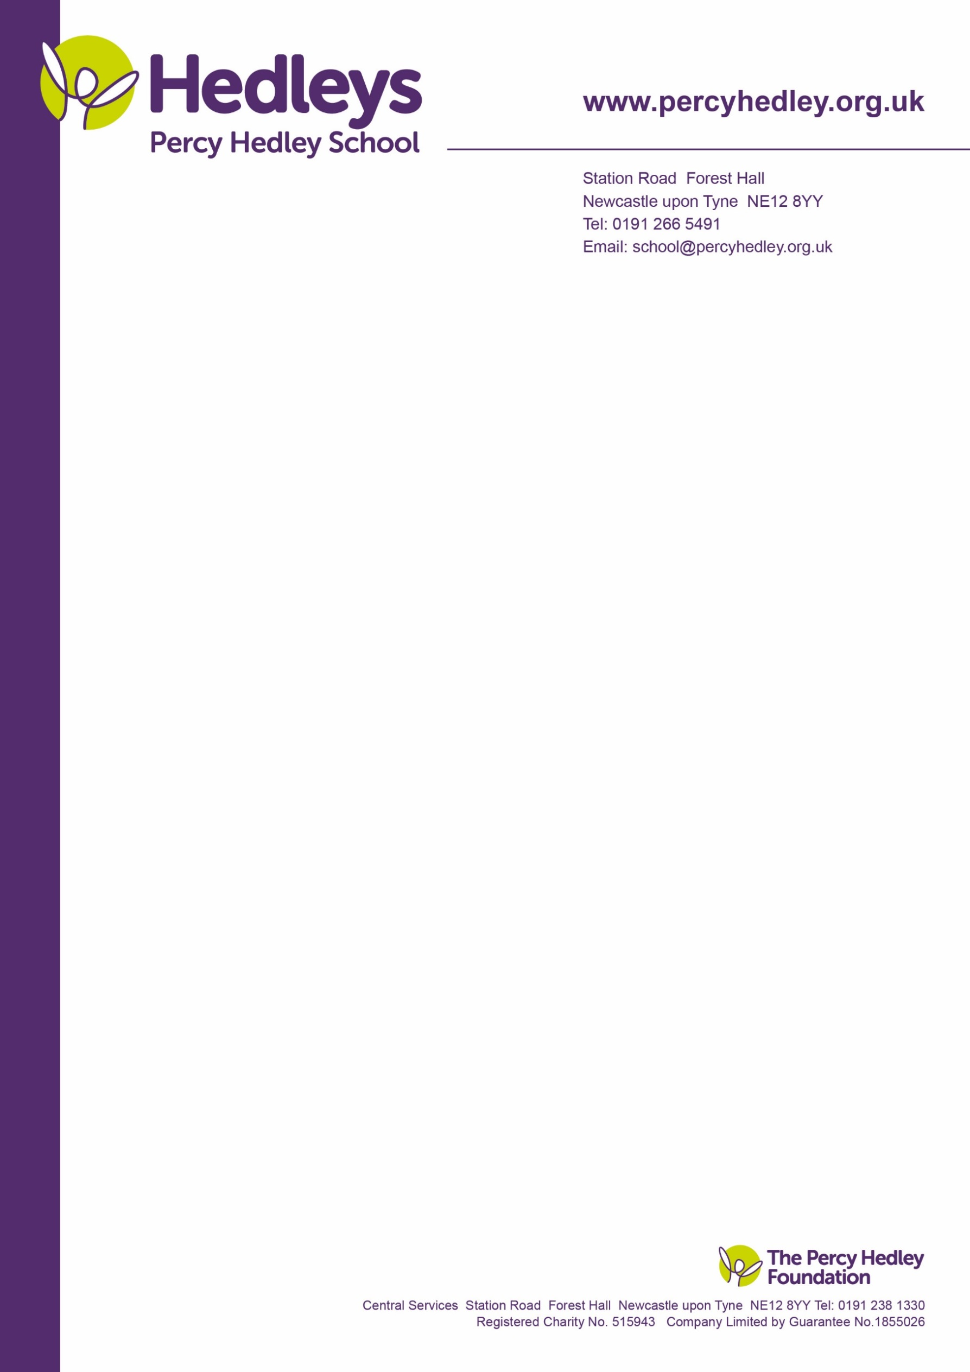

West Lane, Killingworth

Newcastle upon Tyne, NE12 7BH

Tel: 0191 216 1811

Email: school@percyhedley.org.uk

8th March 2018

Dear Parents / Carers,

We would like to share with you some key dates and events, which are taking place across school this half term to celebrate Easter.

**Easter Egg / Easter Bonnet Competition**

Children are invited to enter our Easter egg / Easter bonnet competition, which will be judged on Thursday 29th March.

Please ensure all entries are in by Wednesday 28th March.

**Easter Activities with Parents/Carers**

Parents are invited to come along and join in with Easter activities in school on Tuesday 13th March 2pm-3pm.

(CE Dept – This includes the following classes; Natalie Fitzpatrick, Beth Edwards, Sarah Harrison, Russell Runnacles, Tracy Smithson, Emma Douglas and Kasia Fabiszak).

Your child’s class team will be available to speak with during this time. However if you have any specific issues which you would like to discuss please get in touch with your class team directly so a convenient time can be made to speak, either in person or via telephone call, with the appropriate team member.

**End of Term**

A little reminder Thursday 29th March is our final day in school prior to the Easter Holiday commencing on Good Friday 30th March.

Thank you for your continued support

Tracy Smithson

Head of CE Department