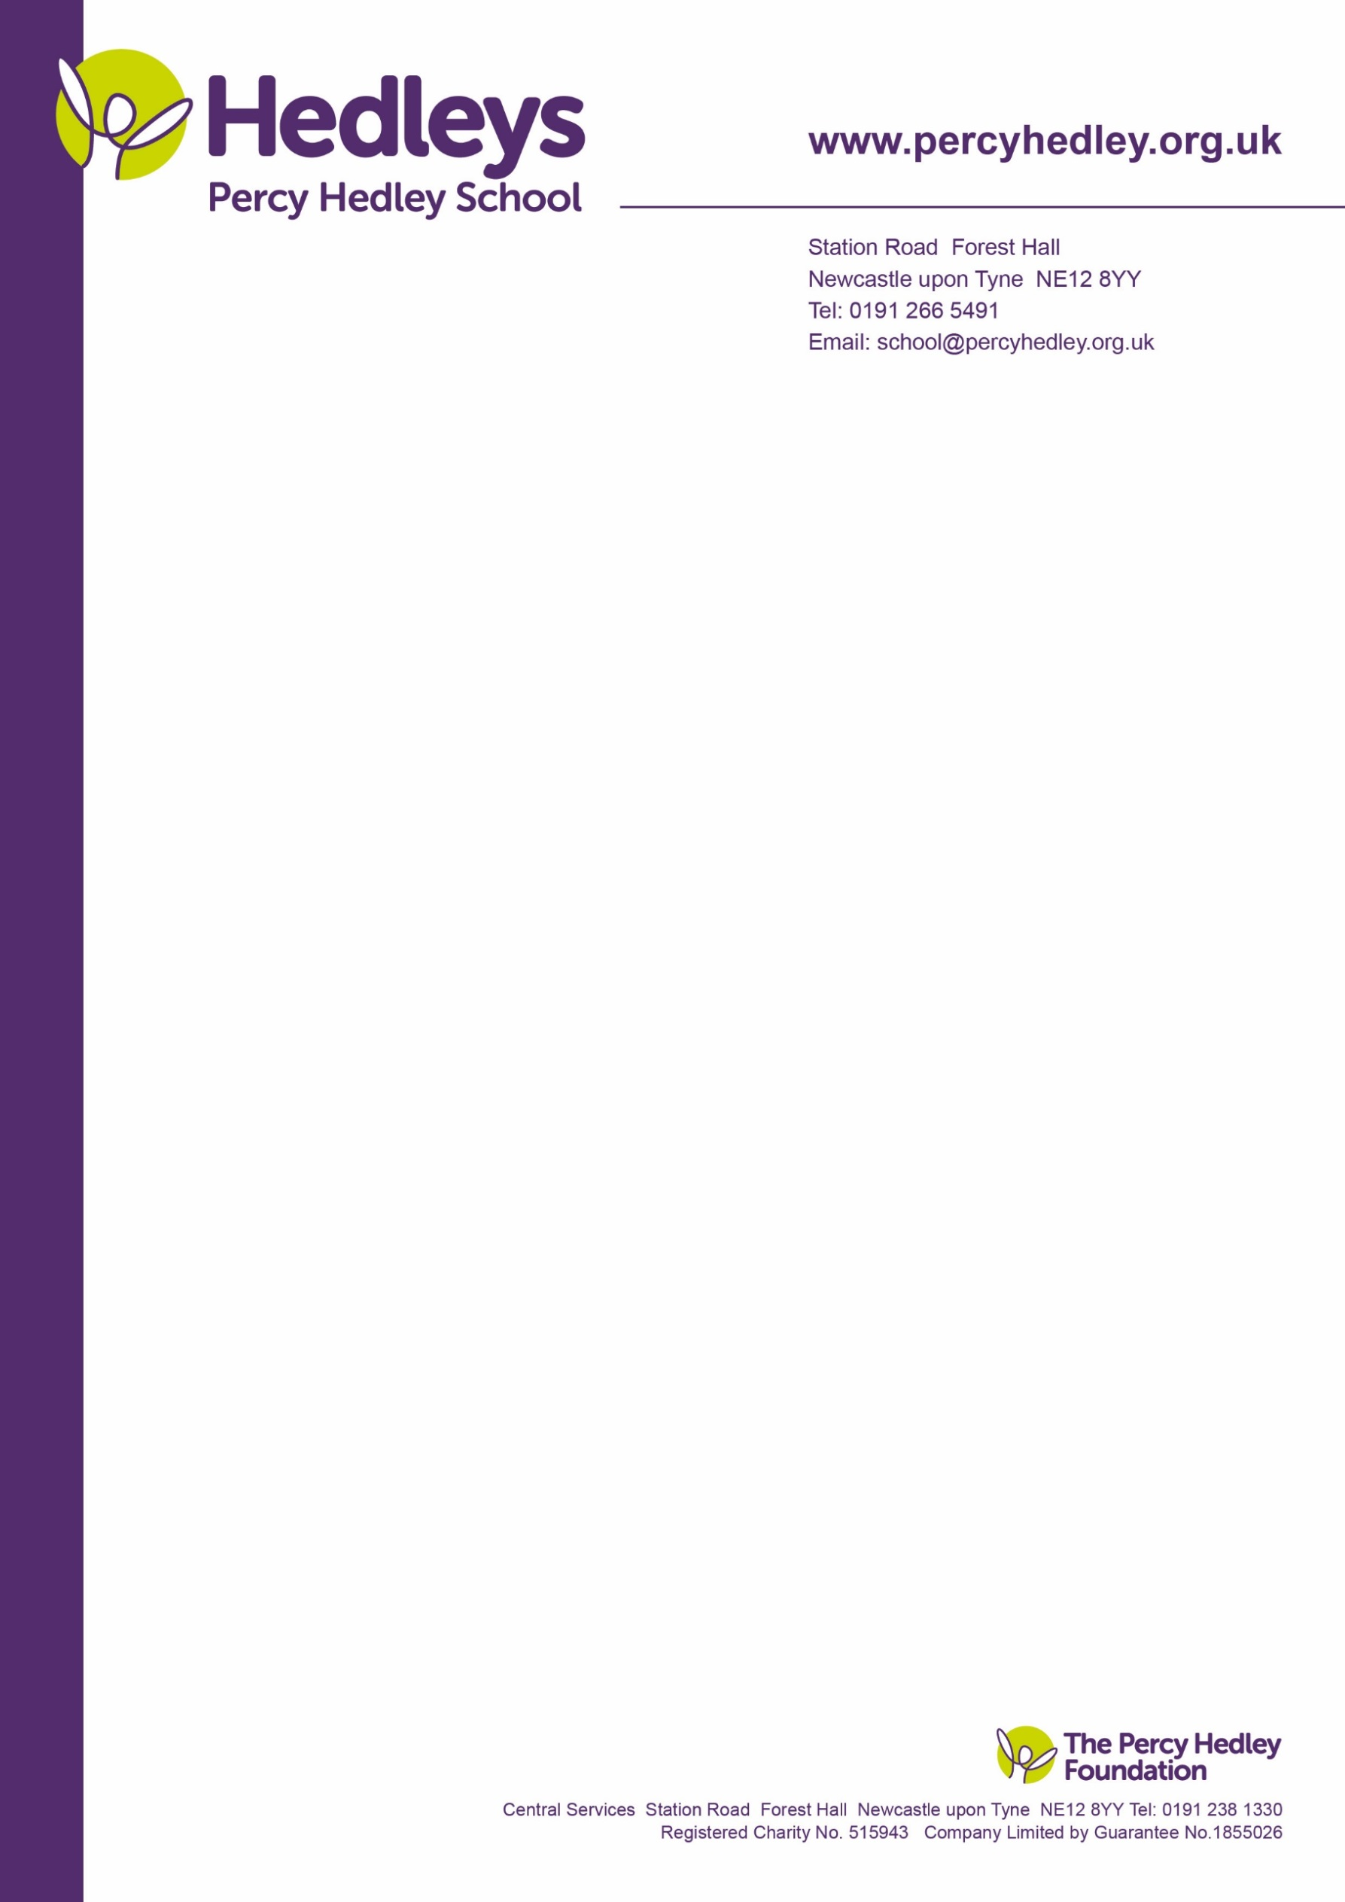

West Lane, Killingworth

Newcastle upon Tyne, NE12 7BH

Tel: 0191 216 1811

Email: school@percyhedley.org.uk

12th September 2017

Dear Parents

We would like to invite you to a parents coffee morning. This will take place on Tuesday 19th September 2017 from 10am to 11am in the dining hall at Killingworth.

This will be an opportunity for you to chat to your class team, discuss the curriculum being taught and targets for the autumn term.

We appreciate that parents have work commitments and therefore if you would like to make an individual appointment, please contact the class team who will arrange a suitable date and time.

If you have any questions please contact me on 0191 2161811 or email me at [t.smithson@percyhedley.org.uk](mailto:t.smithson@percyhedley.org.uk)

I look forward to hearing from you.

Regards

*Tracy Smithson*

Head of the CE Department Key stages 3 & 4.

Name of child: _____________________ Class: ________________

I will be able/unable to attend the parents coffee morning on Tuesday 19th September 2017

Signature of

Parent ________________________________ Date: ___________________________