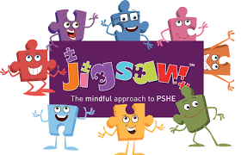

Crawley Green Infant School
Values and PSHE links
2021 - 2022

Month | PSHE theme | Value
September | Being me | Thoughtfulness
October |  | Honesty
November | Celebrating differences | Tolerance
December |  | Respect
January | Dreams and goals | Hope
February |  | Determination
March | Healthy Me | Kindness
April |  | Teamwork
May | Relationships | Friendship
June |  | Forgiveness
July | Changing me | Patience

British values
Democracy
Rule of law
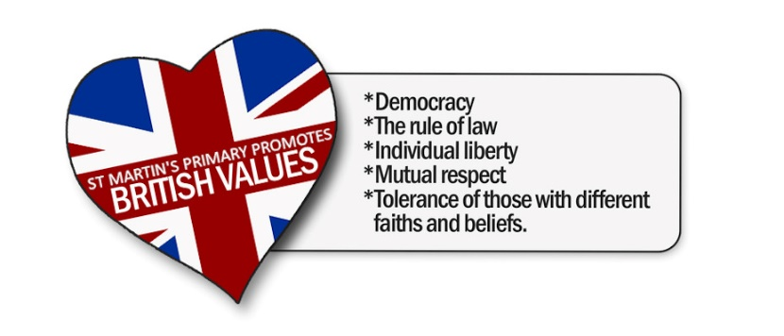
Individual liberty
Respect
Tolerance

