What do the book bands mean & How can I help my child with their reading?

What do Book Band levels mean?
Reading books are graded by difficulty by reading levels known as Book Bands. Each Book Band has its own colour. The chart below gives an indication of the range of Book Band levels at which most children will be reading as they progress through Early Years, KS1 and KS2.
The chart shows the progress of an ‘average’ band of children- but no individual child is ‘average’, so no child makes smooth progress precisely in this way. Children tend to learn in fits and starts – periods of growth followed by periods of consolidation when their progress seems to halt for a while. The periods where you don’t see rapid progress may be worrying, especially after a ‘growth spurt’, but they are important as your child develops confidence in using and applying their newly acquired skills.
If you are ever worried about your child’s progress, talk to their teacher.

Reception – age 4-5 years
Year 1 – age 5-6 years
Year 2 – age 6-7 years

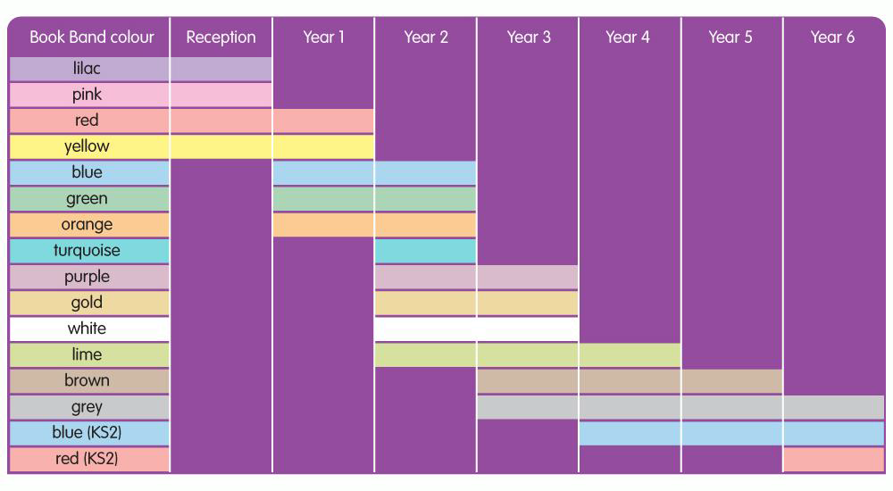

How to support your child reading Lilac level books
Your child is just beginning to discover the excitement of books. Although these books have no words, they are an important introduction to reading. Please encourage your child to:
- Look at the pages in order, and talk about what is happening on the left hand page before the right hand page.
- Talk about what is happening on each page, rather than just talking about what they see in each picture.
- Tell you who or what the book is about.
How to support your child reading Pink-Yellow banded books
Your child is beginning to learn to read. As they read, please help them to:

- Read the words carefully. Give them time to sound out words they don’t know, especially when reading pink and red band books. If they still struggle, encourage them to try sounding out the whole word first, rather than guessing from the pictures or from the first letter.
- Ask your child to sound out and blend only the words they can’t read yet, not every word. Most of the words will begin to be recognised or can be sounded out as you move through the bands. Eventually almost all words will become part of your child’s ‘sight memory’, and they won’t have to sound out at all.
- Give them time to recognise and correct their own mistakes.
- Ask them to talk about what’s happening in the book, encouraging them to make links to events on previous pages.
- On second and third readings of the book, encourage them to read with more pace and with less focus on sounding out the letters in each word, so as to ensure that they understand what the text is about.
- Make a story out of a whole book, rather than focusing just on what is happening on each page.
- Ask your child to tell you about something that happened in the book, or about something they found out in the book

How to support your child reading Blue-Green level books
Your child is now developing into a more confident reader. Encourage them to select from books at the library or bookshop as well as those from school. As they read, you can help by encouraging them to:
- Sound out quickly – and silently – inside their heads, if they need to sound out words.
- Look at the punctuation marks. You may want to model how to read a page of writing, paying attention to punctuation, such as full-stops and question marks.
- Tell you about what the characters in the story are doing and why they are acting in that way
- Show you how they can find particular things that interest them in non-fiction books (contents page, headings, index.)
- Encourage them to select from books at the library or bookshop as well as those from school.

How to support your child reading Orange – Purple level books
At Orange level, the page count increases to challenge and encourage reading stamina. There is an increased use of dialogue to encourage reading with expression. Some more complex sentences are introduced (use of ‘if’, ‘so’ and ‘because’) and include italics to show emphasis. Slightly more literary language is used. Children are increasingly encouraged to infer meaning from the text in order to gain full enjoyment from the story. Turquoise level books include words chosen for appropriateness and impact rather than decodability, with more extended descriptions. Paragraphs begin to develop and more unusual and challenging vocabulary is included. Purple level books have a more challenging vocabulary and story features such as plot, character and setting are developed in more detail. The text in the non-fiction books is presented in a variety of ways.

Your child is now beginning to read with more independence. They should be feeling more confident and will rarely need to sound out words. You can help them by:

- Listening to them when they read aloud. If they make mistakes, but they keep the sense of the text, don’t interrupt. You can revisit that page at the end of the session to check certain words. Encouraging them to begin to read some pages silently, inside their heads.
- Reminding them of useful strategies if they can’t read a word, for example:
-Sounding the word out silently, under their breath
-Dividing a longer word into syllables, or looking at the word
without an –ing or an –ed ending

- Don’t allow them to worry about a word. Tell them what it says and revisit the word once you have completed the book.
- Encourage the use of expression, especially for character-speech in fiction books and paying attention to punctuation. You may wish to model reading some pages aloud for your child to copy.
- Talk about how characters are feeling.
- Talking about how events in the book relate to each other and helping your child to understand how the story builds up in a longer book.
- Asking them to tell you about interesting things they found out and showing you where the information is in the book.

How to support your child reading Gold- White level books
These books include more sophisticated and challenging vocabulary, including word play and the introduction of figurative language. Some Gold books have longer chapters for more sustained reading. White level books encourage children to empathise with the characters and consider why they behave as they do, and how they change during the course of the story. The non-fiction books are divided into sections that require more sustained reading and there is increased challenge in the layout of the information.
Children reading at this level are confident independent readers who can tackle increasingly complex language, story structures and text layout.

Your child is now reading longer books with fewer illustrations, so they continue to need your help to ensure they are getting the full meaning and enjoyment from the text. They may prefer to read one chapter or section at a time, rather than reading the whole book in one session. You can support them by:
- Asking them to read some pages of the book aloud to you so that you can enjoy hearing them reading with expression and pace.
- Asking them to find parts of the text which describe a character or place and talking about the words used in the description.
- Asking for regular updates as to what is happening in the book, so that you know how the different chapters or sections link.
- Talking about how much they enjoy a book, or a type of book. Encourage them to look for more books of the type they enjoy.

How to support your child reading Lime- Grey level books
Although your child is now taking off as a reader. Your child may well not want to read aloud to you anymore because they probably enjoy silent reading more. This is fine as long as you child continues to read actively and not just pass their eyes over the words. It is still important that you read with them and talk to them about their reading. This reassures them that their reading is still important to you, as well as giving you an opportunity to share an enjoyment of books. You can still help them by:

- Continuing to make a time available for regular quiet reading sessions, and reading your book while your child reads.
- Establishing an expectation of a conversation at the end of each reading session: can they tell you what’s happening in their book?
- Ask questions which make your child go back to the book to find answers. Support your child as they develop skills in skimming and scanning to find the information to answer your question.
- Asking them to read aloud some parts of the text which they particularly enjoy. This may include action or description. Talk about how the writer made those parts so enjoyable.
- Talking about how characters develop or how they react to different people, places or events.
- Reading the book yourself so that you can talk together about the smaller details of the book.
- Asking them to explain a character’s motivations
- Discuss the points of view of the character and the narrator
- Continuing to read aloud to your child at bedtime. This shows them the importance you place on reading as well as developing their language, vocabulary and love of story

Free reader
Once your child becomes a free reader, the books that they choose to read in school are intended to be a ‘leisure read’. Although your child should enjoy them, the books need the reader to be fully alert and willing to learn.
You can help them with their comprehension skills by:

- Continuing to make a time available for regular quiet reading sessions, and reading your book while your child reads.
- Suggest that your child invites friends who are also reading the book to a ‘Book Group’. If you skim-read the book first – or ask your child’s teacher – you can prepare some questions for the book group to discuss.
- Before a reading session, ask your child to find and note down some particular information. It could relate to the plot or it could be something like: a really good descriptive passage; three words which are adventurous; two words you want to use in your next piece of writing; an example of something typical a character does or says; how one character’s reaction to another shows their relationship … There are lots of questions you can ask which don’t mean you have to know the book yourself, but just serve to alert your child to its possibilities.

