**SEND Policy and Information Report**

# 



|  |  |  |
| --- | --- | --- |
| **Approved by:** | James O’Doherty | **Date:** October 2024 |
| **Last reviewed on:** | October 2024 | |
| **Next review due by:** | October 2025 | |

**Contents**

1. Aims 3

2. Legislation and guidance 3

3. Definitions 3

4. Roles and responsibilities 3

5. SEND information report 4

6. Monitoring arrangements 8

7. Links with other policies and documents 8



# 1. Aims

Our SEND policy and information report aims to:

* Set out how our school will support and make provision for pupils with special educational needs and disabilities (SEND)
* Explain the roles and responsibilities of everyone involved in providing for pupils with SEND

Corpus Christi Catholic College is a mainstream secondary setting with a Specialist Learning and Cognition Resource Base Provision. We believe that every child should be actively involved in school life and be included in mainstream lessons where ever that is beneficial to the individual student concerned. We acknowledge that there may be times when students must be involved in different activities or groupings in order to be in an environment or situation where they can be meaningfully included. We are very proud that we can accommodate such flexible teaching and learning to allow students to feel included all of the time and we actively change approaches dependent upon the needs and changing needs of individuals.

Students access the Resource Base Provision via SENSAP agreeing the suitability of the placement on the Education Health and Care Plan.

We support students with physical and medical needs, students on the autistic spectrum and with ADHD, students with emotional needs, students with communication and interaction difficulties and students who have more difficulty with learning than the majority of children of the same age. We believe that all our students should be valued equally, treated with respect and be given equal opportunities in all forms of school life.

# 2. Legislation and guidance

This policy and information report is based on the statutory [Special Educational Needs and Disability (SEND) Code of Practice](https://www.gov.uk/government/uploads/system/uploads/attachment_data/file/398815/SEND_Code_of_Practice_January_2015.pdf) and the following legislation:

* [Part 3 of the Children and Families Act 2014](http://www.legislation.gov.uk/ukpga/2014/6/part/3), which sets out schools’ responsibilities for pupils with SEND
* [The Special Educational Needs and Disability Regulations 2014](http://www.legislation.gov.uk/uksi/2014/1530/contents/made), which set out schools’ responsibilities for education, health and care (EHC) plans, SEND co-ordinators (SENDCO s) and the SEND information report

# 3. Definitions

A pupil has SEND if they have a learning difficulty or disability which calls for special educational provision to be made for them.

They have a learning difficulty or disability if they have:

* A significantly greater difficulty in learning than the majority of the others of the same age, or
* A disability which prevents or hinders them from making use of facilities of a kind generally provided for others of the same age in mainstream schools

Special educational provision is educational or training provision that is additional to, or different from, that made generally for other children or young people of the same age by mainstream schools.

# 4. Roles and responsibilities

**4.1 The SENDCO**

The SENDCO is Mr Ged O’Donnell Ms Kim Mosby is the Assistant Principle for Inclusion. They can be contacted on 0113 2009010

They will:

* Work with the headteacher and SEND governor to determine the strategic development of the SEND policy and provision in the school
* Have day-to-day responsibility for the operation of this SEND policy and the co-ordination of specific provision made to support individual pupils with SEND, including those who have EHC plans
* Provide professional guidance to colleagues and work with staff, parents, and other agencies to ensure that pupils with SEND receive appropriate support and high-quality teaching
* Advise on the graduated approach to providing SEND support
* Advise on the deployment of the school’s delegated budget and other resources to meet pupils’ needs effectively
* Be the point of contact for external agencies, especially the local authority and its support services
* Liaise with potential next providers of education to ensure that the school meets its responsibilities under the Equality Act 2010 with regard to reasonable adjustments and access arrangements
* Ensure the school keeps the records of all pupils with SEND up to date

**4.2 The SEND governor**

The SEND governor will:

* Help to raise awareness of SEND issues at governing board meetings
* Monitor the quality and effectiveness of SEND and disability provision within the school and update the governing board on this
* Work with the headteacher and SENDCO to determine the strategic development of the SEND policy and provision in the school

**4.3 The headteacher**

The headteacher will:

* Work with the SENDCO and SEND governor to determine the strategic development of the SEND policy and provision within the school
* Have overall responsibility for the provision and progress of learners with SEND and/or a disability

**4.4 Class teachers**

Each class teacher is responsible for:

* The progress and development of every pupil in their class
* Working closely with any teaching assistants or specialist staff to plan and assess the impact of support and interventions and how they can be linked to classroom teaching
* Working with the SENDCO to review each pupil’s progress and development and decide on any changes to provision
* Ensuring they follow this SEND policy

# 

# 5. SEND information report

On the SEND register we currently have 226 Pupils (28%), 23 of these students have an EHCP (E) with 203 students who have SEN Support (K) (October 2023).

# 5.1 The kinds of SEND that are provided for

Our school currently provides additional and/or different provision for a range of needs, including:

* Communication and interaction, for example, autistic spectrum disorder, Asperger’s Syndrome, speech and language difficulties
* Cognition and learning, for example, dyslexia, dyspraxia
* Social, emotional and mental health difficulties, for example, attention deficit hyperactivity disorder (ADHD)
* Sensory and/or physical needs, for example, visual impairments, hearing impairments, processing difficulties, epilepsy
* Moderate/severe/profound and multiple learning difficulties

**5.2 Identifying pupils with SEND and assessing their needs**

We will assess each pupil’s current skills and levels of attainment on entry, which will build on previous settings and Key Stages, where appropriate. Class teachers will make regular assessments of progress for all pupils and identify those whose progress:

* Is significantly slower than that of their peers starting from the same baseline
* Fails to match or better the child’s previous rate of progress
* Fails to close the attainment gap between the child and their peers
* Widens the attainment gap

This may include progress in areas other than attainment, for example, social needs.

Slow progress and low attainment will not automatically mean a pupil is recorded as having SEN. Therefore, we ensure that is a robust graduated response to early identification of any areas of learning needs by using the different stages of the wave system along with the assess-plan-do-review approach, which is demonstrated in the illustrations below.

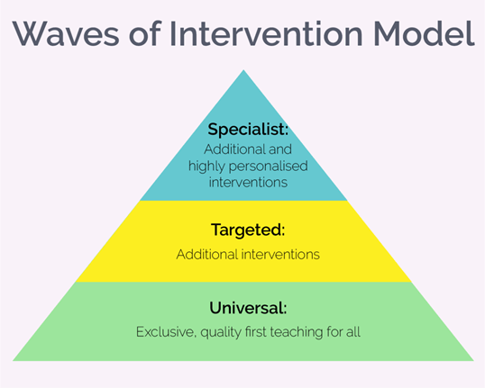 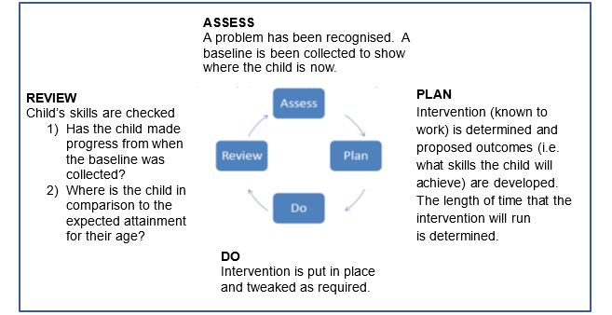

When deciding whether special educational provision is required, we will start with the desired outcomes, including the expected progress and attainment, and the views and the wishes of the pupil and their parents. We will use this to determine the support that is needed and whether we can provide it by adapting our core offer, or whether something different or additional is needed.

**5.3 Consulting and involving pupils and parents**

We identify the needs of students as early as possible by gathering information from parents, education, health and care services and feeder schools prior to the child’s entry into the school.

We will have an early discussion with the pupil and their parents when identifying whether they need special educational provision. These conversations will make sure that:

* Everyone develops a good understanding of the pupil’s areas of strength and difficulty
* We take into account the parents’ concerns
* Everyone understands the agreed outcomes sought for the child
* Everyone is clear on what the next steps are

Corpus Christi Catholic College believes that a close working relationship with parents/carers is vital in order to ensure:

1. early and accurate identification and assessment of SEND leading to the correct intervention and provision
2. continuing social and academic progress of students with SEND
3. appropriate and measurable personal and academic smart targets are set

Parents/carers are kept up to date with their child’s progress through progress reports, parents’ evenings and review meetings. Parent / carers are also invited to half termly coffee afternoons for informal opportunities to meet with the support team and discuss any issues.

In cases where more frequent regular contact with parent/carers is necessary, this is arranged based on the individual students’ needs. The SENDCo may also signpost parents of students with SEND to the local authority Special Educational Needs and Disabilities Independent Advice and Support Services (SENDIASS) where specific advice, guidance and support may be helpful. If an assessment or referral indicates that a student has additional learning needs the parents/carers and the student are consulted about future provision. Parents/carers are invited to attend meetings with external agencies regarding their child, and are kept up to date and consulted about planned action.

Notes of these early discussions will be added to the pupil’s record and given to their parents.

We will formally notify parents when it is decided that a pupil will receive SEND support.

**5.4 Assessing and reviewing pupils' progress towards outcomes**

We will follow the graduated approach and the four-part cycle of **assess, plan, do, review**.

The class or subject teacher will work with the SENDCO to carry out a clear analysis of the pupil’s needs. This will draw on:

* The teacher’s assessment and experience of the pupil
* Their previous progress and attainment or behaviour
* Other teachers’ assessments, where relevant
* The individual’s development in comparison to their peers and national data
* The views and experience of parents
* The pupil’s own views
* Advice from external support services, if relevant

The assessment will be reviewed regularly.

All teachers and support staff who work with the pupil will be made aware of their needs, the outcomes sought, the support provided, and any teaching strategies or approaches that are required. We will regularly review the effectiveness of the support and interventions and their impact on the pupil’s progress.

**5.5 Supporting pupils moving between phases and preparing for adulthood**

We will share information with the school, college, or other setting the pupil is moving to. We will agree with parents and pupils which information will be shared as part of this.

To facilitate the smooth transition for students with support needs both from feeder and non-feeder schools, there is, prior to admission:

* + The attendance of a representative of the College at Year 6 Annual Reviews for students with a Health Care Plan, where possible
  + A transition programme
  + The gathering of additional relevant information from the partner schools
  + The making of appropriate transition arrangements with regard to the transition plan put into place in Year 6, including a bespoke transition package and summer school
  + A timetable for transition planning for all students with SEND
  + Students with special educational needs, together with their parents/carers, are also invited to talk to Director of SEND about the provision for students with SEND. There are extra visits for some students to ensure a smooth transition.
  + Staff training may also have taken place where students with high level needs are to be admitted.

Students with special educational needs admitted to the college, at times other than year 7 transitions, are carefully assessed on admission to ensure their needs are met.

Corpus Christi Catholic College aims to support transition at each stage from Year 7 to 11. Students’ individual needs are planned for and supported using transition plans in Year 6, Year 8 and Year 11. All students with SEND are supported to ensure transition between educational phases is well planned and that provision is in place to aid this process. Information regarding the additional needs of any students is used to plan provision and support a smooth transition. This includes transition to and from Corpus Christi Catholic College.

All students receive information, advice and guidance on Post 16 options and SEND students are escorted on visits to local colleges and Post 16 centres.

**5.6 Our approach to teaching pupils with SEN**

Teachers are responsible and accountable for the progress and development of all the pupils in their class.

High-quality teaching is our first step in responding to pupils who have SEN. This will be differentiated for individual pupils.

We believe that provision for students with special educational needs is a whole school responsibility requiring a whole school response. All teachers are teachers of students with SEND and all have access to information about individual SEND students to ensure every student can access lessons. All students at Corpus Christi Catholic College are valued members of our College community and spend form time in mainstream classes. Teachers are responsible for differentiating according to individual needs to ensure all students can participate and make progress. Tasks and approaches can therefore be adapted to match individual learning styles. All staff are trained and have knowledge of the learning needs of the students in their classes and follow the waves of intervention model to ensure affective 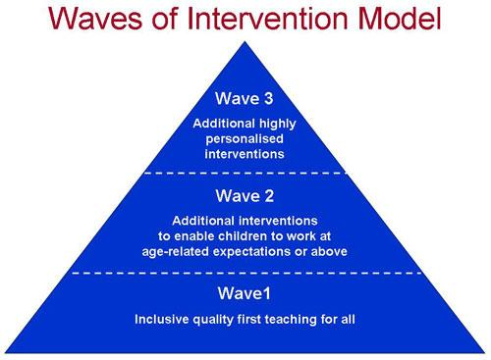intervention is in place at the appropriate time

We will also provide the following interventions:

* **The student Zone**

Support for SEMH (social emotional mental health) and Cognition and learning

The student Zone supports a range of needs that may need to be addressed outside of the classroom as part of the wave 2/3 interventions on a one to one or small group basis.

ASD one to one and small group sessions.

Speech and language.

**The Nurture Group**

* Support for SEMH and also Cognition and Learning is also offered for vulnerable students, who are performing below age related expectations in communicational skills and/or if they need support with improving their mental health and wellbeing. We follow the six principles of Nurture:

1. Children’s learning is understood developmentally
2. The classroom offers a safe base
3. The importance of Nurture for the development of wellbeing
4. Language is a vital means of communication
5. All behaviour is communication
6. The importance of transitions in children’s lives

* We use the Boxall Profile to measure the students’ progress in the Nurture provision

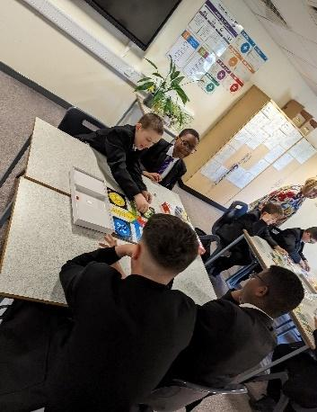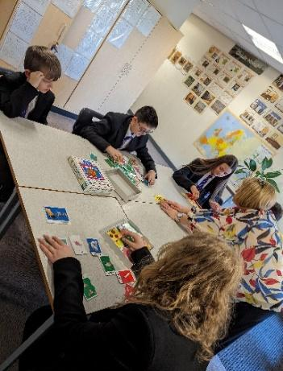

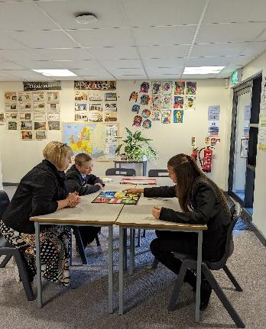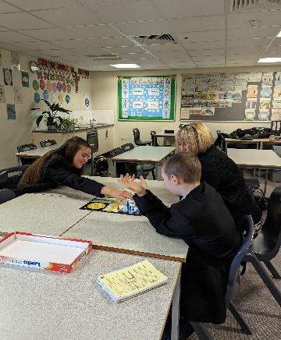

**5.7 Adaptations to the curriculum and learning environment**

We make the following adaptations to ensure all pupils’ needs are met:

* Differentiating our curriculum to ensure all pupils are able to access it, for example, by grouping, 1:1 work, teaching style, content of the lesson, etc.
* Adapting our resources and staffing
* Using recommended aids, such as laptops, coloured overlays, visual timetables, larger font, etc.
* Differentiating our teaching, for example, giving longer processing times, pre-teaching of key vocabulary, reading instructions aloud, etc.

**5.8 Additional support for learning**

**Leadership**

Miss K Mosby – Assistant Principal for Inclusion

Mr G O’Donnell –SENDCo

**Teaching Staff**

Mr J Hall

Miss H Richards

**Support Staff**

Mrs J Navey – SEN / Inclusion Administrator

Mrs P Bradish – Learning Mentor

Mr B Percival – HLTA- SEMH Intervention

Mrs D Ruddock – HLTA

Mrs A Thurman – HLTA

Mrs L Valentine – HLTA

Mrs A Ball- HLTA

Mrs C Myland – Intervention Support Worker

The SEND team is trained to deliver interventions such as literacy and numeracy support, one to one reading, support for SEMH needs, speech and language programs and basic physiotherapy.

Support staff will support pupils on a 1:1 basis as part of wave 3 intervention or where and Education Health Care Plan (EHCP) states the need for one-to-one support.

Support staff will support pupils in small groups as part of wave 2 intervention in liaison with heads of faculty or the head of year.

We work with the following agencies to provide support for pupils with SEN:

* STARS
* Educational psychologists
* Speech and language services
* CAMHS (Child and Adolescent, Mental Health services)
* SENSAP (Special Educational Needs Statutory Assessment Provision) team
* SENDIASS (Special Educational Needs and Disability Information and Advice Support Services)

**5.9 Expertise and training of staff**

We aim to keep all school staff up to date with relevant training and developments in teaching practice in relation to the needs of students with SEND.

The SENDCO and the support team attend relevant SEND courses and staff have access to relevant SEND focused internal and external training opportunities.

The SENDCO, the assistant SENDCO, along with the other members of the senior leadership team, ensure that training opportunities are matched to school development priorities and those identified through the use of provision management. Ongoing training for teachers and TAs is organised as and when required. If a particular students’ needs require specific staff training then this is implemented for example, fire evacuation procedures for students with severe medical needs.

Recent training has included Social Emotional Mental Health awareness and support strategies, SEMH areas of need and how to identify them, understanding Educational Health Care Plans. Training planned for the Autumn term of 2023 will include Trauma and attachment friendly classrooms and specific strategies to support these learners, and specialist ASD training from STARS. There is a program of training in the college which is agreed with Senior Leadership Team in line with the needs of the college.

We have a team of five teaching assistants, including five higher level teaching assistants (HLTAs) One intervention support worker and one learning mentor who are trained to deliver SEND provision.

We use specialist staff for the resource base provision students and aim to have training in place for all teaching staff to support the resource base students.

**5.10 The Resource Base Provision**

The Resource Provision at Corpus Christi is a specialist provision for approximately 22 children in years 7-11 with complex learning difficulties related . The provision is within a mainstream secondary school, with pupils accessing learning within a Base and in the wider school.

Certain subjects (Maths, English, and Life Skills) are taught by specialist SEND teachers within the Base, with other subjects taught by subject specialists in the wider school. Most lessons are taught with Resource Provision groups. However, a number of pupils are given the opportunity to access mainstream lessons where this is appropriate for their skills and talents. Groups are usually hold around 10-12 pupils with one teacher and one member of support staff.

This provision is designated to provide support for students with cognition and learning difficulties. There are a number of reasons why a pupil may need to access this, such as (but not limited to) global delay, Downs Syndrome and Chromosomal deletion syndromes. Pupils often have other needs that require support such as ADHD, Autism, visual or hearing impairments, SEMH needs and physical disabilities. Staff are experienced and trained to support this variety of need.

A number of pupils require very close level of help, such as getting to lessons and supported lunch times. However, most pupils do not require this and they are given as much independence as possible with the knowledge that there will always be a member of staff to help if required.

We currently offer a number of qualifications and programmes such as Entry Level Certificates in Maths, English and Science; ASDAN short courses in History, Geography, Food Technology and Beliefs and Values. There are also a number of pupils who are entered for GCSEs and BTEC level 1 courses.

Our pupils have a range of needs and as a result a range of levels of achievement in certain subjects. Typically, they arrive in year 7 working at a level between year 1 and year 3. Students usually leave with Entry level certificates of levels 1 – 3, with some pupils having gained GCSEs in a variety of core subjects such as English and Maths alongside other curriculum option choices.

In order to access this provision a pupil must have an EHCP which relates to needs that are appropriate to this setting (Cognition and Learning). To apply for a place, please name Corpus Christi Resource Provision as the preferred educational setting during the year 6 EHCP review. Leeds City Council SENSAP will then process the application

**5.11 Securing equipment and facilities**

**Physical environments**

Corpus Christi Catholic College incorporates facilities for students and staff with disabilities. It is easily accessible for all and there are marked parking bays at the front of the College for blue badge holders. A loop hearing system is available on request. There are several disabled toilets around the building, all equipped with handrails and emergency alarms. At present Music and Art rooms are not accessible to wheelchair users.

## Assistive Technology

The College provides access to a limited number of laptops within school to support students with temporary and long- term physical needs and/or literacy related barriers to learning. There is a scheme in school to enable families and students to buy their own device for use on site.

In addition to support from teaching assistants in the classroom and in small groups, Corpus Christi Catholic College provides the following additional resources for our Special Needs Students:

## Transition

We work closely with feeder and other primary schools to make sure that all students feel comfortable with their move to a secondary College. SEND students have the opportunity to have extra visits to school in order to familiarise themselves with the environment and some of the staff they will be working with in the future.

## Homework Support

Enrichment sessions are held throughout the week to support all students with homework and to give access to ICT when necessary.

## Teaching Assistants

Students on the Special Needs register at SEND Support may be allocated TA support. TAs work closely with the child, parents and staff to meet the child’s needs within the College. The SEND Team are always available for students to talk to.

## Educational Testing

In addition to standard testing and assessments and tracking within school there is provision for further assessment. This helps identify students who may need additional support within lessons or may benefit from a more individualised programme of support. It may also provide evidence for examination boards if applications for additional access arrangements for examinations are to be made.

## Exam Access Arrangements

An identification of SEND does not result in automatic exam access arrangements. The process of exam access arrangements for all students is governed by the exams board – JCQ. Students are assessed by a series of tests and if identified as requiring access arrangements, this is co-ordinated between the College exams officer, our qualified assessor and the Director of SEND. Students and parents/carers are notified of their exam access arrangements and support, as approved, is provided.

More details of access arrangements can be found at [www.jcq.org.uk](http://www.jcq.org.uk/)

## School Transport

Where students with SEND require specific transport to and from school, this is arranged by Leeds City Council.

**5.11 Evaluating the effectiveness of SEND provision**

We evaluate the effectiveness of provision for pupils with SEND by:

* Reviewing pupils’ individual progress towards their goals each term
* Reviewing My Support Plans on a termly basis
* Reviewing the impact of interventions after four to six weeks
* Using pupil questionnaires
* Monitoring by the SENDCO
* Using provision maps to measure progress
* Holding annual reviews for pupils with EHC plans

**5.12 Enabling pupils with SEND to engage in activities available to those in the school who do not have SEND**

All of our extra-curricular activities and school visits are available to all our pupils, including our before-and after-school clubs.

All pupils are encouraged to go on our residential trips.

All pupils are encouraged to take part in sports day/school plays/special workshops/religious services.

No pupil is ever excluded from taking part in these activities because of their SEND or disability.

* Students with disabilities are support by key workers to be able to access all activities.
* Corpus Christi Catholic College embeds the teaching of inclusion and equality for the whole college community to prevent disabled pupils from being treated less favourably than other pupils.
* To help disabled pupils access the College we have lift access to all floors, disabled toilets, a hygiene suite, resources and technology to support visually impaired and hearing-impaired students.

Accessibility policy: <https://www.corpusleeds.org/wp-content/uploads/sites/8/2014/06/Accessibility-Policy-June-2019.pdf>

**5.13 Support for improving emotional and social development**

We work hard to ensure that students are included in all aspects of college life. We believe that all our students should be valued equally, treated with respect and be given equal opportunities in all aspects of College life.

Students who struggle during unstructured times are offered a specific area of school to access where they may have a quiet moment and where appropriate they are encouraged to develop socially via structured games and conversation.

Students who have additional emotional needs will receive further support from in-house Thrive practitioners (An Emotional Literacy Programme) or in some cases outside agencies as required for example Child and Adolescent Mental Health Service (CAMHS).

We provide support for pupils to improve their emotional and social development in the following ways:

* Pupils with SEND are encouraged to be part of the school council.
* Pupils with SEND are also encouraged to be part of extra- curricular clubs to promote teamwork/building friendships

We have a zero tolerance approach to bullying.

**5.14 Working with other agencies.**

Corpus Christi Catholic College invites and seeks advice and support from external agencies in the identification and assessment of, and provision for SEND. The College continues to build strong working relationships and shares information and links with external support services in order to fully support our SEND students. Sharing knowledge and information with our support services is essential to effective and successful SEND provision. Where any advice is sought, parents/carers remain involved and updated

The following services may be involved where required:

* + CAMHS
  + STARS
  + SENIT
  + SEMH Inclusion Team
  + East Area Inclusion Partnership
  + Social Care
  + Cluster
  + Educational Psychology Service
  + School Nursing service
  + Speech and Language Service
  + Basis Yorkshire
  + Safe Project.
  + Youth Justice.
  + GIPSIL

**5.15 Complaints about SEND provision**

Complaints about SEND provision in our school should be made to the SENDCO in the first instance. They will then be referred to the school’s complaints policy.

The parents of pupils with disabilities have the right to make disability discrimination claims to the first-tier SEND tribunal if they believe that our school has discriminated against their children. They can make a claim about alleged discrimination regarding:

* Exclusions
* Provision of education and associated services
* Making reasonable adjustments, including the provision of auxiliary aids and services

**5.16 Contact details of support services for parents of pupils with SEND**

Links to SENDIASS and Family Information for SEND offer advice and sign posts parents/Carers to other services within the local authority.

<https://sendiass.leeds.gov.uk/>

<https://familyinformation.leeds.gov.uk/send>

**5.17 Contact details for raising concerns**

For any queries or concerns for students with SEND please contact

SEND@corpusleedsorg.

SENDCo - Ged O’Donnell

Assistant Principal for Inclusion - Kimberley Mosby

Inclusion Administrator - Mrs Navey

**5.18 The local authority local offer**

Our local authority’s local offer is published here: <https://leedslocaloffer.org.uk/#!/directory>

# 

# 6. Monitoring arrangements

This policy and information report will be reviewed by the Assistant Principal for Inclusion **annually**. It will also be updated if any changes to the information are made during the year.

It will be approved by the governing board.

# 7. Links with other policies and documents

This policy links to the following policies

* Accessibility plan
* SEMH
* Equality information and objectives
* Supporting pupils with medical conditions