

Rainbow Class Handbook
Christ Church CofE Primary School
l

Contents
1. Whole School Culture of Inclusion
- Universal Offer
- Targeted Offer
- Specialist Offer
- Summary
2. Inclusion Base: Aims, Ethos and Values
- Aims
- Ethos
- Values
3. Our Classrooms
- Overview of Needs Across the Classroom and Learning Approaches
- Classroom Set-Up: Expectations and Visual Layouts
- Pictures of rooms and outside area
- Work stations
- Classroom Timetables
- Meet the staff

4. The school Day
- Timings, attendance and punctuality
- Uniform and equipment needed

5. Curriculum
- Long Term Overview
- Short Term Planning
- Assessment Information

Resource Base Handbook
1. Whole School Culture of Inclusion
At Christ Church Primary School, inclusion is at the heart of everything we do, guided by our vision to "Let Your Light Shine". We are proud of the culture of inclusivity that we have built – one where the needs of every learner are recognised, valued and supported. This commitment is not questioned or considered an additional task; it is embedded in our daily practice and forms the foundation of our school community.
We believe that when every child is given the opportunity to shine, they illuminate not only their own path but also brighten our entire school community. Our vision reminds us that each child has unique gifts and potential, and it is our responsibility to ensure that every light can shine brightly, regardless of the barriers they may face.
Every decision we make is guided by the principle of equity of opportunity. We consistently consider how each choice, policy and approach impacts all learners, ensuring that no child is left behind. Our aim is to provide an education that enables every pupil to access learning, achieve their potential and thrive within our school environment, allowing their individual light to shine as brightly as possible.
To ensure that this commitment is delivered in a sustainable and embedded way that does not increase staff workload, we follow a structured model of support built around three levels: universal, targeted and specialist. This approach allows us to provide high-quality inclusive practice for all pupils while responding effectively to individual needs as they arise, ensuring that we nurture and support each child's unique light.

Universal Offer
Our universal offer underpins inclusive practice across all classrooms. Many of the approaches originally developed to support pupils with Special Educational Needs and Disabilities (SEND) have been integrated into everyday teaching ensuring that all children can benefit from them. When inclusive strategies are part of general classroom practice all pupils feel supported and staff workload is reduced as individual adaptations become less necessary.
The universal offer includes:
"Let Your Light Shine" through inclusive practice for every child
Our universal offer underpins inclusive practice across all classrooms, ensuring that every child has the opportunity to let their light shine. Many of the approaches originally developed to support pupils with Special Educational Needs and Disabilities (SEND) have been integrated into everyday teaching, ensuring that all children can benefit from them. When inclusive strategies are part of general classroom practice, all pupils feel supported and staff workload is reduced as individual adaptations become less necessary.

The universal offer includes:
- A whole school behaviour policy based on positive relationships – building the trust and connection that allows every child's light to shine
- Widget visuals used across the whole school – consistent labelling throughout to support all learners
- Low cognitive load designed classroom – creating calm, focused learning environment where every child can thrive
- Widget visuals embedded in classroom resources – supporting access for all learners
- Whole-school training – including trauma-informed teaching, adaptive teaching, and Kagan strategies to help staff nurture each child's potential
- Classroom visual timetables – used consistently to provide structure and security
- Planning differentiated four ways – with SEND adaptations that promote access for all learners
- Zones of Regulation – embedded across all classrooms to support emotional wellbeing and self-regulation
- Sensory Circuits – accessible on each floor in school to meet diverse sensory needs
By embedding these strategies within every classroom, we foster an environment where pupils understand different needs, develop empathy and learn how to support both themselves and one another.
Targeted Offer
For some pupils, additional support is provided through a targeted offer to help them overcome barriers and let their light shine more brightly. This may include interventions such as:
- Speech and Language Therapy (SALT)
- Psychotherapy
- School Nurse
- Educational Psychologist
- Language and Communication Team (LACT)
Targeted interventions are not restricted to pupils with a formal diagnosis or those on the SEND register. Children may not be on the caseload of professionals; however, provision may be advised and adapted based on recommendations. We use these supports proactively to identify and meet emerging needs at an early stage, helping to prevent the escalation of difficulties and reduce the need for specialist involvement later.

Supporting pupils to shine through practical strategies
Teachers and support staff are well informed about the range of resources and interventions available and can implement or recommend these when appropriate. These strategies help remove barriers so that every child can access learning and let their light shine. Examples include:
- Individual timetables – providing structure and predictability
- Now and Next boards – helping pupils prepare for transitions and understand what's coming
- Workstations – creating focused learning spaces
- Task planners – breaking down activities into manageable steps
- Movement breaks – supporting sensory and regulation needs
By providing targeted support at the right time, we ensure that every child has the opportunity to overcome challenges, build confidence, and shine in their own unique way.
Summary
Our inclusive ethos ensures that every pupil at Christ Church has access to the support and opportunities they need to succeed. The universal and targeted offers work together to create a seamless framework of provision that responds to the diverse needs of our learners. This approach ensures that inclusion is embedded across the whole school rather than existing as a separate strand of practice.
Building on this strong foundation of inclusive education, the next section outlines how our resource base extends and enhances this provision by offering a more specialised environment for pupils with complex needs while maintaining strong links with the wider school community.

2. Inclusion Base: Aims, Ethos and Values

Aims
At Christ Church’ Inclusion Base, we strive to provide an environment where children and their families feel safe, welcome and supported. We aim to provide a calm, safe, secure, positive and caring environment where everyone is valued and respected equally. Our aim is to provide an inclusive education, that fosters independence, respect for self and others, and positive social skills.
We nurture each child’s individual strengths and interests while offering opportunities to explore new and exciting learning experiences. Pupils are supported to develop strategies that help them overcome challenges, building resilience and confidence as learners. Our holistic approach encourages close collaboration between parents, staff, and professionals to ensure every child thrives.
Our Inclusion base is integral to our school — not an addition. It is at the heart of our inclusive community.
Ethos
Our Inclusion Base is a safe, inclusive, and nurturing environment where learners are understood, valued and supported to reach their full potential. We celebrate every individual’s unique strengths and perspectives, which enrich our school community. Through empathy, structure, and positive relationships, we work with families and professionals to promote independence, confidence and lifelong learning, enabling every pupil to thrive both academically and personally.
Values
- Respect and Koinonia – celebrating diversity and building community
- Friendship – creating genuine belonging and inclusion
- Compassion – providing individualised, understanding support
- Trust – building collaborative partnerships
- Respect – honouring all forms of communication
- Forgiveness – supporting resilience through understanding that mistakes are part of learning
- Thankfulness – celebrating wellbeing and progress

3. Our Classroom

Pupil Needs
Pupils within the resource base present a broad range of needs. Many have additional diagnoses such as ADHD, autism spectrum disorder (ASD), or medical conditions that require careful adaptation of the learning environment.

Learning Environment
The classroom within the Inclusion base is structured to provide a clear progression pathway that reflects pupils' developmental stages and learning needs. The class offers a carefully tailored environment designed to build communication skills, independence and engagement in learning.

Classroom Set-Up:
Our classroom is designed to be welcoming and supportive spaces where all children can learn comfortably and successfully. Here's what you can expect:

A Calm and Organised Environment

Our classrooms are carefully arranged to help children focus on their learning:
- Reduced sensory overwhelm – We keep noise, visual clutter and distractions to a minimum so children can concentrate better
- Clean and tidy spaces – Surfaces are kept clear and organised, making it easier for children to find what they need and feel calm
- Clearly labelled areas – Resources and areas are labelled appropriately so children know where things belong and can work independently
- Well-organised storage – Everything has its place, helping children feel secure and understand classroom routines

Welcoming and Accessible
We make sure every child feels comfortable and can access their learning:
- Inviting atmosphere – The classroom feels warm and friendly, helping children feel safe and ready to learn
- Appropriate displays – We use bright, eye-catching displays that support learning without overwhelming children
- Flexible arrangements – We tailor our classroom setup to meet the specific needs of pupils at different developmental stages, ensuring teaching is sensitive, age-appropriate and developmentally appropriate

Meeting Individual Needs
High quality teaching that is differentiated and personalised is our starting point to ensure accessibility for all pupils This means:
- Adapting the physical space for children with different needs (such as autism, ADHD, dyslexia, or physical needs)
- Providing quiet areas when children need a break
- Ensuring equipment and resources are accessible to everyone
- Creating predictable routines that help children feel secure
School Uniform
Everyday Uniform
- grey skirt/trousers
- white polo shirt/white blouse/white shirt
- navy blue cardigan, jumper or sweatshirt with or without the school logo
- sensible black school shoes- no trainers
- blue-check summer dresses
PE Kit
PE kit should be worn when coming to school every Tuesday.
- school PE t-shirt in navy blue
- dark plain shorts
- black gym shoes
- navy blue school gym bag
- Plain navy blue tracksuit bottoms
- Plain navy blue tracksuit top
School Uniform can be purchased from Emblematic, on the link below, which is in Benton. (Opposite Asda) if you would like it with our school logo on but this is not compulsory.
We take part in Forest School every Tuesday. We have waterproofs and wellies in school for the children to use but you are welcome to send in your own if you wish.
We do go outside in all weathers so children will also need a set of waterproofs and wellies to stay in school.
5. Curriculum
We follow a sensory, pre formal curriculum, based on the needs of the children which focuses on how they learn best. We build up the foundation skills to enable the children to engage with the world and people around them. Our curriculum aims to help the children develop in a range of ways:
- communication and interaction skills
- cognition and thinking skills
- physical development and well being
- emotional regulation and independence
Within Rainbow Class we deliver a range of lessons across the day and week:
- Hands-on daily English and Maths lessons
- Daily 1:1 box time sessions which focus on the targets of the individual child
- Speech and Language sessions based on the child’s specific targets
- Daily RISE Therapy sessions - these aim to support the children’s social and communication skills.
- Weekly cooking sessions which help to foster independence and curiosity - these sessions also provide a safe environment in which children are encouraged to try new foods
- Weekly Forest School sessions with Nursery, Reception and Year 1
- Weekly Science/topic, Music and PSHE lessons
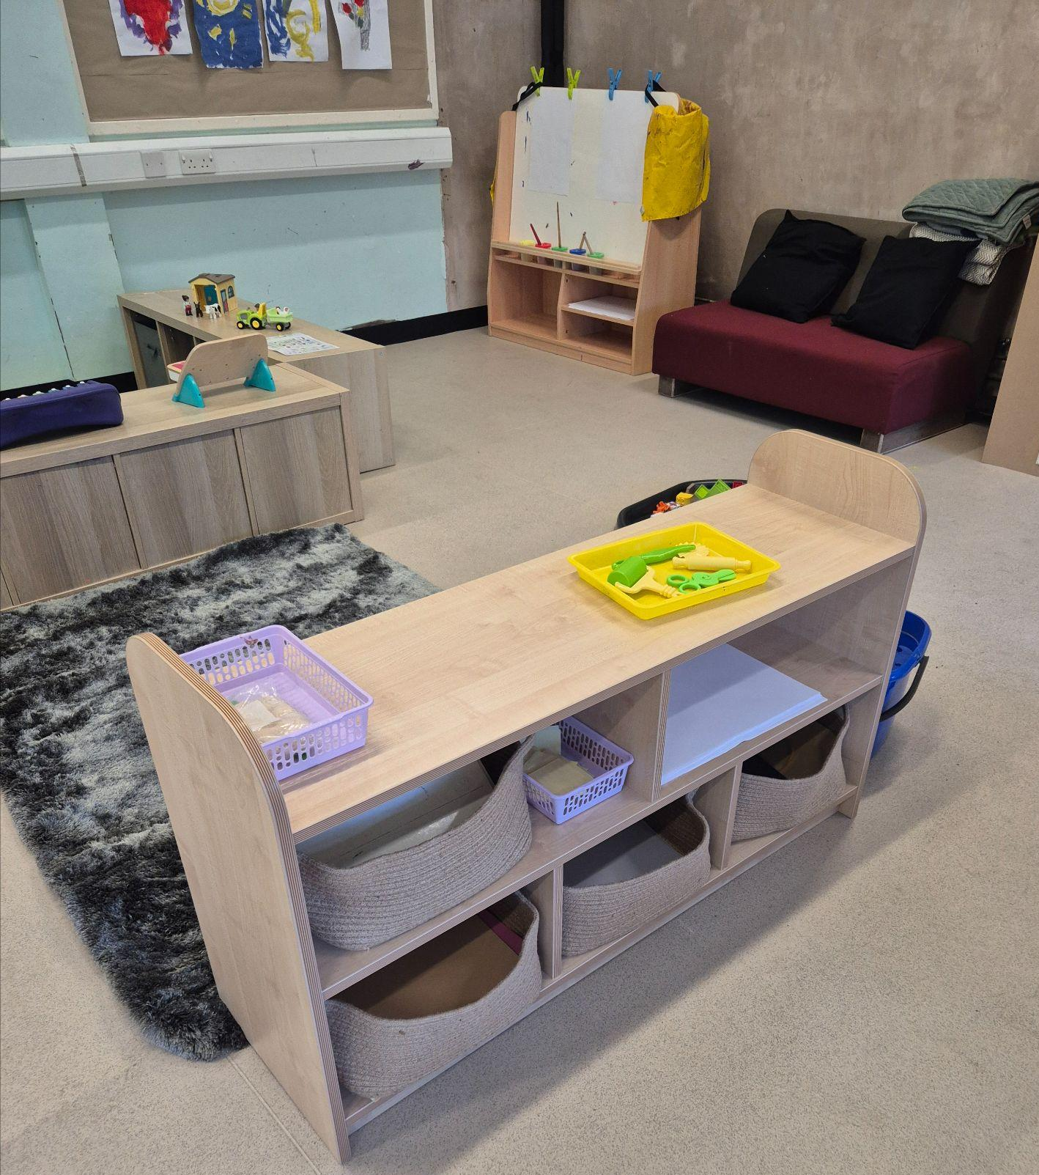
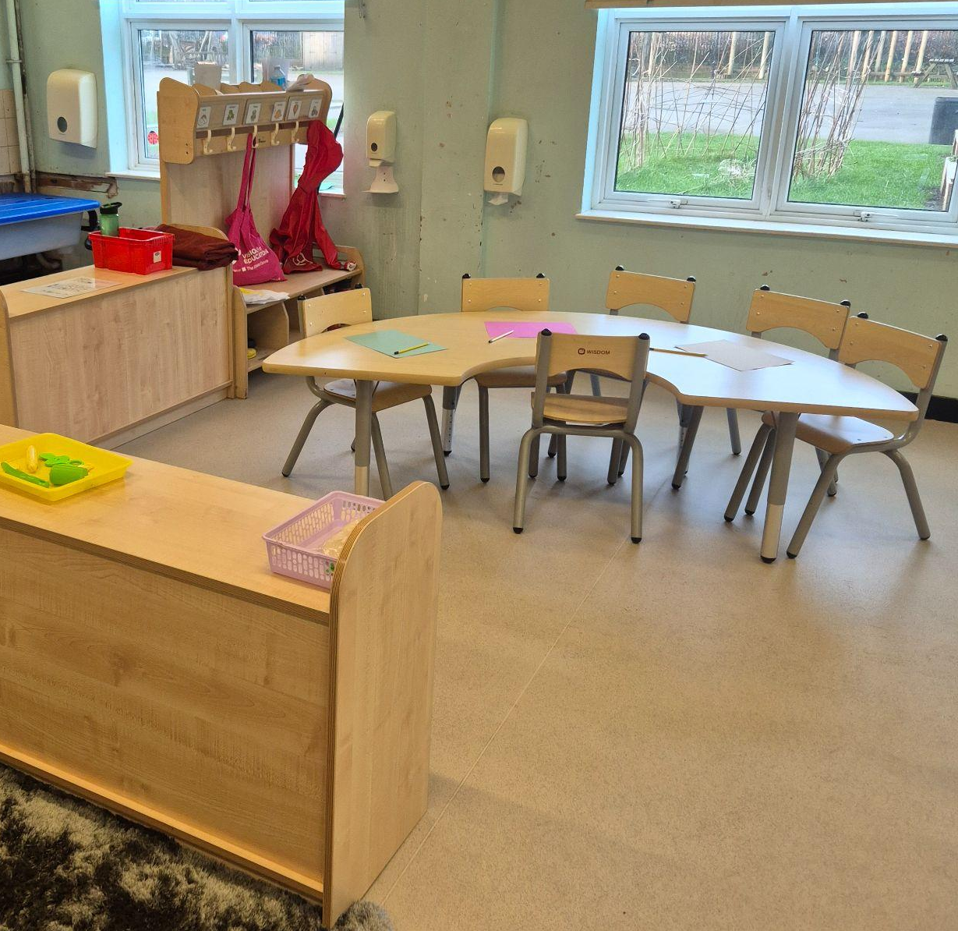
Photographs of Classroom
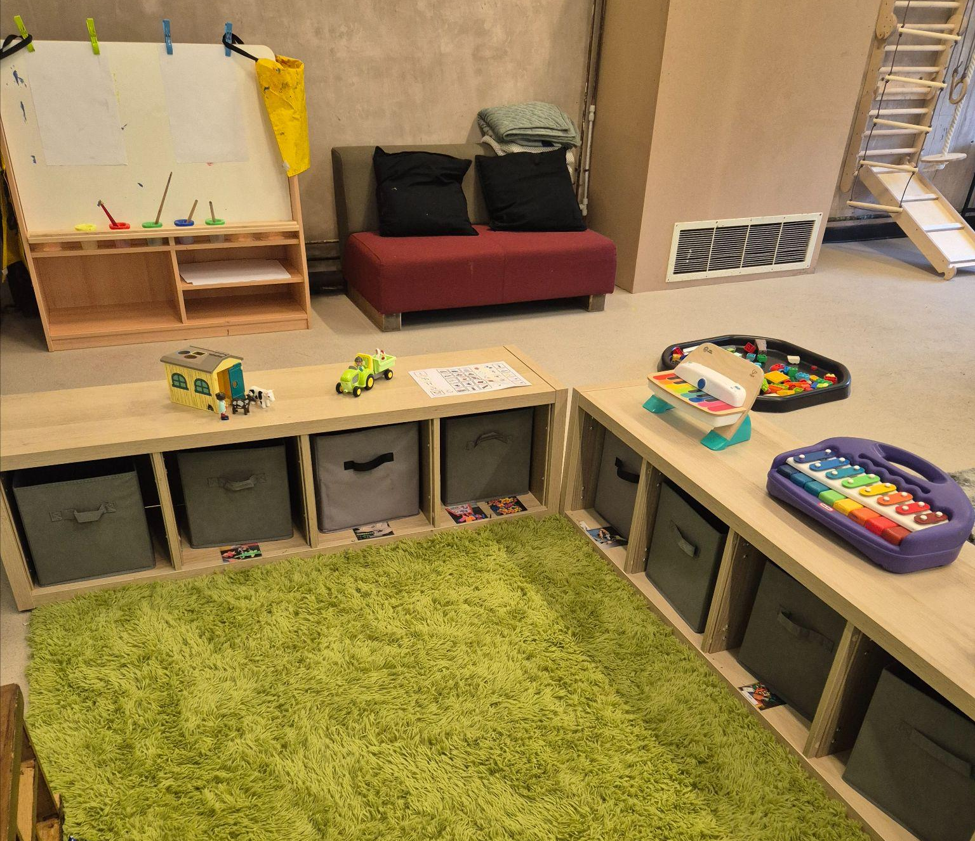

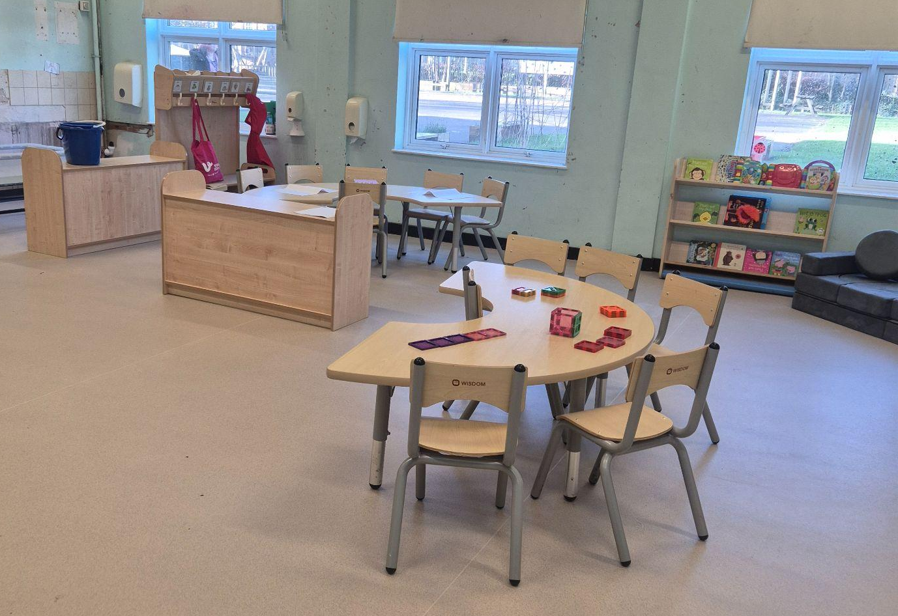

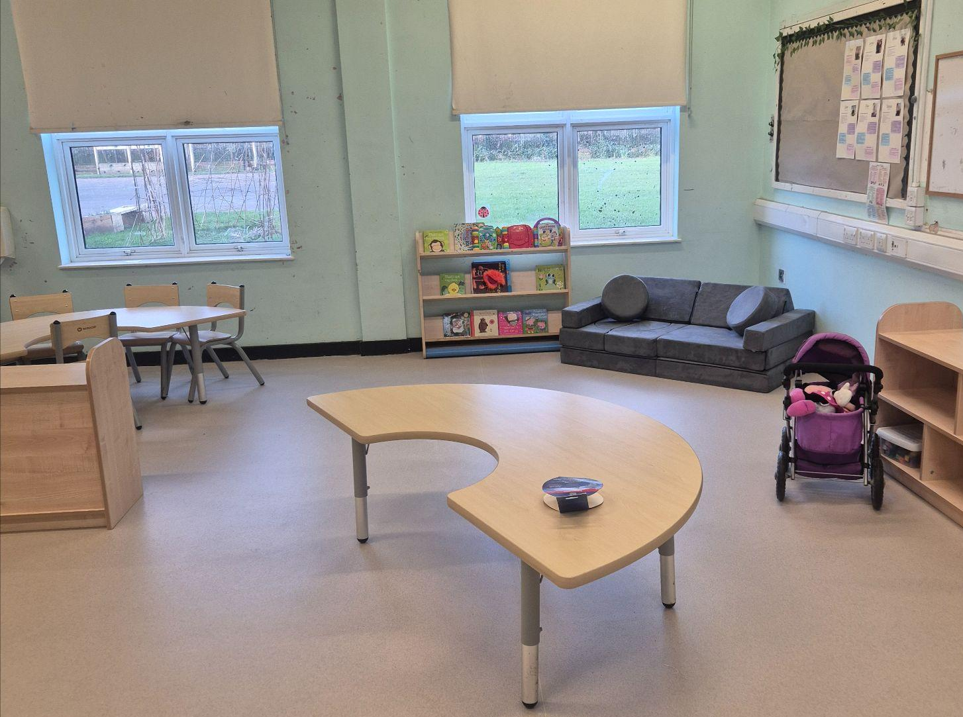

Inclusion Base timetable

 | 8:50-9:00 | 9:00 - 9:30 | 9:30-9:45 | 9:50-10:20 | 10:20 - 10:30 | 10:30 - 10:40 | 10:40 - 11:45 | 11:45 - 1:00 | 1:00-1:15 | 1:15 - 1:20 | 1:20-1:30 |  |  |  | 1:30-2:00 |  |  |  | 2:00 - 2:10 |  |  | 2:10 - 2:30 |  | 2:30 - 2:45 |  | 2:45 - 3:00 | 2:50-3:00 | 3:10pm
M | Good morning welcome  Access provision | Literacy  Access provision | Sensory circuit in hall | RISE therapy | Snack | Outside | Maths  Access provision | Lunch | Afternoon welcome  Storytime | Sensory song in class | Topic and activities introduction |  |  |  | Access Swedish ladder  Box time |  |  |  |  |  |  |  |  |  |  | PSHE | Storytime | Home time
Tu | Good morning welcome  Access provision | Literacy  Access provision | Sensory circuit in hall | RISE therapy | Snack | Outside | PE  Access provision | Lunch | Afternoon welcome  Storytime | Sensory song in class | Topic and activities introduction |  |  |  | Forest School  Box time |  |  |  |  |  |  |  |  |  |  | Sensory song in class | Storytime | Home time
W | Good morning welcome  Access provision | Literacy  Access provision | Sensory circuit in hall | RISE therapy | Snack | Outside | Maths  Access provision | Lunch | Afternoon welcome  Storytime | Sensory song in class | Cooking  Access provision |  |  |  |  |  |  |  |  |  |  | Box time |  |  |  | Sensory song in class | Storytime | Home time
Th | Good morning welcome  Access provision | Literacy  Access provision | Sensory circuit in hall | RISE therapy | Snack | Outside | Maths  Access provision | Lunch | Afternoon welcome  Storytime | Sensory song in class | Music |  |  |  | Access Swedish ladder  Box time |  |  |  |  |  |  |  |  |  |  | Sensory song in class | Storytime | Home time
F | Good morning welcome  Access provision | Literacy  Access provision | Sensory circuit in hall | RISE therapy | Snack | Outside | Maths  Access provision | Lunch | Afternoon welcome  Storytime | Sensory song in class | Science |  |  |  |  | Access Swedish ladder  Box time |  |  |  |  |  |  |  |  |  | Sensory song in class | Storytime | Home time

Meet the Staff
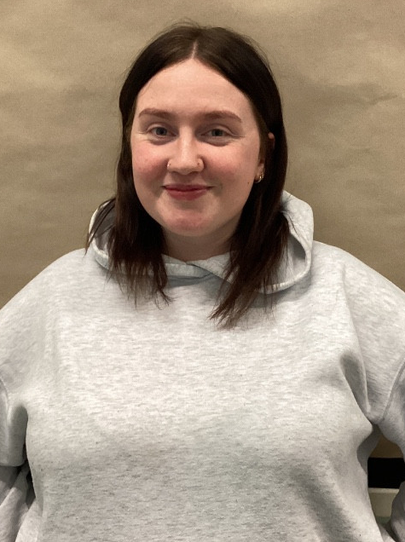
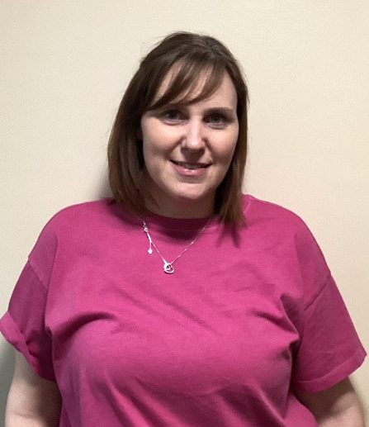

Miss Quinn Mrs Brown
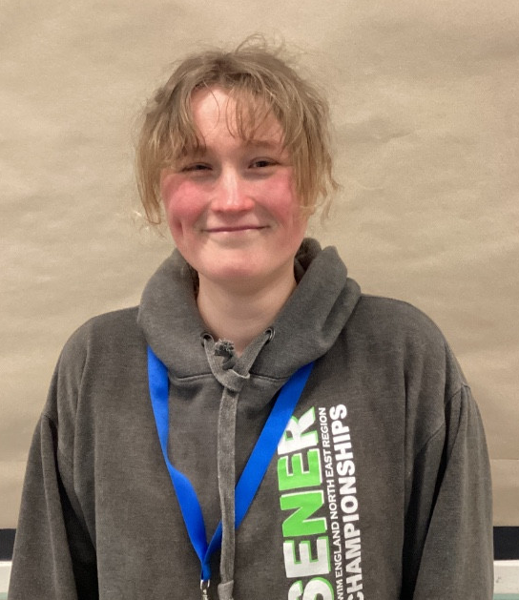

Miss Purdy

4. The school Day

Life in the Inclusion Base: Our Daily Routine

We understand that a predictable routine is vital for our students to feel secure and ready to learn. Our school day is structured to provide a calm, supportive environment where every child can thrive.

Arrival and Departure
To ensure a smooth transition into the school day, our Inclusion Base follows a specific drop-off and pick-up point.
- Start of the Day: The school day begins at 8:55 am. Please bring your child to the Nursery Gate, where they will be met by a familiar member of our team.
- End of the Day: School finishes at 3:15 pm. Children should be collected from the same Nursery Gate.
Using this dedicated entrance helps us manage the sensory environment and provides a consistent "bridge" between home and school.

The Importance of Attendance and Punctuality
Consistency is the foundation of progress, particularly for children within our Inclusion Base. Regular attendance and arriving on time are vital for several reasons:
- Routine and Security: For many children with SEND, a predictable schedule provides a sense of safety. Arriving at 8:55 am allows your child to participate in our "settling in" activities, which helps reduce anxiety and prepares them mentally for the day ahead.
- Social Integration: The start of the day is a key time for social interaction and building peer relationships. Consistent attendance ensures your child doesn't miss these informal but crucial learning moments.
- Specialist Support: Much of our targeted intervention and therapeutic support is scheduled early in the day. Frequent absences or late arrivals can result in your child missing out on the specific, high-impact support outlined in their learning plan.
We understand that mornings can sometimes be a challenge. If you are experiencing difficulties with school attendance or punctuality, please speak with us. We are here to support you and your child in making every school day a success.

Lunchtime and Nutrition
A healthy meal is a key part of our day. We offer several options to suit your child’s needs:
- Reception to Year 2: All children are entitled to a school lunch free of charge under the Universal Free School Meals program.
- Year 3 and Above: School meals are available for purchase. If your child is eligible for Free School Meals (FSM), these will continue to be provided at no cost.
- Packed Lunches: You are more than welcome to provide a packed lunch from home if that is more comfortable for your child.
Our Commitment to Your Child We know that lunchtime can sometimes be a challenge for children with additional needs. Please rest assured that our staff will work closely with you to understand your child’s preferences and sensory requirements, ensuring they feel supported and encouraged to eat a nutritious meal in a way that works for them.

5. Curriculum

Supporting Every Learner: Our Inclusion Base Approach
We are committed to providing a learning environment where every child can thrive, regardless of their starting point. To ensure our pupils in the Inclusion Base receive the most effective support, we have evolved our approach to be highly personalized and therapeutically informed.

A Sensory-First Curriculum
Recognising that many of our learners process the world differently, we have implemented a Sensory Curriculum. This framework moves beyond traditional desk-based learning to focus on the foundational sensory needs of our pupils. By integrating sensory breaks, tactile exploration, and regulated environments, we ensure that children are "ready to learn" by first feeling safe and balanced in their bodies.

Collaboration with Specialists
Progress is a team effort. We don't work in isolation; instead, we bridge the gap between education and clinical expertise. Our teaching staff works in close partnership with external professionals, including the Language and Communication Team (LCT) and Speech Therapists.
By incorporating their specialist strategies directly into the classroom, we ensure that every interaction—from playtime to snack time—is an opportunity for development.

Individualised Targets & EHCPs
No two children follow the same path. Our curriculum is anchored by each child’s Education, Health and Care Plan (EHCP).
- Bespoke Goals: We break down broad EHCP outcomes into manageable, "small-step" targets.
- Data-Driven Progress: These targets are reviewed regularly to ensure children are making strong, measurable progress.
- Holistic Growth: While academic milestones are important, we place equal value on progress in communication, independence, and social-emotional resilience.
Our Goal: To create a nurturing bridge between a child's specific needs and their ultimate potential, ensuring they feel successful every single day.

Sensory Curriculum & Progress: Frequently Asked Questions
To help you understand how our Inclusion Base operates on a daily basis, we have compiled answers to the most common questions regarding our specialised approach.

What does a "Sensory Curriculum" actually look like?
It isn't just about "play"; it is a structured approach to learning. Depending on your child’s needs, this might include:
- Heavy Work: Activities like pushing or pulling to help calm the nervous system.
- Sensory Circuits: A sequence of physical activities (e.g., jumping, spinning, balancing) designed to get the brain ready for learning.
- Rise Therapy: Highly visual sessions designed to build shared attention and communication skills.

How do you track progress if it isn't through standard tests?
We use "Small Steps" tracking on an APP called Tapestry. Because our pupils often make progress in non-linear ways, we celebrate and record:
- Increased time spent engaging with a task.
- Using a new sign or symbol to communicate a need.
- Successfully self-regulating during a moment of frustration.
These achievements are mapped directly back to the outcomes in their EHCP.

How often will my child see the Language and Communication Team?
The Language and Communication Team typically works on a consultative model. They visit the school to assess pupils, set specific targets, and—most importantly—train our staff. This ensures that the specialist strategies they recommend are used by our team every day, rather than just once a term during a therapy visit.

Can I see the targets my child is working on?
Absolutely. We believe the best progress happens when school and home are aligned. We share target sheets regularly and discuss them during:
- Termly PEP (Personal Education Plan) or target review meetings.
- The Annual Review of the EHCP.
- Use of the APP Tapestry so you can see how we are tracking progress in real time
- Looking at the Website Provision Mapping to see your child's learning plan.

Understanding the Impact
By blending therapeutic goals with a sensory-rich environment, we aim for a "whole-child" result:

