Family Fun Day
Celebrate the National Year of Reading with us!
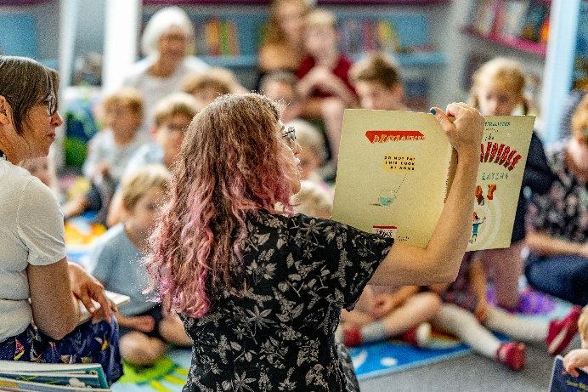
Southbourne Library
Saturday 14th November
9am – 1pm

A morning of FREE book-themed crafts, activities & more!
VR Headsets Drop-in 9.30-11
Gruffalo Storytime 11.30-12

Everyone welcome!
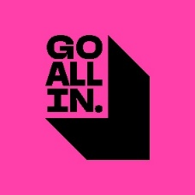
Parents and carers are asked to remain with their child for this activity.

