DRAFT
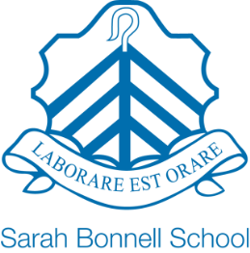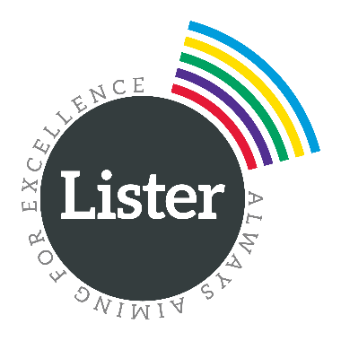

NEWHAM COMMUNITY SCHOOLS TRUST

VISION AND VALUES
The schools in the NCST have a shared commitment to working together to provide a world-class education for young people in Newham, and to developing as centres of excellence for teaching and learning.
We are highly ambitious for our students, and keen to develop their passion for learning. We seek to do this within calm, safe learning environments, where all members of the community treat each other with kindness, tolerance and respect.
We believe that no child should be left behind, that every child can succeed regardless of their starting point, and that every child should have access to a broad and rich range of experiences at school which will support their development as an active member of our community.
We are highly ambitious for our staff, developing a strong culture of continuous professional development. We want the NCST to attract and retain the best teaching and non-teaching staff, and be recognised as an organisation where staff at all levels receive outstanding support in developing their careers.

FOUNDING PRINCIPLES
The Trust will be/has been established in light of a number of founding principles, reflecting a steadfast commitment to:
- maintain each of the Schools’ comprehensive values, inclusive practices and non-selective admissions policies;
- ensuring that the governance of the trust will continue to reflect the schools’ close links with the local community
- recognise and value the contribution of staff to the success of the Trust, and in particular to doing so through
  - formally recognising the Trade Unions that support staff in the Schools
  - securing for all staff terms and conditions which at least match and in some important respects (such as the London Living Wage) improve on those prevailing in Local Authority maintained schools.

PRINCIPLES FOR EFFECTIVE PARTNERSHIP
The Schools have also committed to working in partnership, supporting one another, and there are clear underlying principles around how that partnership will work.
Equal Partners: At all times the partners will strive for consensus in decision making, recognising that each School has both strengths and weaknesses. The Trust will be respectful of each School’s distinctive ethos and identity. The Schools will work collaboratively with each other, sharing resources, knowledge and best practice, to fulfil the Trust’s mission, vision and values.
Transparency: All those involved in the running and oversight of the Trust and the Schools will be open and honest in their dealings with each other.
Subsidiarity: Decisions are to be taken at the level nearest to those affected by those decisions which is compatible with the principles of solidarity and support for the common good, avoiding unnecessary bureaucracy and aiming in so far as possible to make changes to established practices only where it can be demonstrated there is a reasonable need.
Cont’d…/
Solidarity: All those with responsibility for the Trust and the Schools share a particular commitment to the mutual support of all Schools for whom the Trust is responsible, especially those that are in need of assistance at any particular time.
The Common Good: All recognise their responsibility towards the common good, not just of the Schools for whom the Trust is responsible and the wider family of Newham schools, but of all of the families and communities in the areas served by the Trust.

