

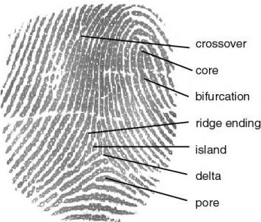
A history of biometrics
Once the domain of the local constabulary, Biometric technology is now being used at many locations around the country. Banks, supermarkets and now even schools and colleges are adopting this increasingly popular technology. Biometrics are not new, their roots have been traced back to ancient Egyptian times. The use of finger images as a security device started with Chinese officials using them to seal documents in the second century BC. Over the last few years the technology has begun to find favor commercially.

Whilst the use of Biometrics has been steadily growing over the last ten years, the past couple of years have seen an explosion in development, interest and vendor involvement.

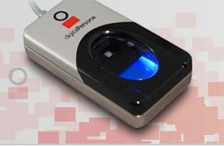

Impact Cashless Catering Systems
Headley Technology Park
Middle Lane, Wythall
Birmingham, B38 0DS

Tel: 01564 829999
Fax: 01564 826999
Email: service@cunninghams.co.uk

Impact Biometrics
Leaving a Lasting Impression
Bio – what?
Biometrics authentication is the automatic recognition of a living being using suitable body characteristics. By measuring an individual's physical features in an authentication inquiry and comparing this data with stored biometric reference data, the identity of a specific user is determined. There are many different biometric features that can be used for authentication purposes these include finger image, signature, iris, retina, DNA or any other unique characteristic. Once a characteristic has been chosen the next stage in the Biometric process is authentication. A biometric feature is saved on to a database. Once the data has been stored, a new scanning of the biometric feature is taken. If the comparison is positive, access to the appropriate application is granted.

The future is in your hands!

Make up of a fingerprint

Impact Biometrics is coming to



Biometrics and Security
Students, parents and staff can rest assured that the fingerprint images cannot be used by any other source for identification purposes. The system uses an image of the finger to create a mathematical algorithm and then discards the finger image; only the numbers remain and these cannot be reinterpreted back into a finger image.

The future is in your hands!



Frequently Asked Questions

Why do you need to take my child’s finger image?
By taking an image of your child’s finger we can turn this information into a digital signature.

Can finger images be used by any other agency?
No, the software we use turns your child’s finger image in to a mathematical algorithm. The image of the finger is then discarded. The information that is stored cannot be used to recreate an image of the child’s finger.

What happens when my child leaves the School?
When a student leaves school all data will be deleted.

How does it work?
When the child places his/her finger on the scanner, the software matches their finger image with the unique digital signature held in the database.

Impact Biometrics Opt-In form
I do wish my child to be included in the Impact Biometric registration process

Name of Pupil:
Year:
Class:
Name of guardian or parent:
Signed:
Please fill in this form and ask your child to return to their tutor by Monday 9th March 2015 at the latest

