Person specification- Estates Manager
Shires MAT is a values driven organisation where Nurture, Equity, Service and Wisdom guide our provision as a Trust. Whilst these values act as an overarching guide across our organisation, each school remains unique, and each context has its own set of school values to support pupils in their learning and development. All staff within the MAT follow an appraisal and development approach linked to NESW and as such it is essential staff members understand and enable the values to permeate through their approaches to staff, pupils and the wider community.
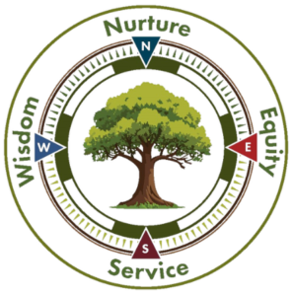
Criteria - These will be assessed through application, interview, references, activities, and
presentations

We recognise that individuals working in estates, catering and facilities management come from many different sectors and are keen to hear from anyone working inside or outside of education.
 | Required | Desirable
Education, Training & Qualifications
Undergraduate degree (or equivalent) with evidence of personal development |  | x
A professional qualification in subject matter related to estates, facilities or health and safety (NEBOSH/ IOSHH / Project management) | x
Experience
Experience of working within estates, facilities management, catering or a related field, preferably in a multisite environment | x
Experience of managing multiple teams and leading transformational change at a senior level | x
Experience in compliance assurance and regulatory reporting within estates or facilities management | x
Experience of all areas of contract management, from scope of works to tender process and implementation and quality assurance | x
Experience of largescale project management, including capital expenditure within an estates context | x
Experience of bid writing and successfully securing external funding on a project basis |  | x
Experience or knowledge of implementing sustainability initiatives |  | x
Skills
Ability to think strategically and understand the link to the success of a day-to-day operation | x
Ability to engage and manage different stakeholders in a complex environment | x
Ability to solve problems via creative solutions | x
Ability to use information technology and digital systems to design efficient management and reporting systems | x
Ability to manage complex income and expenditure budgets, using financial reporting tools to make informed decisions | x
Values & Personal Style
A pragmatic style of leadership that can balance competing priorities sensitively and demonstrates trust values linked to nurture, equity, service and wisdom | x
A good listener who can build coalitions amongst individuals who disagree | x
Resilience and adaptability in managing competing priorities, Commitment to professional growth and continuous learning | x
A strong communicator – both verbal and written | x
An empathy for education and the environment in which the Trust operates | x
A commitment to equality, diversity and inclusion | x

