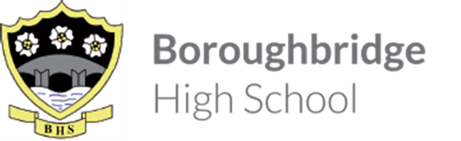

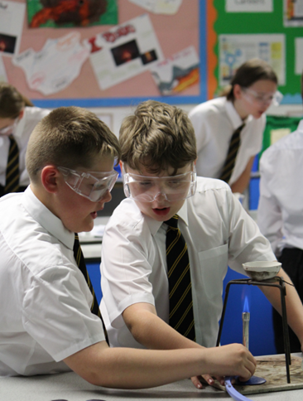
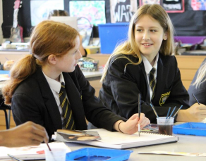
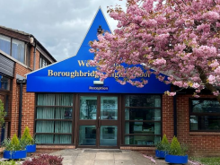
Information for Candidates
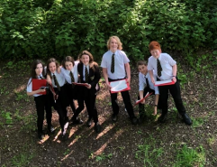
Staff know pupils well at Boroughbridge High School. There are positive relationships between pupils and staff. Ofsted May 2023

Welcome from the Headteacher
Thank you for considering Boroughbridge High School for the next stage of your career where our belief in ‘Aspiration for All’ means that our students are at the heart of our decision making. With around 450 students, we serve the community of Boroughbridge and the wider rural area, attracting students from more than 35 partner primaries which gives our school a welcoming, inclusive atmosphere. We feel like a family and, as such, we know our students well making Boroughbridge High School a good place to work and learn. We all understand our responsibility to ensure that everyone within our school community is safe, happy and successful.
Success, in its widest sense, underpins our mission which is to ensure that all students leave our school, not only with the qualifications that they need to access the next stage of their education or career of choice, but with the skills and confidence to make an active contribution to the communities to which they belong. We understand that this can only happen in an environment where there are high expectations with staff who have the skills and confidence to create high quality, engaging learning experiences which secure good student progress.
We also understand the benefit of partnership working and are federated with King James’s School in Knaresborough.
Just as we know our students well, as a member of staff you will be part of a staff team of 63 with 28 teaching staff, 14 of whom are part-time. You will be known and will have the capacity to make a significant difference to our school community.
This is an exciting time to join Boroughbridge High School. Following our Ofsted Inspection in May 2023, we have introduced ‘Learning Phases’ so that our expectations for each phase of learning, Whole class work, Group and Pair work and Individual work, are clear. We have also been working with the DfE Behaviour Hub programme since January 2024 which has supported us in embedding our phases of learning and deepening our Behaviour for Learning system. This has enabled us to have significant impact on the standard of behaviour and qulaity of learning across the school and, as a school community, we are proud of our progress to date. This good progress has been validated during visits from our Local Authority adviser. However, don’t just take our word for it. if you would like to see for yourself, then please contact us at vacancies@boroughbridgehighschool.com and we would be delighted to show you our school on a working day.
I hope that the opportunity that we have is of interest to you.
Kathryn Stephenson
Safe and happy students are successful

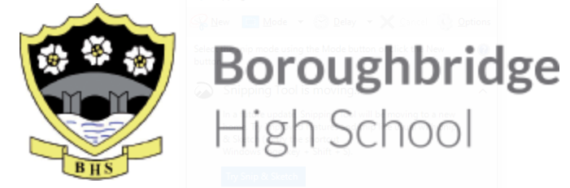

Evening Cleaner
May 2024 start
10-20 hours per week, Full Year
Monday to Friday (hours to be worked between 4pm and 8pm)
Grade: AB, £12 per hour

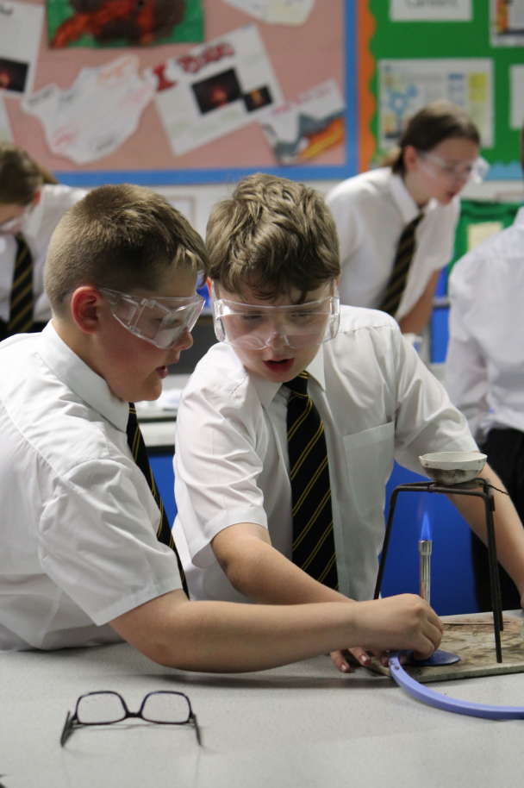
Boroughbridge High School is seeking to appoint self-motivated Cleaners to work the evening shift. You will be working with a highly supportive team, responsible for a wide range of duties which include ensuring that areas of work allocated are cleaned to high standard/specifications.

Boroughbridge High School is a relatively small 11-18 comprehensive school of just less than 500 pupils, and is proud to offer high quality professional development and career opportunities for all staff.

This is a full year contract working 15 hours per week anytime between 4.00pm – 8.00pm (Monday – Friday). In return, we offer a competitive salary, an Employee Discount Scheme and access to a contributory local pension scheme.

You will be able to undertake general cleaning duties; and have the ability to manage time effectively to complete tasks to a high standard, working with minimal supervision.

The school is committed to safeguarding and promoting the welfare of young people and expects all members of staff to share this commitment. An Enhanced DBS check will be required for this post.

For an application form please visit our school website. Completed application forms should be returned via email to vacancies@boroughbridgehigh.com
or by post to Boroughbridge High school, Wetherby Road, Boroughbridge, YO51 9JX and marked for the attention of HR Recruitment by Monday 13 May 2024, midday.

Please note that CVs will not be accepted.

The Cleaning Team

Boroughbridge High School forms part of the ‘Boroughbridge High School and King James’s School Federation’ and is pleased to offer the opportunity to join a highly committed Cleaning Team which delivers an outstanding service to both our students and staff, supporting their good health and wellbeing. Our team is coordinated by an Assistant Site Manager and is crucial in providing assistance to our Maintenance team in the day-to-day look and hygiene of the school.

We appreciate that the cleanliness of school classrooms and equipment is an important factor in the success of our school.

Boroughbridge High School has an extensive range of facilities including: standard classrooms, bespoke classrooms such as: Art, D&T, Food Technology, Science and IT, meeting rooms and offices, an assembly/food hall, IT suites, Performing Arts studio, Music block, fitness suite and a sports hall; plus bungalow facility for outsourced provision.
We are very proud of our high standards and good reputation which enables us to additionally offer a number of our facilities for external hire.

Boroughbridge high school

JOB DESCRIPTION
All job descriptions will be reviewed annually & set in the context of the school’s aims & current development plan

Evening Cleaner
Line Manager: | Assistant Site Manager
Responsible to: | - Assistant Site Manager  - Maintenance Team  - Premises Services Manager
Salary NYCC Band: | Grade AB
Full Time/Part Time: | Part-time
Hours: | 10-20 hours per week  (between 4pm-8pm, Monday to Friday)
Full Year/Term-Time Only: | Permanent - Full Year
Job Evaluated Date: | April 2024

Professional Responsibilities
all associate staff
1. | To work within the North Yorkshire Council’s Conditions of Service
2. | To support the aims, policies, procedures and ethos of the school
3. | To participate in the school’s agreed Performance Management procedures
4. | Help safeguard the welfare of children in the school and ensure services are delivered with regard to equalities
5. | Work safely and co-operate with health and safety procedures
6. | Attend school meetings as appropriate within designated working hours
7. | Undertake appropriate staff training and development activities
8. | Undertake whatever duties might be reasonably requested by the Head or Line Manager
Boroughbridge High School

JOB DESCRIPTION

POST: Evening Cleaner
GRADE: Grade AB
RESPONSIBLE TO: Assistant Site Manager/Maintenance Team/Premises Services Manager
STAFF MANAGED: None
POST REF. NO: |  |  | JOB FAMILY: 4
JOB PURPOSE: |  | To provide a high quality, effective cleaning service to ensure a clean and hygienic environment for all building users.
JOB CONTEXT: |  | The premises team as a whole are responsible for maintaining high standards of cleanliness throughout the school.  The post is required to work with cleaning equipment and products which contain chemicals, but the necessary protective clothing will be provided  Enhanced DBS check is required for this post due to working within a school environment
ACCOUNTABILITIES / MAIN RESPONSIBILITIES
Operational Issues | Carry out cleaning duties within allocated timescales and to take a flexible  approach in order to meet the schools requirements. Duties will include, but are  not limited to:  - General dusting of furniture, fixings and fittings  - Dust control mopping/sweeping of floors  - Vacuuming floors  - Cleaning and polishing floors using electrical buffing machine  - Damp/wet mopping of floors  - Polishing furniture, cleaning internal glass  - Cleaning of sanitary fittings  - Using cleaning materials as instructed  - Specialist cleaning (e.g. stripping and sealing of floors)  - Emptying of waste paper bins  - Wiping surfaces, fixtures and fittings and paintwork cleaning
Communications | - Communicate effectively with other members of staff within the school
Resource management | - Participate in the training and development and performance management processes within the school  - Store cleaning equipment and products safely and securely
Safeguarding | - Be committed to safeguarding and promote the welfare of  children, young people and adults, raising concerns as appropriate
Systems and Information | - Fulfil the necessary administrative tasks associated with the responsibilities of the post  - Undertake all relevant training courses relevant to the post (including COSHH and Manual Handling)
Data Protection | - Comply with Boroughbridge High School’s policies and supporting documentation in relation to Information Governance this includes Data Protection, Information Security and Confidentiality.
Health and Safety | - Be aware of and implement your health and safety responsibilities as an employee and where appropriate any additional specialist or managerial health and safety responsibilities as defined in the Health and Safety policy and procedure.  - Work with colleagues and others to maintain health, safety and welfare within the working environment.  - Perform duties in line with health and safety regulations (COSHH) and take action where hazards are identified, reporting serious hazards to line manager immediately
Equalities | - Boroughbridge High School aims to make sure that services are provided fairly to all sections of our community, and that all our existing and future employees have equal opportunities.  - Within own area of responsibility work in accordance with the aims of the Equality Policy Statement
Flexibility | Boroughbridge High School provides front line services, which recognises the need to respond flexibly to changing demands and circumstances. Whilst this job outline provides a summary of the post, this may need to be adapted or adjusted to meet changing circumstances. Such changes would be commensurate with the grading of the post and would be subject to consultation. All staff are required to comply with County Council and Boroughbridge High School’s Policies and Procedures.
Customer Service | Boroughbridge High School requires a commitment to equity of access and outcomes, this will include due regard to equality, diversity, dignity, respect and human rights and working with others to keep vulnerable people safe from abuse and mistreatment.  - Boroughbridge High School requires that staff offer the best level of service to their customers and behave in a way that gives them confidence. Customers will be treated as individuals, with respect for their diversity, culture and values.
Date of Issue: | April 2024

PERSON SPECIFICATION

JOB TITLE: Evening Cleaner

Essential upon appointment | Desirable on appointment (if not attained, development may be provided for successful candidate)
Knowledge
- Awareness of Health and Safety | - Ability to use floor machines
Experience
- Experience of undertaking general cleaning duties | - Experience of working as part of a team  - Experience of working in the cleaning industry
Occupational Skills
- Able to work with minimum supervision.
- Self-motivated
- Punctuality
- Flexible approach
- Attention to detail
- Ability to manage time effectively to complete tasks to a high level.
- Ability to work both alone and within a team to achieve specified standards
- Good verbal communication skills

Qualifications
- Willingness to undertake training courses commensurate with the role (including COSHH and Manual Handling)
Other Requirements
- Ability to carry out general cleaning duties as detailed in the Job Description
- Enhanced DBS clearance

