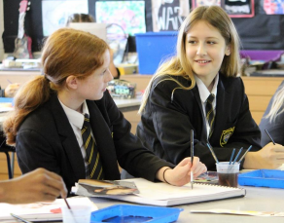
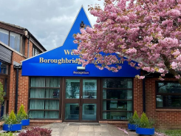
Information for Candidates
Staff know pupils well at Boroughbridge High School. There are positive relationships between pupils and staff. Ofsted May 2023

Welcome from the Headteacher
Thank you for considering Boroughbridge High School for the next stage of your career where our belief in ‘Aspiration for All’ means that our students are at the heart of our decision making. With around 450 students, we serve the community of Boroughbridge and the wider rural area, attracting students from more than 35 partner primaries which gives our school a welcoming, inclusive atmosphere. We feel like a family and, as such, we know our students well making Boroughbridge High School a good place to work and learn. We all understand our responsibility to ensure that everyone within our school community is safe, happy and successful.
Success, in its widest sense, underpins our mission which is to ensure that all students leave our school, not only with the qualifications that they need to access the next stage of their education or career of choice, but with the skills and confidence to make an active contribution to the communities to which they belong. We understand that this can only happen in an environment where there are high expectations with staff who have the skills and confidence to create high quality, engaging learning experiences which secure good student progress.
We also understand the benefit of partnership working and are federated with King James’s School in Knaresborough.
Just as we know our students well, as a member of staff you will be part of a staff team of 63 with 28 teaching staff, 14 of whom are part-time. You will be known and will have the capacity to make a significant difference to our school community.
This is an exciting time to join Boroughbridge High School. Following our Ofsted Inspection in May 2023, we have introduced ‘Learning Phases’ so that our expectations for each phase of learning, Whole class work, Group and Pair work and Individual work, are clear. We have also been working with the DfE Behaviour Hub programme since January 2024 which has supported us in embedding our phases of learning and deepening our Behaviour for Learning system. This has enabled us to have significant impact on the standard of behaviour and qulaity of learning across the school and, as a school community, we are proud of our progress to date. This good progress has been validated during visits from our Local Authority adviser. However, don’t just take our word for it. if you would like to see for yourself, then please contact us at vacancies@boroughbridgehighschool.com and we would be delighted to show you our school on a working day.
I hope that the opportunity that we have is of interest to you.
Kathryn Stephenson
Safe and happy students are successful

School Caretaker
May 2024 start
Full time (37 hours). Full year (52 weeks)
Monday to Friday: £22,737 – £23,893 (NYC Grade CD)
Saturday/Sunday (optional rota): £50.00 fixed rate (includes open and lock up)

Boroughbridge High School is offering an exciting opportunity to support the existing premises team with a broad range of site operational tasks.

The purpose of this role is to ensure a safe, secure, welcoming environment for staff, students and site visitors. Your responsibilities may include: site cleaning and grounds maintenance, ensuring the site is safe and secure, undertaking general porterage and receiving of deliveries to the site, assisting with low-level maintenance and construction tasks, welcoming of external facility hire customers (including assisting with set-up and clear down of equipment as required), driving the school minibus (if eligible).

Hours will be worked on a rotational basis between 7am and 10pm, Monday to Friday. Occasional weekend working may be required on an ad hoc basis to support facilities hire and events. Regular weekend work on a rotational basis may be available.
The post holder may need to be available for emergency call out on a rotational basis.

You will have a helpful and friendly manner, friendly approach, eye for detail, be self-motivated and able to work independently. You will be a responsible key holder. Full training will be provided.

We take pride in our open, friendly ethos and are committed to high quality professional development. You will be directly supporting our Assistant Site Manager, Site Maintenance and Deputy Site & Lettings Manager

The school is committed to safeguarding and promoting the welfare of young people and expects all members of staff to share this commitment. An Enhanced DBS check will be required for this post.

For an application form please visit our school website. Completed application forms should be returned via email to vacancies@boroughbridgehigh.com
or by post to Boroughbridge High school, Wetherby Road, Boroughbridge, YO51 9JX and marked for the attention of HR Recruitment by Monday 13 May 2024, 08.00am.

Please note that CVs will not be accepted.
Information on the School

Boroughbridge High School forms part of the ‘Boroughbridge High School and King James’s School Federation’. Boroughbridge High School is proud to offer this outstanding opportunity to join a highly committed Federation team, who deliver an outstanding service to both our students and staff.

Boroughbridge High School is an 11-18 community comprehensive school which serves Boroughbridge and the surrounding area. With just under 500 students we are a relatively small school which gives us a welcoming, inclusive atmosphere.

We are very proud of our high standards and good reputation.

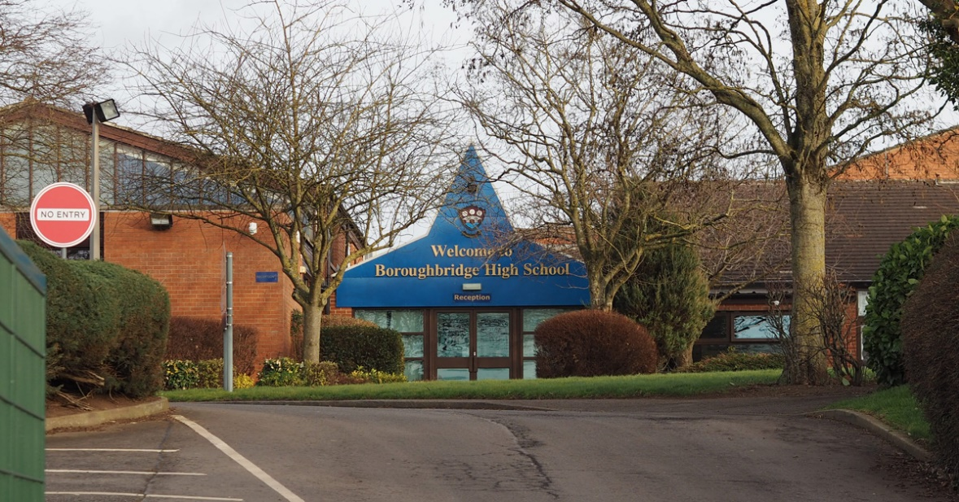
How to Apply

Please download an application form and complete.

Please use the section 16 “Supporting Evidence” on the application form to demonstrate how you can meet the criteria given in the advert.

Please note CVs will not be accepted. Please do not enclose a covering letter as this will not form part of your application.

We are committed to safeguarding and promoting the welfare of young people and expect all members of staff to share this commitment.

An Enhanced DBS disclosure is required for this post through North Yorkshire County Council. This will be arranged for the successful applicant.

Completed application forms should be returned via email to vacancies@boroughbridgehigh.com
or by post to Boroughbridge High school, Wetherby Road, Boroughbridge, YO51 9JX and marked for the attention of HR Recruitment by Monday 13 May 2024, 08.00am.

Thank you for your interest in this post. If you have not heard from us within 21 days of the closing date, please assume your application has been unsuccessful. In that event, may we wish you well in your search for a suitable position.

Boroughbridge High School

JOB DESCRIPTION
All job descriptions will be reviewed annually & set in the context of the school’s aims & current development plan

School Caretaker
Responsible to: | Assistant Site Manager  Premises Services Manager  Deputy Site & Lettings Manager  Headteacher
Salary NYCC Band: | Grade CD
Full Time/Part Time: | Full Time (37 hours)
Hours: | Standardly between 7am and 10pm following a weekly shift pattern
Full Year/Term Time Only: | Permanent - Full Year

Professional Responsibilities
all associate staff
1. | To work within the North Yorkshire Council’s Conditions of Service
2. | To support the aims, policies, procedures and ethos of the school
3. | To participate in the school’s agreed Performance Management procedures
4. | Help safeguard the welfare of children in the school and ensure services are delivered with regard to equalities
5. | Work safely and co-operate with health and safety procedures
6. | Attend school meetings as appropriate within designated working hours
7. | Undertake appropriate staff training and development activities
8. | Undertake whatever duties might be reasonably requested by the Head or Line Manager

POST: School Caretaker
GRADE: CD
RESPONSIBLE TO: Headteacher/Premises Services Manager/Assistant Site Manager (Line Manager)/Deputy Site & Lettings Manager
STAFF MANAGED: None
POST REF: |  |  | JOB FAMILY: 4
JOB PURPOSE: |  | To provide high quality effective general site support services to ensure a secure, safe and hygienic environment for all building users at Boroughbridge High School; as part of the ‘Boroughbridge High School and King James’s School Federation’ premises team.
JOB CONTEXT: |  | The premises team as a whole are responsible for maintaining high standards of cleanliness and maintenance of equipment and buildings throughout the school, and to support with evening/weekend activities (on a rotational basis) such as school events and facilities hire.  The post is required to be a designated key holder, undertake manual handling tasks and work with products which contain chemicals (but the necessary protective clothing will be provided). The post holder may also be required to work outdoors in all weathers to ensure the school premises is safe.  If eligible and holding a clean driving license, the post holder may be requested to support with transfer of pupils; driving a Federation minibus between schools, or to local educational visit locations.  The post holder will be available for emergency call outs on a rotational basis.  This school is committed to safeguarding and promoting the welfare of our pupils and young people. We have a robust Child Protection Policy and all staff will receive training relevant to their role at induction and throughout employment at the School. We expect all staff and volunteers to share this commitment. This post is subject to a satisfactory enhanced Disclosure and Barring Service criminal records check for work with children.  An ability to fulfil all spoken aspects of the role with confidence through the medium of English.
ACCOUNTABILITIES / MAIN RESPONSIBILITIES
Operational Issues | - Undertake cleaning tasks as directed within allocated timescales in order to meet the schools requirements. This will include but is not limited to: dusting, vacuuming, polishing, mopping, floor buffing and floor polishing, polishing of glazing, emptying of waste bins, cleaning of sanitary fittings, graffiti and chewing gum removal (PPE will be provided)  - Collect and assemble waste for collection  - Ensure the security of the building and site, undertaking security checks as required (to support the premises team)  - Act as a designated key holder, locking and unlocking of buildings at pre-determined times (providing response to emergency calls as required)  - Ensure outside areas are safe / clean, kept free from litter, debris, leaves and that there is safe access to the building during adverse weather conditions e.g. snow (as required)  - Undertake general porterage duties whilst on site to include moving furniture and equipment on site as required (supporting with set up for assembles/evening events/community lettings etc as required)  - Receive deliveries to the site as required  - Support with maintenance of the building by checking and replacing light fittings, undertaking minor repairs (not requiring a contractor) of a range of equipment and buildings, painting and decorating (as required) to support the caretaking team  - Support with transportation of students/staff as required on the school minibus on an ad hoc basis (clean full driving license and MiDAS training certificate required) – if eligible  - ‘Meet and greet’ of facilities hirers (evenings and weekends - on a rotational basis)  - Support with set-up/clear down of facilities hire equipment, and/or, checking that hirers have returned hired equipment to appropriate storage locations (evenings and weekends – on a rotational basis)
Communications | - Communicate effectively with other members of staff and pupils within the school  - Welcome community facilities hirers and ensure their requirements are met for commencement of their booking through liaison with the Deputy Site & Lettings Manager
Resource Management | - Participate in the training and development and performance management processes within the school  - Be able to carry out simple informal risk assessments on buildings to identify faults / hazards – report these to the Assistant Site Manager / Maintenance team  - Monitor and report low stock levels to the Assistant Site Manager / Site Maintenance  - Store equipment and products (including chemicals) safely and securely
Safeguarding | - Be committed to safeguarding and promote the welfare of  children, young people and adults, raising concerns as appropriate
Systems and Information | - Fulfil the necessary administrative tasks associated with the responsibilities of the post
Data Protection | - Comply with the Federation’s and local authorities policies and supporting documentation in relation to Information Governance this includes Data Protection, Information Security and Confidentiality
Health and Safety | - Be aware of and implement your health and safety responsibilities as an employee and where appropriate any additional specialist or managerial health and safety responsibilities as defined in the Health and Safety policy and procedure  - Work with colleagues and others to maintain health, safety and welfare within the working environment  - Perform duties in line with health and safety regulations (COSHH) and take action where hazards are identified, reporting serious hazards to line manager immediately
Equalities | - The Federation aims to make sure that services are provided fairly to all sections of our community, and that all our existing and future employees have equal opportunities  - Within own area of responsibility work in accordance with the aims of the Equality Policy Statement
Flexibility | The Federation provides front line services, which recognises the need to respond flexibly to changing demands and circumstances. Whilst this job outline provides a summary of the post, this may need to be adapted or adjusted to meet changing circumstances. Such changes would be commensurate with the grading of the post and would be subject to consultation. All staff are required to comply with Federation and local authority Policies and Procedures.
Customer Service | The Federation requires a commitment to equity of access and outcomes, this will include due regard to equality, diversity, dignity, respect and human rights and working with others to keep vulnerable people safe from abuse and mistreatment.  - The Federation requires that staff offer the best level of service to their customers and behave in a way that gives them confidence. Customers will be treated as individuals, with respect for their diversity, culture and values.

PERSON SPECIFICATION

JOB TITLE: School Caretaker

Essential upon appointment | Desirable on appointment
Knowledge  - Awareness of Health & Safety  - Ability to read and write through the medium of English | - Ability to use tools for making minor repairs
Experience  - Experience of undertaking general cleaning duties  - Experience of carrying out minor repairs | - Experience of working as part of a team  - Experience of driving a large passenger vehicle
Occupational Skills
- Able to work with minimum supervision
- Self-motivated
- Punctuality
- Flexible approach
- Attention to detail
- Ability to manage time effectively to complete tasks to a high level
- Ability to work both alone and within a team to achieve specified standards
- Good verbal communication skills
- Assertiveness and confidence to speak in/to groups of people
Qualifications  - Willingness to undertake training courses commensurate with the role (including COSHH and Manual Handling) | - Clean driving license  - MiDAS certificate – for driving minibus (would be provided at the expense of the school)
Other Requirements
- Ability to carry out general caretaking and cleaning duties as detailed in the Job Description.
- Enhanced DBS clearance
- The ability to converse at ease with customers and provide advice in accurate spoken English is essential for the post

