Teacher of Mathematics
Pay Scale: MPS/UPS
Contract: Full time
Contract Term: Permanent
Start Date: September 2024 (or sooner, if possible)

Are you a committed, inspiring and enthusiastic teacher who is seeking a new role in a school where ‘Aspiration for all’ is always at the forefront of students’ learning? A fantastic opportunity has arisen at Boroughbridge High School for a teacher of Mathematics to join our innovative, supportive and friendly team.

What makes Boroughbridge High School a great place to work and learn?

Thank you for considering Boroughbridge High School for the next stage of your career where our belief in ‘Aspiration for All’ means that our students are at the heart of our decision making. With around 450 students, we serve the community of Boroughbridge and the wider rural area, attracting students from more than 35 partner primaries which gives our school a welcoming, inclusive atmosphere. We feel like a family and, as such, we know our students well making Boroughbridge High School a good place to work and learn. We all understand our responsibility to ensure that everyone within our school community is safe, happy and successful.

Success, in its widest sense, underpins our mission which is to ensure that all students leave our school, not only with the qualifications that they need to access the next stage of their education or career of choice, but with the skills and confidence to make an active contribution to the communities to which they belong. We understand that this can only happen in an environment where there are high expectations with staff who have the skills and confidence to create high quality, engaging learning experiences which secure good student progress. We also understand the benefit of partnership working and are federated with King James’s School in Knaresborough.

Just as we know our students well, as a member of staff you will be part of a staff team of 63 with 28 teaching staff, 14 of whom are part-time. You will be known and will have the capacity to make a significant difference to our school community.

What is our curriculum?
High quality teaching within an ambitious, engaging and inspiring curriculum ensures that students are motivated to learn. Ofsted recognised the quality of our curriculum in May 2023 judging it to be ‘Good’, saying ‘Curriculums are well thought out and sequenced.’

At Key Stage 3

We have a three-year Key Stage 3 curriculum enabling students to study the full range of National Curriculum subjects in depth along with an extensive PSHCE (Personal, Social, Health, Citizenship and Economic) programme. Students begin to personalise their curriculum at the end of Year 8 before making their GCSE option choices at the end of Year 9.

At Key Stage 4

At GCSE, students are taught Core GCSEs across the two years. For Option Subjects, students follow a Stage not Age curriculum which means that they study two of their four option subjects in Year 10, taking the exam at the end of Year 10. This enables students to secure two GCSE/BTEC qualifications whilst developing deep knowledge of exam technique in Year 10 which they can then apply to their subjects during Year 11. All students have access to an EBacc curriculum. This is complemented by the PSHCE curriculum.

The Mathematics Department

Currently, the Maths Department consists of the Head of Department (Natalie Cummins) and three other Maths teachers. This post has risen due to the previous post holder moving to a different part of the country.

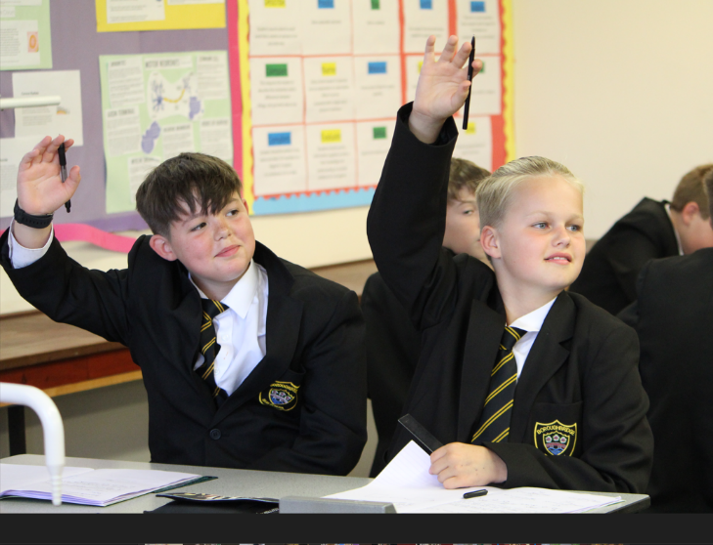
Mathematics is taught in four specialist classrooms with a Mathematics Team Room in the centre of them. At Key Stage 3, students follow a spiral curriculum based around number, geometry and measures, algebra and data handling. Students have 7 lessons each fortnightly lesson cycle (2 weeks) in Years 7, 8 and 9. At Key 4, students follow the AQA Mathematics specification. Students have 7 lessons each fortnightly lesson cycle in Years 10 and 11.

You can find out more about the Mathematics curriculum and view our Curriculum Progression maps at https://www.boroughbridgehigh.com/curriculum/subjects/

In Mathematics, students are taught in mixed ability classes for the first half term of Year 7 and are then placed into sets. The Department develop their own resources in order to ensure that teaching meets individual student needs.

Why is this an exciting time to join Boroughbridge High School?

This is an exciting time to join Boroughbridge High School. Following our Ofsted Inspection in May 2023, we have introduced ‘Learning Phases’ so that our expectations for each phase of learning, Whole class work, Group and Pair work and Individual work, are clear. We have also been working with the DfE Behaviour Hub programme since January which has supported us in embedding our phases of learning and deepening our Behaviour for Learning system. This has enabled us to have significant impact on the standard of behaviour across the school and, as a school community, we are proud of our progress to date. This good progress has been validated during visits from our Local Authority adviser. However, don’t just take our word for it. if you would like to see for yourself, then please contact us at vacancies@boroughbridgehighschool.com and we would be delighted to show you our school on a working day.

In return for your hard work and dedication to our school we can offer you a range of benefits. As an employee of Boroughbridge High School you will be entitled to our range of rewards on the NYCC ‘Everybody Benefits’ scheme and, as a school we will also strive to support you through high quality professional development.

If you would like to discuss the post, please contact the Head of Maths, Natalie Cummins, on ncummins@boroughbridgehigh.com

Information on How to Apply

Application forms and further details are available from the school website www.boroughbridgehigh.com Please download an application form and complete.

Please use the section 16 “Supporting Evidence” on the application form to demonstrate how you can meet the criteria given in the advert.

Please note CVs will not be accepted. Please do not enclose a covering letter as this will not form part of your application.

We are committed to safeguarding and promoting the welfare of young people and expect all members of staff to share this commitment.

Closing date: Midday, Wednesday 8th May 2024.
Interviews: w.b. 13th May 2024

Enhanced Level DBS Disclosure is required for appointment to this post. This will be arranged for the successful candidate.

We are committed to meeting the needs of our diverse community and aim to have a workforce reflecting this diversity. We are also committed to safeguarding and promoting the welfare of children, young people and adults. We expect all staff and volunteers to share this commitment'.

Completed application forms should be returned via email to vacancies@boroughbridgehigh.com or by post to Boroughbridge High school, Wetherby Road, Boroughbridge, YO51 9JX and marked for the attention of Wendy Firth.

Thank you for your interest in this post. If you have not heard from us within 21 days of the closing date, please assume your application has been unsuccessful. In that event, we wish you well in your search for a suitable position.

Main scale Teacher Job Description

Job Title: Teacher of Mathematics

Grade: MPS/UPS

Responsible To: Head of Mathematics

Job Purpose: Promote effective learning, appropriate achievement and educational, social and personal progress of all pupils for whom the teacher is designated as being responsible, consistent with the aims of the school and the Teachers’ Standards

Key Responsibilities:

• Set high expectations which inspire, motivate and challenge pupils
• Promote good progress and outcomes by pupils
• Demonstrate good subject and curriculum knowledge
• Plan and teach well-structured lessons
• Adapt teaching to respond to the strengths and needs of all pupils
• Make accurate and productive use of assessment and data
• Manage behaviour effectively to ensure a good and safe learning environment
• Fulfil wider professional responsibilities

Uphold public trust in the profession and maintain high standards of ethics and behaviour, within and outside school, by:

• Treating pupils with dignity, building relationships rooted in mutual respect, and at all times observing proper boundaries appropriate to a teacher’s professional position
• Having regard for the need to safeguard pupils’ wellbeing, in accordance with statutory provisions
• Showing tolerance of and respect for the rights of others
• Not undermining fundamental British values, including democracy, the rule of law, individual liberty and mutual respect, and tolerance of those with different faiths and beliefs
• Ensuring that personal beliefs are not expressed in ways which exploit pupils’ vulnerability or might lead them to break the law
• Teachers must have proper and professional regard for the ethos, policies and practices of the school in which they teach, and maintain high standards in their own attendance and punctuality. Teachers must have an understanding of, and always act within, the statutory frameworks which set out their professional duties and responsibilities.

PERSON SPECIFICATION

JOB TITLE: Teacher of Mathematics

GRADE: MPS/UPS

CRITERIA | ESSENTIAL | DESIRABLE | ASSESSMENT
Qualifications & Training  Relevant degree  PGCE or equivalent | X  X |  | 1  1
Experience  Teaching Maths across Key Stages 3 & 4  Teaching Maths to a range of abilities  Proven record of success in teaching Maths | X  X  X |  | 1, 2, 4  1, 2, 4  1, 2, 4
Skills & Knowledge  Teaching using a range of styles and resources  Excellent classroom practitioner | X  X |  | 1, 2, 4  3, 4
Personal Qualities  Able to work as part of a team  Ability to contribute to curriculum development  Excellent organisation | X  X  X |  | 1, 2, 3, 4  1, 2, 3, 4  1, 2, 4
Other Requirements  Motivation to work with children and young people.  Ability to form and maintain appropriate relationships and personal boundaries with children and young people.  Emotional resilience in working with challenging behaviours; and, attitudes to use authority and maintaining discipline.  Commitment to Safeguarding | X  X  X  X |  | 1 & 2  1, 2 & 3  1, 2 & 3  1 & 2
Equal opportunities  To assist in ensuring that NYCC’s equalities policies are considered within the school’s working practices in terms of both employment and service delivery | X |  | 1 & 2

Assessment:
- From application form
- Probing at interview
- Documentary Evidence including References
- Other e.g. Class Teaching

