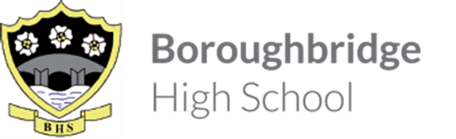

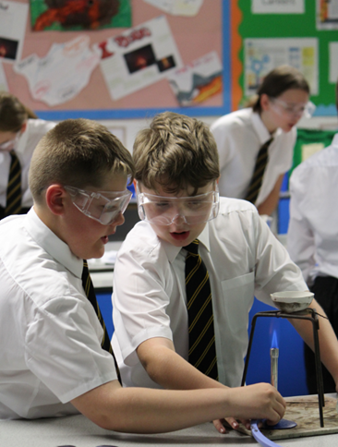
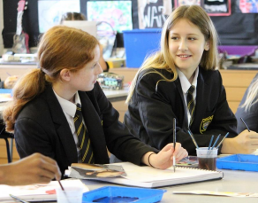
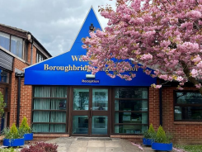
Information for Candidates
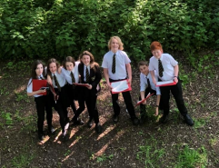
Staff know pupils well at Boroughbridge High School. There are positive relationships between pupils and staff. Ofsted May 2023

Welcome from the Headteacher
Thank you for considering Boroughbridge High School for the next stage of your career where our belief in ‘Aspiration for All’ means that our students are at the heart of our decision making. With around 450 students, we serve the community of Boroughbridge and the wider rural area, attracting students from more than 35 partner primaries which gives our school a welcoming, inclusive atmosphere. We feel like a family and, as such, we know our students well making Boroughbridge High School a good place to work and learn. We all understand our responsibility to ensure that everyone within our school community is safe, happy and successful.
Success, in its widest sense, underpins our mission which is to ensure that all students leave our school, not only with the qualifications that they need to access the next stage of their education or career of choice, but with the skills and confidence to make an active contribution to the communities to which they belong. We understand that this can only happen in an environment where there are high expectations with staff who have the skills and confidence to create high quality, engaging learning experiences which secure good student progress.
We also understand the benefit of partnership working and are federated with King James’s School in Knaresborough.
Just as we know our students well, as a member of staff you will be part of a staff team of 63 with 28 teaching staff, 14 of whom are part-time. You will be known and will have the capacity to make a significant difference to our school community.
This is an exciting time to join Boroughbridge High School. Following our Ofsted Inspection in May 2023, we have introduced ‘Learning Phases’ so that our expectations for each phase of learning, Whole class work, Group and Pair work and Individual work, are clear. We have also been working with the DfE Behaviour Hub programme since January 2024 which has supported us in embedding our phases of learning and deepening our Behaviour for Learning system. This has enabled us to have significant impact on the standard of behaviour and qulaity of learning across the school and, as a school community, we are proud of our progress to date. This good progress has been validated during visits from our Local Authority adviser. However, don’t just take our word for it. if you would like to see for yourself, then please contact us at vacancies@boroughbridgehighschool.com and we would be delighted to show you our school on a working day.
I hope that the opportunity that we have is of interest to you.
Kathryn Stephenson
Safe and happy students are successful.
Information about the school
Engaging and inspiring curriculum
High quality teaching within an engaging and inspiring curriculum ensures that students are motivated to learn.
At Key Stage 3
We have a three-year Key Stage 3 curriculum enabling students to study the full range of National Curriculum subjects in depth along with an extensive PSHCE (Personal, Social, Health, Citizenship and Economic) programme. Students begin to personalise their curriculum at the end of Year 8 before making their GCSE option choices at the end of Year 9.
At Key Stage 4
At GCSE students follow a Stage not Age curriculum which means that they study two of their four option subjects in Year 10, taking the exam at the end of Year 10. This enables students to secure two GCSE qualifications whilst developing deep knowledge of exam technique in Year 10 which they can then apply to their subjects during Year 11. All students have access to an EBacc curriculum.
At Key Stage 5
We have temporarily suspended entries to our Sixth Form and a consultation is currently underway with the proposal to change the age range by permanently removing sixth form provision from 31st August 2024. As part of our Federation we work closely with King James’s School, Knaresborough at post-16.
Curriculums are well thought out and sequenced.
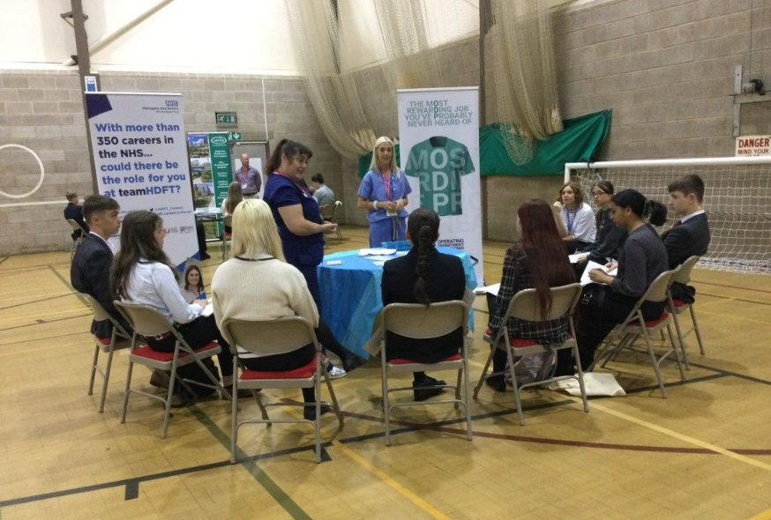
Teachers have secure subject knowledge and apply this well in lessons. Ofsted 2023
Across the Key Stages, our Personal, Social, Health and Citizenship education programme prepares students for the challenges of life beyond school. Careers education is an integral part of the curriculum in all years. Students have the opportunity to work with our qualified careers advisor along with attending careers conferences, listening to visiting speakers, carrying out mock interviews and meeting people from the local community along with work experience. This means that students have a detailed knowledge of the options available to them so that they can make an informed choice.
Our students go on to a range of options including further and higher education, apprenticeships and full-time employment.
Futures
Pupils receive effective careers advice and guidance. They experience a range of activities to help them learn about different careers This helps them to prepare for the future. Ofsted 2023
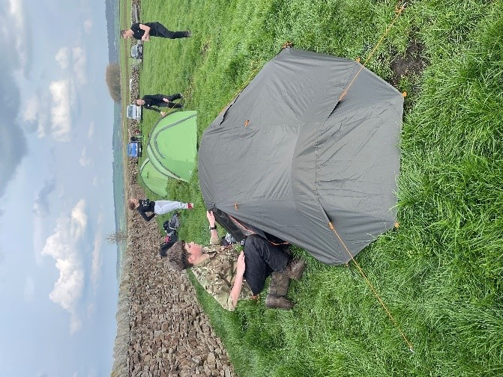
Because we have a commitment to ensuring that students have the skills and confidence to make an active contribution to the communities in which they belong, we encourage students to take every opportunity to develop their leadership skills.
All students have the opportunity to get involved in activities such as the Duke of Edinburgh’s Award and Sports leadership and, across the age range, are able to contribute to whole school decision making by becoming part of the School Council. Each year we have Year 10 and Year 11 Prefects who take an active role in school events.
There are a range of extracurricular activities that pupils can participate in and pupils speak enthusiastically about these. Ofsted 2023
Consistently high-quality teaching and learning ensuring Aspiration for all
We celebrate the fact that all students are individual but we are consistent in having the same high expectations of all and are committed to supporting students to make maximum progress. Through Teaching and Learning Agreed Practice for teachers, we ensure that we use data intelligently to plan for individual student needs.
Alongside this detailed planning, where students have Special Educational Needs or Disabilities, we have an experienced team of support staff who offer further support in two main ways: the assistance of extra support in the classroom and through individual or small groups sessions. These include interventions for students who need support with their literacy and numeracy skills.
Pupils with special educational needs and/or disabilities (SEND) have access to the full curriculum.
Leaders identify and understand the additional needs of pupils with SEND. Staff receive appropriate information which allows them to make adjustments to ensure that pupils with SEND can complete their work. Ofsted 2023
Students who are supported
Students are well supported at Boroughbridge High School. Students meet their Form Tutors daily. The Form Tutor monitors their personal and academic progress. Each year group has a Pastoral Manager who oversees their wellbeing and monitors their Attendance, Attitude to Learning and Behaviour for Learning so that they can support students if and when necessary.
Students will also be taught by a range of subject teachers. Students are encouraged to approach any member of staff if they need help or have anything that they wish to discuss.
Creating a positive learning environment
In order to create a positive learning environment we have a Climate for Learning strategy which includes an Attitude to Learning, Behaviour for Learning and Homework scale so that students know what is expected of them. This is complemented by our classroom expectations for whole classwork, pair and group work and individual work which were introduced following our Ofsted inspection in May 2023. All of these are linked to our Rewards system so that students understand that how they conduct themselves every moment of every day is important.

