

**Special Educational Needs & Disabilities (SEND) Information Report 2022-2023**

**The Local Offer**

The Children and Families Bill was enacted in September 2014. From this date Local Authorities (LA) and schools are required to publish and keep under review information about services they expect to be available for children and young children with special educational needs and disabilities (SEND) aged 0-25. The LA refer to this as the ‘Local Offer’. The intention of the Local Offer is to improve choice and transparency for families. It will also be an important resource for parents in understanding the range of services and provision in the local area. This is available online from [www.gateshead.gov.uk/localoffer](http://www.gateshead.gov.uk/localoffer)

**The Special Education Needs Information Report**

Schools utilise the LA Local Offer to meet the needs of SEND pupils as determined by school policy, and the provision that the school is able to provide. Schools refer to this as ‘The Special Educational Needs Information Report’. The Information Report is set out in a series of questions and answers which aims to give parents and carers clear information about what each school and setting provides.

At Bensham Grove Nursery School the views of parents and carers are highly regarded. It is important that we all work together to do the best for every child. All schools are supported to be as inclusive as possible with the needs of pupils with Special Educational Needs and Disabilities being met in a mainstream setting whenever possible.

The broad areas of SEND are:

* Communication and Interaction
* Cognition and Learning
* Social, Emotional and Mental Health Difficulties
* Sensory and/or Physical

|  |
| --- |
| 1. **Who are the best people to talk to in this school about my child’s difficulties with learning / special educational needs or disability (SEND)?** |
| * Your child’s Key-worker is the person you see every day and who you can talk to about your child’s strengths, abilities and needs, in order to be fully involved in all areas of your child’s development. At Bensham Grove Nursery School we believe in the ‘strong relationship’ approach and we enable all practitioners to make accurate observations of their key children in order to know and understand their needs, development and progress, and work within the team to ensure that full access and engagement with the curriculum is achieved. * Nursery Teacher, Lesley Chesson is the SENDCo (Special Educational Needs and Disabilities Co-ordinator) for Bensham Grove Nursery School. Lesley works with the nursery team, the children, parents and professionals to co-ordinate the systems and provision which best meet the needs of all children in the Nursery from identification onwards. Lesley works very closely with practitioners in liaison with all outside support services to plan provision and intervention activities, which effectively support children’s learning. * Your key person or Lesley can talk with you about your child’s development and needs. * Denise Kilner, Head Teacher is responsible for managing all aspects of the school, including support for children with SEND. Denise and Lesley will ensure that SEND systems and provision are monitored, updated and delivered with regard to the Code of Practice and Early Years Foundation Stage Statutory Framework. * The SEND Link Governor is Rachel Robson. Denise, Head Teacher ensures that the Governing body is kept updated with any information relating to SEND. All parties work together in maintaining the highest standards of activity and support, which includes budget management, deployment of resources and regular visits to quality assess the provision. |

|  |
| --- |
| 1. **What are the different types of support available for children with SEND in Bensham Grove Nursery School** |
| •At whatever age your child joins us at Bensham Grove Nursery School their Keyperson will get to know you from the home visit onwards. A great emphasis is given to the emotional health and wellbeing of all the children reflected in rigorous safeguarding procedures, and in developing effective relationships with parents and carers and in establishing a safe, nurturing environment for all children to thrive and achieve. It is understood by all practitioners that a child’s personal, social and emotional (PSE) development is crucial to children engaging in all learning. The area of PSE is recognised as being one of three prime areas in the EYFS which importantly underpins all areas of learning and development.  •Your child’s key person will join your child in play and talk, making observations and developing their ideas and modelling different play opportunities reflecting on your child’s experience, wellbeing, interests and progress.  •The key person will work with the nursery team and SENCo, share observations, celebrate achievements, share areas of development and make accurate observations and assessments. If it is seen that your child would benefit from additional support, we will talk with you at the identification stage and fully inform you of the Early Years quality teaching taking place. Planned, targeted enrichment activities and or intervention will be planned. This may be in small groups, specifically provided in play or on an 1:1 basis. If appropriate we will seek a request for permission to make a referral to the Speech and Language Therapy Service (SALT) for screening, advice and guidance at the earliest opportunity.  •This means we are taking additional action to support your child. At this point your child will be receiving targeted support from nursery. Your child’s engagement and progress in response to this additional target support will be closely monitored.  •If it is felt that your child requires further specialist advice we will discuss with you seeking advice from the Area Senco or in making a referral to the Early Years Pre School Panel to help your child to make progress. This is a multi-agency panel at which a child’s needs are considered and they are allocated support identified be best meet their needs.  •A ‘Support Plan’ will be drawn up which will identify three key targets identified for your child and this will enable activities to be effectively delivered and shared, with key specific targets identified.  •Close observation and assessment will be part of the on-going process to closely check on development and progress, and SENCo monitoring will maintain high quality teaching and intervention activities, and form part of the ASSESS, PLAN, DO and REVIEW cycle which parents will be part of.  •If your child continues to present with delay in all or some areas of their development, we will talk with you about making a request for a specialist service for guidance in supporting your child’s learning, such as the Educational Psychology Service.  •This expert level of support enables us all to understand your child’s needs better and implement the most appropriate activities to support their progress and development.  •If progress continues to be below what is expected through the on-going assessment of your child’s development and progress, a decision will be made to hold a multi-agency child-centred meeting to talk about the next steps of action to be taken to meet the needs of your child.  •If it is agreed that a higher level of support is required, discussions with parents and linked professionals will take place to consider a request for formal statutory assessment called an Education and Health Care Plan and an application will be made.  **Formal Statutory Assessment (EHCP):**   * The school (or you) can request that the Local Authority carry out a statutory assessment of your child’s needs. This is a legal process which sets out the amount of support that will be provided for your child. * After the request has been made to the ‘Panel of Professionals’ (with a lot of information about your child including some from you) they will decide whether they think your child’s needs (as described in the paper work provided), are such that they need a statutory assessment. If this is the case, they will ask you and all professionals involved with your child to write a report outlining your child’s needs. If they do not think your child needs this, they will ask the school to continue with the current support. * After the reports have been sent, the ‘Panel of Professionals- SEND Team’ will decide if your child’s needs are such that they require an EHCP. If this is the case, they formulate an Education Health Care Plan(EHCP) from the information they have been provided with. * The EHC Plan will outline the number of hours of individual/small group support your child will receive from the Local Authority and how the support should be used and what strategies must be put in place. It will also have long and short-term goals for your child.   Please see the flow chart below which shows the process and family intervention timescales. |

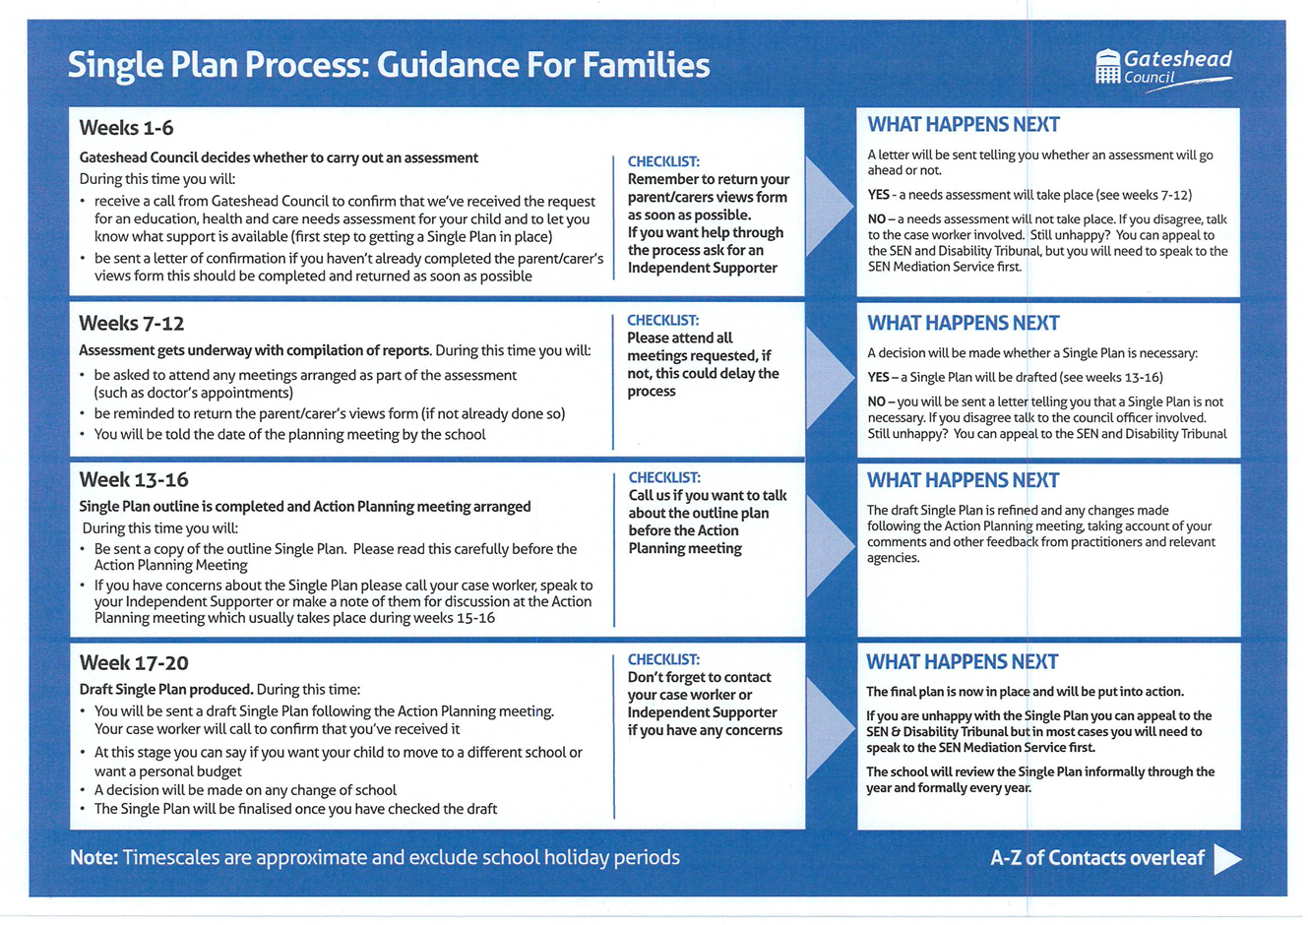

|  |
| --- |
| 1. **How can I let the school know I am concerned about my child’s progress in school?** |
| * For day to day concerns there is the opportunity to speak to your child’s key person at arrival and collection. If your child arrives earlier in the day or stays later, please let a member of staff know that you would like to speak to your child’s keyperson, and they will ensure that the message is communicated. * We understand that your child’s needs are of great importance and if you are concerned, we would like to speak to you at the earliest opportunity * Please call school office on: 0191 4334090 and arrange to speak to the SENCo. |

|  |
| --- |
| 1. **How will the school let me know if they have any concerns about my child’s learning in school?** |
| * If your child is identified as not making progress the school will set up a meeting to discuss this with you in more detail and to listen to any concerns, you may have too. * The school will plan any additional support your child may receive and inform you of progress and achievement. * The school will discuss with you any referrals to outside professionals to support your child’s learning. |

|  |
| --- |
| 1. **How is extra support allocated to children and how do they progress in their learning?** |
| * The EYAIT is a commissioned service, funded by Gateshead Council from the High Needs Funding Block and is made up of specialist teachers, Portage workers, teaching assistants. This team offers assessment, intervention, support and review for children who are experiencing significant barriers to their development and learning and for whom specialist intervention is needed. They also support staff working in early years settings by offering advice and modelling appropriate strategies with children. * The Headteacher decides on the deployment of resources for Special Educational Needs and Disabilities in consultation with the SENCo and school governors, on a basis of needs in the school. |

|  |
| --- |
| 1. **Who are the other people providing services to children with SEND in this school?** |
| **Directly funded by the school:**   * Additional Teaching Assistants for 2022-2023 * SENCo * Through School SLA – Educational Psychology Service   **Paid for centrally by the Local Authority but delivered in school:**   * Early Years Assessment and Intervention Team * Sensory Service for children with visual or hearing needs – Low Incidence Needs Team (LINT) * Speech and Language Therapy.   **Provided and paid for by the Health Service but delivered in school:**   * Health Visitor Team * Occupational Therapy * Physiotherapy |

|  |
| --- |
| 1. **How are the teachers in school helped to work with children with an SEND and what training do they have?** |
| * The SENCo role is to support the Key person in planning for children with SEND. * The school plans for training for all staff to improve the teaching and learning of children including those with SEND. This includes whole school training on all SEND issues. * Individual teachers and support staff attend training courses run by outside agencies that are relevant to the needs of specific children in their class or attend training such as PECS, EPS service behaviour support and have allocated review sessions with EPS where required for specific children and needs. |

|  |
| --- |
| 1. **How will teaching be adapted for my child with SEND?** |
| * Your child’s key person will plan learning activities according to the specific needs of all the children in their group and will ensure that your child’s needs are met. * Trained staff will support the needs of your child where necessary. The team will work together to share advice and strategies to best meet the needs of children’s age, stage and specific needs to optimise their progress. * Specific resources and strategies will be used to support your child individually and in groups following observations, advice and recommendations from practitioners and multi-agency colleagues. * Planning and teaching will be adapted on a daily basis if needed to meet your child’s learning needs. |

|  |
| --- |
| 9. **How will we measure the progress of your child in school?** |
| * Your child’s progress is continually monitored by their key person. * Their progress is reviewed termly in the Early Years Prime areas of development:   + Personal, social & emotional development   + Communication and Language Development   + Physical Development * Children may have an SEN Support Plan with personal targets which will be reviewed termly with your contribution and targets may be adjusted or new targets developed following discussion around your child’s needs. * Progress of children with an EHCP is formally reviewed at the Annual Review with all adults involved with the child’s education. * The HeadTeacher and SENco will work closely with the nursery team and continue to monitor your child’s progress. |

|  |
| --- |
| 1. **How accessible is the school environment?** |
| * The entrance to the building is at ground level and children/families accessing 3-5 year old provision access the lower ground using the stairs or lift as required * We have a large toilet cubicle with wide access. * We have a shower facility. * We have disabled car parking bays. * There is an accessible adult/family toilet available. * There are dual height handrails available on lower stairs. * Our learning environment is large and specifically set out for easy access for children with mobility difficulty. * We ensure, wherever possible that equipment used is accessible to all children regardless of their needs. * Our outdoor environment varies in gradient; however, spaces are accessible via pathways and ramps. |

|  |
| --- |
| 1. **How will my child be included in activities outside the classroom?** |
| * Activities and school trips are available to all. * Risk assessments are carried out and procedures put in place to enable all children to participate. It is important that communication is made between both parties to ensure that risk assessments reflect the needs of your child when in the community or on a visit for example to make this robust. * If it is deemed that a high level of 1:1 support is required a parent/carer may be asked to accompany their child during the activity. |

|  |
| --- |
| 1. **What if my child has medical needs?** |
| * If a child has a medical need then a detailed Health Care Plan is compiled with support from the medical professionals involved with the child e.g.; community paediatric nursing team /Asthma Management Team and in consultation with parents/carers. * Plans are discussed with all staff. * Where necessary and in agreement with parents’/ carers medicines are administered in school but only where signed Medication consent form is in place to ensure the safety of both child and staff member. Medication must be labelled by a medical professional for the child. * Risk assessments are completed to support children with complex medical needs. If required a Personal Emergency Evacuation Plan (PEEP) will be completed to support an emergency evacuation for individuals if required. * Key staff have completed Paediatric First Aid training which is renewed every three years. |

|  |
| --- |
| **13. How will the school prepare and support my child to join the setting or transfer to a new setting in the next stage of their development?** |
| * We recognise that transitions can be difficult for a child with SEND and take steps to ensure that any transition is a smooth as possible. * Discussions between the previous nursery / setting prior to your child joining our school. * A transition review or Team around the family (TAF), if held, is planned for parents/carers and all professionals involved with your child to discuss with the receiving SENco and/ or class teacher any arrangements and support required to meet your child’s needs. * Additional visits are arranged for children who need extra time in their new setting and strategies discussed in a personalised way to best support your child. * All necessary records about your child are passed on to their receiving school. |

|  |
| --- |
| **14. How are parents involved in the setting? How can I be involved?** |
| * All parent/carers are welcome in the school and encouraged to join parent groups, stay and play sessions, special events or our craft workshops. * Your child’s key person or SENCo is regularly available to discuss your child’s progress or any concerns you may have and to share information about what is working well at home and school so similar strategies can be used, to discuss your child’s progress or any concerns/worries you may have. * All information from outside professionals will be discussed with you with the person involved directly, or where this is not possible, in a report. * SEN Support Plans will be reviewed with your involvement each term. |

**Complaints**

* Complaints Parent/carers should contact the Head Teacher and /or SENCO with any complaints about the provision that the pupil is receiving at school. *If the complaint is not resolved, the school has a complaints policy which can be found at****:***[***benshamgrovecommuitynurseryschool@gateshead.gov.uk***](mailto:benshamgrovecommuitynurseryschool@gateshead.gov.uk)
* *Parents*/carers can contact the Special Educational Needs and Disability Information and Advice Service which is run by Barnardos in Gateshead (tel 0191 4784667). This is a free, confidential service for young people who have SEND and their parent/carers. The service is available whether or not the young person has a Single Plan.
* Gateshead Council has developed a Local Offer which provides information about education, health and social care support for children and young people with SEND in Gateshead.
* The Local Offer can be found at **www.gateshead.gov.uk/localoffer.**

