Name:
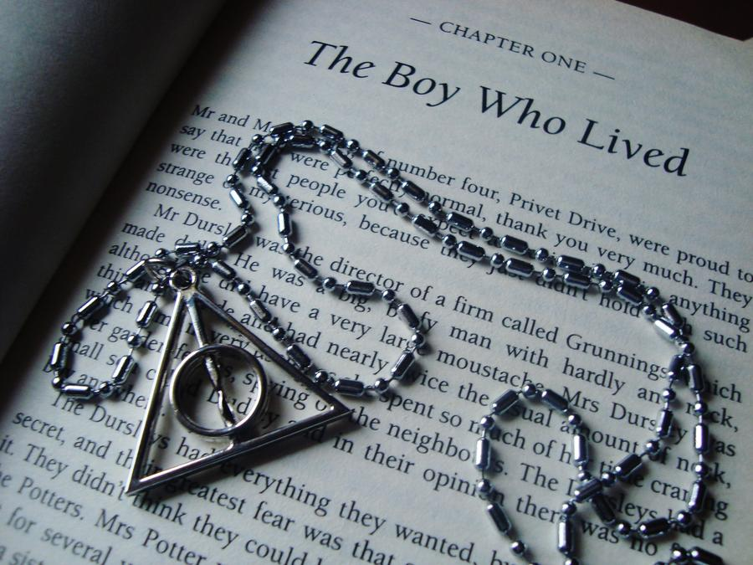
Year 6 to Year 7 Transition Booklet for English
Session 1
LO: To be able to select and retrieve information from a text and infer meaning from it.
Harry Potter and the Philosopher’s Stone
Nearly ten years had passed since the Dursleys had woken up to find their nephew on the front step, but Privet Drive had hardly changed at all. The sun rose on the same tidy front gardens and lit up the brass number four on the Dursleys' front door; it crept into their living room, which was almost exactly the same as it had been on the night when Mr. Dursley had seen that fateful news report about the owls. Only the photographs on the mantelpiece really showed how much time had passed. Ten years ago, there had been lots of pictures of what looked like a large pink beach ball wearing different-colored bonnets - but Dudley Dursley was no longer a baby, and now the photographs showed a large blonde boy riding his first bicycle, on a carousel at the fair, playing a computer game with his father, being hugged and kissed by his mother. The room held no sign at all that another boy lived in the house, too.
Yet Harry Potter was still there, asleep at the moment, but not for long. His Aunt Petunia was awake and it was her shrill voice that made the first noise of the day.
"Up! Get up! Now!"
Harry woke with a start. His aunt rapped on the door again.
"Up!" she screeched. Harry heard her walking toward the kitchen and then the sound of the frying pan being put on the stove. He rolled onto his back and tried to remember the dream he had been having. It had been a good one. There had been a flying motorcycle in it. He had a funny feeling he'd had the same dream before.
His aunt was back outside the door.
"Are you up yet?" she demanded.
"Nearly," said Harry.
"Well, get a move on, I want you to look after the bacon. And don't you dare let it burn, I want everything perfect on Duddy's birthday."
Harry groaned.
"What did you say?" his aunt snapped through the door.
"Nothing, nothing . . ."
Dudley's birthday - how could he have forgotten? Harry got slowly out of bed and started looking for socks. He found a pair under his bed and, after pulling a spider off one of them, put them on. Harry was used to spiders, because the cupboard under the stairs was full of them, and that was where he slept.
When he was dressed he went down the hall into the kitchen. The table was almost hidden beneath all Dudley's birthday presents. It looked as though Dudley had gotten the new computer he wanted, not to mention the second television and the racing bike. Exactly why Dudley wanted a racing bike was a mystery to Harry, as Dudley was very fat and hated exercise - unless of course it involved punching somebody. Dudley's favourite punching bag was Harry, but he couldn't often catch him. Harry didn't look it, but he was very fast.
Perhaps it had something to do with living in a dark cupboard, but Harry had always been small and skinny for his age. He looked even smaller and skinnier than he really was because all he had to wear were old clothes of Dudley's, and Dudley was about four times bigger than he was. Harry had a thin face, knobbly knees, black hair, and bright green eyes. He wore round glasses held together with a lot of Scotch tape because of all the times Dudley had punched him on the nose. The only thing Harry liked about his own appearance was a very thin scar on his forehead that was shaped like a bolt of lightning. He had had it as long as he could remember, and the first question he could ever remember asking his Aunt Petunia was how he had gotten it.

Now choose a level of challenge. Knut is the easiest level, sickle is the middle level and galleon is the hardest level. Push yourself!

Knut Challenge – I can retrieve information from a text:
- How long has Harry lived with the Dursleys?
- What street did they live on?
- How had the photos changed over the years?
- What was special about that day?
- Why was Harry used to spiders?
- Why was it a mystery to Harry that Dudley wanted a bike for his birthday?
- Why were Harry’s glasses broken?
- What unique feature does Harry have on his head?
- Why did Harry look skinnier and smaller than he was?
- What was Harry responsible for doing?
- What was the first question ever Aunt Petunia asked Harry?
Sickle Challenge – I can select information from a text and make simple inferences:
- What time of day was it?
- How old do you think Dudley might be?
- How had the photos changed over the years?
- Why was Dudley unable to punch Harry?
- What exercise did Dudley enjoy?
- Find four adjectives that describe Harry’s appearance.
- What do we know about the neighbourhood?
- What do you think Dudley is like?
- Why did Harry look skinnier and smaller than he was?
- Why was the table almost hidden?
- What was the first question ever Aunt Petunia asked Harry?
Galleon Challenge – I can infer from a text, using evidence and terminology:
- What impression do you get of Aunt Petunia? What makes you think this?
- Why might Harry feel like he had had the same dream before?
- Find all the adjectives that describe Harry’s appearance.
- What do you think is meant by the ‘fateful news report’?
- What language feature is used in Dudley’s name?
- How old do you think Dudley might be?
- Why does the author say Aunt Petunia’s voice is shrill? What impact does this have?
- Why would the author say that the sun ‘crept’ into the living room?
- What type of person is Dudley? Justify your response using examples from the text.
- Why do you think Harry didn’t look fast?
- Find as many examples of alliteration as you can.
______________________________________________________________________________________________________________________________________________________________________________________________________________________________________________________________________________________________________________________________________________________________________________________________________________________________________________________________________________________________________________________________________________________________________________________________________________________________________________________________________________________________________________________________________________________________________________ ______________________________________________________________________________________________________________________________________________________________________________________________________________________________________________________________________________________________________________________________________________________________________________________________________________________________________________________________________________________________________________________________________________________________________________________________________________________________________________________________________________________________________________________________________________________________________________
______________________________________________________________________________________________________________________________________________________ ______________________________________________________________________________________________________________________________________________________________________________________________________________________________________________________________________________________________________________________________________________________________________________________________________________________________________________________________________________________________________________________________________________________________________________________________________________________________________________________________________________________________________________________________________________________________________________
______________________________________________________________________________________________________________________________________________________
______________________________________________________________________________________________________________________________________________________________________________________________________________________________________________________________________________________________________________________________________________________________________________________________________________________________________________________________________________________________________________________________________________________________________________________________________________________________________________________________________________________________________________________________________________________________________________
______________________________________________________________________________________________________________________________________________________
Session 2
LO: To be able to produce a letter that uses the appropriate structure and language.
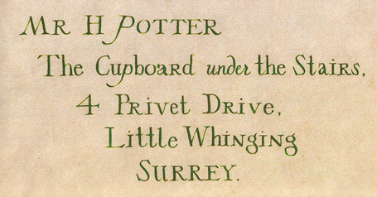
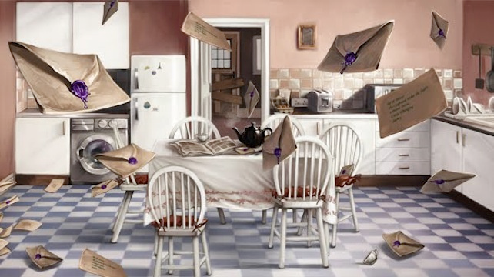
Harry receives an avalanche of letters from Hogwarts but he isn’t allowed to open even one!
Imagine what the letter could contain and write it up. Use the address below and the correct format.
Features of a letter:

______________________________________________________________________________________________________________________________________________________________________________________________________________________________________________________________________________________________________________________________________________________________________________________________________________________________________________________________________________________________________________________________________________________________________________________________________________________________________________________________________________________________________________________________________________________________________________ _________________________________________________________________________________________________________________________________________________________________________________________________________________________________ ______________________________________________________________________________________________________________________________________________________________________________________________________________________________________________________________________________________________________________________________________________________________________________________________________________________________________________________________________________________________________________________________________________________________________________________________________________________________________________________________________________________________________________________________________________________________________________
______________________________________________________________________________________________________________________________________________________
______________________________________________________________________________________________________________________________________________________________________________________________________________________________________________________________________________________________________________________________________________________________________________________________________________________________________________________________________________________________________________________________________________________________________________________________________________________________________________________________________________________________________________________________________________________________________________
______________________________________________________________________________________________________________________________________________________
_______________________________________________________________________________________________________________________________________________________________________________________________________________________________________________________________________________________________________________________________________________________________________________________
Session 3
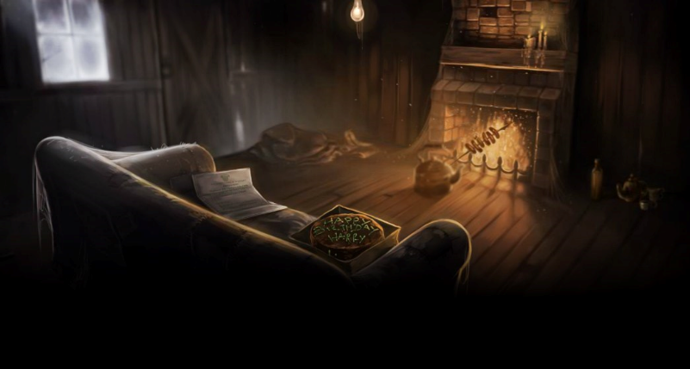
LO: To understand how to analyse language to explore the atmosphere created.
How does the writer create a strong atmosphere in this extract?
Read the extract, then match up the techniques in the boxes to part of the text.

BOOM. They knocked again. Dudley jerked awake.
‘Where’s the cannon?’ he said stupidly.

There was a crash behind them and Uncle Vernon came skidding into the room. He was holding a rifle in his hands – now they knew what had been in that long, thin package he had brought with them.

‘Who’s there?’ he shouted. ‘I warn you – I’m armed!’

There was a pause. Then –

SMASH!

The door hit with such force that it swung clear off its hinges and with a deafening crash landed flat on the floor.

A giant of a man was standing in the doorway. His face was completely hidden by a long, shaggy mane of hair and a wild, tangled beard, but you could make out his eyes, glinting like black beetles under all the hair. The giant squeezed his way into the hut, stooping so that his head just brushed the ceiling. He bent down, picked up the door and fitted it back easily back into the frame. The noise of the storm outside dropped a little. He turned to look at them all.
Varied sentence lengths
Imagery
Pathetic fallacy
Violent language

Wild, animalistic characterisation
Extreme strength and size

Now use what you have found in the text to answer the question. Write in full paragraphs and try to explain WHAT the writer has done, HOW they have done it and WHY they have done it (the effect on the reader).

Here are some words and phrases to help you:

implies
conveys
gives us the impression that
suggests
emphasises
highlights
indicates
evokes

______________________________________________________________________________________________________________________________________________________________________________________________________________________________________________________________________________________________________________________________________________________________________________________________________________________________________________________________________________________________________________________________________________________________________________________________________________________________________________________________________________________________________________________________________________________________________________ _________________________________________________________________________________________________________________________________________________________________________________________________________________________________
______________________________________________________________________________________________________________________________________________________________________________________________________________________________________________________________________________________________________________________________________________________________________________________________________________________________________________________________________________________________________________________________________________________________________________________________________________________________________________________________________________________________________________________________________________________________________________ _________________________________________________________________________________________________________________________________________________________________________________________________________________________________
_________________________________________________________________________________________________________________________________________________________________________________________________________________________________
______________________________________________________________________________________________________________________________________________________ _________________________________________________________________________________________________________________________________________________________________________________________________________________________________
_________________________________________________________________________________________________________________________________________________________________________________________________________________________________
______________________________________________________________________________________________________________________________________________________ _________________________________________________________________________________________________________________________________________________________________________________________________________________________________
_________________________________________________________________________________________________________________________________________________________________________________________________________________________________

Session 4
LO: To be able to describe your own wizard character.
- Draw a quick sketch of what you expect a wizard to look like. Label it with your thoughts.
- Make a list of things you expect a wizard to do.
- Create a spider diagram of personality traits you would expect a wizard to have.
WIZARD

Read the text carefully and discuss the answers to the questions with a partner. Write down your answers, ready to feed back to the rest of the class.
Albus Dumbledore
Nothing like this man had ever been seen in Privet Drive. He was tall, thin and very old, judging by the silver of his hair and beard, which were long enough to tuck into his belt. He was wearing long robes, a purple cloak which swept the ground and high-heeled, buckled boots. His blue eyes were light, bright and sparkling behind half-moon spectacles and his nose was very long and crooked, as though it had been broken at least twice. This man’s name was Albus Dumbledore.
- What in this description suggests this man is magical?

- What in this description suggests this man is worldly?

- What in this description suggests this man is a force for good?

- Now choose from the list at the start of the session what you would like your own wizard to be like.
- Think about his appearance, his personality and his history. How can you bring those to life in only one paragraph?
- Write that paragraph now, using a range of punctuation, sentence structures and exciting vocabulary.
____________________________________________________________________________________________________________________________________________________________________________________________________________________________________________________________________________________________________________________________________________________________________________________________
____________________________________________________________________________________________________________________________________________________________________________________________________________________________________________________________________________________________________________________________________________________________________________________________
____________________________________________________________________________________________________________________________________________________________________________________________________________________________________________________________________________________________________________________________________________________________________________________________
____________________________________________________________________________________________________________________________________________________________________________________________________________________________________________________________________________________________________________________________________________________________________________________________
____________________________________________________________________________________________________________________________________________________________________________________________________________________________________________________________________________________________________________________________________________________________________________________________
____________________________________________________________________________________________________________________________________________________________________________________________________________________________________________________________________________________________________________________________________________________________________________________________
____________________________________________________________________________________________________________________________________________________________________________________________________________________________________________________________________________________________________________________________________________________________________________________________
______________________________________________________________________________________________________________________________________________________________________________________________
Session 5
LO: To be able to plan and produce a creative piece of writing.
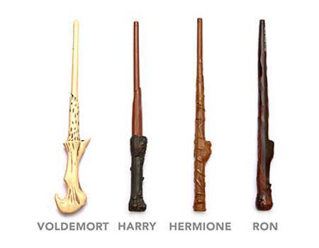
“Every Ollivander wand has a core of a powerful magical substance, Mr. Potter. We use unicorn hairs, phoenix tail feathers and the heartstrings of dragons. Try this one. Beechwood and dragon heartstring. Nine inches. Nice and flexible. Just take it and give it a wave.”
Design and label your own wand.
Give it a suitable name. (Names that suggest magic and wonder)
What kind of wood is it made from?
What does it have for its core?
How long is it?
What kind of spells is it especially good for?
Any other special design features? (For example, an extra-comfort grip, detailed carvings, an anti-rebound feature.)
An advertising slogan.

Planning:

